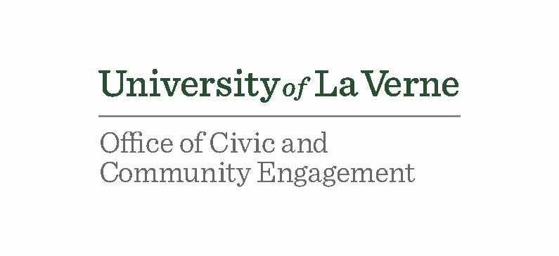
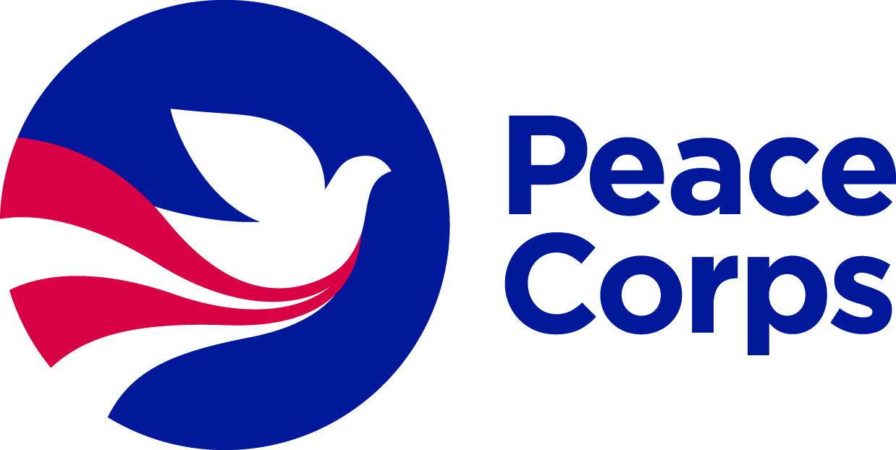

Template Student Application

Name: ________________________________ Student ID: _____________ Date: __________

Phone: ____________________ Email: _____________________________________________

Major(s): _____________________________ Minors(s): _______________________________

Expected Graduation (month and year): ______________________ Cumulative GPA: ________

- Training and experience in a specific work sector
Please check the box of the sector in which you would like to serve:

- Education
- Health
- Environment
- Agriculture
- Youth in Development
- Community Economic Development

Note: Actual Peace Corps assignments are based on local needs, and thus may or may not align seamlessly with your qualifications. Flexibility is key to the Peace Corps experience!

- Coursework. List the number and name of 3 courses in this same sector that you plan to take, and the semester in which you plan to take them (it is fine if you’ve already taken them).
Note: The courses you include on this application may change, but it’s good to have a plan.

- Course: _____________________________________ Semester and year: _____________
- Course: _____________________________________ Semester and year: _____________
- Course: _____________________________________ Semester and year: _____________

- Hands-on experience in that same sector (must total at least 50 hours).
Describe what you plan to do:

- Foreign language skills
Requirements depend upon desired Peace Corps volunteer placement site. (1) Latin America/ Spanish-speaking countries two 200-level courses. (2) West Africa/ French-speaking countries one 200-level course in any Romance Language. (3) Everywhere else no explicit requirements, but language skills are a plus.

If you intend to learn a foreign language, please list which one: ____________________

List the top 2 foreign language courses you plan to take:

Course 1: ________________________________________ Semester and year: _____________
Course 2: ________________________________________ Semester and year: _____________

Or describe your alternative learning process (e.g., native speaker):

- Intercultural competence
List the core course and two approved electives you plan to take:
Core course: _______________________________________ Semester and year: _____________
Elective 1: _________________________________________ Semester and year: _____________
Elective 2: _________________________________________ Semester and year: _____________

- Professional and leadership development
- Professional resume feedback: When do you plan to meet with [ULV Career Services] for a one-on-one resume review? Month and year: ______________________________________
- Professional interview prep: When do you plan to meet with [ULV Career Services] for an interview workshop? Month and year: ______________________________________
- Describe a leadership experience that you intend to pursue:
For example, leading a work or volunteer project, serving on the executive board of a student organization, or organizing a big campus event.

______________________________________ _________________
Signature of Student Date

______________________________________ _________________
Signature of Peace Corps Prep Coordinator Date

