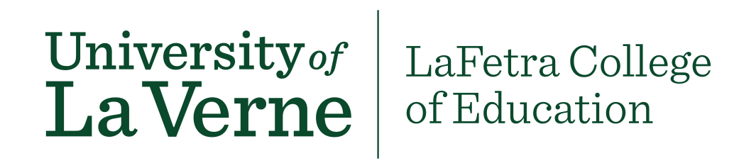

Course Approval Process for LVE 400 Courses
There are two opportunities for faculty to teach LVE 400.
- Developing a New Course
Faculty across colleges and departments are encouraged to propose a new 1-unit course. Faculty determine the topic for the course and focus on reflection and three of the Universities Baccalaureate Learning Outcomes, Intercultural Competence, Critical Thinking and Written Communication Skills.

Or

- Embed the 1 unit Into an Existing Course
Faculty can embed the unit into an existing course.
Course Approval Process
- Complete the GE Course Proposal Cover Sheet
- Complete the LVE 400 General Education (University Reflection attribute) Course Proposal Template
- Complete a syllabus (Please include the following content in your syllabus: Course title, course description, LVE 400 student learning outcomes (SLO’s) evidence of SLO’s, all assignments, rubrics, texts and/or readings).
- Attach these documents and the syllabus for the course and send them to Cindy Giaimo-Ballard cgiaimo-ballard@laverne.edu

