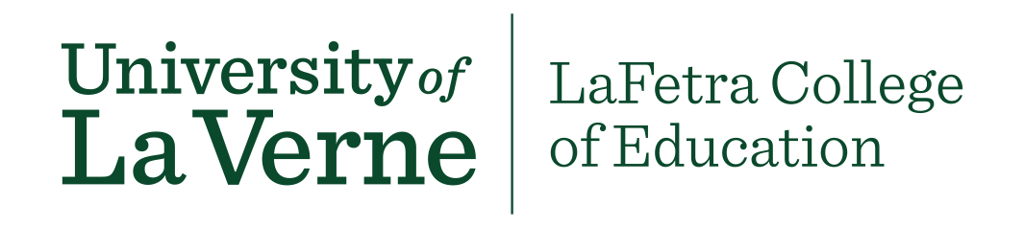

LVE 400 General Education (University Reflection Attribute)
Course Proposal Template

Whether you are developing a new course, or embedding the unit into an existing course, this form must be filled out and returned to Cindy Giaimo-Ballard (cgiaimo-ballard@laverne.edu) along with the GE Course Approval Form and your syllabus. Please email Cindy for a sample syllabus.
These are LVE 400 Student Learning Outcomes (SLO’s)
At the end of the course, students will be able to:
- demonstrate competency in writing reflections for three of the Baccalaureate Learning Outcomes; Intercultural Competence, Written Communications, and Critical Thinking/Information Literacy.
- think critically on their knowledge, skills and attitudes throughout the course.
- reflect on their own intercultural competency and how the conclusions relate to their personal and professional development.
- research intercultural competency and prepare a new artifact for their ePortfolio.
- relate their knowledge, skills and attitudes by participating in an intercultural capstone assignment/presentation.
Student Learning Outcomes | How does this course meet each SLO? | How are the SLO’s measured?
demonstrate competency in writing reflections for three of the Baccalaureate Learning Outcomes; Intercultural Competence, Written Communications, and Critical Thinking/Information Literacy.

think critically on their knowledge, skills and attitudes throughout the course.

reflect on their own intercultural competency and how the conclusions relate to their personal and professional development.

research intercultural competency and prepare a new artifact for their ePortfolio.

relate their knowledge, skills and attitudes by participating in an intercultural capstone assignment/presentation.

