CS-LAB: Computer Science Lab (11/02/2020)
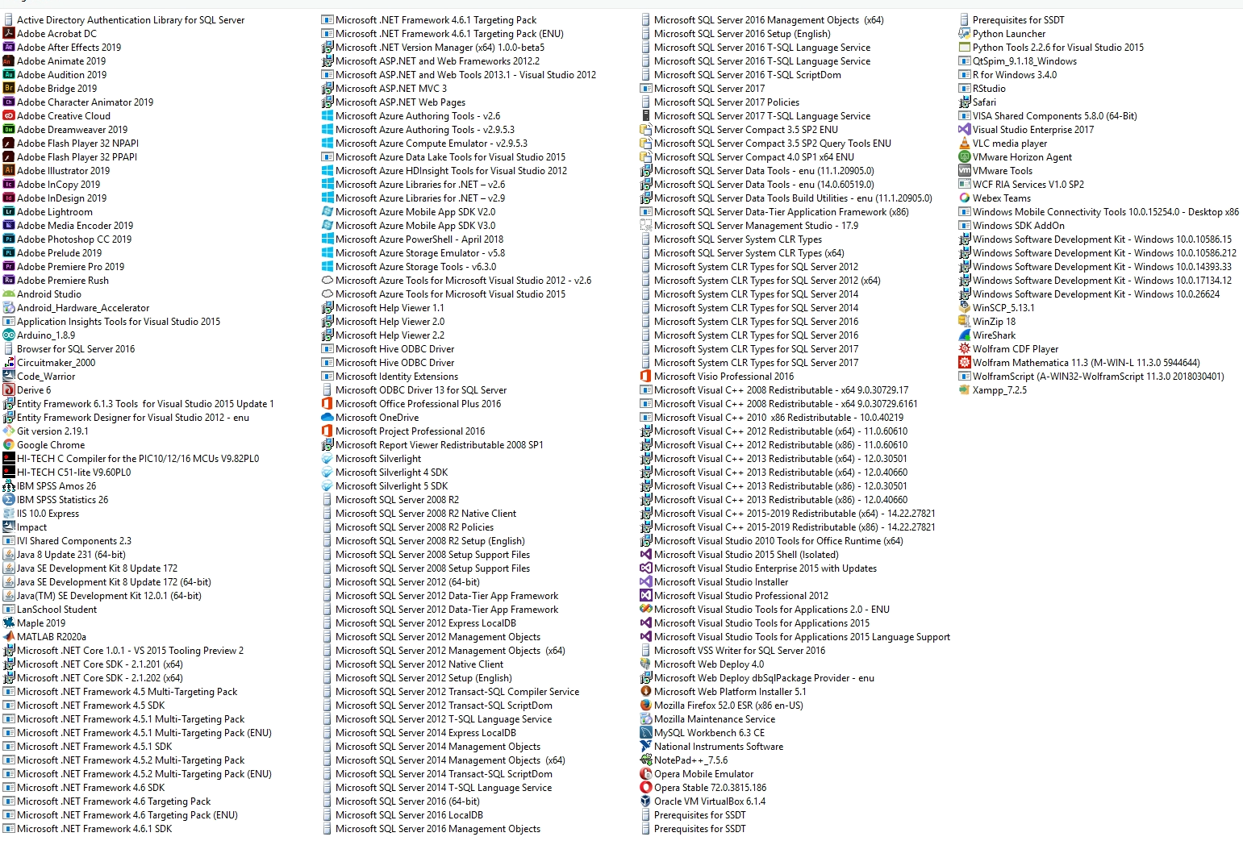
Student_VDI2: Student Computer Lab (11/02/2020)
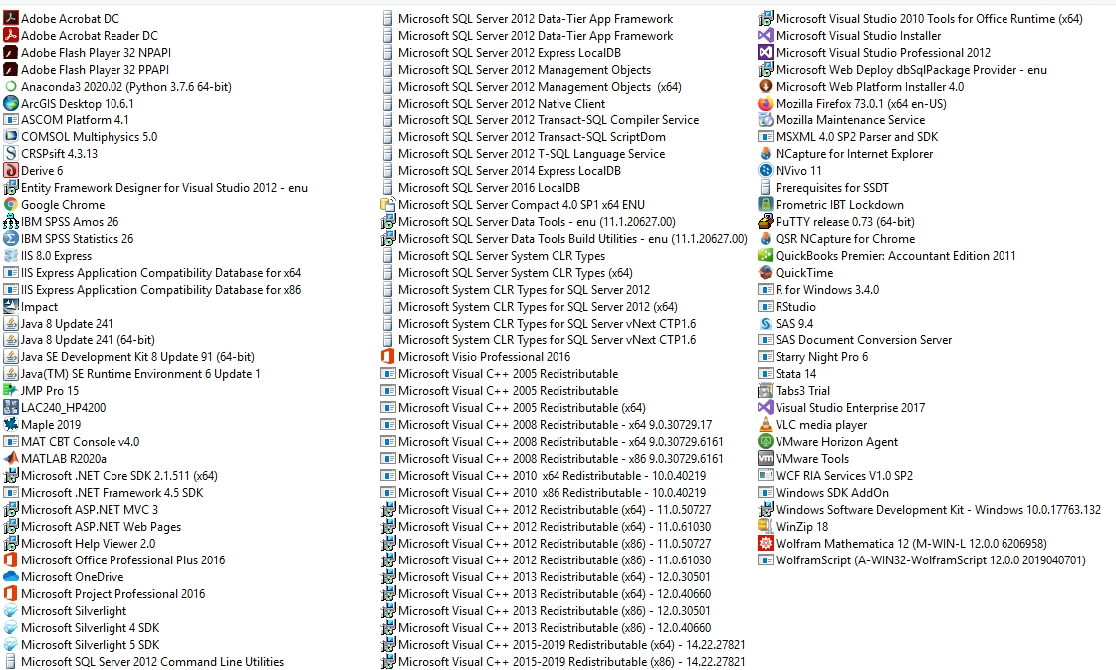

ULV-AS: Administration/Staff (11/02/2020)
