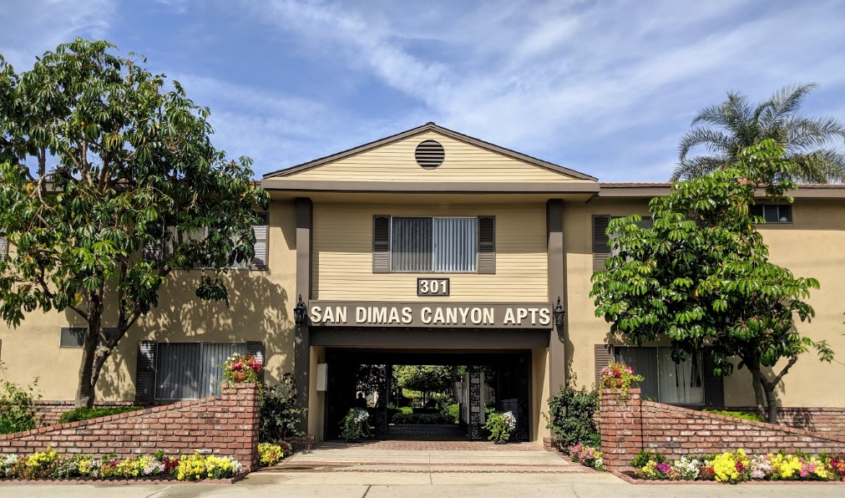
San Dimas Canyon Apartments
Daniel Spradley Property Manager
301 North San Dimas Canyon Road San Dimas, CA 91773
Email: sandimascanyonapts@gmail.com
Office: 909-599-5586 Fax: 909-599-7627 Cell: 262-298-2981
APARTMENT INFORMATION:
2 Bedroom/2 Bathroom: 1150 sq. ft. $1650.00 - $1700.00 with 1 Year Lease
3 Bedroom/2 Bathroom: 1250 sq. ft. $1900.00 - $2000.00 with 1 Year Lease
Month to Month Lease will be an additional $50.00 per month
Security Deposit: $1,000.00

San Dimas Canyon Apartments is a beautiful 102-unit community is a quiet, friendly with beautiful landscaping. Our apartments are the most spacious in town with Central Air/Heating. We would like to partner with The University of La Verne and offer a special of 1-month free rent with a 12-month lease signed to all students and faculty.
Please contact with any questions

