Program Review of the

University of La Verne

Academic Support and Retention Services

October 1, 2011

*Prepared and Written*

*by*

Carlos C. Cervantes, Ed.D.

Associate Dean

*Faculty Advisor*

Alden Reimonenq, Ph.D.

Professor of English

*External Reviewer:*

Nicholas Warner, Ph.D.

Claremont McKenna College

*Research and Review Collaborators:*

Lee Knous

Patti Nonemaker

Vanessa Martinez

Adeline Cardenas-Clague

Table of Contents

Executive Summary……………………………………………………………………………….3

1. Program or Department Mission…………………………………………………………...5
2. Program or Department Goals and Objectives……………………………………………..6
3. Description of Program/Department Capacity……………………………………………..7
4. Effectiveness Indicators…………………………………………………………………..29
5. Findings…………………………………………………………………………………...30
6. Action Recommendations…………………………...……………………………………79
7. Action Plan………………………………………………………………………………..82

Appendices………………………………………………………………………………………84

References………………………………………………………………………………………140

**Executive Summary**

Academic Advising Office (hereafter, AAO) delivers services that impact the entire traditional undergraduate student population (hereafter, students) at the main campus. The office oversees advisor assignments and coordinates academic support and retention activities. It provides training and logistical support for 89 faculty advisors and 7 staff advisors. It is also responsible for coordinating new student advising and registration events in the winter and summer seasons. AAO provides an academic home to undeclared students and monitors all students, including, and especially, those who are “at-risk” of failing such as those who are on academic warning or probation. It handles student cases related to academic warning, probation, and disqualification, including appeals for exceptions to university academic policies, academic reinstatement requests, and work study employment appeals that exceed the 20-hour per week limitation. Staff participates in various faculty and administrative committees that affect students via curricular, policy, and procedural decisions. AAO also coordinates and facilitates advising and retention initiatives involving various student-focused interventions and supportive workshops. All these activities are aimed at retaining and graduating students by engaging with, and supporting them.

La Verne has experienced record enrollments and increased attention to the importance of retaining students semester to semester, year to year, yet AAO’s budget has been cut by as much as a quarter forcing AAO to make due with fewer human and material resources. AAO has faced increasing cases of academic probation and pressure points in retention and graduation rates within certain student subgroups such as international students and First Year Resource Program.

Despite its budget cuts and increased workloads in student probations and retention efforts, AAO has managed to improve the quality and consistency of information that students and advisors receive from the office in conducting academic and administrative business with the University. This information affects the relevance and quality of advising sessions, registration processes, and satisfactory academic progress toward degree completion. Its activities and decisions are shaped by evidence-based data that have allowed staff and faculty to identify groups of students who are “at-risk” of failing, in establishing a clearer profile of its students, and improving processes, decision making, and learning outcomes. AAO’s responsibilities for academic advising, including reporting, assessment, and intervention efforts continue with limited financial and staffing resources. Nevertheless, these efforts have been recognized widely across campus, including WASC (2010 Capacity and Preparatory Review), and have allowed it to strengthen the rapport it has with important student, administrative, and faculty constituencies.

The office’s activities have built on previous efforts to provide logistical support for academic advisors and students by focusing more on intrusive efforts and case management, improved intervention strategies, the implementation of advising standards and learning outcomes, and to maximize the full potential of SunGard’s Banner Information System to establish a fully functioning data-driven decision-making department. Technological enhancements are frequently explored to facilitate academic advising and to improve tracking and reporting mechanisms to determine effective retention and advising strategies. Budget limitations prevent AAO from exploring with any seriousness any software or product enhancements that can streamline retention efforts.

Survey data suggests that most students are satisfied with the academic advising they receive at La Verne. These students demonstrate appreciation for advisors’ ability to answer academic and policy questions and their mentoring in non-academic topics. These students generally tolerated some advisors’ weak understanding of academic policies as long as they made good faith efforts to find the answers, refer them to those who can help, and most importantly that students felt they were treated as individuals and that advisors were genuinely concerned for them. Students who complained had three main issues with their academic advisors, 1) they felt their advisors were indifferent and unhelpful, 2) advisors did not know academic policies and requirements (and made no effort to find out), and 3) advisors were unavailable and hard to reach.

Academic advising is among a long list of professional activities and duties that faculty advisors do. Faculty advisors for traditional undergraduates represent 92% of academic advisors. Faculty advisors are also involved in other professional obligations such as departmental and campus governance, teaching loads, committee work, off-campus and professional obligations, research and publications requirements, including tenure-track considerations for senior and junior faculty.

Advising loads within certain academic units exceed the 1-29 (advisor to student) national average and La Verne’s 1-21 (advisor to student) ratio. Although all tenure and tenure-track faculty are expected to serve as academic advisors as part of their contractual obligations, data shows that the distribution of advising among faculty within several academic departments is inequitable.

AAO generally receives high marks in providing online and training support to academic advisors. Despite the availability of workshops and professional development opportunities, fewer than 20% of advisors attend these events. The challenges of limited faculty participation in academic advising, including workshops and seminars, and to some extent deep-rooted frustrations, may persist as long as advising loads within individual departments persist. There is a nearly 60/40 split among the advisors who were surveyed in support of a faculty advising model. Most advisors agree, however, that academic advising is an integral part of a comprehensive retention program. Advisor feedback and comments suggest that those who do not support the current faculty advising model also have very specific grievances concerning what they perceive as weaknesses in the current model. There appears to be little interest in advising outside their majors; many feel that academic advising and large case loads take time and effort away from other duties and responsibilities. Many would prefer that AAO take over academic advising in general education and requirements outside the major.

1. **Department Mission**

**Mission**

The primary purpose of the Office of Academic Advising at the University of La Verne is to assist students in the development and implementation of their educational plans. To this end the Office of Academic Advising subscribes to the philosophy of developmental advising.

Advising at La Verne is a cooperative effort between the advisor and student that consists not only of course planning and selection, but also the development of the person as a whole. This includes the selection of career and life-long goals.

We subscribe to the principle that academic advisors work to strengthen the importance, dignity, potential and unique nature of each individual served within the academic setting. The work of advisors is guided by the beliefs that:

* students are responsible for their own behavior
* students can be successful as a result of their individual goals and efforts
* students have a desire to learn
* learning needs vary according to individual skills, goals and experiences
* students hold their own beliefs and opinions
* students are active participants in the advising process, and
* students will think critically about their roles and responsibilities as scholars and as members of the La Verne community

1. **Department Goals and Objectives**

**Goal 1: Increase traditional undergraduate participation in advising and registration activities.**

*Objectives*

1. All incoming freshmen and transfer students will participate in advising and registration activities.
2. All incoming freshmen and transfer students will be assigned an academic advisor by the start of the first semester.

**Goal 2: To encourage as a result of academic advising the development of strong advisor-advisee relationships and learning outcomes such as the understanding of policies and requirements.**

*Objectives*

1. Use Developmental Advising as the theoretical framework for establishing outcomes.
2. All students will have satisfying advising experiences.
3. All first-time freshmen and transfer students will know about services and degree requirements.
4. All academic advisors will understand services and general education requirements.

**Goal 3: To increase persistence and retention rates of traditional undergraduates.**

*Objectives*

1. Reduce the number of traditional students who are on academic probation.
2. Improve Junior-Senior Persistence Rates toward Graduation.

**Goal 4: To implement educational and training opportunities that supports academic advisors and their advisees.**

*Objectives*

1. Develop technological and online resources to support academic advisors.
2. Implement mid-term report module via SunGard’s Banner to identify traditional undergraduates who are at-risk.
3. Develop workshops and professional development opportunities for traditional undergraduates and advisors.

**III. Description of Department Capacity**

*Physical Location and Staffing*

AAO is centrally located in Woody Hall. It shares a lobby with other vital offices—Financial Aid, Registrar, and Student Accounts—that work directly with students. AAO’s location allows the staff to collaborate with colleagues and to advocate on behalf of students when they interact with the offices that share lobby space in Woody Hall.

AAO consists of the Associate Vice-President for Academic Affairs, the Associate Dean, one Support Services Specialist, one Academic Advisor, and one Retention Specialist (one year appointment). The AAO leadership and staff are 12-month, full-time employees. The Academic Advisor also serves as a part-time Records Analyst with the University Registrar. The Support Services Specialist provides clerical and administrative support to the Associate Vice-President, Associate Dean, Academic Advisor, and the Retention Specialist. The Support Services Specialist also provides clerical and administrative support to the University Registrar (individual), whose office is located in the Academic Advising side of Woody Hall.

Organizational Chart

*Budget*

Total non-salary expenditures increased from $22,570 in 2008 to $24,983 in 2009, a net gain of 11%. However, 2009 to 2010 expenditures were cut by 28%, remaining flat at $19,525 for 2011, as noted in Table 1.

Table 1 – Non-Salary Budget Expenditures

|  |  |  |
| --- | --- | --- |
| Fiscal Year | AAO Budget (Non-Salary Expenses) | Change % |
| 2008 | $22,570 | --- |
| 2009 | $24,983 | +11% |
| 2010 | $19,525 | -28% |
| 2011 | $19,525 | --- |

Travel and lodging budgets were cut entirely for 2009. The travel budget remained unfunded through 2011. Funding for lodging increased to $1,500 for fiscal years 2010 and 2011. However, as noted in Table 2, current funding is $1,100 less than in 2008.

Table 2 – Non-Salary Budget Line Items

|  |  |  |  |  |  |
| --- | --- | --- | --- | --- | --- |
| Items | 2008 | 2009 | 2010 | 2011 | Change % |
| Travel | $1,546 | $0 | $0 | $0 | -100% |
| Lodging | $2,600 | $0 | $1,500 | $1,500 | -42% |

Budget cuts in travel and lodging eliminated staff participation in regional or national conferences in 2009 and 2010 that required airline travel. Conference participation was limited in 2009 and 2010 to a single staff member each year and to local events (within driving distance) that did not require lodging. The travel budget remained unfunded from 2009 to 2011.

Table 3 lists other budget items. The Supplies budget increased from $1,725 in 2008 to $2,425 in 2009, remaining flat for fiscal years 2010 and 2011. Contracted Services expenditures remained flat at $2,800 from 2008-2011. Other budget line items experienced nearly 50% cuts, such as Dues Memberships, Non-computer Equipment, Postage, and Printing. Expenditures for meals and catering increased in 2009 ($1,178) and again in 2010 ($1,200), remaining flat for 2011.

Table 3 – Non-Salary Budget Line Items

|  |  |  |  |  |  |
| --- | --- | --- | --- | --- | --- |
| Items | 2008 | 2009 | 2010 | 2011 | Change % |
| Supplies | $1,725 | $2,425 | $2,425 | $2,425 | +41% |
| Contracted Services | $2,800 | $2,800 | $2,800 | $2,800 | --- |
| Dues Memberships | $845 | $400 | $400 | $400 | -52% |
| Non-PC Equipment | $830 | $400 | $400 | $400 | -52% |
| Postage | $4,173 | $4,173 | $2,173 | $2,173 | -48% |
| Printing | $5,000 | $9,657 | $5,677 | $5,677 | -42% |
| Meals & Catering | $380 | $1,178 | $1,200 | $1,200 | +2% |
| PC Hardware | $500 | $500 | $500 | $500 | --- |

Computer-related expenditures remained flat at $500 which prevents basic computer upgrades. A single computer replacement would wipe the PC Hardware budget for the entire budget year at current market prices. Technological advancements within AAO have been obtained with the use and help of training, technical, and programming assistance by OIT, which is measured in hours worked by their programmers and technicians. AAO has been creative in its adoption of technologies by maximizing the use of current tools such as the Midterm Reporting module via SunGard’s Banner System (with OIT’s programming support), Microsoft Office Suite and Word Press. AAO has also adopted free tools such as Eventbrite, Facebook and Twitter at the cost of salary and wage-based expenditures and hours worked.

Technological tools such as Starfish Retain or Hobson’s Retain that would enhance AAO’s persistence and retention activities cannot be considered, much less afforded with the current budget. The Contracted Services budget would also be insufficient to cover the costs that are associated with annual licensing requirements for these tools. The net gains in tuition revenue for one FTE and one half-time FTE above AAO’s stated goals (as noted in Table 4) would pay for the cost of technological tools that would enhance AAO’s persistence and retention activities at the main campus. Contracted tools such as Starfish or Hobson’s Retain can be adopted across campus in support of persistence and retention activities for adult and graduate student populations which would reduce the operating cost of such tools on a per-student basis.

Table 4 – Persistence Gains

|  |  |  |  |  |
| --- | --- | --- | --- | --- |
|  | Fall 2009 | Spring 2010 | Fall 2010 | Spring 2011 |
| Persistence Goal | 974 | 1,319 | 1,083 | 1,650 |
| Actual Enrollment | 1,024 | 1,339 | 1,097 | 1,690 |
| Net Difference | +50 | +20 | +14 | +40 |
| Persistence Rate | 90% | 93% | 92% | 93% |
| Estimated Tuition Revenue (FTE) in excess of Goals | $706,250 | $282,500 | $208,600 | $596,000 |

Although the department has managed to operate despite a 28% reduction in the non-salary budget, it has done so in light of historic increases in unduplicated traditional undergraduate enrollments as noted by Institutional Research’s 2010 Fact Book.

According to the Fact Book, freshmen enrollments from 2009 to 2010 increased by 62%. Total unduplicated student enrollments grew from 1,540 to 1,896, an increase of 23%. The increase of 23% of unduplicated students is inclusive of FTE and non-FTE enrollments (such as non-degree seeking students who are advised and monitored by AAO). From 2009 to 2010, FTE for main campus undergraduates increased from 1,479 to 1,846, an increase of 25%.

In 2009 and 2010, AAO received budget approvals of $2,500 for Temporary wages for fiscal years 2008-2010. These allocations to wages paid for temporary, part-time staff that supported AAO’s persistence and retention activities. In 2011, AAO obtained approval for a temporary, full-time Retention Specialist, increasing the Temporary Wages budget to $25,550. The Retention Specialist was hired to sustain AAO’s student persistence gains from the three previous semesters, as noted in Table 4.

As Table 4 shows, AAO persistence and retention activities have a positive financial impact. However, AAO’s persistence and retention activities are driven by altruistic goals of advancing students’ educational goals and aspirations, inclusive of its own mission and that of the University. AAO’s activities have positive educational benefits for the individual students that it monitors despite its material and human resource challenges and budget cuts. AAO would be remiss if it did not recognize that its work could not have been possible without the dedicated support of faculty and other support offices, as noted in various sections of this review. The collective work of AAO and others is made easy when students have positive social and academic experiences that facilitate their decisions to persist semester-to-semester, year-to-year until they accomplish their educational goals.

*Event Planning*

AAO plans major advising and registration events and workshops months in advance. AAO staff members market their events via social networks, email, and flyers. AAO staff must schedule dates, times, and locations for the events. Catering is ordered and must be confirmed just prior to the events. Classrooms or halls must be reserved, and they must ensure that technical or audio/vision support is available. AAO works with guest speakers and collaborators to make sure their schedules coincide with the projected event days and times. AAO staff members collect and distribute program information and materials and ensure timely publishing and distribution. They develop meet and greet and check-in protocols and train student and staff volunteers on check-in procedures.

The AVP, Associate Dean, and the Retention Specialist are responsible for planning and organizing any pre-event meetings, including all operational, implementation, and pre- and post- event tasks. They act as the points of contact for, contact of, and provide assistance to guest speakers and participants. They evaluate, recommend, and implement operational changes for future program enhancements. They participate in cross-functional project teams that are responsible for campus-wide events such as Commencement, Summer Opportunities for Advising and Registration (SOAR) days, and College Preview Days. Specific examples of programs and events are described in more detail below.

*Student Workshops*

Each semester at least two workshops on selecting a major are offered to students who are undeclared or have selected a major, but who are unsure about their selection. The workshops are not designed to discuss specific majors or their requirements.  The workshops are aimed to help students who have not selected a major or who are reconsidering their current major.  They focus on conceptual tools that help students to self-reflect about their knowledge base, values, skills, and interests as legitimate sources for assessing the quality and interest of a particular major and whether or not a major is a good personal match based on what they deem as important in their lives. The narratives, examples, and exercises are pedagogically sound, are backed by research and evidence, and are framed through the lenses of developmental advising.

Starting in fall 2010, AAO offered three Registration Workshops for main campus traditional students. Close to 150 students attended the Registration Workshops. These workshops will be held each semester (fall/spring) before advising begins for the next semester. The workshops were designed to help and teach students to prepare for academic advising and registration. Students were taught how to navigate MyLaVerne, how to search for courses online, how to read WebCAPP, and how to register. They were also taught how to prepare for their academic advising meetings, how to maximize their time with advisors, and how to make advising appointments. AAO and Registrar staff members reviewed the general education requirements and answered questions. Students who attended any one of these workshops were provided with free food and were rewarded by moving up one time slot in their registration appointments. Workshop planning and hosting are described in more detail in the event planning section above.

*Advisor Training and Professional Development*

Advisor training is the foundation of a strong and healthy advising program. According to Koring (2005), a strong training program should address three areas:

1) Conceptual: best practices and theories that advisors need to know;

2) Informational: knowing institutional policies and procedures;

3) Relational: the skills advisors need to relate effectively with their students.

AAO’s training workshops and individual sessions are designed to address the conceptual, informational, and relational aspects of training. AAO carefully considers what materials must be presented in the workshops and what can be presented in other formats such as print and electronic training manuals, advisor newsletters, and a comprehensive body of advising worksheets, forms, and rubrics (http://sites.laverne.edu/academic-advising/). Developmental advising is used as the theoretical framework for designing the workshops and training sessions. AAO’s Academic Advisor Handbook is pedagogically sound and backed by research. The handbook is updated continuously to reflect the most up-to-date, most accurate information that is available to AAO. Each new advisor receives the handbook, is individually trained on FERPA and academic policies and procedures, and they are introduced to and briefed on advising theories, best practices, and learning outcomes.

La Verne is among the fewer than 25% of colleges and universities that offer formal advisor training programs, among 20% of institutions that offer a series of workshops throughout the year, and among 33% that provide individualized training (King 2000). Unlike other schools that provide rudimentary and minimal training with factual information that lead to the selection and scheduling of courses, AAO’s training program is comprehensive and pedagogically sound by focusing also on advising concepts, best practices, and relationship building.

AAO joined the College of Business and CAPA/RCA to offer additional training and professional development to advisors across campus by subscribing to NACADA’s 2010-2011 webinars. These webinars focused on topics of importance to advisors in the areas of concepts and theories, best practices, and retention (Appendix A). Fall 2010 webinars were well attended among academic advisors from CAPA/RCA, with limited participation from main campus, traditional undergraduate advisors based on RSVP data.

Participants verbalized their gratitude to the organizers for offering the webinars. The webinars provided professional opportunities for academic advisors who mostly represented RCA/CAPA. Participants also noted a desire for future professional development opportunities, which they felt were limited and adhoc. The Associate Dean of AAO is working to provide Blackboard access to university academic advisors where they will be able to access research articles pertaining to academic advising and college student retention. Blackboard would also provide academic advisors with the opportunity to share case studies, to pose questions, and to provide solutions to case studies or posted problems.

*Winter and Spring Commencements*

AAO supports the Division of Student Life and the Office of the Registrar in organizing winter and Spring Commencements. The AVP serves as the Master of Ceremonies in each of the major commencement ceremonies. The Associate Dean and AAO staff provide logistical support to the Registrar staff by helping with student check-in, cap and gown distribution and fitting, name checking, meet and greet students and guests, organize graduates by program, and guiding and instructing graduates on processional orders and protocols. Event participation is typically a day-long commitment.

*Academic Affairs Support*

AAO supports academic advising in the main campus by offering academic services and workshops to students’ year-around. AAO organizes and conducts between 4-6 SOAR events each summer and advising and registration appointments each winter that results in the advising and registration of each new freshman and transfer class. AAO handles major, minor, and advisor changes via forms and data entry in Banner. It handles academic appeals on behalf of the Undergraduate Appeals Committee, and it engages in persistence and retention activities and interventions (see Enrollment & Retention Management section below). The AVP and Associate Dean identify and communicate with students who are on academic probation, academic warning, are academically disqualified, or who appeal for academic reinstatement after disqualification, handle expired leaves of absence or unauthorized withdrawals, and handle students who have not registered, but are attending classes. AAO also assists students who want to file leaves of absence or who want to return after a leave of absence has expired.

AAO serves as the primary resource for advisors’ questions or concerns regarding academic advising, academic standing, or student behaviors that need attention. Advisors are encouraged to email, call, or visit AAO when they need advising support and assistance on advising-related or student behavior concerns. AAO continuously updates its online resources (forms, worksheets, handbooks, and course scheduling rubrics) in support of advisors and frequently updates them on important topics that impact academic advising such as course additions and cancelations, and new policies and procedures. Online resources for advisors (and students) also include a handbook for advisors, a leave of absence handbook, and selecting a major handbook (http://sites.laverne.edu/academic-advising/downloads/).

*Academic Advising Monitoring*

As of the fall 2010, the University of La Verne had 2,054 active traditional undergraduates at the main campus. There are 86 faculty and 7 staff advisors who are assigned advisees (students) either by their own academic units or by AAO. More specifically, AAO directly assigns students to advisors for 24 out of the 58 majors, and minors respectively. All other advisor-to-student assignments are handled internally by each academic department. The academic departments that make their own advisor assignments report back to AAO for input in SunGard’s Banner System. All student requests for changes of advisors, majors, major concentrations, and minors are handled and processed by AAO. As points of reference, the National Academic Advising Association’s (NACADA) recommended advisor-to-student ratio is 1-300. Habley (2004) reported that 73% of among 1,500 colleges and universities that were surveyed required faculty advisors to advise an average of 29 students. At La Verne, the advisor-to-student ratio is 1-to-21. However, certain programs and departments at La Verne have higher advisor-to-student ratios as noted in Appendix B.

AAO oversees academic advising of students, broadly speaking. In other words, AAO is tasked with monitoring, developing, maintaining, and supporting a viable and effective faculty advising model that is based on a developmental advising framework that meets the needs and expectations of traditional undergraduates and is reflective of the Mission of AAO and the University of La Verne.

*Admissions to Confirmation of Attendance*

AAO receives, prepares, and redistributes advising files that are sent from the Undergraduate Admissions Office. Due to the University’s rolling admissions process, the Admissions Office photocopies and hand-delivers hundreds of admissions files to AAO year-round. Advising files consist of copies of admissions documents and transcripts. Upon arrival of files, AAO completes the advising files by including cover sheets to each file that summarize a student’s academic level, standardized exam scores, contact information, whether transcript information has been articulated, and whether or not a student has completed required placement tests in math and/or writing. AAO hand-delivers the advising files to the academic departments across campus. This process may take days or weeks to complete depending on the work load at any one time. AAO staff must recruit academic advisors (faculty and staff) to submit advising schedules for midyear or summer advising of newly admitted students. AAO coordinates advising appointments for newly admitted students to ensure that each student has been assigned an academic advisor, has been advised, and has registered for courses. AAO handles calls from prospective, admitted, and continuing students, including, on occasion, calls from parents on behalf of their children concerning academic progress or with questions or concerns about academics, degree requirements, and academic advising.

La Verne relies on paper-based advising files that are not easily transferred among different departments as students change, add, or drop academic majors and/or minors. On average, college students switch majors 2-3 times during their undergraduate careers (Ronan, 2005). These advising files are sometimes not retrievable due to faculty advisor transition or availability when students change degree objectives or claim misadvisement. The physical transportation of files may also compromise the security of these files in possible violation of FERPA guidelines. Inefficiencies in processing files in a timely fashion arise when physical files are not delivered to AAO upon request of a student’s change of degree objective. When advisors are not available or do not return files promptly to AAO for reassignment, students experience advising and/or registration delays while they wait for their files to be transferred from one advisor to another and when new programs or departments refuse to see new students without their advising files, as noted below:

“Hello, My name is [deleted] and I've had many back and fourth emails with [deleted] concerning my academic advisor, I don't know who my [major deleted] academic advisor will be since I switched from a [deleted] major into a [deleted] major at the beginning of the year… It’s been more than a week and I have not heard anything.”

AAO is considering options to transition away from paper-based advising files to paperless advising files to address the concerns and frustrations that have been described above. However, serious proposals for a paperless recordkeeping and advising process may require funding that cannot be paid with current budget allocations in technology (non-hardware) and contracting.

Accountability is difficult because the faculty and staff advisors do not report directly to AAO. Nevertheless, the office works directly with advisors, department chairs, and academic deans when handling disputes that are brought to AAO’ attention by the affected individuals (students or parents). AAO nurtures collaborative relationships directly with advisors, faculty, department chairs, and academic deans in order to handle issues concerning advising disputes and complaints. However, issues concerning advisor discipline and reprimands fall on the department chairs and academic deans.

*Academic Advising of Undeclared and Major Traditional Undergraduates*

AAO is the academic home for all undeclared students and for students who are enrolled on a temporary, non-degree status. Students who are allowed to enroll on a part-time, non-degree status are limited to a total of no more than 11 semester hours. Students who want to exceed the 11 semester hour limit must apply for admission. Non-degree seeking students are assigned to the Associate Dean who monitors and advises them. Students who are admitted as full-time, degree seeking status, but who have not declared a major, are considered as Undeclared until they select an academic major. Each undeclared student is assigned one academic advisor among five that are available until s/he declares a major. Four undeclared advisors are also faculty members who serve as advisors to their own majors. The fifth advisor is the full-time staff advisor within AAO. The Associate Dean, Associate Vice-President (AVP), and the Retention Specialist also advise undeclared students on a part-time basis. The full-time staff advisor within AAO also advises students who have been assigned a staff or faculty advisor within their declared major.

More specifically, the AAO Academic Advisor provides academic advising, including general education, major and graduation requirements to traditional undergraduate students (declared and undeclared). She serves as an expert advising resource on all academic policies & procedures and assists the Associate Dean with advisor and student training. She assists students on a walk-in basis with questions regarding advising, graduation, and commencement. She serves as an expert advising resource for faculty advisors and assists advisors and students in the interpretation and articulation of CAPP. She is also responsible for the Athens population currently pursuing degree completion plans, and any matters related to current or former Athens students in relation to degree certification and clarification on the Athens program at the time of said students’ enrollment.

The AAO advisor participates in presentations and information sessions and serves as a liaison with Undergraduate Admissions, Student Accounts, and Financial Aid. She assists the Associate Dean with the planning and preparation for continuing student advisement and new student orientation, advising and registration. She provides and analyzes reports for the division with recommendations for potential enrollment and retention strategies. She represents AAO at committees, as needed.

The AAO staff advisor also serves as an Academic Records Analyst for the University Registrar who is responsible for rendering official evaluation of academic records, including transfer coursework, substitution forms, and degree and registration verifications to Foreign Embassies on behalf of La Verne’s international students who are sponsored by their home countries to study in the United States. She serves as liaison to the Office of Undergraduate Admissions on academic issues related to new freshmen and transfer students. She performs comprehensive reviews of academic history and assessment of class standing, commencement clearances, and collaborates with the Registrar on policies & practices related to evaluations, both admission and graduation. She also handles special projects as assigned by the AVP, Associate Dean, or the Registrar.

The ratio of staff to students at AAO is 1/514. The AAO staff of four people provides academic and administrative support to students and faculty, as noted in this review, in addition to part-time academic advising of undeclared students by the AVP, the Associate Dean, and the Retention Specialist. AAO only counts on a single, full-time staff advisor to serve the advising needs of students at the main campus, as noted in more detail above. The AAO staff advisor was directly responsible for monitoring and advising nearly 80 undeclared students in the fall 2010. The AVP and the Retention Specialist agreed to become academic advisors on a part-time basis to help reduce the staff advisor’s work load (the Associate Dean advises students who are enrolled on a part-time, non-degree track). The AVP and Retention Specialist accepted advising files and are now advising nearly 30 students.

The Associate Dean solicited the help of faculty advisors who advise undeclared students, in addition to their own major declared students. All five faculty advisors accepted to advise more students to help reduce the work load of the AAO staff advisor. The reassignment of nearly 40 student files among AAO staff members and faculty advisors helped to reduce the AAO staff advisor’s load from 80 to 40, resulting in a 1 to 40 ratio. However, the staff advisor’s academic advising load increased once again with the assignment of spring 2011 admitted students. The advising load is expected to grow again with the admission of new students for the fall 2011. The current advising ratio of 1-40 is manageable given the recommended national advising standards of 1-300 set by NACADA for full-time academic advisors. In practice, however, the AAO staff advisor’s work load is substantially higher when she makes herself available to her own advisees and other students who need advising but cannot reach their own advisors or their advisors could not help them, as noted in Appendix C.

*Academic Advising for Declared Major Students*

Students who are admitted with a declared major are directly assigned to an academic advisor within their chosen major. The vast majority of students with declared majors have positive and enriching advising experiences with their advisors. Most appear to be able to reach and communicate with their advisors within a reasonable amount of time and many advisors are proactive in reaching out to students and making themselves available during office hours, by appointment, phone, or email. Most advisors are accessible to their students despite their many other responsibilities on campus. As will be noted in another section of this review, senior surveys show that 74% of seniors were satisfied or very satisfied with their advising experiences. However, nearly a quarter of respondents had neutral, bad, or very bad advising experiences. It is also noteworthy that freshmen surveys suggest some level of disconnect with academic advisors. The following observations will address several challenges that might contribute to the neutral or negative advising experiences that are captured in freshmen and senior student surveys.

Although all major-declared students have an assigned major advisor, the reality is that many advisors still depend on or expect AAO to advise their students about general education courses and requirements as noted in sign-in rosters that were collected by AAO during the fall 2010 registration season (Appendix C). It is also evident that major-declared students seek counsel with the AAO advisor when they cannot find, reach, or get along with their assigned major advisor as noted below:

“This is to inform you that several students have visited our office claiming that [DELETED] has been unresponsive to multiple attempts to reach him for advising.  He has ignored my requests to address his students’ advising needs. The students who have visited us have been distressed in advance of their registration appointments.  Although Patti Nonemaker has filled in to answer general questions (at my request to minimize their distress), this is not the ideal situation because it is our preference that students should be seeing their major advisors.”

When the full-time advisor in AAO, the Associate Dean, the AVP, or the Retention Specialist fill in for department advisors who are not available or unreachable the advisor-to-student ratio increases for the entire AAO staff. As a result, AAO must handle the steady visits and calls from undeclared and major students in the absence of their assigned major advisors.

Faculty members, who also serve as advisors, are hired on 10-month contracts. As a result, departmental advising for the most part stops at the end of the fall semester (mid-December through January) due to winter break and the end of the spring semester (mid-May through mid-August). During the winter and summer months, and with some exceptions in certain programs or majors, academic advising stops across campus making it very difficult for new and continuing students who need advising to connect with their advisors. However, academic advising is an on-going annual process that is not restricted by academic calendars or individual’s schedules. Rather, academic advising requires a high degree of flexibility and year-round staffing to meet the individual advising and registration needs and schedules of students which are fluid and revolving, as noted below:

“Unfortunately these general kinds of ‘I'd be glad to advise but’ without specific appointment time availability is what we usually get near the beginning of the school year. It makes it very difficult for us to actually schedule appointments. Sometimes we get lucky and find the advisor in their office to set up the appointment but most of the time the student doesn't want to wait to get advised or to hear back from us once an advisor gets back to us with an appointment time.”

Because AAO is open year-round, the four staff members of AAO are challenged each winter and summer seasons when individual students need academic advising and registration help, but cannot reach their major advisors. AAO must also manage the advising and registration needs of newly admitted freshmen and transfer students during winter and summer months in the absence of most academic advisors.

*Advising and Registration of Newly Admitted Students*

Summer advising and registration is coined as SOAR (Summer Opportunity for Advising and Registration). Although the process for summer academic advising and registration was in existence prior to the Associate Dean’s arrival in spring 2009, he named it “SOAR” in spring 2010 with the support of SOAR organizing stakeholders to more appropriately describe the event’s function to all the participants (it also helps distinguish it from Orientation which is held at the start of each fall semester). AAO coordinates 4-6 SOAR days each summer for all new freshmen students and their parents. SOAR days were designed to introduce students and parents to the University’s academic policies and procedures, to university services and programs, and on financing college. Students can also obtain ID cards, parking permits, and set up payment plans. New students and parents may also interact with fellow students (new and continuing), some faculty members, and staff from the offices of Advising, Financial Aid, the Registrar, Admissions, and Student Accounts (Appendix D). The day’s capstone event concludes with student advising and registration for fall classes. SOAR is an all-day, orientation-type program.

AAO collaborates with the Division of Student Affairs to reserves classrooms, computer labs, and library spaces, tents, chairs, and tables, technology and audio/visual support, catering, and program publishing for all SOAR days. AAO and Student Affairs recruit continuing students and faculty who can help with advising and registration sessions, meet and greet sessions, and a variety of student and parent information sessions. AAO arranges advisor pay schedules with Human Resources and Payroll and collects advising appointment information to ensure that advisors are paid accurately and on-time. Faculty advisors who agreed to advise new students in the summer are paid $40 for every student they advise individually or in a group. In summer 2010, the Dean of Arts and Sciences offered a stipend of $2,500 to faculty who agreed to participate in virtual communities, in SOAR activities, and academic advising on SOAR and non-SOAR days. Overall coordination and leadership for the execution of SOAR days falls entirely on AAO and the Division of Student Affairs, with the active support of the academic deans from Arts & Sciences and the School of Business. The office of Student Accounts, Financial Aid, and the Registrar are asked to be active participants in SOAR activities and to provide services and counsel to new transfer and freshmen students and parents.

AAO corresponds with and welcomes all admitted students in writing. AAO invites newly admitted freshmen and their parents to SOAR days. The office is the main point of contact for newly admitted and confirmed students and parents in guiding them through the testing, advising, and registration processes in person, by phone, email, and postal correspondence. AAO also provides new students with detailed documentation and online resources. AAO ensures that new students have complied with placement testing, have been assigned an academic advisor, have set up advising appointments (with an advisor or someone else), and have registered for courses.

Freshmen who cannot attend a SOAR day are advised individually by phone or in person depending on the schedule and availability of academic advisors in their respective majors. In the absence of a major advisor, AAO staff may fill in to advise the new student(s) and strongly encourage follow-up meetings with the major advisor at the start of the fall semester. New students who cannot attend a campus-based SOAR event are strongly encouraged to view SOAR Online (http://www.laverne.edu/academic-advising/soar), a collection of custom-made videos that introduce new students to academic policies and procedures, student rights and responsibilities, financial aid orientation, the selection of a major, and registration tutorials.

Transfer students are advised individually throughout the winter and summer seasons according to faculty availability. If there are no faculty members available to meet with transfer students individually then they are advised by AAO staff. Students who are advised by an AAO staff person are strongly encouraged to meet with their major advisor as soon as possible to review and to adjust their schedules. Because transfer students do not participate in SOAR activities due to their individualized need for advising on specific transfer and articulated courses, SOAR Online attempts to fill the gap by providing them with academic orientation through a virtual forum. SOAR Online is designed to help new transfer students to integrate into La Verne’s academic and social community by introducing them to important academic and social topics as noted in the previous paragraph. AAO and other university stakeholders are developing ideas to offer SOAR days for transfer students for the 2011 summer. However, the success of SOAR days for transfer students depends heavily on the participation of academic advisors who would have to be recruited.

*Summer Attrition*

AAO staff members enter into student recruitment-mode each winter and summer when confirmed students (those who pay $200 deposit) delay in being advised and registered for the new semester. Students who pay their $200 deposit but then become non-responsive to persistent and frequent efforts by AAO staff to reach them (by phone and email) for academic advising and registration become “soft confirms” meaning they are at-risk of not attending La Verne, which contributes to summer attrition. Summer attrition is defined as the loss of students who are first admitted and confirm, but decide to not attend La Verne. In most cases summer attrition occurs prior to students’ attendance at SOAR. In summer 2011, over 85% of students who confirmed did not attend SOAR. Those who attended SOAR, but later withdrew, did so as a result of finances and other non-SOAR issues.

La Verne does a poor job in determining why students choose to not attend La Verne. In fact, La Verne has no formal mechanism in place to document why students chose to not attend the university. The lack of reliable information that helps to explain summer attrition results in contentious bickering among individual offices about anecdotal causes for losing newly admitted students even if the reasons for students’ non-attendance are completely outside the control of individuals or units such as AAO, Financial Aid, or the Division of Student Affairs, among others. The lack of reliable information makes it difficult for university stakeholders to address students’ reasons for not attending La Verne and to target their efforts based on reliable data.

Limited quantifiable evidence suggests that summer attrition is caused by a variety of reasons such as, but not limited to financial (sticker shock or not enough financial aid), La Verne was not a student’s first or second-choice school, we do not have the major of choice, or any number of reasons that are more personal in nature and beyond the control of any individual person or office at La Verne. In summer 2011 AAO collected student feedback via online form of those who communicated to AAO that they would not attend. Several students filed written responses for not attending La Verne in fall 2011:

“Although I love the University of La Verne and its campus, especially from Spotlight Weekend, I feel that attending UCR would be a better fit for me. I find that the location, majors, and clubs/Greek Life suit me to a better extent.”

“I really, really enjoyed the calm atmosphere of La Verne, and the campus was beautiful, but unfortunately the tuition and housing prices were too expensive for me. Thank you so much for the offer to attend La Verne.”

“I decided not to attend La Verne because the remaining tuition costs after financial aid and loans were too much for me to take on as my parents are unwilling to pay the remaining fees.”

“I decided to not attend the University of La Verne because I felt like that was not the school for me and I want to go somewhere close to home for now. I am grateful that La Verne accepted me, but i just had a change of plans. Thank you for the opportunity.”

*International Student Advising and Registration*

The University of La Verne has attracted larger numbers of international students from the Middle East and Asia, primarily. Between the academic years of 2002 and 2010, the number of FTE international students who confirmed and enrolled increased from 5 to 34, a rise of 85%, as noted in Graph 1.

The increase in international students has contributed to La Verne’s diverse student body. However, it has come with its own challenges as AAO, faculty, and academic and administrative offices have had to accommodate these students for academic advising, registration, and orientation programs that run parallel to sessions that are offered to domestic students. These students also arrive with other issues that require La Verne’s attention and monitoring such as visa compliance and travel requirements, embassy-imposed requirements for satisfactory academic progress, and their own, unique, social and academic challenges.

Table 5 – International Students (FTE)

Source: Banner Extracts

The International & Study Abroad Center is primarily responsible for immigration and visa-related matters concerning international students. AAO is responsible for coordinating advising and registration for international students. International student orientations are held twice annually: once in the winter for spring admits and once in the summer for fall admits. As noted earlier, AAO must recruit academic advisors to advise international students and, as such, experiences the same challenges in meeting the basic advising and registration needs that domestic students experience when advisors are not available. AAO’s standard operating procedures mirror the steps taken for domestic students: it handles issues related to timely correspondence with students, making and receiving phone calls and correspondence (postal or by email), arranging testing dates, checking for completed transfer course work and testing requirements, setting up advising appointment dates, and following up with registration-related issues.

International student orientations are held very late in the winter and summer months and are in addition to, but fall outside of SOAR days. These orientations are sometimes within days or a weekend of the start of the fall or spring semesters as a result of visa and travel-related issues that sometimes are beyond the students’ control. The uncertainty of the students’ arrival makes it difficult for AAO to effectively work with the Learning Enhancement Center and academic advisors in setting up testing and advising appointments in advance of their arrival, as noted in the following comment:

“they [International & Study Abroad Center] don’t expect international students to tell them an anticipated arrival date and they don’t ask them or track that information.  That unfortunately is the reason why we scramble around at the last minute for everything [testing, advising, and registration].  It’s kind of like trying to throw together a dinner for 10 guests who unexpectedly show up at your door – the kind that say “we’re coming in to town at end of the month” but never give you more details than that until you see the whites of their eyes one day at your doorstep.”

As noted in the observation above, AAO needs to work more closely with the International & Study Abroad Center to better coordinate the arrival of international students. Improving the certainty of students’ arrival to campus will help AAO to better coordinate activities such as placement testing, orientation, advising, and registration.

AAO and ISAC collaborate each semester in conducting pre-departure meetings with groups of students who plan to study abroad during the fall or spring semesters. AAO staff members explain how university academic policies impact the transfer and articulation of course work that is completed abroad. They also cover issues pertaining to academic advising and registration at La Verne while they are abroad. Students are expected to work directly with their academic advisors to determine the transferability of courses in their majors. General education courses must be reviewed and approved by the articulation officer in collaboration with the appropriate department when necessary. Students and/or advisors notify the University Registrar with specific directives pertaining to the articulation of courses after the courses are transferred back to La Verne.

*Academic Appeals – Undergraduate Appeals Committee Support*

AAO supports the Undergraduate Appeals Committee’s (UAC) work in hearing appeals for exceptions to university academic policies. AAO staff members serve as resources to students who visit Woody Hall to inquire about the appeals process. Staff members collect appeals from students and make sure the necessary signatures, statements, and supporting documentation are included. The Support Services Specialist coordinates and schedules meeting dates, times, and locations by soliciting committee members’ feedback. The Specialist provides the Registrar (person) each week with the clerical support to prepare for meetings. The UAC meets almost weekly each calendar year, hearing an average of 785 appeals a year (Appendix E). Between 2008 and 2010, a total of 2,636 appeals were filed to AAO for review by the UAC committee. Between January and March 2011, a total of 281 appeals were filed for review.

UAC committee members include faculty (voting members), AAO Associate Dean (non-voting member), the University Registrar (person; non-voting), and representatives from CAPA/RCA (voting members). The time that is spent in each appeal depends on the complexity of each case. Each appeal is considered individually, the merits of each case are discussed and deliberated, and voice votes are cast. The Registrar (person) moderates the meetings, provides counsel about university academic policies, contributes to the discussions, and calls on faculty for voice votes that are based on a simple majority. The Registrar records the voting results and any special instructions or stipulations that the committee might attach to individual decisions. The Associate Dean also serves as a resource to university academic policies, contributes to the discussions, but does not vote. The Associate Dean serves as the alternate moderator of the meetings in the Registrar’s absence.

The Specialist drafts the decision letters to all the students whose appeals were read at each meeting. The Specialist records the committee’s decisions and special instructions into the Banner system for each student, checks for proof of payments, and returns the files to the stacks. The Registrar (person) and/or the Associate Dean represent the UAC when meeting with individual students who want to discuss or dispute the committee’s decisions. The Registrar and/or Associate Dean also carry out and enforce the committee’s decisions and/or special instructions. The Registrar and/or the Associate Dean may, for example, solicit from advisors or instructors information that might support or substantiate a student’s claim or excuse, to solicit information such as, but not limited to the last day of attendance, satisfactory academic progress, the completion of assignments, or their endorsement and support of a student’s appeal.

*Department Academic Honors*

AAO solicits from academic departments each spring semester the names of students who have been recognized for their academic achievements for that academic year. All students (not just graduating seniors) are eligible for department honors (these honors are not recorded with the University Registrar as part of the students’ permanent record). AAO recognizes and notifies these students with congratulatory letters and orders customized engraved pens (paid for by AAO). The AAO staff pick-up the engraved pens and notify the academic departments of their arrival for pick-up. The office notifies the university community by publishing the names of the honored students in the final printed edition of the Campus Times (also paid for by AAO). Many academic departments honor their students at their expense at end-of-the-year ceremonies and banquets.

*VA and Foreign Embassy Enrollment Certifications*

Veteran Affairs (VA) education benefits are not automatically approved or provided to veterans, active military personnel, or their dependents. Students who want to claim VA educational benefits are expected to submit a Request for Certification form each semester they are enrolled at La Verne. Students are expected to file for VA benefits as soon as they register for courses in order to expedite these benefits. The AAO Support Services Specialist supports the Registrar’s efforts each year to obtain VA approval of university policies and procedures to safeguard La Verne’s ability to comply with the VA’s educational benefits requirements.

The staff advisor in AAO is the main point of contact for international students who are required by their national embassies or ministries of education to file enrollment and degree certifications. She works directly with students and their advisors to meet the conditions that are imposed by these entities. Students who fail to meet these conditions risk not receiving recognition of the degree by their ministries of education or losing the financial support that make it possible for them to live and study in the United States. The Associate Dean, in collaboration with the Director of the International and Study Abroad Center, will occasionally correspond with international students who returned to their home countries and were later denied student visas by U.S. Embassy or consular missions abroad.

*Committee Involvement*

The AVP and Associate Dean, primarily, are actively involved in managing the daily affairs of AAO. The AVP supervises the Office of The Registrar, AAO, the LEC, GSS, and the Center for Teaching and Learning (CTL). The AVP and Associate Dean also assist the Registrar in recommending and monitoring the impact of university-wide academic policies and procedures with faculty, faculty committees, committee chairs, academic deans, and the Provost. The Associate Dean reports to the AVP. The AVP and Associate Dean are also involved in university-wide administrative and faculty committees that affect students via curricular, policy, and procedural decisions. Participation in faculty committees is based on a non-voting status, but they are expected to fully participate in discussions, to make proposals, and to provide logistical support to faculty committee members. The AVP or the Associate Dean may also, on occasion, be asked to make presentations and/or recommendations on certain topics related to academic advising and retention or to provide data as needed by Committee Chairs and/or faculty members.

The AVP and Associate Dean’s participation in various committees fulfill important functions in support of AAO’s mission to support and enhance a fully functioning, healthy, and viable academic advising program at the main campus. Involvement in committees also supports fully-functioning, healthy, and viable office management, inter-departmental collaboration and cooperation, and staff support and morale. The AVP and Associate Dean actively contribute to discussions pertaining to academic policies and procedures and how these may impact all main campus traditional undergraduates, and their subgroups. The AVP and Associate Dean will occasionally attend administrative or faculty committee meetings in each other’s absence or as guests (by invitation) to Faculty Senate and Assembly. In many cases, their participation in committees grants them the unique opportunity to be at the forefront of decision making that may have campus-wide implications. As such, new policies and procedures that are voted on by faculty committees, Senate, and Assembly may require short-time or long-term advanced planning by AAO and/or the Registrar to execute and enforce new policies and requirements. The Associate Dean also participates in academic committees in support of students such as senior thesis defense committees in Athletic Training and Movement and Sports Science and doctor of education dissertation committees. The list of committees and working groups is noted in Appendix F.

*Retention Intervention Strategies*

Most retention studies point to the freshman year and the start of the sophomore year as the most likely time for dropping out of college. Many of these studies focus on student attitudes and behaviors that affect the way they interact with their environments, but also how they develop attitudes toward their social and classroom experiences (Bean, 2005). Perceptions and intent to leave college are impacted by students’ attitudes about attachment to their institutions, their attitudes about being students, how well they performed academically, social factors in college, bureaucratic barriers, financial resources, and external factors such as family or work obligations.

Institutional involvement and intrusiveness are needed to identify students who are at-risk of failing or dropping out. Success can be measured on whether or not institutions are able to shape (or change) student attitudes and behaviors that lead to successful outcomes such as improved academic performance. Students who choose to leave the university may view their decisions to leave La Verne as a positive rather than a negative act (Tinto, 2006). Students may leave with the understanding that they are transitioning to another institution for entirely personal reasons that have nothing to do with their experiences on campus. Even in cases where students leave the university as a result of academic disqualification, such a departure may have a positive impact if such an experience gives students an opportunity for self-reflection and maturation.

At its most basic level, institutions must have in place the human, financial, and service resources to support student success. Institutions must also have policies and procedures that are student-friendly and devoid of obstructionist red tape in their ability to finance their education, to be advised, to register, and to seek assistance. While retention interventions that directly reach out to students at La Verne (inclusive of programming, workshops, orientations, and other activities) are within conventional practices in higher education, at times we overlook the work and time expended in the background and in other areas of university management that support and enhance these efforts. In short, the preceding observations suggest that more focus should be placed on the conditions within our institution in which our students have to navigate, placing as much rigor and attention on what we do to support success as we do in trying to figure out the attributes for departure that impact students themselves (Tinto, 2006).

The AVP noted that retention strategies require the active involvement of the entire campus community to retain students at La Verne. Faculty members are critical in identifying students who are not attending classes, not passing their classes, and reporting students in crisis. However, there are many others who work in the background to reach out and help students in handling academic, financial, and personal issues that impact persistence. AAO and Student Accounts, for example, take the lead in organizing calling efforts, in making referrals, and scheduling appointments with respective constituencies to help resolve the issues that compromise student persistence. The AVP noted that “retention is not something we do; it’s the ‘result’ of all the good work that we have done to keep students here. In truth, retention is the ‘by product’ of all our collective efforts.” As such, the following items outline the AAO retention and intervention efforts, followed by a retention matrix that is used to identify students who are considered at risk of failing, dropping out, or not graduating.

1. **Early Alert System/Intrusive Advising** – has been in place for a number of years to notify students who have been identified by faculty and/or staff as “high risk” of not persisting. Faculty members report students who have stopped attending classes, reported a crisis to them, are not grasping the course material, or demonstrating behavioral issues. The AVP and Associate Dean follow up to intervene and may also solicit the involvement from various university stakeholders, including academic advisors.

2. **Mid-Term Deficiency Notices** – Midterm notices been in place for several years. Instructors of main campus courses are asked to identify students who are not passing their courses with a C grade or better. The notices are scheduled to correspond with the midterm exam schedule and are distributed around the 6th week of each semester. Instructors provide specific areas of concern including; exam scores, frequent absences, missing assignments and/or inability to manage the rigor of the course(s). Students who are struggling in courses or who stopped attending are notified. Individual academic advisors are also notified. The AVP and Associate Dean follow up to intervene and may also solicit the involvement from various university stakeholders.

The Midterm deficiency process has evolved from a manual process to one that is entirely automated in handing over 300 courses each semester. The Banner-based midterm module replaces a midterm report process that was handled entirely by hand.  The new midterm report will help AAO to spend its time focusing on intervention and retention efforts instead of dissemination of faculty feedback rosters and student progress reports. The new module improves the way that instructors notify students whom they consider as “at-risk” of failing individual courses.

3. **CAPP** – the Office of the Registrar has developed a degree audit program that is now available to students online (WebCAPP). (Web)CAPP provides students with current information on their progress toward degree completion. Based on the student’s selected major, the CAPP report identifies those classes that are being applied in fulfillment of the major. CAPP reports are tied to each student’s catalog and degree objectives. As students’ plans change (and are reported to AAO), so do CAPP reports. All CAPP reports include progress information in General Education and other degree requirements that are stipulated in the catalog of record.

4. **Academic Probation Reports** – all students who have made unsatisfactory academic progress at the end of each semester are notified by AAO by postal mail, with a copy of the report sent to their academic advisor and other university constituencies on a need-to-know basis. The AVP or Associate Dean schedule individual meetings with each student to identify the challenges that may be affecting their academic performance.

AAO is considering ways to notify students electronically, shifting from a manual to an automated process.

5. **Academic Disqualification Reports** – all students who have made unsatisfactory academic progress for the second semester are notified by AAO by postal mail that they have been disqualified, with a copy of the report sent to their academic advisor and other university constituencies on a need-to-know basis. The AVP or Associate Dean schedule individual appointments with each student to discuss how to rehabilitate their grade point average so that s/he can restore good academic standing. In some cases, it is possible to rehabilitate the GPA at La Verne. In other cases, it is necessary for the student to attend a community college and return to La Verne following a leave of absence. In severe cases, the AVP or Associate Dean may deny appeals for academic reinstatement and require students to leave the university for up to two consecutive semesters to demonstrate the ability to be successful by taking courses elsewhere and then reapply for reinstatement.

AAO is considering ways to notify students electronically, shifting from a manual to an automated process.

6. **Withdrawals and Leave of Absence** – all students who visit the Offices of Advising or Registrar with a request to withdraw are asked to complete a form that includes clearances from the Office of the Registrar, Student Accounts, and Financial Aid, concluding with an exit interview with AAO AVP or Associate Dean. The AVP or Associate Dean will meet individually with each student to try to resolve any problem he or she may be facing. The AVP or Associate Dean will inquire with students about why s/he has decided to take a leave of absence or withdraw permanently from the university. They help students to consider all possible options and implications that are associated with leaves of absence and withdrawals. The AVP and Associate Dean will make every effort to retain students who are considering withdrawing permanently from the university by addressing the students’ concerns which may have impacted their decisions to withdraw from the university.

7. **Early Registration** – AAO begins preparing students to register for the upcoming semester about half-way into the current semester. AAO reaches out and notifies students about the importance of and to prepare for advising and registration appointments. Each semester students are given a window of time to meet with his or her academic advisor, plan out their course schedule for the next semester, and to obtain the advisor approval code. Students are encouraged to register during their registration appointment days and times for next semester’s classes, gaining access only with the advisor approval code. Registration is “open” after the appointment days have lapsed. Advance notices by AAO and the necessity for advisor approval code (AAC) (assigned only by advisors) help to ensure that each student has met with an academic advisor and is making progress toward graduation.

8. **Non-Registered** – About two weeks after registration opens each semester, AAO identifies continuing students who did not register for the upcoming semester. The student lists are divided between students who have back balances and have a financial hold and students who do not have back balances or holds. AAO communicates with students who have not registered by email and will correspond with those who reply by making referrals to the Offices of Financial and/or Student Accounts, as needed. AAO follows-up with letters to their homes and makes phone calls to students to inquire about their enrollment plans, to make referrals, or to resolve any non-financial issues they may be experiencing.

9. **Non Registered with HOLDS** – the list of non-registered students with HOLDS is managed by Student Accounts. The Student Accounts staff members coordinate with the Office of Financial Aid staff members to resolve financial issues (back balances or missing documents) on an individual basis.

Between the three departments (AAO, Financial Aid, and Student Accounts), 350-400 students are contacted each semester.

*Retention Matrix: Efforts to Identify and Support At-risk Students*

1. **Request mid-term Progress Reports from instructors – Reach out to students deemed “at-risk.”**

Frequency: Every semester.

1. **Students in good standing who have a cumulative GPA of 2.0-2.5.**

Frequency: Every semester (end).

1. **Students with Academic Warning (AW) designation whose term GPA falls below 2.0 but cumulative GPA remains above 2.0.**

Frequency: Every semester (end).

1. **Students in good standing with 45+ semester hours but have not yet declared a major.**

Frequency: Every semester (end).

1. **Identify Students with Collection holds (in collaboration with Student Accounts).**

Frequency: Every semester.

1. **Students with “active status” who have not enrolled in continuous semesters, danger of becoming “inactive.”**

Frequency: Every semester.

1. **Students enrolled in less than 12 units (FT) – Negative impact on financial aid.**

Frequency: Every semester (Continuous from start of reg. to first week of new semester).

1. **Active students who have not registered for upcoming semester.**

Frequency: Every semester, start of registration season in mid-semester through first week of following semester.

1. **Students with expired Leave of Absence (LOA).**

Frequency: Every semester.

1. **Students with Leave of Absence status coming to expiration.**

Frequency: Every semester.

1. **Track Leave of Absence students - Collect reasons for LOA.**

Frequency: Each semester

1. **Conduct exit interview of withdrawn students – collect reasons for leaving.**

Frequency: Rolling.

1. **Identify and notify students (juniors and seniors) who have not filed an application for graduation.**

Frequency: each spring.

1. **Students who have withdrawn from 8+ semester hours during current semester at 4th / 8th / 12th weeks. (Conceptual Stage).**

Frequency: Every semester.

*Registration and Course Management*

AAO staff, in collaboration with the University Registrar, advises academic deans and department chairs regarding analysis and forecasting of classes needed, including information pertaining to time and sequencing information to help meet enrollment goals. AAO also consults with academic deans and department chairs on matters pertaining to degree requirements, academic advising, and about issues that may have an impact on student registrations and retention, principally on the state of academic advising at the individual, departmental, and division levels.

AAO monitors and tracks student persistence and registration patterns in support of budget and registration goals. AAO develops fall and spring re-registration strategies in collaboration with academic deans, department chairs, faculty members, advisors, budget staff, and other university stakeholders. Of particular importance is its accessibility and outreach to students facing challenges that compromise persistence. AAO serves as the primary point of contact for students at-risk of failing due to academic, financial, or personal issues, including those students (newly admitted and continuing) who need help with advising, registration, graduation, transfer, or any number of other issues. As noted in other areas of this document, AAO also establishes processes for new and continuing students to be advised, register, and matriculate as full-time students. As such, it serves as primary liaison with administrative offices that have a direct impact on students’ ability to register or finance their education.

*Technological and Online Support Resources*

AAO has invested considerable time and effort, in collaboration with the Office of Information Technology (OIT) and the Office of the Registrar to enhance its online and technological resources for students, advisors, and faculty. AAO actively reviews and considers technological enhancements that will facilitate information gathering, streamline the dissemination of information or data, and to support advising and registration activities of students and advisors.

The department website offers forms, handbooks, and general information concerning student rights and responsibilities, frequently asked questions sections, video tutorials, newsletters, and contact information. AAO also has online presence in Facebook and Twitter to communicate quickly and effectively with individuals who have chosen to follow AAO via these social networks (http://sites.laverne.edu/academic-advising/).

Constraints in Contracted Services and Computer Hardware budgets limit AAO’s abilities to consider with any seriousness contracted tools such as Starfish Retain or Hobson’s Retain. As noted in the budget section of this review, the adoption of contracted tools can enhance AAO’s persistence and retention efforts at the cost of one FTE and one half FTE. AAO has demonstrated success in retaining students in the absence of such tools. However, these gains were obtained as a result of labor intensive efforts (during business and non-business hours) and not as a result of efficient use of technologies at its disposal, which would free up staff time for more effective interventions and gains in retention and academic advising.

Moving to paperless recordkeeping in academic advising cannot be considered with any seriousness without budgetary support to consider tools such as SunGard’s DegreeWorks or Urban Insight’s UAdvise. The adoption of either technology would virtually eliminate paper-based academic advising recordkeeping and improve procedural bottlenecks in the distribution or retrieval of paper-based advising folders, as noted in detail in an earlier section of this review. Technological and online support enhancements (from where it used to be) can be measured in salary expenditures and hours worked by AAO and OIT programmers, including creative uses of existing software (Microsoft Office and Banner) and the adoption of free online tools such as Facebook, Twitter, WordPress, and Eventbrite.

1. **Effectiveness Indicators**

**Academic Advisor Surveys**

Electronic surveys were sent to all main campus academic advisors (both faculty and staff), a total of 96 notices were sent. Forty academic advisors responded (5 staff and 35 faculty). The surveys assessed advisors’ perceptions about the health and general state of academic advising at the main campus, their perceptions of and nature of their interactions with advisees, and finally to assess the support services offered by AAO.

**Student Surveys**

Electronic surveys were sent to all main campus traditional undergraduates, a total of 2,142 notices were sent. One hundred eighty-one students responded. The surveys assessed students’ perceptions about the health and general state of academic advising, their perceptions about their advisors’ attitudes and the nature of their interactions. Students were asked to assess the support services offered by AAO. Students who participated in the survey were placed in a drawing for one of two University Bookstore gift certificates.

**College Freshman and Senior Surveys**

AAO analyzed and described CIRP data pertaining to freshmen and senior surveys focusing on academic advising. CIRP surveys focused on general student satisfaction toward academic advising. Although the student surveys that were conducted by AAO were much more specific than the CIRP surveys, the CIRP surveys nevertheless are important indicators for determining general satisfaction about academic advising.

CIRP data also included freshmen feedback about summer 2010 SOAR. The data was analyzed to determine general satisfaction with SOAR.

**Retention Statistics**

AAO analyzed all available data pertaining to the persistence, retention, and graduation rates of traditional undergraduates. Whenever possible, AAO reviewed and analyze data pertaining to traditional undergraduate subgroups such as by race/ethnicity, gender, FYRP status, and international status.

1. **Findings**

**Goal 1: Increase traditional undergraduate participation in advising and registration activities.**

*Objectives*

1. All incoming freshmen and transfer students will participate in advising and registration activities.
2. All incoming freshmen and transfer students will be assigned an academic advisor by the start of the first semester.

AAO is challenged each winter and summer season to recruit staff and faculty advisors within the academic departments to provide academic advising to students who have declared specific majors. In the absence of staff or faculty advisors from specific departments, AAO staff or its single advisor will advise students individually or in small groups. Although we praise and elevate expectations among students and parents on the strength of our faculty advising model and the benefits of individualized advising (which is well deserved in most instances), the summer advising and registration events end anticlimactically when many freshmen are advised in groups by non-faculty, non-advising staff and student mentors.

Faculty members who agree to advise in the summer months do so “out of contract” and have been paid $40 per student. Faculty participation rates in the summer dates hardly meet the needs of newly admitted freshman and transfer students. Less than 30% of faculty advisors participated in summer advising in 2009. Faculty involvement in summer 2010 in SOAR and advising activities increased to 50%. The Dean of Arts & Sciences was actively involved in recruiting additional faculty for summer advising in 2010. Additionally, faculty advisors were asked to participate in SOAR activities, virtual communities, and academic advising in SOAR and non-SOAR days for a $2,500 stipend. In winter 2010 (December-January) only 53% of the academic departments submitted advising hours (or “by appointment only” notices) to AAO to advise spring admitted freshmen and transfer students (Appendix D).

Despite the challenges that are posed in coordinating academic advising appointments and day-long SOAR events, in recruiting staff and faculty advisors, and guiding new freshmen and transfer students through testing, advising, and registration, AAO has managed to meet the most basic advising and registration needs of students making due with the staff it has available and with the important support they receive from the academic advisors who make themselves available to newly admitted students. As noted in Appendix D, SOAR days are busy on-campus events.

According to Institutional Research’s Local CIRP Survey (2010), fall 2010 freshmen who responded to the CIRP survey (N=353), 69%, indicated they attended a SOAR day during the summer. Among these, 49% attended with either a parent or guest.

Graph 1. SOAR/orientation: Participation in SOAR during the summer (2010, *N* = 353)



Source: Institutional Research (2010)

The level of satisfaction for SOAR among survey participants (N=246) was high: 83% were very satisfied (33.3%) or satisfied (50%). Fifteen percent of surveyed students were “somewhat satisfied” with SOAR activities.

Graph 3. SOAR/orientation: Satisfaction with SOAR’s activities (2010, *N* = 246)



Source: Institutional Research (2010)

Among the areas of advising and registration that needed attention based on CIRP feedback was to work more closely with Student Accounts to minimize delays to registration when University of La Verne Promissory Notes are not filed on time and prior to attending advising appointments. Specifically, 31% of students experienced registration delays as a result of unsigned, unfiled University of La Verne Promissory Notes. Despite the many efforts by AAO to notify students (postal correspondence, online information, and check-in materials) of the importance of filing Promissory Notes in advance of their advising appointments, 31% did not get the message.

Graph 4. SOAR: Did signing a promissory note delay the registration process (2010, *N* = 353)



Source: Institutional Research (2010)

CIRP feedback supports AAO’s views that faculty and staff participation is important in embracing La Verne’s student-centered focus and in meeting the needs of students who want to engage with faculty and their major departments. Qualitative data indicates that students want the following interactions with faculty and university personnel:

* Something where we interact with our own specific majors so we can get to know people in our major
* More meeting of teachers and school personnel
* Getting to know professors
* More time talking about how credits and graduation requirements work
* A better understanding of classes to take with advisor(s).
* More time to register for classes
* Something with a more one-on-one approach
* Academic advising helping with scheduling classes rather than just students and teachers (staff volunteers).
* More information about specific majors
* Getting to know your major
* More time with counselor (academic advisor)
* Class scheduling help
* More one-on-one time with officials and advisors to get worries and questions answered
* More personalized schedule information on classes
* Brief breakdown of majors or career choices
* More student interaction

Retention research supports the importance of faculty involvement with students (Chickering & Reisser, 2005; Kuh et al., 2006; Light 2001; Tinto, 1993). Tinto (1993) suggests that the first six weeks of a freshman’s first semester are the most important because it is within this time that most students build perceptions about their individual fit at their chosen institution and whether to drop out, withdrawn, transfer, or persist at their chosen school. Because the freshman dropout rate nationally is roughly 55%, most colleges and universities have focused much of their retention efforts and programs to first-time freshmen, with faculty involvement in many cases being a central feature in these interaction activities.

According to CIRP data (N=234) (2008), 58% of first-time freshmen indicated having been advised by “an academic advising staff member,” (not necessarily an academic advisor) yet only seven out of the 96 advisors of record are full-time staff advisors. The data on Table 5 suggests that over half of the freshmen were advised by staff and/or student volunteers, not academic advisors, in the summer months.

Fifteen percent of first-time freshmen indicated as having received academic advising by an athletics coach (9.4%) or someone else (but not an academic advisor) (5.6%). Among the students who indicated as having received advising by an athletics coach, 17% were men, compared to 6% of women. Six percent of first-time freshmen indicated they did not receive any kind of academic advising (first-time freshmen do not require advising codes to register for the first time). Only 21% of first-time freshmen indicated having been advised by a faculty member. In short, 73% of first-time freshmen surveyed indicated receiving academic advising from someone other than an academic advisor despite the fact that 92% of advisors of record are faculty members.

This data supports AAO’s own data that faculty involvement in academic advising in the summer is limited and insufficient to meet the individual needs of first-time freshmen (and transfer students, but not captured in CIRP data). CIRP data suggests that academic advising for first-time freshmen fell short of meeting the individual needs of the majority of freshmen students who were surveyed in their first semester of enrollment at La Verne.

Table 5 - CIRP Freshmen 2008 – Advising (ULV Supplemental Question)

University of La Verne # Resp- FTFT FRESHMEN # of TRANSFER All Nonsect 4yr Coll # of YOUR INSTITUTION

First-time Full-time ondents Men Women Total Resps Men Women Total Men Women Total Resps Men Women Total

What has been the primary 100 132 234

Source of academic advising you have received from ULV so far?

A 45.9 46.0 46.0 63.6 67.7 66.7 53.5 59.5 57.7

B 27.0 28.6 28.0 12.1 18.2 16.7 19.7 22.1 21.4

C 16.2 7.9 11.0 18.2 5.1 8.3 16.9 6.1 9.4

D 2.7 7.9 6.0 6.1 4.0 4.5 5.6 5.5 5.6

E 8.1 9.5 9.0 0.0 5.1 3.8 4.2 6.7 6.0

A= individual advising by an academic advising staff member

B= individual advising by a ULV faculty member

C= individual advising by a coach in the ULV athletic department

D= Other

E= Received no academic advising

Source: Institutional Research (2010)

**Goal 2: To encourage as a result of academic advising the development of strong advisor-advisee relationships and learning outcomes such as the understanding of policies and requirements.**

*Objectives*

* 1. *Use Developmental Advising as the theoretical framework for establishing outcomes.*

Developmental advising is used as the conceptual and theoretical framework that guides the various AAO activities, workshops, training sessions, and correspondence. Developmental advising is embedded in its mission statement (Department Mission, pg. 4). A developmental advising framework views academic advising as a partnership between students and advisors, with clear responsibilities and learning outcomes for both parties. Developmental advising encourages students to become active participants and stakeholders of their own education and advising. Developmental advising encourages advisors to advise the whole student (personal well-being and satisfactory academic achievement) and not simply to be used as a vehicle for selecting courses, signing forms, or giving information (Crookston, 1972; King, 2005).

As noted by Raushi (2003), "to advise from a developmental perspective is to view students at work on life tasks in the context of their whole life settings, including the college experience" (p. 6). Developmental advising encourages advisors to proactively monitor students’ progress, help students to establish and achieve personal and academic goals, and to map out a path to academic success and graduation that is reflective of students’ changing needs, maturation, and development (Creamer, 2000). AAO staff have in mind other college student development and advising theories such as psychosocial theory, person-environment interaction theory, cognitive developmental theory, to name a few, to guide their advising decisions, training, and activities based on the changing individual needs of students (Creamer, 2000).

AAO’s use of developmental advising is founded in best practices and research. AAO actively teaches that the use of developmental advising is more like a marathon than a sprint; its concepts and ideas are established and achieved when academic advisors and students build rapport and relationships over time and over many advising meetings, semester to semester, year to year. As such, AAO’ efforts were validated and legitimized when in the spring 2010 WASC representatives publicly acknowledged AAO’s efforts and commitment to developmental advising (2010), noting that:

“ULV is to be commended for providing an effectively planned and administered developmental academic advising program for its undergraduate and graduate students. The Advising Center delivers services consistent with best practices in the field… the approach to academic advising for traditional undergraduate students is proactive. This especially appears to be the approach for first-year students and those on academic probation. The culture of the University is described as ‘high touch, high student/faculty contact’ and this is reflective in the academic advising program” (pg. 28).

Also noteworthy is La Verne’s representation in NACADA’s Advising Syllabus Clearinghouse as a best practices university that has adopted and shared with peers its version of the academic advising syllabus (http://www.nacada.ksu.edu/clearinghouse/Links/syllabi.htm).

* 1. *All students will have satisfying advising experiences.*

Research consistently indicates that academic advising is one of the most important and effective in student retention (Bean, 2005; Lang, 2001; Tinto, 1993, 2005). Staff and faculty academic advising and involvement in the lives of students can significantly impacts students’ decisions to persist beyond the first year (Heisserer & Parette, 2002).

Institutional Research reported via the 2009 College Senior Survey (Table 6) that 74% of graduating seniors were very satisfied (40.3%) or satisfied (33.2%) with academic advising. Thirteen percent of graduating seniors indicated neutral feelings toward academic advising. Thirteen percent of graduating seniors were dissatisfied (7.1%) or very dissatisfied (5.9%).

Table 6: CSS-2009 College Senior Survey

Advising

Total Men Women

University of La Verne Your Inst Comp 1 Comp 2 Your Inst Comp 1 Comp 2 Your Inst Comp 1 Comp 2

Graduating Seniors 243 5,968 14,679 57 2,448 5,447 186 3,520 9,232

Academic advising

Very satisfied 40.3% 24.8% 25.7% 35.7% 24.1% 24.7% 41.8% 25.2% 26.3%

Satisfied 33.2% 38.0% 39.3% 23.2% 37.3% 38.6% 36.3% 38.4% 39.7%

Neutral 13.4% 22.5% 19.9% 19.6% 23.8% 21.6% 11.5% 21.6% 19.0%

Dissatisfied 7.1% 10.8% 10.8% 14.3% 10.7% 10.5% 4.9% 10.9% 10.9%

Very dissatisfied 5.9% 3.9% 4.3% 7.1% 4.1% 4.6% 5.5% 3.8% 4.1%

Total (n) 238 5,813 14,364 56 2,370 5,299 182 3,443 9,065

Mean 3.95 3.69 3.71 3.66 3.67 3.68 4.04 3.70 3.73

Standard Deviation 1.16 1.08 1.09 1.30 1.08 1.09 1.11 1.08 1.09

Significance - *** *** - - *** ***

Effect Size - 0.24 0.22 - -0.01 -0.02 - 0.31 0.28

Comp 1 = Private and nonsectarian 4 year colleges

Comp 2 = Private, nonsectarian, and religious 4 year colleges

Source: Institutional Research (2010)

The 2009 College Senior Survey overall suggests that academic advising generally meets the needs of the majority of continuing students (74%) once they engage and connect with academic advisors compared to peer institutions (Comp 1: 63%; Comp 2: 65%). The CIRP data shows that 59% of La Verne men were very satisfied (35.7%) or satisfied (23.2%) compared to higher rates of satisfaction among men in peer institutions.

Twenty-one percent of La Verne men (N=57) were very dissatisfied (14.3%) or dissatisfied (7.1). Nearly 20% of La Verne men indicated neutral feelings toward academic advising. Peer institutions noted higher neutral feelings toward advising, but lower dissatisfaction rates in men. Seventy-eight percent of La Verne women noted being very satisfied (41.8%) or satisfied (36.3%). Twelve percent of women indicated neutral feelings toward academic advising. Peer institutions noted lower satisfaction rates and higher neutral rates in women.

AAO conducted an online survey that asked students’ perceptions about academic advising. A total of 181 traditional undergraduates responded to the survey.

Ninety-four percent of the student felt their academic advisors were generally accessible to them during office hours, by appointment, phone, or by email throughout the semester. Only 7% of students surveyed felt they could not connect with their academic advisors.

Graph 6: Survey Inquiry: My advisor is generally accessible to me during office hours, by appointment, phone, or by email throughout the semester.

|  |  |  |  |
| --- | --- | --- | --- |
|  |  | N | % |
|  |  |  |  |
| Strongly Agree |  | 114 | 63% |
| Agree |  | 56 | 31% |
| Disagree |  | 10 | 6% |
| Strongly Disagree |  | 1 | 1% |

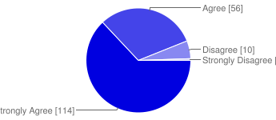

Despite the heavy workload that academic advisors have, who are mostly faculty, they are generally accessible on multiple occasions during the academic year. The AAO survey shows that 83% of students communicated with their academic advisors two or more times in a single semester. Eighteen percent of students communicated with their advisor once in a single semester.

Graph 7: Survey Inquiry: How many times do you communicate with your academic advisor in a single semester?

|  |  |  |  |
| --- | --- | --- | --- |
|  |  | N | % |
|  |  |  |  |
| Never |  | 0 | 0% |
| Once |  | 32 | 18% |
| Twice |  | 56 | 31% |
| Three times |  | 43 | 24% |
| Four or more times |  | 50 | 28% |

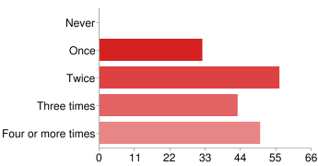

Advisors’ accessibility to students appears to have a positive impact on students’ perceptions about their value as individuals in a college campus. The AAO survey noted that 90% of students agreed or strongly agreed that their academic advisors showed concern for them as individuals, compared to only 9% who disagreed or strongly disagreed.

Graph 8: Survey Inquiry: My advisor shows concern for me as an individual.

|  |  |  |  |
| --- | --- | --- | --- |
|  |  | N | % |
| Strongly Agree |  | 93 | 51% |
| Agree |  | 71 | 39% |
| Disagree |  | 13 | 7% |
| Strongly Disagree |  | 4 | 2% |

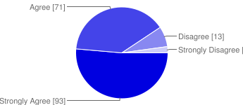

Eighty-nine percent of the students agreed or strongly agreed that their academic advisors encouraged them to engage in the advising process by asking questions and to share their concerns, compared to 11% of students who did not feel the same way.

Graph 9: My advisor encourages me to ask questions and to share my concerns.

|  |  |  |  |
| --- | --- | --- | --- |
|  |  | N | % |
| Strongly Agree |  | 88 | 49% |
| Agree |  | 73 | 40% |
| Disagree |  | 18 | 10% |
| Strongly Disagree |  | 2 | 1% |

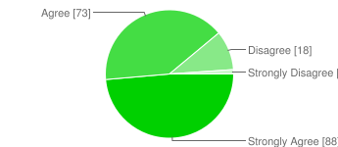

Eighty-eight percent of students agreed or strongly agreed that their academic advisors helped them to develop and attain their educational goals and interests, compared to 12% who did not feel the same way.

Graph 10: My advisor helps me to develop and attain my educational goals and interests.

|  |  |  |  |
| --- | --- | --- | --- |
|  |  | N | % |
| Strongly Agree |  | 95 | 52% |
| Agree |  | 65 | 36% |
| Disagree |  | 17 | 9% |
| Strongly Disagree |  | 4 | 2% |

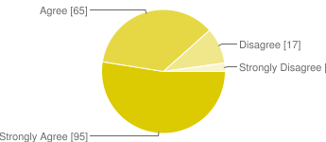

Sixty-five percent of students agreed (51%) or strongly agreed (14%) with the statement that advising sessions generally consisted of scheduling classes only. Thirty-five percent of students disagreed (28%) or strongly disagreed (7%) with this statement.

Graph 11: Survey Inquiry: My advising sessions generally consist of scheduling classes only.

|  |  |  |  |
| --- | --- | --- | --- |
|  |  | N | % |
| Strongly Agree |  | 26 | 14% |
| Agree |  | 92 | 51% |
| Disagree |  | 51 | 28% |
| Strongly Disagree |  | 12 | 7% |

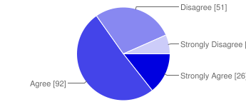

The observer notes that this survey inquiry is not necessarily contradictory to other inquiries that focus on student and advisor preparedness and advisors’ general concern for the students’ well-being, goal-setting, and success. Rather, it may suggest that advising meetings vary in scope and focus based on the changing individual needs of students (Creamer, 2000). The observer also notes that the majority of students communicate with their advisors two or more times in a single semester which may lend to differing needs and topics in each meeting or interaction.

When students were asked to consider what statement best described how they would rate their academic advisor overall, 80% rated their advisor as doing a “Good Job” (29%) or “Great job” (51%). Fourteen percent of students felt their advisors were doing a “Fair Job” in meeting their basic advising needs. Six percent of students felt their academic advisor did a “Poor Job” in meeting basic advising needs.

Graph 12: What statement best describes how you would rate your advisor overall?

N %

|  |  |  |  |
| --- | --- | --- | --- |
| No Opinion |  | 2 | 1% |
| Poor job, my advisor rarely meets my advising needs |  | 10 | 6% |
| Fair job, my advisor meets basic advising needs |  | 25 | 14% |
| Good job, helped me to understand my major and GE requirements |  | 52 | 29% |
| Great job, helpful in areas beyond my major and GE requirements |  | 92 | 51% |

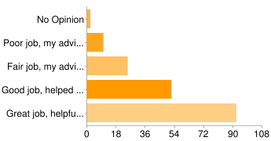

AAO solicited comments from students who completed the survey. Inquiry 19 stated, “Please use this space to express any comments, concerns, or suggesting you may have regarding your academic advising experience. The more detailed the response, the more helpful your response will be.” More than two-thirds of the responses were positive toward academic advising. About one third represented students’ negative experiences with academic advising or systemic issues that were unrelated to their academic advising experiences.

The evaluator categorized several themes from the feedback. The first themes focused on students’ general appreciation for the helpfulness of their advisors. Specifically, most students focused on advisors’ positive attitudes, their concern for students as individuals, and for mentoring in areas that went beyond scheduling classes and course requirements. Several students generally tolerated some advisors’ lack of policy or requirement knowledge as long as the advisors made good faith efforts to find the right answers, make referrals, and most importantly, if the advisors demonstrated genuine concern for students as individuals. The following quotes are representative of students’ responses:

“I am absolutely pleased with my advisor! She does not just help me get classes, but listens to me and understand who I am as a person. Once I graduate I want to stay in touch with her! I'm going to England in the Fall, and I'm going to send her something too. In other words, she is not just an advisor but a friend. She actively listens, and promptly responds to all my many emails. If she doesn't know the answer, she will ask for assistance. That is the sign of wonderful advisor. I've even recommended her to friends. She's an ally and a resource here at ULV, and I'm so happy with her.”

“[DELETED] is a great advisor and is very well rounded in all areas. If all advisors can be as well rounded as her all students would be set for their academic years at La Verne. Advisors should be educated on the ge's, what can count towards ge's and one's major. Also with the help of a interest level test I was able to narrow down and choose my major. Maybe dispersing more of these school wide would help students decide on a major faster.”

“My academic advisor is in my department and has even been my professor so working with her has been easy to make a good relationship. i like that it was so convenient to talk to her whenever i had a question, not just around academic advising times, and she was available whenever i had a question or concern.”

There were several students who had mixed experiences with academic advising, as noted below:

“My academic advising experience has been good overall. My first year was not so good because I did not feel that my advisor for my previous major [DELETED] was that much concerned. I ended up taking a class that freshmen should not take, I ended up failing the class, which lowered my GPA and affected my financial aid. My second year of financial aid has been exceptional, I feel like my current advisor really cares about my classes and my growth in my major.”

“I love my advisor [DELETED]! She helps me so much. And she is always emailing all of her advisees about important dates and study abroad trips that can apply for our business electives. Thanks to her I'm on track to graduate. My advisor before [DELETED] was really rude and had me taking classes that I did not need to take.”

“The fact that I was not able to keep the same advisor throughout my four years at La Verne was a bit disappointing. When I think of an advisor I also think of a mentor, someone that will be leading you along the way towards graduation. Sometimes, advisors do not care for the students' wants and just want to make a schedule that will get them out as soon as possible. They should get to know their students more, maybe even before they begin classes in the fall.”

“I was satisfied overall with my experience. My advisor was very helpful in most areas. He may have not been as helpful in regards to specific GE and Core requirements or very specific details regarding graduation requirements but he was very helpful in every other area.”

There were three general themes from students who had negative advising experiences: 1) students complained about advisors’ negative or indifferent attitudes toward them, 2) students perceived their academic advisors were not knowledgeable about academic policies or requirements, and 3) advisors were unavailable and hard to reach. These themes are represented below:

“My advising experience was different this is my first semester here, although my advisor was helpful I still felt that most of my answered were left unanswered, and the ones he said he would get back to me with he never did, I would contact him numerous times via Email and office visits and he never could find the correct answers. i Met with Him several times regarding Graduation of Spring 2012, and One day he said Yes no Problem other time he said not looking good because he didn't count my credits correctly, it was a very discouraging.”

“My advisor [DELETED] doesn't show any care for my major and the classes I want to take, and is hardly ever available and when she is whether in person or by email, she is either unresponsive or doesn't show much care.”

“Some advisors do not know how to advise and you can tell they do not want to be advisors. Pick professors who want to advise or hire people who can actually help students get on track to graduate on-time.”

“I wish my advisor would do more than just the minimum and seem more interested in me and what I want to do. I feel like there are awkward moments where he doesn't ask me if I have any questions or concerns, so I bring them up myself.”

“I was disappointed with my advisor. I feel that he did not focus on my educational goals or me as a student. WHEN he was present for my appointment we spent 5 minutes going over which classes I was planning on taking, I told him and he agreed or suggested one of his courses. The other 30 minutes was him rambling on about something irrelevant. I say "when" because on a few occasions he did not show up for my appointment and I had to reschedule.”

Student responses about advisors’ attitudes, helpfulness, general knowledge, or availability overlapped with Survey inquiry number 20 which said, “Please provide overall suggestions for improving the programs or services that are offered by the Office of Academic Advising in Woody Hall. The more detailed the response, the more helpful your response will be.” All unedited responses for the themes can be found in Appendices G and H, respectively.

* 1. *All students will know about services and degree requirements.*

An important factor in the academic success of students is their understanding of academic policies and requirements. The AAO survey found that 90% of students agreed or strongly agreed to the statement that they had received help from their academic advisors to understand degree requirements, college policies and procedures, including advisors’ inquiries about their individual academic progress (which supports the majority of students’ feelings that they are treated as individuals as noted in a previous survey statement).

Graph 13: My advisor helps me to understand degree requirements, college policies/procedures, and asks about my academic progress.

|  |  |  |  |
| --- | --- | --- | --- |
|  |  | N | % |
| Strongly Agree |  | 89 | 49% |
| Agree |  | 74 | 41% |
| Disagree |  | 14 | 8% |
| Strongly Disagree |  | 4 | 2% |

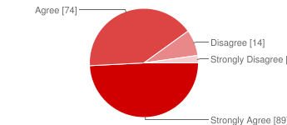

Ninety-three percent of students agreed (39%) or strongly agreed (54%) with the survey inquiry that they arrived to their advising meetings prepared with questions or concerns about their degree requirements, policies or procedures, and with future academic plans. They also agreed or strongly agreed that they had copies of their CAPP reports and/or transcripts and had reviewed them prior to their advising meetings.

Graph 14: Survey Inquiry: I prepare for meetings with my advisor (e.g., I arrive with questions/concerns about degree requirements, college policies/procedures, future academic plans, etc. I have copies of my CAPP report and/or transcripts and have reviewed them before advisement meetings).

|  |  |  |  |
| --- | --- | --- | --- |
|  |  | N | % |
| Strongly Agree |  | 98 | 54% |
| Agree |  | 70 | 39% |
| Disagree |  | 9 | 5% |
| Strongly Disagree |  | 4 | 2% |

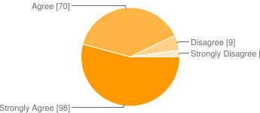

Ninety-six percent of students agreed (49%) or strongly agreed (47%) with the statement that they generally take an active role in their advising sessions. Only 4% of students disagreed with this statement.

Graph 15: I generally take an active role in my advising sessions.

|  |  |  |  |
| --- | --- | --- | --- |
|  |  | N | % |
| Strongly Agree |  | 85 | 47% |
| Agree |  | 88 | 49% |
| Disagree |  | 8 | 4% |
| Strongly Disagree |  | 0 | 0% |

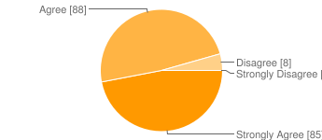

Eighty-three percent of students felt that their academic advisors made the effort to refer students to other persons, offices, or resources if they could not address a student’s concerns. Seventeen percent of students felt that their academic advisor did not make an effort in referring students to university resources.

Graph 16: If my advisor cannot address my concerns, s/he makes the effort to refer me to the appropriate person, office, or resource.

|  |  |  |  |
| --- | --- | --- | --- |
|  |  | N | % |
| Strongly Agree |  | 89 | 49% |
| Agree |  | 62 | 34% |
| Disagree |  | 14 | 8% |
| Strongly Disagree |  | 5 | 3% |
| Not Applicable |  | 11 | 6% |

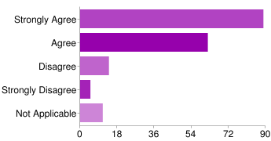

Eighty-eight percent of students agreed (59%) or strongly agreed (29%) that they were generally satisfied with the support and services offered to them by AAO. Twelve percent disagreed (9%) or strongly disagreed (3%) with this statement.

Graph 17: I am generally satisfied with the support and services offered by the Advising Office in Woody Hall.

|  |  |  |  |
| --- | --- | --- | --- |
|  |  | N | % |
| Strongly Agree |  | 52 | 29% |
| Agree |  | 106 | 59% |
| Disagree |  | 17 | 9% |
| Strongly Disagree |  | 6 | 3% |

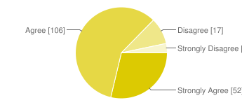

Eighty-six percent of students agreed (59%) or strongly agreed (29%) with the statements that online support resources that are offered by AAO were adequate and useful. Fourteen percent disagreed (12%) or strongly disagreed (2%).

Graph 18: The online support resources that are offered by the Advising Office are adequate and useful.

|  |  |  |  |
| --- | --- | --- | --- |
|  |  | N | % |
| Strongly Agree |  | 31 | 17% |
| Agree |  | 125 | 69% |
| Disagree |  | 21 | 12% |
| Strongly Disagree |  | 4 | 2% |

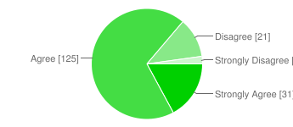

AAO has been more active in reaching out to students through electronic and print media (social media, e-mail, letters, and Campus Times ads) to reach out to students. Eighty-eight percent of students agreed (61%) or strongly agreed (27%) with the inquiry that they had received at least one form of correspondence from AAO. Eleven percent disagreed (9%) or strongly disagreed (2%) with this inquiry.

Graph 19: I have received at least one form of correspondence from the Academic Advising Office.

|  |  |  |  |
| --- | --- | --- | --- |
|  |  | N | % |
| Strongly Agree |  | 49 | 27% |
| Agree |  | 111 | 61% |
| Disagree |  | 17 | 9% |
| Strongly Disagree |  | 4 | 2% |

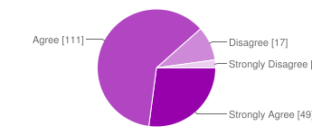

Sixty-six percent of students identified themselves as coming from the College of Arts & Sciences, followed by 20% from the College of Business and Public Policy, and 14% from the College of Education.

Graph 20: About you: Undergraduate major area of study

|  |  |  |  |
| --- | --- | --- | --- |
|  |  | N | % |
| College of Arts and Sciences |  | 119 | 66% |
| College of Business and Public Mgmt |  | 37 | 20% |
| College of Education |  | 25 | 14% |

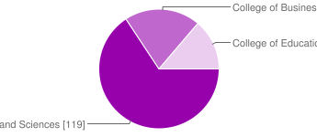

Students appreciated advisors’ ability to answer policy or requirement questions or to direct students to appropriate resources if they could not answer questions, as noted below:

“I found my experience to be very helpful. Each of my questions were answered by my adviser. He made sure to find answers that he could not answer himself and sent me the information within a timely manner.”

“[DELETED] is my advisor and he couldnt be more helpful. He truly makes me feel important and addresses any concerns or qusetions I might have promptly and with amazing detail.”

“Having all of he advisors know what the classes are for the following semesters. Know the requirements and basic knowledge for what ever degree/prerequisites that La Verne requires. I always felt as though, i was having to look it up on my own, and when i would ask he didn't seem to know and had to call to find answers from other advisors registrars. Over all it was good but when i asked for advice on which classes i should or shouldn't take He could never give me specific answers it was more along the lines of here are the classes you need fit them in to your schedule. and I wanted him to help guide me a little bit more, just a little overwhelming.”

About half of the students generally had positive experiences interacting with AAO having met their advising needs or answering academic questions, as noted in the quotes below:

“Woody Hall as always been very helpful and I havent been disappointed.”

“In my opinion I really don't feel like there are any changes to be made. It was very helpful and pretty easy to get good help.”

“i think they are both very helpful and reliable. they are always there for help and answers.”

Several students were grateful for the quality of academic advising they received, the timeliness of responses, or workshops they attended from AAO, as noted below:

“In the Office of Academic Advising in Woody Hall I have only worked with [DELETED]. She was terrific in guiding me to choose the right classes and ultimately choosing my major. I am very thankful for her help and would reccomend her to anyone.”

“Keep [DELETED]....she's the best.”

“I haven't dealt with Academic Advising too much in Woody Hall, but the few time I have they have been very helpful and answered the questions I've had. The advising workshop they put on was very helpful and informative also.”

“The emails sent by the Office of Academic Advising always help. [DELETED] particularly always answers the questions I have through email.”

A considerable number of students commented on 1) not knowing or not being entirely clear what services AAO offered, 2) the perceived lack of/or insufficient communication from AAO concerning academics, registration deadlines, and requirements, 3) difficulty in navigating or finding resources such as websites, CAPP reports, 4) procedural or office management observations, and 5) perceived indifference from staff at reception, as noted below:

“The programs should make more of an effort to let students [know] what is available.”

“I am not familiar with the Office of Academic Advising in Woody Hall.”

“have a general idea of what classes to expect to be offered one year in advance so students can plan ahead, not just one semester in front of their present one.”

“I would suggest to making the forms easier to find on the website.”

“The school should send e-mails to inform students to start making appointments with counselors before class registrations.”

“Sometimes it is hard to get a hold of the person that you need to talk to but it is otherwise good.”

Several students addressed their concerns about offices other than AAO. Specifically, several students shared their thoughts about the Office of Financial Aid or “Woody Hall.” Others confused services that are offered or managed by the University Registrar and several others focused on perceived experiences (positive and negative) with their academic advisors.

I think that students shouldnt have to ask for a CAPP Report, they should automatically receive them every semster.

The online and capa report is hard to access and a little confusing if you have transfer courses.

I started with a different adviser which was not responsible for the same track I am in. Once I switched I noticed the difference. Having an adviser that is knowledgeable about the major and the specific track is very helpful.

“Academic Advising has always gone smooth for me and my questions were answered without problem. Financial Aid on the other hand....”

“I think that the program is not on the same page with all the services provided. There is a lot of he said she said and i end up and not just me but a lot of students are brought in a circle and have no clue what to do or who to go to.”

Demographic Information of student and advisor respondents can be found in Appendix I. Complete and unedited comments can be found in Appendices G and H.

* 1. *All academic advisors will understand services and general education requirements.*

As noted above, 90% of students agreed or strongly agreed that their academic advisors helped them to understand degree and university requirements while 83% of students agreed or strongly agreed that advisors made referrals if they could not address students’ concerns.

Among the 40 academic advisors who took the AAO survey, 100% agreed or strongly agreed to the statement that they helped their advisees to understand degree requirements, college policies and procedures and to ask about their students’ academic progress.

Graph 21: I help my advisees to understand degree requirements, college policies/procedures, and ask about their academic progress.

|  |  |  |  |
| --- | --- | --- | --- |
| Strongly Agree |  | N  28 | %  70% |
| Agree |  | 12 | 30% |
| Disagree |  | 0 | 0% |
| Strongly Disagree |  | 0 | 0% |

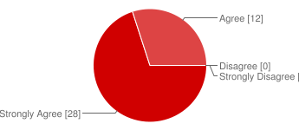

Eighty-one percent of advisors agreed or strongly agreed that the amount of training and support they received from AAO was appropriate and adequate. Twenty-one percent of advisors disagreed (13%) or strongly disagreed (8%) that the training they received from AAO was appropriate or adequate. However, 63% of advisors who felt that training was not appropriate or adequate had not attended a training session at least once in the last 12 months.

Graph 22: The amount of training and support I receive from the Advising Office is appropriate and adequate.

|  |  |  |  |
| --- | --- | --- | --- |
|  |  | N | % |
| Strongly Agree |  | 19 | 48% |
| Agree |  | 13 | 33% |
| Disagree |  | 5 | 13% |
| Strongly Disagree |  | 3 | 8% |

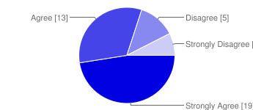

Eighty-three percent of advisors agree (50%) or strongly agree (33%) that the online resources that are offered by AAO are helpful and adequate in advising students.

Graph 23: The online support resources that are offered are helpful and adequate in advising students.

|  |  |  |  |
| --- | --- | --- | --- |
|  |  | N | % |
| Strongly Agree |  | 13 | 33% |
| Agree |  | 20 | 50% |
| Disagree |  | 4 | 10% |
| Strongly Disagree |  | 3 | 8% |

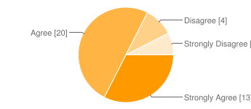

|  |  |  |  |
| --- | --- | --- | --- |
|  |  |  |  |
|  |  |  |  |
|  |  |  |  |
|  |  |  |  |
|  |  |  |  |

*Other Findings*

One hundred percent of advisors indicated being available to students during office hours, by appointment, phone, or by email throughout the semester.

Graph 24: I am generally accessible to my advisees during office hours, by appointment, phone, or by email throughout the semester.

|  |  |  |  |
| --- | --- | --- | --- |
|  |  | N | % |
| Strongly Agree |  | 36 | 90% |
| Agree |  | 4 | 10% |
| Disagree |  | 0 | 0% |
| Strongly Disagree |  | 0 | 0% |

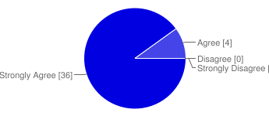

Sixty-three percent of advisors agreed (18%) or strongly agreed (45%) that students generally prepared for their advising meetings. Thirty-eight percent of advisors (disagreed (8%) or strongly disagreed (30%) that students generally prepared for their advising meetings.

Graph 25: My advisees, generally, prepare for their advising meetings (e.g., they arrive with questions/concerns about degree requirements, college policies/procedures, future academic plans, etc. they have copies of their CAPP reports and/or transcripts).

|  |  |  |  |
| --- | --- | --- | --- |
|  |  | N | % |
| Strongly Agree |  | 7 | 18% |
| Agree |  | 18 | 45% |
| Disagree |  | 12 | 30% |
| Strongly Disagree |  | 3 | 8% |

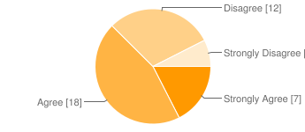

Ninety-eight percent of advisors agreed (33%) or strongly agreed (65%) with the statement that they help advisees to develop and attain their educational goals and interests. Only 3% (N=1) disagreed.

Graph 26: I help my advisees to develop and attain their educational goals and interests.

|  |  |  |  |
| --- | --- | --- | --- |
|  |  | N | % |
| Strongly Agree |  | 26 | 65% |
| Agree |  | 13 | 33% |
| Disagree |  | 1 | 3% |
| Strongly Disagree |  | 0 | 0% |

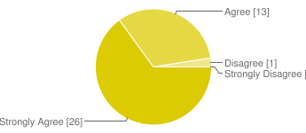

One hundred percent of advisors agreed or strongly agreed with the statement that they encourage their advisees to ask questions and to share their concerns.

Graph 27: I encourage my advisees to ask questions and to share their concerns.

|  |  |  |  |
| --- | --- | --- | --- |
|  |  | N | % |
| Strongly Agree |  | 33 | 83% |
| Agree |  | 7 | 18% |
| Disagree |  | 0 | 0% |
| Strongly Disagree |  | 0 | 0% |

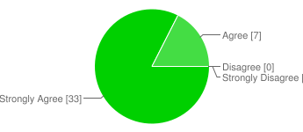

Sixty-three percent of advisors agreed (20%) or strongly agreed (43%) that having faculty serving as academic advisors was an effective advising model. Thirty-eight percent disagreed (33%) or strongly disagreed (5%) that faculty advising was an effective model.

Graph 28: Having faculty serve as academic advisors is an effective advising model.

|  |  |  |  |
| --- | --- | --- | --- |
|  |  | N | % |
| Strongly Agree |  | 17 | 43% |
| Agree |  | 8 | 20% |
| Disagree |  | 13 | 33% |
| Strongly Disagree |  | 2 | 5% |

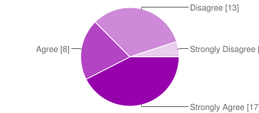

Sixty-three percent of advisors agreed (15%) or strongly agreed (48%) that they would prefer to advise on the major requirements only. Thirty-eight percent disagreed (33%) or strongly disagreed (5%).

Graph 29: I prefer to advise on the major requirements only.

|  |  |  |  |
| --- | --- | --- | --- |
|  |  | N | % |
| Strongly Agree |  | 19 | 48% |
| Agree |  | 6 | 15% |
| Disagree |  | 11 | 28% |
| Strongly Disagree |  | 4 | 10% |

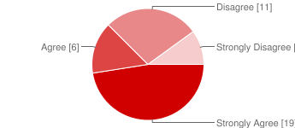

Sixty-three percent of advisors attended at least one advisor training session in the last 12 months. Thirty-eight percent of advisors did not attend a training session in the last 12 months.

Graph 30: I attended at least one Advisor Training session in the last 12 months

|  |  |  |  |
| --- | --- | --- | --- |
|  |  | N | % |
| Strongly Agree |  | 17 | 43% |
| Agree |  | 8 | 20% |
| Disagree |  | 10 | 25% |
| Strongly Disagree |  | 5 | 13% |

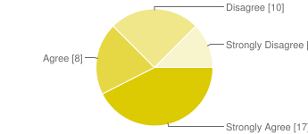

Ninety-seven percent of advisors agreed (40%) or strongly agreed (57%) that academic advising was an integral part of a comprehensive retention program. Only 3% (N=1) disagreed.

Graph 31: Academic advising is an integral part of a comprehensive retention program.

|  |  |  |  |
| --- | --- | --- | --- |
|  |  | N | % |
| Strongly Agree |  | 23 | 57% |
| Agree |  | 16 | 40% |
| Disagree |  | 1 | 3% |
| Strongly Disagree |  | 0 | 0% |

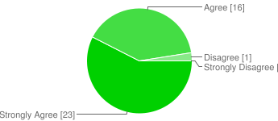

Fifty-three percent of advisors agreed (40%) or strongly agreed (13%) that good advising is generally rewarded. Forty-eight percent disagreed (38%) or strongly disagreed (10%) that good advising was generally rewarded.

Graph 32: Good advising is generally rewarded.

|  |  |  |  |
| --- | --- | --- | --- |
|  |  | N | % |
| Strongly Agree |  | 5 | 13% |
| Agree |  | 16 | 40% |
| Disagree |  | 15 | 38% |
| Strongly Disagree |  | 4 | 10% |

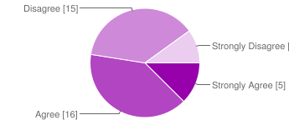

Twenty-five percent of advisors agreed (20%) or strongly agreed (5%) that advising sessions generally consisted of scheduling classes only. Seventy-five percent of advisors disagreed (55%) or strongly disagreed (20%) that advising sessions generally consisted of scheduling classes.

Graph 33: My advising sessions generally consist of scheduling classes only.

|  |  |  |  |
| --- | --- | --- | --- |
|  |  | N | % |
| Strongly Agree |  | 2 | 5% |
| Agree |  | 8 | 20% |
| Disagree |  | 22 | 55% |
| Strongly Disagree |  | 8 | 20% |

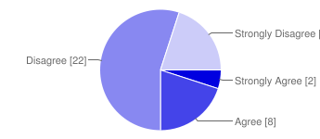

Seventy percent of advisors agreed (55%) or strongly agreed (15%) that advisees generally take an active role in their advising sessions. Thirty-percent disagreed (25%) or strongly disagreed (5%) that advisees took an active role in their advising sessions.

Graph 34: Students, in general, take an active role in their advising sessions.

|  |  |  |  |
| --- | --- | --- | --- |
|  |  | N | % |
| Strongly Agree |  | 6 | 15% |
| Agree |  | 22 | 55% |
| Disagree |  | 10 | 25% |
| Strongly Disagree |  | 2 | 5% |

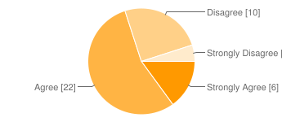

AAO advisor survey requested feedback from academic advisors in two areas of interest: 1) “Please use this space to express any comments, concerns, or suggestions you may have regarding your academic advising experience,” and 2) “Please provide overall suggestions for improving the programs or services that are offered by the Office of Academic Advising in Woody Hall.

One theme that overlapped resoundingly among advisors is their general dislike for the general education requirements and a strong desire for separating general education advising and major advising. Several advisors viewed AAO as the natural place for housing a staff of full-time advisors who would advise students in general education and overall degree requirements. The following quotes illustrate these views:

“Having faculty serve as advisors is a disservice to the students. Faculty do not have the training, resources, or time given teaching and research responsibilities. A separate advising office, that does not have faculty involved as advisors, would be more effective and helpful to the students.”

“Also, advising adds a huge work load to already overworked faculty (at least in our department). I think the university should adequately staff the academic advising office so that students can get help with the GE requirements from them and come to faculty for the major only.”

Faculty should be involved in professional development of students and in activities to help mentor students. However, advising for general education requirements, dealing with transfer units, etc., really should be handled by the advising office directly.

“It would be preferable for faculty to be responsible for advising students on their major requirements (as well as overall educational goals and career aspirations), but having another party be responsible for GE requirements and other graduation requirements (sufficient upper level courses, 128 total units, values, etc.)”

Many advisors believe that general education should be separated from major advising; there is a common dislike for general education requirements and many believe that there are too many changes in general education, as noted below.

**“**Although I have been advising for many years, I find myself hesitating to do GE advising because a single class can meet so many requirements. I find myself getting angry at the GE requirements when a second semester freshman is in the process of finishing his/her them wonders what to take next. I dislike and am embarrassed by our current GE requirements. “

“The seemingly ongoing shift in General Education requirements (etc., which courses count for what requirement) is hard to follow. Faculty are prepping courses, engaged in scholarship, involved in community service (both on and off campus) and mentoring students. Following these ongoing changes is a bit much at times, particularly when you have 30+ advisees asking different questions about different courses and general education requirements.”

“It would also help to revamp the GE program which is ridiculously complicated. Keep it simple. So many courses in the social sciences, in the humanities, etc. and you're done. Every class should teach students how to think critically, yet we have it as a value that you pick up only in certain classes.”

Several academic advisors had positive experiences with AAO’s services and support structures, as noted below,

“I want to congratulate the Academic Advising Office for being available and accessible MORE than I truly anticipated. Often, I would expect to leave a message with [DELETE], & he would usually answer the phone and address my students' concern on the spot. Thanks for your dedicated & passionate attention to Advising, [DELETE]. Sincerely,[DELETE]”

“You're very good, pretty easy to get a hold of. [DELETE] is a great addition to the staff. I'd give you more staff -- professional academic advisors -- to do the advising and free up faculty to do more academic, less administrative, work (like research).”

“Advising support gets better every year. Thank you.”

“The Office of Academic Advising is doing a fantastic job! Specifically: training offered, sharing of information, utilizing feedback to make improvements.”

Academic advisors who commented on AAO’s services and support focused on two general areas: 1) improvements in communication with academic advisors, and 2) concern for certain online tools or resources. The following quotes illustrate these points:

“Sometimes it is difficult to reach someone in Academic Advising over the phone when a student is in for advising and a specific question comes up that needs to be answered before the student leaves or registers. Maybe having more staff on the phones during peak advising periods would be useful.”

“Advisors should be included on emails to students from the registrars and advising office so we are aware of information being dispersed to students. It would prove helpful. Also more frequent communications regarding policy and requirement changes such as changes made by UGAP etc. would be appreciated so we could keep our students better informed and be assured that we are giving current and correct advice. Also knowing such information such as graduation schedules, and graduation information such as deadlines for clearing students etc would be appreciated for the above reasons.Also if we could know the registration periods at the beginning of the semester, it would be helpful forI planning our calendars especially if it would be more consistent instead of changing from semester to semester. More communication in general would be appreciated. It has improved.”

“Even though I go fairly often to the web site to get forms, I still have to search and look for them. They are not that easy to find. Also, there is confusion about whether forms are on your website or the registrar's.”

Several advisors had concerns with online tools or resources that are managed by the University Registrar:

“The Capp reports are not up to date. The transfer evaluation reports usually are not correct. There need to be two to three stop days at the University where counseling is performed. The University used to have those stop days. If the University puts a premium on student advising, then it must provide opportunities for quality advising. Faculty advisers need to have access to student transcripts from students outside their majors/counseling list. We perform cross academic advising for students who, for one reason or another, are not able to meet with their assigned adviser. If you want us to advise students with authority, let us have access to the student transcript records.”

“The Office of Academic Advising provides a variety of helpful resources and support services (thank you!), but it can still be an overwhelming task to ensure that students are meeting their graduation requirements. While the online degree evaluation report faculty can access is helpful, it is not particularly user-friendly and often confuses both faculty and students.”

“As a Department Chair, I need to electronically review all of the courses offered in my Department and Division, not only the courses that I teach.”

Others focused on ways that students could help alleviate advisors’ workload, as noted below:

“During Freshman Orientation, please make it clear to students that they should go see their faculty advisor before registration begins at the end of every semester (and this means responding to emails from advisors who wish to set up appointments with them).”

“It often becomes a tug-of-war with advisees who procrastinate and wait until the last minute to schedule an advising appoinment. They become upset when I refuse to grant them their advising code without meeting with them or if I am unable to immediately schedule them. It is difficult for them to comprehend that I my calendar is limited due to appoinments with other students. This is a common experience that occurs every semester and regrettably the least rewarding element of the advising experience.”

Complete and unedited comments can be found in Appendices J and K.

**Goal 3: To increase persistence and retention rates of traditional undergraduates.**

*Objectives*

1. *Improve Junior-Senior Persistence Rates toward Graduation.*

Institutional Research reports that La Verne is consistently successful in retaining first-time freshmen into the second year. Between fall 2001 and fall 2009, an average of 82% students were retained from the freshman to sophomore year. Table 7 shows longitudinal retention data between 2000-2009. These first-year retention statistics validate research that indicates that involved and engaged freshmen students are more likely to persist.

Table 7: First to Second Year Retention of Traditional First-time Freshman

|  |  |  |  |  |  |  |  |  |  |
| --- | --- | --- | --- | --- | --- | --- | --- | --- | --- |
| **All College** |  | % | N | % | N | % | N | % | N |
| 2000 | 411 | 82.5% | 339 | 73.7% | 303 | 69.6% | 286 | 20.7% | 85 |
| 2001 | 396 | 85.6% | 339 | 77.0% | 305 | 61.6% | 244 | 21.2% | 84 |
| 2002 | 367 | 86.9% | 319 | 69.5% | 255 | 66.2% | 243 | 22.3% | 82 |
| 2003 | 356 | 78.9% | 281 | 72.2% | 257 | 67.4% | 240 | 26.1% | 93 |
| 2004 | 399 | 87.5% | 349 | 77.9% | 311 | 72.4% | 289 | 22.3% | 89 |
| 2005 | 353 | 80.2% | 283 | 69.7% | 246 | 64.3% | 227 | 17.8% | 63 |
| 2006 | 332 | 83.7% | 278 | 70.2% | 233 | 67.2% | 223 | 21.7% | 72 |
| 2007 | 344 | 78.8% | 271 | 69.5% | 239 | 65.4% | 225 | 0.0% |  |
| 2008 | 327 | 77.4% | 253 | 69.4% | 227 | 0.0% |  | 0.0% |  |
| 2009 | 339 | 83.5% | 283 | 0.0% |  | 0.0% |  | 0.0% |  |

Source: Institutional Research (2010)

La Verne has managed to sustain freshmen to sophomore persistence rates reflecting positive student satisfaction in other areas of their college experience. These positive highlights are tempered when one examines sophomore-to-junior retention rates (72% average from 2000-2008); junior-to-senior retention rates (67% average from 2000-2007) and graduation rates between 2000-2006 (38% after 4 years; 50% after 5 years; 54% after six years).

First-year retention rates among transfer students show similar successes. For example, first-year retention rates between 2000 and 2008 were 80% average. Second-year retention between 2000 and 2008 demonstrate a drop to 48%. The third year retention rate dropped to 20% from 2000-2007.

Transfer student graduation rates within two years between 2000 and 2008 was 23% on average. Graduation rates within three years doubled to 43% on average from 2000-2008. Fifty percent of transfer students graduated within four years. The graduation rate increases to 53% after 5 years. Fifty-five percent of transfer students graduated within 6 or more years.

It is possible that transfer students are spending more time at La Verne (longer than two years) to complete their degrees due to any number of reasons such as admission prior to reaching junior status, the non-transferability of subject units that must otherwise be earned at La Verne, or financial, academic, or personal circumstances that might delay timely graduation.

Retention and graduation rate tables by race and gender for first-time freshman and transfers can be found in Appendix L and M, respectively.

*Midterm Reporting & Retention and Intervention Strategies*

AAO automated its midterm report process after nearly 18 months of planning, development, and testing with OIT and the Registrar to improve departmental work efficiency and workload. The new process automated the recording and reporting of at-risk students to academic advisors, AAO, and the students themselves. AAO also conducts retention and intervention strategies to identify and intervene with at-risk students and their subgroups. More details can be found in another section of this review.

*Senior Residency Requirements*

In spring 2011, Faculty Senate approved increasing the University residency requirement for newly admitted traditional undergraduate students starting in fall 2011. The new residency requirement increases the minimum residency from 32 semester hours (25% of the total value of the degree) to 40 semester hours (31% of the total value of the degree). Faculty Senate also approved a senior residency limit that will require traditional undergraduates to complete 16 of the last 32 semester hours in residence.

AAO expects that this new residency requirement will strengthen the perceived value of the La Verne degree and will help to improve student retention and graduation rates at the junior and senior years, respectively. The new residency policy also aligns La Verne with peer institutions that have strict residency policies and that have higher graduation rates at the 4th, 5th, and 6th year benchmarks, as noted in Appendix N. AAO will review persistence and retention rates as the new residency policy takes effect.

*Retention Outreach Outcomes and Observations*

In several semesters of outreach work, with the assistance of seasonal help and later by the Retention Specialist, AAO was able to meet and exceed enrollment projections in each of the last four semesters. For example, in summer 2009 AAO identified 125 continuing students who had not registered for fall 2009.  By the end of the summer, 40 percent of the students who were called had registered. After several rounds of emails, letters, and phone calls, the interventions yielded the following results:  
  
40% (50 students) registered for classes  
9.6% (12) withdrew from La Verne (most of the reasons were financial)

2.4% (3) took Leaves of Absence (LOA).  
  
Of the remaining 59 students, 64.5% (39 students) had some type of hold on their account, preventing them from registering.

In spring 2010 semester, AAO reported fall to spring persistence rate of 94%. In fall 2010 semester, AAO reported spring to fall persistence rate of 92%. In spring 2011, AAO reported fall to spring persistence rate of 93%.

The AVP believed that the main campus was experiencing a “very healthy persistence rate from semester to semester.” The AVP also indicated that “students identify their primary reason for leaving as financial, due largely to an outstanding back balance that prohibits their continuing registration.” In cases where students had financial difficulties, many of them opted to take leaves of absence for a semester with plans to return once their balances were cleared with Student Accounts. In fewer cases, students who expressed “personal” reasons for leaving, AAO would walk them through the withdrawal process which includes interviews with the Office of the Registrar, Student Accounts, Financial Aid, and Academic Advising.

*Leaves of Absence and Withdrawals*

Although we have over 50 years of retention literature and we know why students leave college at the macro level, La Verne has only recently begun to fully track and study why students decide to leave La Verne specifically, prior to graduation. This information is still in its initial stages, but the data that is available is helping to answer questions that could only be answered as a result of individual and anecdotal information.

For example, AAO data shows that among all student who filed a leave of absence (N=288) between fall 2005 and fall 2010, 35% indicated Study Abroad, followed by 21% who indicated financial reasons, 17% Other (not disclosed) reasons, 10% Unknown (not disclosed reasons), 7% Personal Reasons, 6% Medical, 5% indicated two or more reasons, 2% Academic, 1% By Appeal, and 1% for Military Service. Qualitative data captured specific reasons such as leave of absence by appeal, death in the family, academics, work, financial then study abroad reasons, religious missionary work, and academic disqualification extensions.

Initial withdrawal data from Institutional Research (2010) shows that among 25 students who withdrew from the university from 2009 to 2010, 72% were women. Sixty-six percent of the students self-identified as White (even though 47.8% of respondents identified themselves as Hispanic/Latino on a separate question). Seventeen percent of students identified as African American. Sixty percent of respondents indicated being first-time freshmen when they first entered La Verne. Forty percent identified as transfer students. Seventy-two percent of respondents indicated La Verne as their first choice school at the time of entry, compared to 12% who indicated La Verne as their second and third choices. Nearly a quarter of the respondents did not seek advice from a university official before making the decision to withdraw from the university. Only 8% of students consulted with academic advisors.

AAO has redesigned the University’s Leave of Absence/Withdrawal document. The redesign aims to help ensure that students who choose to formally leave the university will do so only after they have consulted with The University Registrar, Student Accounts, Financial Aid, and the Academic Advisor. The Associate Dean of AAO concludes this process with an exit interview with students as a last gasp effort to try to address the concerns that might have prompted the student to withdraw or to file a leave of absence. AAO also developed a Leave of Absence/Withdrawal Handbook that explains to students in detail the steps to be taken by students considering leaving the university prior to departure (http://sites.laverne.edu/academic-advising/files/2010/11/LOAHandbookSept20101.pdf).

*First-Year Resource Program*

Table 8 shows the second year persistence rates of first-time freshman by semester

and FYRP and non-FYRP status. Graph 23 illustrates the dramatic drop in persistence rates.

Table 8: Second Year Persistence Rates for FYRP and non-FYRP students.

|  |  |  |  |  |
| --- | --- | --- | --- | --- |
|  | Fall 2004 | Fall 2005 | Fall 2006 | Fall 2007 |
| Non-FYRP | 87% | 80% | 85% | 84% |
| FYRP | 88% | 71% | 77% | 60% |

ULV Institutional Research: Banner extraction February 2009

Graph 35: Second Year Persistence Rates for FYRP and non-FYRP students.

Sophomore to junior persistence rates for FYRP students dropped steadily by cohort. For example, Table 9 shows the persistence rates by cohort. The 2004 cohort of first-time freshman in FYRP persisted to junior status at a rate of 75 percent compared to 77 percent of non-FYRP students. The 2005 cohort of first-time freshman who were not in FYRP persisted to junior status at a rate of 70 percent compared to FYRP students who persisted at a rate of 51 percent. The 2006 cohort who were not in FYRP persisted to junior status at a rate of 72 percent and FYRP students persisted at a rate of 59 percent.

Table 9: Persistence Rates to Junior Status

|  |  |  |  |  |  |
| --- | --- | --- | --- | --- | --- |
|  |  | Term 2, Spring | Term 3, Fall (Soph) | Term 4, Spring (Soph) | Term 5, Fall (Jr) |
| Fall 2004 | Non-FYRP | 95% | 88% | 87% | 77% |
|  | FYRP | 95% | 88% | 88% | 75% |
| Fall 2005 | Non-FYRP | 94% | 80% | 76% | 70% |
|  | FYRP | 90% | 71% | 63% | 51% |
| Fall 2006 | Non-FYRP | 96% | 85% | 80% | 72% |
|  | FYRP | 90% | 78% | 71% | 59% |

ULV Institutional Research: Banner extraction February 2009

*International Students*

AAO reviewed retention and graduation rates for international students in late fall 2009 and spring 2010. The review came about as a result of reported classroom observations from instructors who were concerned about the academic and English language under-preparedness of many international students. AAO reviewed academic data of international students, as noted below.

Table 10: Admitted Traditional Undergraduate, Domestic & International Students by Cohort

|  |  |  |  |
| --- | --- | --- | --- |
| **Students Admitted Fall 2008** | | | |
|  |  |  |  |
|  | Freshmen/Advanced Freshmen | International | Transfer/Readmit |
| # Students | 231 | 15 | 79 |
| Avg GPA | 3.02 | 2.72 | 2.98 |
| Table 11: Admitted Traditional Undergraduate, Domestic & International Students by Cohort | | | |
| **Students Admitted Fall 2009** | | | |
|  |  |  |  |
|  | Freshmen/Advanced Freshmen | International | Transfer/Readmit |
| # Students | 304 | 25 | 109 |
| Avg GPA | 2.93 | 2.35 | 3.00 |

AAO reviewed the academic outcomes of 102 international students that it identified from Banner system. Table 12 shows that of the 102 international students, 29% had GPA’s that were lower than 2.0; 65% had less than 3.0 GPA. Only 52% of the students were in good standing. Thirty-eight students (37%) were not in good academic standing.

Table 12: Confirmed International Student Tracking, Fall 2002-Spring 2010.

Confirmed International Student Tracking, Fall 2002-Spring 2010

105 Total (3 excluded from stats below).

102 w/ GPA’s and Academic Status:

36 students w/ GPA of 3.0<

36 students w/ GPA 2.0-2.99

30 students w/ GPA 1.99 >

Ave. Group GPA: 2.47

53 students in Good Standing (2.0 or higher)

38 students with Marks of AD, AP, AW, or AX:

25 AP (Academic Probation)

8 AW (Academic Warning)

3 AD (Academic Disqualification)

2 AX (Academically Disqualified, but Academically Reinstated by petition)

AAO noted that among the 102 students, 38 (50%) were not in good academic standing and were no longer enrolled at La Verne. AAO reported that among the 102 students only 11 had graduated between fall 2002-spring 2010.

Table 13: Analysis of International Students Separated by Enrollment Status.

102 Total separated by enrollment status:

53 students are enrolled in spring 2010:

34 students w/ GS

12 students w/ AP

5 students w/ AW

2 students w/ AX

38 students are no longer enrolled at ULV:

19 students w/ GS

13 students w/ AP

3 students w/ AW

3 students w/ AD

11 students graduated (not included in the 38 students who are no longer enrolled at ULV).

AAO reported its findings to university stakeholders in spring 2010 which resulted in the increase of human and financial resources to help support the academic and social integration of international students, including the increase of admissions standards starting in fall 2011 (Appendix O).

A program review concerning international students was completed and filed with Institutional Research in spring 2011 which addresses the issues that impacted international students. This program review will not revisit the details that were addressed in the other Program Review except to say what role AAO had in collecting and reporting retention and graduation data, as noted above, that led to meaningful and proactive changes to international admissions and academic and social integration steps.

In late Spring 2011, the repercussions of AAO’s reporting about international students continues with academic changes to the way international students will be academically and socially integrated, how they will be advised and registered, including the designation of a dedicated international student advisor who will be the primary point of contact, along with the continued involvement of the International and Study Abroad Center, LEC, and AAO. More work remains to be done in improving the academic success among international students.

1. *Reduce the number of traditional students who are on academic probation.*

*Academic Probation*

The University of La Verne is a commuter school and must consider how this reality impacts the quality and quantity of time that students spend on campus. Most of our students are commuters who must work to meet their life and educational goals and obligations when financial aid packages are insufficient to cover their educational expenses. La Verne is also attracting and admitting low income and remedial students. La Verne is not alone in facing the challenges of attracting and accepting students who are in need of remedial education.

According to Tinto (1998), 4 in 10 students who enter college are in need of some form of remedial education because their academic skills are at a sixth grade level in reading, writing, and math. In many cases, the colleges and universities that offer remedial education are making up for the deficiencies in their students’ K-12 education. Finally, it is estimated that nearly 90 percent of college and universities offer some kind of remedial education (Tinto, 1998). Some have argued that remedial education has no place in higher education. Others believe that two-year colleges are the best places for remedial students (Tinto, 1998). These arguments, however, are irrelevant when individual schools make decisions to admit students who are academically weak.

The successes for retaining our students beyond the freshman and sophomore years are diminished when nearly 20% of each entering class since 2004 was admitted with remedial needs. Of concerns as well, is the longitudinal drop in every indicator of success such as high school GPA, SAT, and institutional GPA among our students. We are also witnessing considerable stressors on persistence and graduation rates among our international students who were admitted to La Verne with standards that prior to fall 2011 were the lowest among peer institutions (Appendix O).

The case load of students who are on academic probation has increased substantially for AAO. Academic probation cases appear to coincide with the increase of newly admitted students and the admission of students under the First Year Resource Program (FYRP). FYRP students are admitted by the Admissions Office when counselors perceive that students are admissible despite low standardized exam scores and/or high school grades. FYRP students must agree to participate in a study skills course in their first semester of enrollment and are strongly encouraged to use tutoring services in the Learning Enhancement Center (LEC).

Two academic advisors in LEC are dedicated to monitor and advise FYRP students until they transition out of FYRP. The specific criteria used to identify students who are admissible under FYRP are unclear to the staff of AAO despite several efforts to quantify the criteria that is used to admit students under FYRP. Despite the university’s best efforts to provide academic support to students in FYRP, gaps remain in remediating the academic underpreparedness of these students.

Since fall 2004, as noted in Table 14, La Verne has seen a steady increase in the number of students who were admitted to La Verne as FYRP students (with a slight dip in fall 2008), denoting academic deficiencies in overall academics, English, and math.

Table 14: Freshman Cohort Admitted as FYRP as a Percentage of the Total Student Cohort.

|  |  |  |  |  |  |  |  |  |  |  |  |  |  |  |  |
| --- | --- | --- | --- | --- | --- | --- | --- | --- | --- | --- | --- | --- | --- | --- | --- |
| FALL 2004: | |  | FALL 2005: | | |  | FALL 2006: | | |  | FALL 2007: | |  | FALL 2008: | |
| FYRP | **NON FYRP** |  | **FYRP** | **NON FYRP** | |  | **FYRP** | | **NON FYRP** |  | **FYRP** | **NON FYRP** |  | **FYRP** | **NON FYRP** |
| 51 | 306 |  | 40 | | 284 |  | 55 | 258 | |  | 76 | 240 |  | 56 | 214 |
| Admitted as FYRP as Percentage of the Total Student Cohort | | | | | | | | | | | | | | | |
|  | 14% |  |  | | 12% |  |  | 18% | |  |  | 24% |  |  | 21% |

AARS: Banner Extraction, Spring 2009

As stated previously, a steady number of new students were FYRP students. These students were admitted to La Verne with lower high school GPA’s and SAT scores. For example, Table 16 lists the academic profiles of every entering freshman class from fall 2004 to fall 2008. Every entering class from 2004 to 2008 had lower high school GPA’s on average.

Table 15: High School GPA at Admission by Cohort.

|  |  |  |  |  |  |  |
| --- | --- | --- | --- | --- | --- | --- |
|  | Fall 2004 | | FA2005 | FA2006 | FA2007 | FA2008 |
| Non-FYRP Ave. Admit GPA | 3.54 | 3.54 | | 3.55 | 3.48 | 3.48 |
| FYRP Ave. Admit GPA | 3.14 | 3.06 | | 2.95 | 2.87 | 2.83 |

AARS: Banner Extraction, Spring 2009

SAT scores were lower overall for FYRP students compared to non-FYRP cohorts as illustrated in Table 17.

Table 16: SAT Scores at Admission by Cohort.

|  |  |  |  |  |  |
| --- | --- | --- | --- | --- | --- |
|  | Fall 2004 | FA2005 | FA2006 | FA2007 | FA2008 |
| Non-FYRP Ave. SAT | 1033 | 1047 | 1029 | 1015 | 1023 |
| FYRP Ave. SAT | 905 | 895 | 896 | 859 | 882 |

AARS: Banner Extraction, Spring 2009

High school GPA is a strong indicator of academic success in college for the first year. Students who were admitted with low high school GPA’s also earned low university GPA’s as noted in Table 18. The deepest declines came in the fall 2008 semester.

Table 17: University GPA after First Year by Cohort.

|  |  |  |  |  |  |
| --- | --- | --- | --- | --- | --- |
|  | Fall 2004 | FA2005 | FA2006 | FA2007 | FA2008 |
| Non-FYRP Ave. ULV GPA | 3.08 | 2.98 | 3.03 | 2.93 | 3.03 |
| FYRP Ave. ULV GPA | 2.92 | 2.4 | 2.5 | 2.19 | 2.15 |

AARS: Banner Extraction, Spring 2009

Academic underpreparedness correlates with an increase in the number of students who were placed on academic probation (AP). Table 19, Graph 36 shows the number of students on academic probation by cohort. As the average ULV GPA dropped, the percentage of students on academic probation rose concurrently.

Table 18: Percentage of Students Placed on Academic Probation (AP).

|  |  |  |  |  |  |
| --- | --- | --- | --- | --- | --- |
|  | Fall 2004 | FA2005 | FA2006 | FA2007 | FA2008 |
| Non-FYRP AP | 3.10% | 6.10% | 5.70% | 5.40% |  |
| FYRP AP | 1.80% | 4.90% | 12.10% | 18.70% |  |

ULV Institutional Research: Banner extraction February 2009

Graph 36: Percentage of Students Placed on Academic Probation (AP).

ULV Institutional Research: Banner extraction February 2009

The information in Tables 18 and 19 suggest that FYRP participation did not significantly improve the academic opportunities for success or retention of these students. FYRP participation, including enrollment restrictions to 14 semester hours, and specialized academic advising and monitoring had no positive impact on students’ persistence or academic success. The FYRP program did not prepare students to succeed academically at La Verne because students were not taught applied or basic content skills to remediate poor academic preparation.

Tinto (nd.) suggests that first-year programs have an important role in retaining students, but must be part of a broader retention plan that includes effective academic skills preparation, advising, high academic expectations, support (social, academic, and financial), feedback (early warning, mid-term, and learning assessments), and social and academic involvement in learning. Tinto indicates that while many schools report sizable increases in student persistence as a result of FYE-type programs, most report modest gains. He concludes that “the main reason is that most retention programs are largely non-academic in nature” and that successful retention programs lie in “better education during the first year” (p. 4). FYE programs at La Verne (defunct since fall 2008) did not address the academic deficiencies of their students any more than FYRP does in the absence of FYE.

*Interventions*

AAO took steps to address deficiencies in academic advising of FYRP students. The LEC staff has adopted many AAO recommendations for improving advising, monitoring, and outreach of FYRP students. The LEC staff has also adopted an advising syllabus that outlines student and advisor responsibilities and expectations and learning outcomes. They have also adopted the Path to Graduation and Four-Year Course Plan rubrics (also provided by AAO) that help to enhance academic advising and course planning. Faculty members can play a crucial role in supporting these efforts by developing interventions that will address the remedial deficiencies of these students.

Because the vast majority of students in FYE were also FYRP students, their poor academic preparation in high school left these students with a monumental remedial burden that FYE or academic advising via FYRP alone could not give them. Thus, FYRP students arrived academically handicapped and ill-prepared for the rigors of college; the FYE structures were ill-equipped to help students to overcome these academic deficiencies. In the absence of more intensive academic mediation and support at La Verne, they risked continued failure. When FYE was phased out in fall 2008 due to budget cuts and limited faculty involvement, the remedial needs of students remained.

As in the case of international students, AAO brought its concerns about FYRP to university stakeholders. To their credit, the Dean of Arts & Sciences, the Provost, and University President committed to addressing the need to help improve the academic outcomes of not only FYRP students, but also all the students who might need tutoring from LEC in writing or math based on the anticipated need for the fall 2009 class.

AAO analyzed data pertaining to the 2009 freshman cohort as of August 13, 2009 and how they placed in La Verne’s writing placement exam.  Two hundred eighty two students (282) tested for placement into Writing 106, 109, or 110.  Writing 106 and 109 are considered remedial levels: 69.1 percent placed in either Writing 106 (19.5 percent) or 109 (49.6 percent); only 30.8 percent of students placed into Writing 110.

In spring 2010 the Dean of Arts & Sciences secured tutoring assistance from math faculty, and increased tutoring from experienced persons, including additional funds to cover the administrative costs of tutoring in LEC for both writing and math. Since then the LEC Director has petitioned to make permanent the current funding to support current tutoring services.

**Goal 4: To implement technology that supports academic advisors and their advisees.**

*Objectives*

1. *Implement technology and online resources to support academic advisors. [Implement mid-term report module via Sungard’s Banner to identify traditional undergraduates who are at-risk].*

As noted in several sections of this review, AAO has enhanced its online resources in support of academic advisors and undergraduate students. AAO has revamped its website and has added other pages with self-service forms and information concerning academics and student rights and responsibilities. Its mission statement has been updated, and it has automated several administrative processes concerning SOAR sign-ups, midterm reporting, SunGard’s Banner tools, and an online presence in popular social networks.

*Midterm Reporting*

AAO asks instructors each semester at midterm (between the 6th and 9th week) to identify students who are not meeting satisfactory academic progress in courses. AAO tracks participation rates among instructors. However, there are instructors who do not report students at midterm because 1) they do not have anyone to report and do not notify AAO to count toward the participation rate, 2) they do not want to assign a midterm grade (but will communicate directly with students their concerns), or 3) they choose to not participate at all.

It was not until spring 2009 that AAO began to track participation rates for midterm reporting. Before spring 2009, AAO’s midterm reporting process (distribution, collection, and reporting) was handled entirely by paper-based rosters. AAO staff would transcribe instructors’ grades and comments on letterhead and mailed letters to at-risk students.

Between Fall 2009-Fall 2010, AAO transitioned to midterm report distribution by e-mail and PDF documents, but the collection of documents was still paper-based; AAO staff would transcribe and report instructors’ comments to at-risk students by e-mail.

In spring 2011, AAO (with the help of OIT and the Registrar) automated the midterm report via MyLaVerne eliminating entirely the manual and paper-based distribution, collection, and dissemination of notices from instructors to at-risk students. When instructors click on the submit button of their midterm class roster, the system automatically triggers emails to the instructor, the primary advisor of record, to the student, and to AAO.

In all instances, the AAO, with the help of academic advisors, communicate with at-risk students to intervene and address concerns that might be impacting students’ academics in individual courses or to address behaviors (non-attendance, tardiness) that might be impacting students’ academic standing.

Table 20 shows participation rates between spring 2009 and fall 2010 increased from 44% to 90%, dropping to 60% in spring 2011.

Table 20: Instructor Participation Rates in Midterm Report Submissions.

|  |  |  |  |
| --- | --- | --- | --- |
| Term | Percent | N | Method of Process |
| Spring 2009 | 44% | Unknown | Manual |
| Fall 2009 | 53% | Unknown | E-mail/Manual |
| Spring 2010 | 44% | Unknown | E-mail/Manual |
| Fall 2010 | 90% | 189/211 | E-mail/Manual |
| Spring 2011 | 60% | 160/268 | Automated |

*Online Retrieval of AAC (Academic Advising Codes)*

AAO, in collaboration with the University Registrar and OIT, provided academic advisors direct access to AAC via MyLaVerne in fall 2009. Prior to this time period, AAC lists were generated by hand from Banner system and delivered via campus mail and later by emails to academic advisors prior to the start of academic advising each semester.

When AAC lists were added to MyLaVerne academic advisors could directly access these codes in roster format for their advisees. This process eliminated the manual processes to retrieve and distribute codes to academic advisors.

*Online Advisee Rosters*

The online retrieval of AAC codes served as the model for the development of an advisee roster for academic advisors. Still in its initial phase, AAO anticipates providing academic advisors with accurate and up-to-date rosters of their advisees by semester. These rosters will accurately reflect information that is already available from Banner forms. The rosters will have basic, at-a-glance, information about individual advisees such as academic standing, GPA, contact information, and units completed. AAO also anticipates providing academic advisors with the option to email students individually or as a group by tying the roster with their local email client such as Microsoft Outlook.

*SOAR Online Presence & Registration*

Summer Opportunity for Advising and Registration (SOAR) provides students the opportunity in the summer to handle important academic and administrative business with the university in advance of the fall semester. As noted in previous areas of this review, SOAR participation culminates in the advising and registration of students for courses in advance of the fall semester.

Prior to summer 2011, AAO’s method of inviting and signing up students to SOAR were handled almost entirely by hand and several repeat phone calls to students. Long overdue, the process for signing up individual students to SOAR 2011 has transitioned entirely online via a self-serve process (http://sites.laverne.edu/academic-advising/soar/). The self-serve process reflects deliberate efforts to address advisors’ concerns that had become a normal, yet frustrating process during academic advising and registration. Specifically, one of the frustrations by advisors was the students’ inability to register on a timely basis because academic files were not complete as a result of a missing promissory note, missing examination scores, or transcripts. As noted in a previous section of this review, 31% of students who attended SOAR 2010 experienced delays as a result of missing promissory notes.

SOAR registration online deliberately attempts to reduce the instances where promissory notes become the main obstacle for a student’s inability to register for courses being advised at SOAR. Students are asked to file University of La Verne promissory notes to Student Accounts prior to attending and arriving to SOAR. The registration process addresses concerns for missing placement examinations by facilitating students’ ability to make appointments for testing in advance of attending SOAR. AAO and LEC collaborated to schedule examination dates that would be convenient to students that included Saturday and SOAR-day testing.

Students are also strongly encouraged via the SOAR website to make housing arrangements and to obtain financial aid counseling. The SOAR website also aims to prepare students for academic advising and registration prior to arriving on campus.  These administrative steps are aimed to prevent delays in advising and registration, primarily, but also addresses important administrative steps concerning Financial Aid and Student Accounts.

When students complete the preliminary steps prior to attending SOAR, they can register online via Eventbrite (http://www.eventbrite.com/event/1441065265). Online registration provides a self-service option for students to register online at any time during the registration period. Student registration notifications are delivered to AAO with time stamps indicating SOAR registrations occurring seven days a week, 24-hours a day.

*SOAR Online*

AAO has also taken steps to accommodate students who cannot attend SOAR on campus due to extenuating circumstances. AAO developed SOAR Online which is available only to students with whom AAO shares a non-public website (Appendix P). SOAR Online is a variation of the public SOAR website for a campus visit. SOAR Online is designed with similar preparatory steps that need to be settled prior to setting up a phone appointment for academic advising and registration. The main feature of SOAR Online is the availability of 9 videos that were recorded by AAO staff focusing on the academic, financial, and administrative topics that are covered on campus during SOAR days.  The videos also address academic and social integration topics that students should be aware of prior to arriving on campus in August. A built-in assessment and confirmation form in SOAR Online ensures that students have familiarized themselves with these topics prior to being advised by phone.

The development and online presence of SOAR and SOAR Online coincides with the university’s record increase in traditional student applications and enrollments. While manual processes and personalized calls to new students may have worked as little as two years ago, the record increase in student enrollments warrant processes that are automated. The AAO staff has been freed up in time and duties to focus on SOAR preparations and management of the reservation lists. AAO staff now focus on ensuring that new students who sign up for SOAR have complied with preliminary administrative steps such as timely payment of their tuition deposit, the filing of the university promissory note, and the reservation and completion of required placement examinations.

*AAO Website*

The AAO website has more than tripled in size since spring 2009, adding necessary information and documents that are useful to students and advisors to conduct important academic and administrative business. As noted in the surveys, the website needs to be reviewed to make it easier to navigate. The Downloads page appears to be the primary focus of attention by several individuals who felt that the retrieval of documents is confusing or difficult to navigate.

AAO uploaded video tutorials focusing on registration-related topics and topics concerning motivation, self-empowerment, and major and course selections (http://sites.laverne.edu/academic-advising/video-tutorials/).

AAO posts newsletters and current events and workshops online. Reservations for any one of AAO’s workshops can now be made online. AAO no longer processes reservations by hand. Observations for online reservations show similar user behaviors as those noted for online SOAR reservations with posted time stamps spanning seven days a week, 24-hours a day.

AAO updated and posted the advisor handbook online in PDF format. It added other workbooks to help assist advisors and students, such as the Withdrawal and Leave of Absence Handbook and Selecting a Major Handbook. The website also provides other forms that are often used by students and/or advisors to complete academic business with the university (http://sites.laverne.edu/academic-advising/downloads/).

The website provides course rotations that were solicited from academic departments (http://sites.laverne.edu/academic-advising/course-rotations/). These course rotations provide students with course offering that are accurate up to 4-years (http://sites.laverne.edu/academic-advising/files/2010/11/FourYearPlanApr10.pdf) in consultation with their academic advisors.

AAO provides a robust frequently asked questions section covering a full gamut of topics such as academic issues and grades, academic rights and responsibilities, general education and major requirements, grading issues, graduation, and leave of absence and withdrawal.

As of late spring 2011, AAO provides undergraduates the opportunity to send “thank you” grams to their academic advisors from the advising website (http://sites.laverne.edu/academic-advising/thank-you-note/). AAO is providing students with the opportunity and framework to identify and recognize the work of academic advisors through the filing of “thank you” grams. AAO is developing an application process to identify and recognize effective academic advisors with an “advisor of the year” award. AAO plans to solicit applications for advisor of the year from traditional students spring 2012 and FEATS will be asked to review and select the winner. The award will be offered at the staff and faculty recognition ceremony in spring 2012.

1. *Develop workshops and professional development opportunities for traditional undergraduates and advisors.*

*Traditional Undergraduates*

Traditional undergraduates are invited each semester to attend one of several workshops (http://sites.laverne.edu/academic-advising/events/). Students may select and register online for Selecting a Major or Student Registration workshops. These workshops were developed by AAO staff using developmental advising as a theoretical framework.

The Selecting a Major workshops, which are accompanied by its handbook, were designed to help student to select a major or to reconsider their current major. The workshop focuses on conceptual skills development and self-reflective exercises as legitimate sources for selecting a major based on the students’ knowledge base, values, skills and interests. The aim is to help students to select a major that is a good personal match based on what they deem as important in their lives. In short, students who find task value in activities or are interested in topics will tend to be happier and more successful than those who selected majors that they do not like. Helping student to find a major that is a good fit may have a positive impact on their academic performance in terms of GPA, persistence, and graduation. Each workshop attracts approximately 7-12 students. Students who participate and do not have meal plans are treated to either lunch or dinner at Davenport, paid for by AAO. Survey responses were collected, but there was insufficient participation (N=3) to make the results useful for interpretation or actionable.

The Student Registration workshops are held each semester prior to the start of academic advising for the next semester. Students are taught to prepare for their academic advising appointments in the spirit of listed student responsibilities as noted in La Verne’s advising syllabus (Advising Syllabus: http://sites.laverne.edu/academic-advising/files/2010/11/AdvisingSyllabusOct10.pdf). Specific tasks include, how to find courses by attribute, how to develop a course schedule and academic plan, and a review of general education and academic requirements, and a general question and answer period. Students who choose to participate are treated to pizza and soft drinks and are moved up one time slot in their registration period. Over 200 students have attended at least one workshop between fall 2010 and spring 201.

Surveys were distributed to students who attended fall 2010 or spring 2010 Student Registration workshops. One hundred and sixteen surveys were distributed in fall 2010, 31 responded. In spring 2011, 90 surveys were distributed and 20 responded.

How useful would you rate the content of information that is provided at our workshops?

Fall 2010: 77% percent of students were satisfied (58%) or completely satisfied (19%), while 22% were somewhat satisfied (19%) or completely dissatisfied (3%).

Spring 2011: 100% of students were satisfied (55%) or completely satisfied (45%).

How helpful or unhelpful [was] the General Education requirements review? (The review covered how to register for classes by GE attribute and how to explore areas of interest while fulfilling required GE classes).

Fall 2010: 71% of students found the review as helpful (39%) or definitely helpful (32%); 29% found the review as somewhat helpful.

Spring 2011: 100% found the review helpful (50%) or definitely helpful (50%).

Did you obtain new information about policies and requirements?

Fall 2010: 90% of students felt they learned somewhat new information (58%) or plentiful information (32%); 10% felt they did not obtain new information.

Spring 2011: 100% felt they learned somewhat new information (75%) or plentiful information (25%).

How prepared or unprepared do you feel for your academic advising session this month?

Fall 2010: 52% of students felt prepared (36%) or totally prepared (16); 39% felt somewhat prepared or totally unprepared (10%).

Spring 2011: 95% of students felt prepared (30%) or totally prepared (65%); 5% felt somewhat prepared.

Based on the benefits, would you recommend our Advising/Registration workshops to your fellow classmates?

Fall 2010: 90% of students would definitely recommend (48%) or somewhat recommend (42%); 10% would somewhat not recommend (7%) or definitely not recommend (3%).

Spring 2011: 95% would definitely recommend (80%) or somewhat recommend (15%); 5% would somewhat not recommend.

Did you feel that the length of time was appropriate for all the material and to have your questions asked?

Fall 2010: 77% of students felt the time was sufficient, 19% not sufficient, 3% too lengthy.

Due to technical issues in fall 2010, many responses identified the lack of internet access as an impediment to having a good session. Several students thought that they would have opportunities to meet with someone one-on-one:

“Please have MyLaVerne up and running next time”

“you should make it optional for students to make one on one appointments with someone after the workshop. Maybe send a clip board with times students can sign up to go talk to someone during the presentation.”

In spring 2011, the AAO staff made sure that all the technical issues had been resolved prior to each event. The AAO staff had learned from their fall experiences and the comments and survey responses indicated overall improvements in every category. Some students were thankful for the food, the majority of students were thankful for the workshops:

“Keep up the good work. Continue to provide food; it helps when students can attend the workshop without being grumpy because they are hungry.”

“its a great workshop. encouraging student to go more than once is a good idea because things become clearer the more times we go.”

“The workshop was full of good information and I learned a lot of valuable information and feel more comfortable about how to look for classes.”

“I think purchasing the pizza is a waste of money because the workshop should be for those that would like to get a head. The pizza is more or less as a prize for attending, while the information gained from attending the workshop should be the prize.”

*Academic Advisor Workshops*

Advisor workshops and professional development opportunities such as NACADA’s webinars, although important, appear to fall short in levels of participation as evidenced by reservation data for training workshops and webinars. AAO staff observed that fewer than 20 percent of active advisors attend advisor workshops in any given semester (Appendix F) despite the fact that many advisors were confused or frustrated with general education requirements and policies. Fewer than 5 percent of main campus advisors attended any one of the NACADA webinars in the fall 2010 and spring 2011. Several webinars were attended entirely by CAPA/RCA advisors. Although, 21% of advisors disagreed (13%) or strongly disagreed (8%) that the training they received from AAO was appropriate or adequate, 63% of these advisors had not attended any training session in the last 12 months.

Among the advisors who attended fall 2010 workshops, 13 responded to a survey that was sent by AAO. In spring 2011, only 5 responded to the survey.

Fall 2010: One hundred percent of respondents indicated being satisfied (46%) or definitely satisfied (54%) overall with the advising workshops.

Spring 2011: 100% indicated being satisfied (20%) or definitely satisfied (80%).

Advisors were asked to “rate the content of information that is provided at our workshops.”

Fall 2010: 62% indicated “excellent,” followed by 31% (above average), and 8% “average.”

Spring 2011: 80% indicated “excellent,” followed by 20% (average).

Advisors were asked how helpful the WebCapp review was.

Fall 2010: 46% found the review as “definitely helpful, 46% found the review as “helpful,” and 8% found it “somewhat helpful.”

Spring 2011: 80% definitely helpful, 20% average.

Advisors were asked how helpful the general education requirements review was.

Fall 2010: 92% of advisors found the review as “helpful” (69%) or somewhat helpful (23%).

Spring 2011: 80% definitely helpful; 20% helpful.

Based on the benefits, advisors were asked if they would recommend the workshops to their colleagues.

Fall 2010: 69% “definitely would recommend” and 31% would “recommend.”

Spring 2011: 80% “definitely would recommend” and 20% would “recommend.”

In fall 2010, 92% of advisors felt the 90 minute length of the workshops was sufficient versus 8% who felt it was “too lengthy.” In spring 2011 the question was not asked.

In spring 2011, advisors were presented an online appointment tool and asked how likely they were to adopt it; 100% would very likely (60%) or likely (40%) adopt it.

Advisors were asked if they felt that the “Academic Advising [office] is offering the services we advertise?”

Fall 2010, qualitative responses were: “absolutely,” “yes,” “yes, I think it’s helpful to have the web site set up with resources for students and easy access to forms for us,” “absolutely.”

Spring 2011, responses were, “Yes. Moving to an online midterm evaluation system was great. But it is also REALLY important to allow online comments with those evaluations,” and two “yes” responses.

Advisors were asked to share general impressions about academic advising; respondents in 2010 shared comments that were similar to those found in the most recent Program Review survey: several had misgivings for the number of advisees they have to see, the under-preparedness for advising by students, the general dislike of general education advising, and the impression that faculty should not be advising general education:

Fall 2010:

“Trying to see 80-90 advisees (traditional and CAPA) during advising period.”

“so much to do, so little time”

“Numbers… there are a lot of students to advise. The new CAPP report available online doesn’t seem to be as easy to read as the last CAPP for Track 2.”

“Ill prepared advisees, especially in regards to General Education requirements.”

Spring 2011:

“Having students come prepared to advising sessions.”

“Students do not want to prepare for appointments or they schedule several appointments and do not show up for any of them.”

Too many advisees, to little time.”

“Getting all the major requirements in within 4 years.”

Academic advisors were asked what AAO could do to ensure that “we meet Advisor’s/Advisees needs.” Advisors had a variety of responses:

Fall 2010:

“Continue to have general advisors available for faculty who can’t accommodate large numbers of students during the advising period”

“Yes, I just don’t feel it’s helpful for students to have me to do the advising for the GE. It’s complicated and seems like a waste of my time to explain it to them. In not a fan of faculty doing advising at all… still not convinced it’s the best use of our time. But that’s the way things are set up here, so I do it.”

“You are doing it. We have already discussed summer advising and more complete records before we advise.”

Spring 2011:

“Make sure that students who DO know their majors when they enter as freshmen actually are advised the first time by a professor in their major field. Implement a system whereby the advisor is automatically sent an email when the change EVERY time a student makes a change in their schedule.”

“Keep doing what you are doing (requesting feedback)”

Advisors were asked to comment on how AAO could improve its workshops:

Fall 2010:

“I have been to many advising workshops, and felt that this one was one of the best-both informational and time efficient.”

“separate new advisor and returning advisor training.”

“It would be helpful to have a 1-2 year matrix for other departments. Sometimes we have students that want to transfer. I always refer them away, but it would be helpful to be able to make sure they are on the right track as well.”

Give moee case studies of typical problems/solutions that arise in advising sessions and how to deal with them.”

“Thanks. You guys rock.”

Spring 2011:

“Continue to talk about common issues that can come up in advising sessions and how to handle them, and common problems that students find themselves in due to poor advising and/or not paying attention to advise from advisors, and what we can do about it.”

“You could possibly offer a part 1 and 2 (beginner and experienced).”

“Overall, I think your workshops are valuable. I learn something new each time I attend. I would like to adopt the online appt tool. A short event or tutorial to set that up would be great. Thanks!!!”

*Key Findings from the Surveys*

Quantitative and qualitative data suggest that the majority of students are satisfied or very satisfied with the advising they receive from their academic advisors. Most students appear to appreciate advisors’ ability to answer academic and policy questions and they appreciated mentoring in non-academic topics. Many tended to tolerate advising shortcomings in general education and other areas of academic policy as long as academic advisors made good faith efforts to find the answers, refer them to those who can help, and most importantly that students felt that their advisors were genuinely concerned for them as individuals and for their well-being. Students who complained had three main issues with their academic advisors, 1) they felt their advisors were indifferent and unhelpful, 2) advisors did not know academic policies and requirements (but made no effort to find out), and 3) advisors were unavailable and hard to reach.

Academic advisors and students generally agree in many of the survey inquiries (that were nearly identical) with regard to perceived advising experiences and outcomes such as general concern for students’ well-being, explanation of degree and policy requirements, concern for students as individuals, and concern for students’ academic and personal success.

Academic advising is one of many professional activities and duties that are expected of faculty (who represent 92% of academic advisors for traditional undergraduates). Faculty who serve as academic advisors are also expected to meet the professional obligations that are demanded of them by their academic departments, teaching loads, committee work, off-campus and professional obligations, research and publications requirements, including tenure-track considerations for senior and junior faculty.

Advising loads within certain academic units exceed the 1-29 (advisor to student) national average and La Verne’s 1-21 (advisor to student) ratio. Although all tenure and tenure-track faculty are expected to serve as academic advisors as part of their contractual obligations, data shows that the distribution of advising among faculty within several academic departments is inequitable.

It is said that good academic advising is rewarded with more advising while bad advising is rewarded with no advising. The challenges of limited faculty participation in academic advising, including workshops and seminars, and to some extent deep-rooted frustrations, may persist as long as advising loads within individual departments persist. As noted in a previous section, of the 40 advisors who were surveyed, it was almost 60/40 in favor of a faculty advising model. Advisor feedback and comments suggest that those who do not support the current faculty advising model also have very specific grievances concerning what they perceive as weaknesses in the current model.

A substantial number of advisors indicated they were not confident in advising students about general education requirements and student services. Without a strong understanding of academic policies and requirements outside their respective programs, advisors may be finding reasons to devalue parts of their advising duties. There appears to be little interest in advising outside their majors; many feel that academic advising and large case loads take time and effort away from other duties and responsibilities.

The 63% of faculty who supported a faculty advising model were less vocal about the benefits and rewards of academic advising. However, one statement stood out as an ideal perspective if La Verne’s faculty advising model is to persist:

“I feel very fortunate to be an academic advisor for the University of La Verne. I value our students and feel privileged to serve them. I feel rewarded when they cross that stage at graduation. I feel my diligence in providing accurate advice is rewarded by their growth and development.”

It is noted in psychological studies that people’s behaviors are reflected in their attitudes toward an activity, a task, or a chore. Positive advisor attitudes are important to improve self-efficacy among advisors to advise with confidence and to help students to achieve academic and social success. Lack of confidence in advising for general education, in addition to teaching and professional work loads and untenable advising loads may be affecting some faculty attitudes relating to the task value of advising. Low task value may be diminishing the perceived value among some faculty who serve as academic advisors.

1. **Action Recommendations**

**Increase traditional undergraduate participation in advising and registration activities.**

* All incoming freshmen and transfer students will participate in advising and registration activities.
  + AAO will communicate more effectively with students and parents about the benefits of enrolling and participating in Summer Opportunity for Advising and Registration (SOAR).
  + Develop effective alternatives to SOAR when/if students cannot attend SOAR.
* All incoming freshmen and transfer students will be assigned an academic advisor by the start of the first semester.
  + Work directly with academic deans and chairs to recruit a representative group of faculty who can serve as academic advisors to incoming students who can help transition them through their first year at La Verne.
  + Academic advisors can help build rapport with new students by being proactive in reaching out to them within the first two weeks of the new semester and courage a visit.

**To encourage as a result of academic advising the development of strong advisor-advisee relationships and learning outcomes such as the understanding of policies and requirements.**

* Use Developmental Advising as the theoretical framework for establishing outcomes.
  + Establish a clear understanding within the university community, students, instructors, and advisors about developmental advising and how this theoretical framework can enhance and strengthen student retention and graduation.
  + Academic advisors should adopt the academic advising syllabus as a tool for establishing expectations with their advisees, including the understanding and comprehension of their mutual responsibilities in the advising partnership.
  + The use of the advising syllabus can be used as the framework for establishing learning outcomes as a result of academic advising.
* All students will have satisfying advising experiences.
  + Establish a process for receiving student feedback about their academic advising experiences to inform individual advisors and their department chairs about their advisees’ perceptions about their academic advising experiences.
  + AAO will include more topics related to rapport and relationship building so that advisors can strengthen their bond with advisees in non-classroom settings.
* All first-time freshmen and transfer students will know about services and degree requirements.
  + AAO will schedule Student Registration workshops at more locations and more time slots to capture a greater number of students to help prepared them for academic advising meetings by instructing them about academic policies and procedures and services on campus.
  + AAO will develop an online review and assessment module for students who cannot attend a Student Registration workshop.
* All academic advisors will understand services and general education requirements.
  + Work with and train academic advisors who are not confident with general education and other academic policies.
  + Encourage larger advisor participation in training workshops to diminish advisors’ concerns about general education.
  + Faculty should revisit the general education requirements with the intent to minimize its complexity, without undermining the breadth and depth of its learning outcomes.

**To increase persistence and retention rates of traditional undergraduates.**

* Reduce the number of traditional students who are on academic probation.
  + AAO staffing and budget needs should increase to handle the record growth of traditional undergraduates who are expected to enroll at La Verne.
  + AAO staffing shortage limits its ability to effectively monitor at-risk students and to intervene effectively.
  + The faculty admissions committee should reconstitute with the intent to help shape each entering class and to help review and identify remedial students who have the potential to succeed.
  + AAO and LEC directors should work with the Admissions counselors to establish quantifiable rubrics for the identification and selection of FYRP students.
  + The university should reduce the number of students who are admitted with remedial deficiencies and FYRP participation.
  + Any First-year Experience-type courses that remedial students are required to take should focus on teaching applied skills that have a direct impact on academic achievement.
  + International students should be integrated socially and academically to the university to help improve their academic achievement.
  + Instructor participation rates in filing midterm reports should improve in order to identify and engage with students who are at-risk of failing to help reduce the number of students who fail courses and end up on probation.
* Improve Junior-Senior Persistence Rates toward Graduation.
  + AAO staff increases can help it to further enhance its retention interventions based on it rubric and retention intervention module, including the identification of student subgroups that might also be at risk of failing.
  + AAO will reach out to students earlier and more often upon reaching junior status to apply for graduation.
  + The University should strengthen its residency requirements to improve the retention of junior and senior students who would otherwise leave the university to transfer units from elsewhere at the expense of lost tuition revenue.
  + The application for graduation fee should not be the reason or an impediment to a student’s willingness to apply for graduation.

**Goal 4: To implement educational and training opportunities that supports academic advisors and their advisees.**

* Develop technological and online resources to support academic advisors.
  + AAO’s technology budget should be funded to help it to review and seriously consider adopting third-party software and/or applications that can support and enhance academic advising and retention efforts.
  + AAO will continue to work with OIT and University Registrar to explore technological improvements and enhancements of Banner.
  + AAO will solicit from academic advisors feedback about technological enhancements they would like to see to streamline and improve academic advising.
* Implement mid-term report module via SunGard’s Banner to identify traditional undergraduates who are at-risk.
  + AAO will work with OIT to enhance the midterm report module.
  + AAO will work with academic deans and chairs to support and improve instructor participation rates in midterm report submissions.
* Develop workshops and professional development opportunities for traditional undergraduates and advisors.
  + AAO will collaborate with academic advisors to develop workshops that will cover topics that will help them to become more effective advisors.
  + AAO will formulate a standard procedure for soliciting feedback from students and advisors about the effectiveness of workshops and professional development opportunities to encourage self-reflection and improvements.
  + Academic deans and/or department chairs should consider funding membership dues to NACADA for their academic advisors.
  + Academic deans and/or department chairs should support and encourage their advisors’ participation in regional or national advising conferences.

1. **Action Plans**

Summer 2011, 2012

* AAO will roll out the SOAR website and SOAR Online in advance of advising and registering newly admitted students.
  + AAO will survey overall impressions of SOAR and other experiences.
* AAO will solicit feedback from academic advisors who participate in SOAR advising to learn from and make adjustments to planning and execution of events.
  + AAO will ask whether there were impediments to the advising and registration of newly admitted students such as missing promissory notes or placement exams.

Fall 2012

* AAO will explore opportunities for expanding the number of student and advisor workshops to maximize their participation.
* AAO will redesign advisor training workshops that will incorporate more topics related to rapport and relationship building.
* AAO will communicate with academic advisors to encourage more of them to adopt the use of the advising syllabus.
* AAO will encourage academic advisors to reach out to new and continuing students within the first two weeks of the start of the semester.
* AAO will continue to work with OIT to enhance MyLaVerne advising tools, especially the midterm report module and online advisee roster.
* AAO will develop an application process for identifying the “advisor of the year” award.
* AAO will work with academic deans and department chairs to address heavy advising loads in individual departments.
* AAO will work with LEC to streamline the transitioning of FYRP students to major departments.
* AAO will work with LEC, the Division of Student Life, and advisors to facilitate the social and academic transition of newly admitted students via SOAR or SOAR Online.
* AAO will work with academic deans, chairs, and advisors to explore advising models that retain faculty advising, but that also alleviates the advising loads in high impact programs.

Spring 2013

* AAO will review and adopt feasible recommendations from SOAR 2011 in the preparation for SOAR 2012.
* AAO will continue to monitor the retention of traditional undergraduates and its subgroups.
* AAO and LEC will collaborate with the Admissions Office to establish criteria and formalize the identification of FYRP students.
* AAO will institutionalize the use of surveys and feedback from university stakeholders and constituents in activities that it hosts.
* AAO will institutionalize the use of surveys and solicit feedback from students about their academic advising experiences each semester with the intent to give academic advisors immediate and timely feedback about their advising effectiveness.
* AAO will collaborate with FEATS to solicit feedback from undergraduates to identify and select the advisor of the year award to be presented at the staff and faculty recognition ceremony in early May 2012.
* AAO will institutionalize the use of surveys to solicit feedback from students about learning outcomes as a result of academic advising as noted in the advising syllabus.

Appendix A

NACADA Webinars (2010-2011)

**Foundations of Academic Advising Series**

**DW33: September 16, 2010** (Thursday) – Building the Framework: Advising as a Teaching and Learning Process.

**DW34: November 3, 2010** (Wednesday)  **–** The Conceptual Component of Advising: Developing the Purpose, Values, and Frameworks for Why We Do What We Do.

**DW38: March 3, 2011** (Thursday)– The Informational Component of Academic Advising: Policies, Procedures and Beyond.

**DW41: May 19, 2011** (Thursday)– The Relational Component of Academic Advising: Strategies for Effective Communication, Rapport Building & Student Engagement.

Academic Advising for Student Retention and Persistence Series

DW35: November 18, 2010 (Thursday) *– Tips and Tools for Advising as a Teaching and Learning Process* - REGISTRATION is CLOSED.

DW36: December 15, 2010 (Wednesday)  *– Cultivating the Potential in At-Risk Students.*

DW37 February 2, 2011 (Wednesday) *–* *Understanding and Addressing the Needs of Adult Learners.*

DW39 March 31, 2011 (Thursday) *– A Strengths Development Approach*

DW40 April 27, 2011 (Wednesday)  *–Strategies for Increasing Advising Effectiveness with Decreasing Resources*

Appendix B

Academic Advising Loads

|  |  |  |  |  |
| --- | --- | --- | --- | --- |
| **Division and Major(s)** | **Assigned By** | **Advisors** | **Notes** | **#** |
|  |  |  |  |  |
| **Behavioral Sciences** | **Department** |  |  |  |
| Anthropology |  | Advisor 1 |  | 28 |
| Behavioral Science |  | Advisor 2 |  | 28 |
| Criminology |  | Advisor 3 |  | 27 |
| Sociology |  | Advisor 4 |  | 26 |
|  |  | Advisor 5 |  | 30 |
|  |  | Advisor 6 |  | 29 |
|  |  |  |  |  |
| Psychology |  | Advisor 1 |  | 28 |
|  |  | Advisor 2 |  | 33 |
|  |  | Advisor 3 |  | 27 |
|  |  | Advisor 4 |  | 8 |
|  |  | Advisor 5 |  | 49 |
|  |  | Advisor 6 | Not taking any more students | 30 |
|  |  | Advisor 7 |  | 21 |
|  |  | Advisor 8 |  | 30 |
|  |  |  |  |  |
| **College of Business** | **Departments** |  |  |  |
| Accounting |  | Advisor 1 |  | 79 |
| Business Administration |  | Advisor 1 | Not taking any more students | 1 |
| Economics |  | Advisor 1 |  | 97 |
| International Business & Language |  | Advisor 1 | International Business & Language only | 24 |
| Marketing |  | Advisor 1 | Accounting only | 17 |
|  |  | Advisor 2 | Sabbatic SP11-Not taking any more students | 59 |
|  |  | Advisor 3 |  | 109 |
|  |  | Advisor 4 | Special circumstances only | 3 |
|  |  |  |  |  |
| Organizational Management |  | Advisor 1 |  | 15 |
|  |  |  |  |  |
| Public Administration |  | Advisor 1 |  | 11 |
|  |  |  |  |  |
| **Communications** | **Department** |  |  |  |
| Broadcasting |  | Advisor 1 |  | 22 |
| Communications |  | Advisor 1 |  | 40 |
| Journalism |  | Advisor 1 |  | 41 |
|  |  | Advisor 2 |  | 29 |
|  |  | Advisor 3 |  | 24 |
|  |  |  |  |  |
| **Computer Sciences** | **Department** |  |  |  |
| Computer Science |  | Advisor 1 |  | 11 |
| E-Commerce |  | Advisor 1 |  | 22 |
|  |  | Advisor 2 |  | 36 |
|  |  |  |  |  |
| **Education** | **Advising Office** |  |  |  |
| Child Development |  | Advisor 1 |  | 40 |
|  |  |  |  |  |
| Education |  | Advisor 1 | Undecided only | 9 |
|  |  |  |  |  |
| Liberal Studies |  | Advisor 1 |  | 133 |
|  |  | Advisor 2 | Number Includes 17 Undecided | 18 |
|  |  |  |  |  |
| **Fine Arts** | **Advising Office** |  |  |  |
| Art and Art History |  | Advisor 1 |  | 10 |
|  |  | Advisor 2 |  | 32 |
|  |  | Advisor 3 | Reassigned to [Advisor] during sabbatical | 2 |
|  |  |  |  |  |
| Music |  | Advisor 1 |  | 9 |
|  |  | Advisor 2 |  | 13 |
|  |  |  |  |  |
| Photography |  | Advisor 1 |  | 35 |
|  |  |  |  |  |
| Speech Communication |  | Advisor 1 |  | 28 |
|  |  |  |  |  |
| Theatre Arts |  | Advisor 1 |  | 12 |
|  |  | Advisor 2 | Sean taking his during his SP11 sabbatic | 7 |
|  |  | Advisor 3 |  | 13 |
|  |  |  |  |  |
| **First Year Resource Program** | **LEC Office** |  |  |  |
|  |  | Advisor 1 | May have Major or be UNDE | 39 |
|  |  | Advisor 2 | May have Major or be UNDE | 74 |
|  |  |  |  |  |
| **Humanities** | **Advising Office** |  |  |  |
| Comparative Literature |  | Advisor 1 | Number includes 11 Undecided | 29 |
| Creative Writing |  | Advisor 2 | Number includes 10 Undecided | 16 |
| Liberal Arts |  |  |  |  |
|  |  |  |  |  |
| English |  | Advisor 1 |  | 10 |
|  |  | Advisor 2 |  | 7 |
|  |  | Advisor 3 |  | 7 |
|  |  | Advisor 4 |  | 39 |
|  |  |  |  |  |
| Modern Languages |  | Advisor 1 | Single language only | 4 |
|  |  | Advisor 2 | Single language only | 14 |
|  |  | Advisor 3 | Single language only | 20 |
|  |  |  |  |  |
| Philosophy |  | Advisor 1 |  | 10 |
|  |  |  |  |  |
| Religion and Religion/Philosophy |  | Advisor 1 |  | 3 |
|  |  | Advisor 2 |  | 3 |
|  |  | Advisor 3 | Not taking any more students | 8 |
|  |  |  |  |  |
| **Legal Studies** | **Advising Office** |  |  |  |
| Legal Studies |  | Advisor 1 |  | 22 |
|  |  | Advisor 2 |  | 19 |
|  |  |  |  |  |
| **Movement & Sports Sciences** | **Department** |  |  |  |
| Athletic Training |  | Advisor 1 |  | 64 |
| MSS |  | Advisor 1 |  | 18 |
|  |  | Advisor 2 |  | 34 |
|  |  | Advisor 3 |  | 40 |
|  |  | Advisor 4 |  | 1 |
|  |  | Advisor 5 |  | 12 |
|  |  | Advisor 6 |  | 0 |
|  |  |  |  |  |
| **Natural Sciences** | **Department** |  |  |  |
| Biology |  | Advisor 1 |  | 17 |
| Environmental Biology |  | Advisor 2 |  | 34 |
| Environmental Management |  | Advisor 3 |  | 10 |
| Natural History |  | Advisor 1 |  | 50 |
|  |  | Advisor 2 |  | 17 |
|  |  | Advisor 3 |  | 3 |
|  |  | Advisor 4 |  | 12 |
|  |  | Advisor 5 |  | 28 |
|  |  |  |  |  |
| Chemistry |  | Advisor 1 |  | 29 |
|  |  |  |  |  |
| Mathematics |  | Advisor 1 |  | 1 |
|  |  | Advisor 2 |  | 23 |
|  |  | Advisor 3 |  | 2 |
|  |  | Advisor 4 |  | 1 |
|  |  |  |  |  |
| Physics |  | Advisor 1 |  | 7 |
|  |  | Advisor 2 |  | 1 |
|  |  |  |  |  |
| **Non Matriculated** | **Advising Office** |  |  |  |
| Special Student |  | Advisor 1 | Unofficial Advisor | 18 |
| BCA & Exchange |  |  |  |  |
|  |  |  |  |  |
| **Social Sciences** | **Department** |  |  |  |
| History |  | Advisor 1 |  | 28 |
| International Studies |  | Advisor 2 |  | 18 |
| Political Science (also Pre-Law) |  | Advisor 3 |  | 12 |
| Social Science |  | Advisor 4 |  | 25 |
|  |  | Advisor 5 |  | 22 |
|  |  | Advisor 6 |  | 5 |
|  |  |  |  |  |
| **Undecided** | **Advising Office** |  |  |  |
|  |  | Advisor 1 | See Humanities |  |
|  |  | Advisor 2 | See Humanities |  |
|  |  | Advisor 3 |  | 21 |
|  |  | Advisor 4 |  | 19 |
|  |  | Advisor 5 | See Education |  |
|  |  | Advisor 6 | See Education |  |

Appendix C

Sign-in Sheets, Fall 2010 Advising

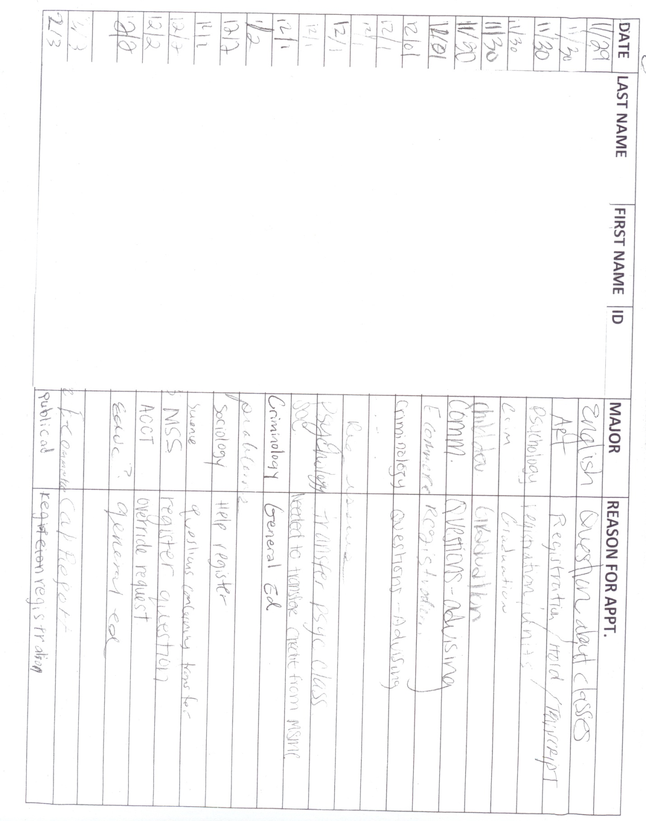

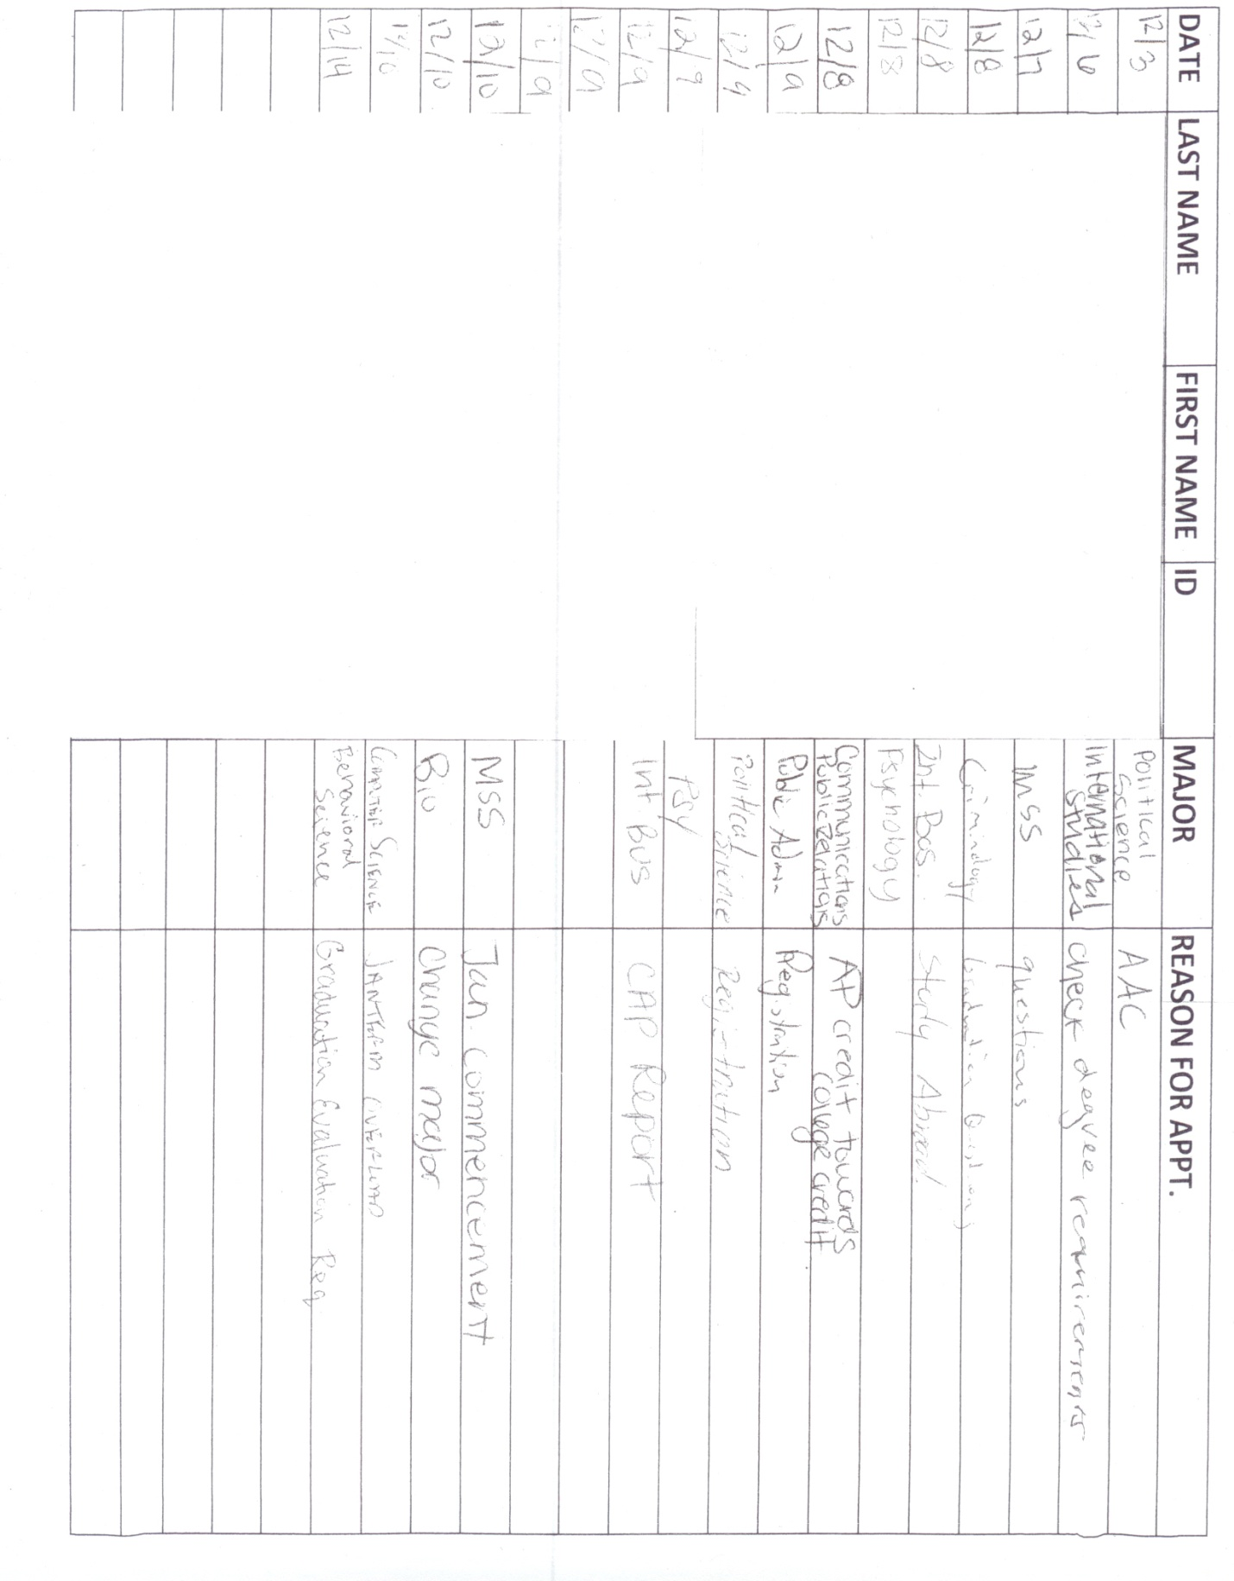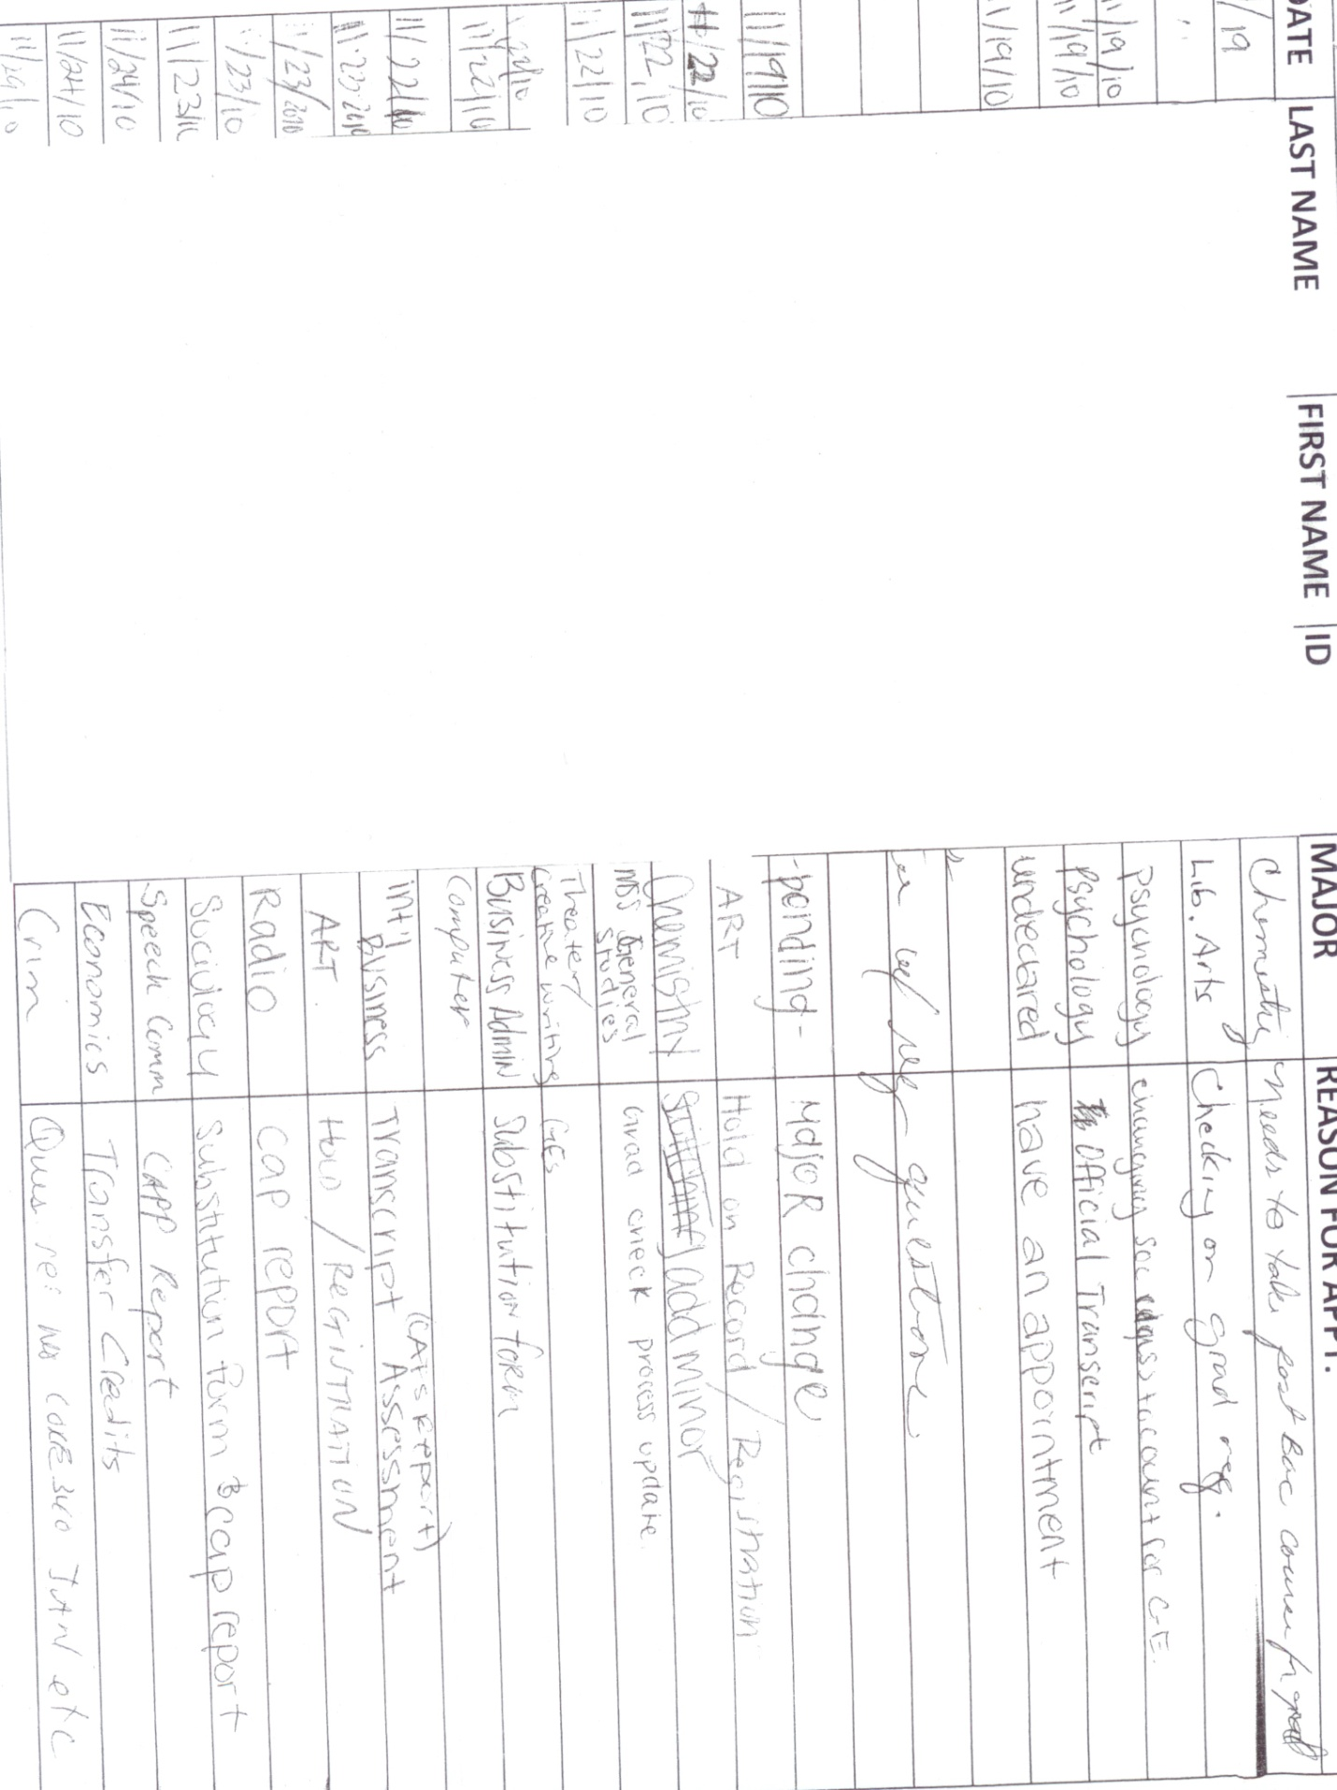

Appendix D

SOAR 2010 Schedule

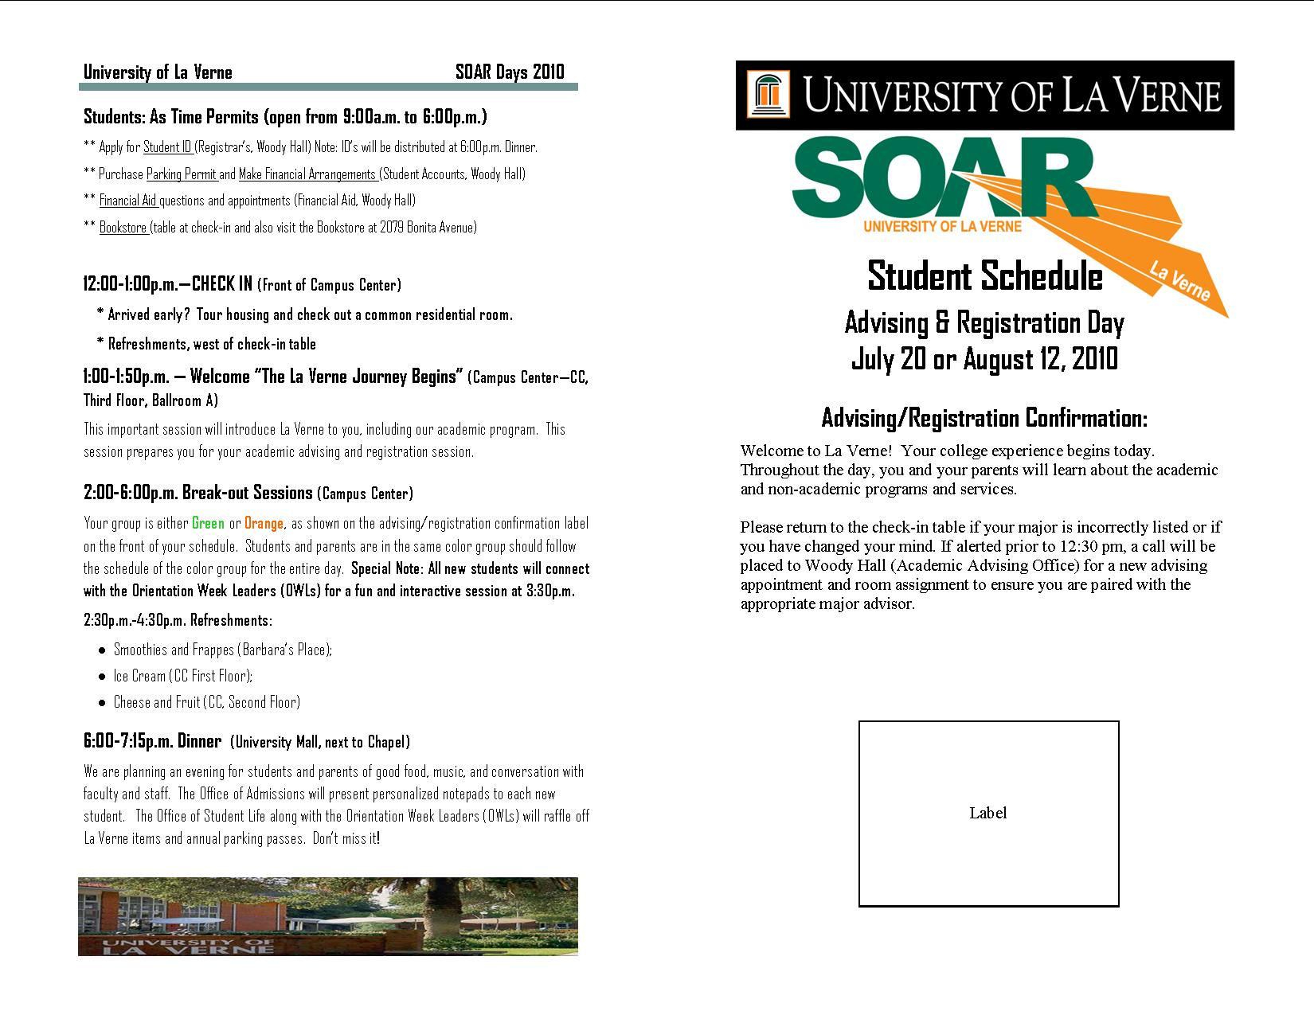

Appendix E

Count of Reviewed Appeals to Undergraduate Appeals Committee (UAP)

|  |  |  |  |  |  |  |
| --- | --- | --- | --- | --- | --- | --- |
| **Month** | **Week 1** | **Week 2** | **Week 3** | **Week 4** | **Week 5** | **# of Wks** |
| Jan-08 | 23 | 22 | 22 | 16 | 25 | **108** |
| Feb-08 | 13 | 28 | 52 | 24 | 23 | **140** |
| Mar-08 | 25 | 6 | 19 |  |  | **50** |
| Apr-08 | 19 | 24 | 25 | 11 | 18 | **97** |
| May-08 | 28 | 18 | 26 | 16 |  | **88** |
| Jun-08 |  |  |  |  |  | **0** |
| Jul-08 | 44 |  |  |  |  | **44** |
| Aug-08 | 30 |  |  |  |  | **30** |
| Sep-08 | 32 | 41 | 24 |  |  | **97** |
| Oct-08 | 13 | 9 | 7 | 14 | 9 | **52** |
| Nov-08 | 8 | 23 |  |  |  | **31** |
| Dec-08 | 26 | 24 | 15 |  |  | **65** |
| Jan-09 | 35 | 9 | 38 |  |  | **82** |
| Feb-09 | 27 | 25 | 20 | 22 |  | **94** |
| Mar-09 | 24 | 17 | 16 | 15 |  | **72** |
| Apr-09 | 16 | 20 | 15 | 13 |  | **64** |
| May-09 | 22 | 18 | 16 | 16 | 12 | **84** |
| Jun-09 | 2 |  |  |  |  | **2** |
| Jul-09 | 40 |  |  |  |  | **40** |
| Aug-09 | 4 | 31 |  |  |  | **35** |
| Sep-09 | 15 | 39 | 18 | 44 |  | **116** |
| Oct-09 | 10 | 12 | 12 | 7 | 8 | **49** |
| Nov-09 | 24 | 17 | 19 |  |  | **60** |
| Dec-09 | 23 | 24 | 16 |  |  | **63** |
| Jan-10 | 4 | 29 | 16 | 18 |  | **67** |
| Feb-10 | 28 | 24 | 34 |  |  | **86** |
| Mar-10 | 31 | 16 | 22 | 15 |  | **84** |
| Apr-10 | 12 | 17 | 17 | 22 |  | **68** |
| May-10 | 17 | 16 | 20 |  |  | **53** |
| Jun-10 | 7 | 31 |  |  |  | **38** |
| Jul-10 | 41 |  |  |  |  | **41** |
| Aug-10 | 40 |  |  |  |  | **40** |
| Sep-10 | 16 | 24 | 70 | 19 |  | **129** |
| Oct-10 | 15 | 22 | 7 | 22 |  | **66** |
| Nov-10 | 9 | 15 | 16 | 17 |  | **57** |
| Dec-10 | 34 | 29 |  |  |  | **63** |
| Jan-11 | 12 | 49 | 12 |  |  | **73** |
| Feb-11 | 34 | 46 | 37 |  |  | **117** |
| Mar-11 | 25 | 29 | 37 |  |  | **91** |
| **Total Appeals** | **828** | **754** | **648** | **311** | **95** | **2636** |

Appendix F

Committee Involvement

|  |  |
| --- | --- |
| *Administrative Committees & Working Groups* | *Faculty Committees* |
| BDMS (Banner Document Management System) | Undergraduate Appeals (UP) |
| PMG (Program Management Group) | Undergraduate Academic Policies (UGAP) |
| Provost’s Council | General Education (GE) |
| Board of Trustees | Faculty Excellence in Advising and Transfer Services (FEATS) (sub-committee to UGAP and GE) |
| SOAR Steering Committee | Faculty Senate (as needed) |
| Senior Management | Faculty Assembly (as needed) |
| Student Services Group | Movement & Sport Science and Athletic Training Undergraduate (Senior) Thesis Defense Committees |
| Counseling Network | Doctor of Education Dissertation Committee |
| Commencement Planning Committee |  |
| Staff & Administrative Search/Hiring Committees |  |

Appendix G

Student Survey Inquiry 19: Please use this space to express any comments, concerns, or suggestions you may have regarding your academic advising experience. The more detailed the response, the more helpful your response will be.

|  |
| --- |
| **19. Please use this space to express any comments, concerns, or suggestions you may have regarding your academic advising experience. The more detailed the response, the more helpful your response will be.** |
| that students ned to meet with their adviisor three times a semester this does not inculde advisisng. |
| Everything has gone smoothly during my advising . |
| The more time spent with advisee makes us feel more comfortable |
| [DELETED] is amazing I am very involved, I ask many questions, and need alot of imput. She has always been willing and able to meet my high standards. If she doesn't know an answer she will reearch it or put me in contact with who can help me. She is speedy in returning emails, phone calls. |
| Picking an advisor in your own major is nervewrecking and may be easier if the advisor was assigned by the best relation to your major. |
| [DELETED] is my advisor and he couldnt be more helpful. He truly makes me feel important and addresses any concerns or qusetions I might have promptly and with amazing detail. |
| Amazing Professor, mentor and advisor. I love my Political Science Department. |
| My academic advising experience has been good overall. My first year was not so good because I did not feel that my advisor for my previous major (psychology) was that much concerned. I ended up taking a class that freshmen should not take, I ended up failing the class, which lowered my GPA and affected my financial aid. My second year of financial aid has been exceptional, I feel like my current advisor really cares about my classes and my growth in my major. |
| Great advisory staff |
| My advising experience was different this is my first semester here, although my advisor was helpful I still felt that most of my answered were left unanswered, and the ones he said he would get back to me with he never did, I would contact him numerous times via Email and office visits and he never could find the correct answers. i Met with Him several times regarding Graduation of Spring 2012, and One day he said Yes no Problem other time he said not looking good because he didn't count my credits correctly, it was a very discouraging. |
| I feel that my advisor is a great person to work with and provides the right materials for getting out of school on time. I wish that students wouldnt interrupt a session thats in progress. |
| Being that I started in spring I feel that I dikd not get as much information as someone who started in fall. I did not know how to find out exactly what courses I needed to take to graduate. Or that I could graduate in 3 1/2 years. |
| I really appreciate my advisor, but it is a little hard to use the online resources. |
| Great job, helped me for credential program as well. |
| I think that once you are at the University of La Verne for a couple of semester it sometimes seems pointless to have to go see your adviser every semester. To me it would be beneficial to go once a year and of course can go whenever I have questions. |
| [DELETED] is my adviser and she's amazing. She pushes her students to do their best and monitors our progress. She has never given me misinformation because she double checks everything. |
| My advisor was very helpful when I was choosing which classes to take for the semester. Also she made sure that I was able to find the days and hours I wanted to get for my classes and that there were no problems. My advisor would ask me questions about what I was interested in for a major and even told me who the best people were to ask about my major choice. She is very helpful, cheerful, nice and made me feel welcomed. |
| I want to get ahead and take summer school but my advisor discouraged me a little. |
| I've only met with my adviser once (I recently declared my major). The time that I met with him went well, and he helped me see the pros and cons about my ideal schedule for next fall. |
| my advisor is very welcoming to questions and listens to my suggestions. I hear differently from other students about other advisors, so perhaps advisors should better engage in what the student plans to do (jobs, internships, clubs, etc.) so all of it can tie into the 4 year schedule |
| Personally, I do not need advising because everything I need to know about which classes I have to take are on the website. Buy I can see why advising would be helpful to keep most students on track. |
| Overall it was been a great experience. |
| My academic advising experience has been really good. I really like my advisor she helps me out a lot with classes that I am taking now and classes that I plan on taking next semester. |
| I feel that academic advising of seeing your advisor before be able to pick your classes is a great idea. It helps keep me on track. |
| [DELETED] has been a very big help in my scheduling and experience here at ULV. She shows a large amount of concern and guides me towards success. |
| Easy to get in contact with, very helpful. |
| I believe that a counselor should be encouraging and help students reach their educational goal, despite their opposition towards it. i feel that if an advisor has a concern about a students educational goals they should discuss them instead of discouraging them to pursue the goal without reason. |
| My advising has been good so far. |
| My first visit to my counselor was did not go so well. She was unprepared and i had some questions and she couldn't answer them. |
| I was satisfied overall with my experience. My advisor was very helpful in most areas. He may have not been as helpful in regards to specific GE and Core requirements or very specific details regarding graduation requirements but he was very helpful in every other area. |
| Everytime I've gone to my academic advisor, she is always very kind and helpful. I'm not afriad to ask questions she makes me comfortable to do so. |
| Generally, my advisor is knowledgeable in areas regarding classes concerning my major. He will direct me to different persons that can help further my understanding if he is not able to sufficiently do so. However, having students on two or more sets of GE requirements makes it confusing for everyone and wastes time having to pull up CAPP reports. |
| My advisor has been extremely helpful and cares for my future |
| I love having someone guide me to get my schedule set for the next semester. |
| Overall, my academic advisor has been very helpful, but I believe all advisors should be able to answers beyond major requirements. |
| The sessions are good. I do most of the work though. I do most of the research to make sure im staying on track. |
| [DELETED] is a Good advisor |
| My advisor knew about the teaching styles of the professors to help suggest professors that may be more beneficial to my learning style. A very helpful advisor that knows very much about the Education program. |
| I'm a freshman and have been confused about scheduling appointments for advising about next semester/year classes. Both times this has come around I felt uninformed about by when I must have this meeting. |
| Advising at ULV is not good. |
| My advisor does not answer my questions and just leaves me wondering the answer. I feel lost without a clue of who to ask my questions to |
| I love my advisor [DELETED]! She helps me so much. And she is always emailing all of her advisees about important dates and study abroad trips that can apply for our business electives. Thanks to her I'm on track to graduate. My advisor before [DELETED] was really rude and had me taking classes that I did not need to take. |
| I am absolutely pleased with my advisor! She does not just help me get classes, but listens to me and understand who I am as a person. Once I graduate I want to stay in touch with her! I'm going to England in the Fall, and I'm going to send her something too. In other words, she is not just an advisor but a friend. She actively listens, and promptly responds to all my many emails. If she doesn't know the answer, she will ask for assistance. That is the sign of wonderful advisor. I've even recommended her to friends. She's an ally and a resource here at ULV, and I'm so happy with her. |
| Academic advising is great, they help me in everything I need. They don't hesitate to take time to help me, no matter how long it takes to explain. |
| i would like to go through the exact courses i would need for me GE's so i have a better understanding of what to expect in my future schedule. |
| My advisor is extremely helpful with all of my needs. Whether it's picking a schedule I prefer, to talking to professors and overriding if necessary so that I may get into my classes. I always leave my advisor office feeling accomplished. |
| [DELETED] was my advisor for more than three semesters and she was really helpful. I wasn't sure where I wanted my college direction to take me but she gave me lots of advice and helped me explore my options. Without her help I wouldn't be doing this well in school. [DELETED] is now my advisor and I have already talked to him a few times on what the options are in the [DELETED] department. He is very knowledgeable and I can count on his help whenever I need it. |
| i love my advisor, she is the best! |
| The only negative I feel is the lack of personal time. Meaning, the office is just a divider, it is not a private office. |
| Great. |
| My advisor [DELETED] doesn't show any care for my major and the classes I want to take, and is hardly ever available and when she is whether in person or by email, she is either unresponsive or doesn't show much care. |
| I have had a great experience with my advising. A little concern would be my advisers changing. |
| My advisor is very helpful in every aspect. She gives me her opinion on what classes I should take and gives me a glimpse of what the classes will be like. |
| I would like to meet more often with my advisor |
| Phones should be answered more often. |
| Would like if my advisior actually suggested what classes to take in a semester not let guess what I beleive is right. |
| I have no complaints about my advisor or my academic advising experience. When I have my appointments they are usually to help with class and schedule selecting and it is truly helpful. It puts me on my path to graduating in three years and with my degree. Outside of appointments I go to her for other things an she is helpful with that too. |
| My two academic advising experiences were great, I have had two different advisers , and recently redirected to a new because I have declared a major. Both advisers where helpful and nice. |
| I feel some of the workers in Woody Hall are not very helpful and pass judgment on students. They are supposed to be there to assist us, not to be rude and to look at us like we are supposed to know everything. We ask questions because we want answers, not for some dumbfounded look. Student Accounts and Financial Aid are wonderful. :) |
| My adviser has been a GREAT help to me since the moment I entered the university |
| I believe that when students first meet their advisors that they should be given a checklist of all required classes in the major/minor. |
| I think it would be more beneficial to everyone involved if the counselor came prepared for session as much as you did. for example a list of scholarships or tools for you if you need help |
| advisor always look at my transcripts each time to keep me on track but I would like more help to guide me toward the next step after graduation. Like internship, possible places connected with school to get jobs, how to get information on other schools for law school. Other advisors for different jobs seem to be more involved with their students in leading them in the right direction after graduation. |
| advisor always look at my transcripts each time to keep me on track but I would like more help to guide me toward the next step after graduation. Like internship, possible places connected with school to get jobs, how to get information on other schools for law school. Other advisors for different jobs seem to be more involved with their students in leading them in the right direction after graduation. |
| Advisers are great, I prepare a lot though so for most people they would be more helpful, for me they just confirm or reject my prospective class schedules. |
| As long as I make sure I come in with knowledge on what I want to take and why my session goes smoothly. |
| No comments everything is good! |
| I wish my advisor would do more than just the minimum and seem more interested in me and what I want to do. I feel like there are awkward moments where he doesn't ask me if I have any questions or concerns, so I bring them up myself. |
| [DELETED] is the most valuable asset of the Anthropology department. She has made all the difference in my academic career. |
| Every interaction I have had has been extremely helpful. |
| Great job! |
| My advisor is great. He knows exactly what he is doing, and gives me the best chance at doing well at La Verne. Also he is giving me the best chance at going to a Graduate program. |
| My advisor does a great job. They help ne whenever I see him and have a question about anything that is why our advising meetings are not too long becase Pat does a good job asking me how I am doing and also my old advisor always let's me know she will be there to help me out whenever I need it. |
| They are always helpful. |
| My advisor has helped me a lot and she is very helpful. I would be lost if it was not for her. I would only like to say keep doing what you are doing and keep up the good work. |
| I have fortunately not had any problems with my advisor. She is extremely helpful and knowledgeable when it comes to helping me choose my classes. |
| fall semester no meeting with her. second semester i met once and it was a good meeting because i felt like i was ready with what i wanted to take and it was in and then out. quick |
| [DELETED] is very insightful and wants to hear how I'm doing outside of school as well. |
| My advisor is super helpful!! |
| [DELETED] is a great advisor and is very well rounded in all areas. If all advisors can be as well rounded as her all students would be set for their academic years at La Verne. Advisors should be educated on the ge's, what can count towards ge's and one's major. Also with the help of a interest level test I was able to narrow down and choose my major. Maybe dispersing more of these school wide would help students decide on a major faster. |
| My academic advising experience has been helpful and my advisor encouraged me to partake in extracurricular activities. He showed concern with the problems that I addressed him about my academics. |
| I find it very useful to have a list of classes or an idea of what classes to take when I meet with my adviser. |
| I switched my academic advisor at the end of last semester to [DELETED] and she has helped me so much in the short amount of time she has been my advisor. I now feel confident in knowing what classes I will take when and I have a clear picture of when I will graduate now. She has gone above and beyond to find out answers to different questions I have had for her (and believe me I have had a lot). I have felt at ease after all of my meeting with her versus leaving confused like I did with my previous advisor. She has always been willing to squeeze me in where she can and I appreciate everything she has done for me. :) |
| I found my experience to be very helpful. Each of my questions were answered by my adviser. He made sure to find answers that he could not answer himself and sent me the information within a timely manner. |
| It was amazing! |
| Every semester by myself i chose my classes and basically showed them to my advisor for her to say okay here is your advisory code. There was nothing more said or discussed and then to find out i was missing a general education class i needed to graduate with. My advisor never notified about anything. |
| There is only one main advisor and student advisors to help. There need to be more advisors in the college of education to help students fully understand what is expected of them. |
| good help |
| I have had at least 3 different advisors and I know that it is partly because I have changed my major. My current advisor was not very helpful. I went in for my last advising session for my second semester of my senior year with my classes picked out and my capp report. He did not know how to read the CAPP report, but he said that the classes I signed up for should fullfill my requirements. The registrar called me right before the beginning of summer to let me know that the Mass Media class I registered for was not fullfilling the correct requirement. I was stuck on the first week of my last semester trying to add a class to make sure I could graduate in May and it was not an easy task. This was the only bad experience I have had with my advising here. |
| My advisor isn't always available Some questions aren't answered because advisor is unsure  To fix: have a back-up to every advisor.. some secondary go-to person  make sure advisors also know g.e. info |
| I have had a very good experience |
| the advisors seem to have very little time on campus which makes it very hard to meet with them and i do notice when i do get the chance it is a very quick meet. |
| [DELETED] is great. She really makes sure to return all e mails and phone calls. She even calls to make sure we received e mails when we do not respond for a few days. She is really help full. |
| I haven't been to the academic advising center in woody hall as of right now i have Ebony Williams As an Adviser and she's been helpful. i have not meant at all with my minor adviser and just selected my major adviser today. |
| My advisor is great! She goes out of her way to help me even in areas that do not include my major classes. She listens to my concerns about classes, professors, and classes which helps because she takes what students say into consideration when they are choosing courses and professors. |
| Its good, but the advisor's should know more about the GE requirements. |
| I love [DELETED] in the [DELETED] office. She is absolutely amazing and so helpful. She provides me with so much information and always is there to answer any questions. |
| My advisor is always there to answer any questions I have. I feel he does care about how I am doing in school. |
| I really felt that the advising was good. However I personally feel the scheduling is a little weak and can improve. Over it is ok. THe office needs to have better scheduling communication between the students. |
| I'm satisfied with my experience/ |
| [DELETED] is really helpful as an academic adviser. She is friendly and is approachable. I enjoyed her a lot this year as a teacher and an adviser |
| I have had an excellent experience with my advisor. [DELETED] |
| I was switched to a new advisor this semester due to my old advisor going on sabbatical. I was concerned at first that I would not be as comfortable with the new advisor, but have found that there was nothing to worry about and my new advisor had been well educated on my file and where I was in the program. I am very happy with how everything turned out. |
| Academic Advising does an adequate job of informing students of the registration procedures. However, the information on the website is sometimes hard to locate. The advisors seem well prepared and know their information. |
| My adviser is also my professor for my major so I see him quite often. He does tend to get a bit sidetracked with conversations very easily so meeting with him has always been a bit time consuming. Overall he tells me what classes I should take to fill graduation requirements, and that's very helpful. Since he is also my professor for those classes, he knows how time consuming they are and can advise me to either take more or less units. |
| my adviser does a good job. he does off on tangents so the meetings go a little longer than necessary but they are good. |
| The way academic advising is done at La Verne is great. The one on one experience paired with advisors wanting to know more about you as an individual and getting to know students outside of academics is very helpful. Other colleges you go into an advising meeting get the classes you need and you leave, and the advisor student relationship really doesn’t exist. |
| I have not had a bad experience with my advisor. |
| I wish my class would have had the Skills for Success class as a requirement for graduation. It was very helpful to me, but came a bit too late due to the fact that I am a senior |
| I had a great academic advising experience. My advisor was very helpful, he answered all my questions and I feel that he seriously cares about all his advisees. |
| I was disappointed with my advisor. I feel that he did not focus on my educational goals or me as a student. WHEN he was present for my appointment we spent 5 minutes going over which classes I was planning on taking, I told him and he agreed or suggested one of his courses. The other 30 minutes was him rambling on about something irrelevant. I say "when" because on a few occasions he did not show up for my appointment and I had to reschedule. |
| My academic advisor is in my department and has even been my professor so working with her has been easy to make a good relationship. i like that it was so convenient to talk to her whenever i had a question, not just around academic advising times, and she was available whenever i had a question or concern. |
| I really like my advisor, after switching majors he has helped me put my graduation date into view. |
| My advisor is great, I love working with him and would like to keep him as my advisor. |
| The fact that I was not able to keep the same advisor throughout my four years at La Verne was a bit disappointing. When I think of an advisor I also think of a mentor, someone that will be leading you along the way towards graduation. Sometimes, advisors do not care for the students' wants and just want to make a schedule that will get them out as soon as possible. They should get to know their students more, maybe even before they begin classes in the fall. |
| Communication! You know the saying, one hand doesn't know what the other is doing? Well, all the fingers are uninformed too. I am in the theatre department, and those who are not in the theatre department have no idea what the requirements are. Those who are seem to be under the mistaken belief that their classes are the only one that matters.  As a theatre major, a student most take three "Upper Literature Classes." Some people are confused as to what does and does not count, and one of the three advisers tells everyone that Masters of the Drama only needs to be taken once as well as one other Upper Literature Classes, but Masters of the Drama needs to be taken once on its own and CAN be taken for a literature class as well. Most of this adviser's students are confused.  Furthermore, for these three literature classes, the department's added some options, but after your adviser tells you these options are viable, you then take the class and have to proceed to go to Woody Hall and fill out a form TO BE SIGNED by your adviser to say that you actually do have credit for these classes.  This may be more of a department issue, being that the faculty have not managed their classes with the school, however, it is very frustrating and nerve wracking. |
| I think they advisers should know registration dates. |
| Nothing. Great experience every year. Everyone has been very helpful |
| I have always had a wonderful experience when I see my Advisor, but I have heard it is not the case with other Advisors. |
| It would be better if the curriculum was not constantly changing. |
| Overall, my experience regarding academic advising has been very good. [DELETED] goes out of his way to answer any questions even if they correspond to other areas (i.e financial aid). He is good with replying to emails and to appointments. |
| I met with my advisor in the fall to talk about spring semester.. But while trying to get an appointment with him to talk about classes in the fall was a major hassle. He wouldn't respond to my emails and he was never in his office at any time I tried to drop in. I asked the advising office in Woody Hall what I should do, (sense my advisor wouldn't answer or get back to me) and do to the fact registration was in less than a week. She said, "Just keep trying." Which did not solve my problem at all?   But then she suggested I could also talk to Ruth Trotter (Head of Art Department) as well. The whole situation ended up turning out much better this way. Professor Trotter Helped me to understand what I had left to do, what I needed to graduate and she really cared about my situation. I was much appreciated of her attitude on the short notice appointment, and over all suggestions / help. I will not even think twice to email or ask for future advising appointments with her first. |
| This past academic advising appointment went very well! I was well prepared and had what classes I still needed to take and a in progress plan of my schedule for the next year and half. Michelle was very helpful and we cross referenced my list with her requirements and came out on the same page. I was very pleased to see this that I will be able to graduate early. |
| Wish the sesion was longer i feel rushed at times. |
| My advisor has been REPEATEDLY incorrect in terms of what courses are being offered (what semester), what classes to take in series (pre-requisites), what courses satisfy what requirements, what courses are needed for my major/concentration. I have corrected my advisor multiple times on requirements each meeting. Other students with the same major and similar educational backgrounds have had nearly exact experiences.  This has resulted with teachers refusing to let me (and others under the same advisor) take a class because pre-requisities were not met - entirely new schedules were necessary.  In short, advisors should be experts on what they are required to advise or immediately know who to refer a student to. |
| My advisor is really good. She really helps all my questions. Thanks a lot. |
| my academic advising for the year has been great and i love my advisor |
| I suggest that the advisor creates an education track plan that lists the courses the student should take for every term for the remainder of the student's stay at the university. |
| My academic advising experience has been remarkable. [DELETED] is very helpful in my major and life in general. I feel very prepared to finish my undergraduate degree and graduate. |
| All offices in Woody hall seem to be very unorganized and unaware of how to help, or direct, the student to with their needs. Numerous student, including myself, have felt like we were, at many times, scrambling to find signatures and get approvals that were unnecessary. This caused us more stress and anxiety that simply could have been avoided. |
| I wish that the ULV core requirements (like life long learning or interdisciplinary) were more easily recognizable. I always have trouble trying to figure those classes out. |
| My academic adivising experiences went swell; there were absolutely no troubles. One of my advisors who I talk with least still remembers me. |
| I recently changed my major and my last advisor was terrible. He was only available when I was in class so it made scheduling meetings difficult. He once emailed me my advisor code and did not bother to meet with me. He always seemed to mock my career objectives and never properly explained GE or major requirements requirements when I asked. However, I recently switched majors and my new advisor is top-notch. I firmly believe that there is a problem with some advisors. Some faculty members are not fit to be advisors. |
| My adviser was not very knowledgeable about the courses needed for my major. He could have helped me map out my last two years for a better understanding of what i needed to do. Also, i think advisers in general should let students know the details regarding the internship class such as they need to get an internship in advance. |
| I had a very frustrating experience during my academic advising. I transferred into La Verne this spring with 104 units in which met several requirements. I also was a very late transfer and received my classes the first day of spring semester. I had NO clue of the numbering system LaVerne used and which classes I should start by taking. So I relied on my advisor whom very briefly did a rough sketch of all my needed classes and said I could graduate Spring 2012. This spring I ended up taking only 12 units. She had mentioned that it be a rough 1 and half years but not knowing ANYTHING about how LaVerne's classes went and what was required I just thought it will be tough but doable. The problem is is that the advisor NEVER stressed how important it was to take a maximum number of units during this spring in order to be eligible to graduate in spring 2012. I specifically told her I was relying on her to make the decisions needed until I figured out how the whole process works. I still have NO IDEA which classes of my transferred classes she is using for which section of the requirements. So even if I were to do all this on my own, I wouldn't know which classes fit into what category(overrides, etc). I have yet to actually see if I have enough upper division classes in my schedule to graduate on time. There is 2 overrides my advisor has not put into the system or whatever so I can't speak with a graduation counselor because my CAPP report will be wrong. My situation is very complicated, and I need more than a 1 hour advising appt to get this handled. I need someone that is not hurrying me up and just procrastinating the work for later. Instead of just throwing classes on a paper, I need someone to calculate it all out and see if it is correct. Im paying 15,000 dollars a semester and I don't want to play a guessing game each semester.  I found out at my advising appointment I would need to take 2 classes in summer school, 18 units in the fall, 5 units during janterm, and go on academic overload IF it gets approved for the spring. NEVER did my advisor express to me that this is the type of schedule I would need in order to finish in May 2012. I'm determined to graduate in spring 2012 because of grad school and being a single mom it is tough going to school.  I understand that the professors are busy, but advising is apart of their job. It is a VERY important piece to completing college in a reasonable time. I've unfortunately heard MANY other students have errors in credit calculation and being too SHORT to graduate. They had to make it up by doing papers or they were just out of luck. Therefore my recommendation is to have a team of advisors specifically for the majors and not the professors doing the advising. |
| Needs to be more thorough in terms of information regarding when to take classes and information about classes in the department |
| I think my advisor does a very good job in addressing all my concerns and in reccommending courses that would be useful to me in respect to my future career. |
| It will be great if we can make an appointment online. |
| The only suggestion I have would be for students going in to their advising appointments: be prepared. Have an idea of your long-term and short-term goals when you go into that meeting so your adviser can help you as much as possible. |

Appendix H

Student Survey Inquiry 20: Please provide overall suggestions for improving the programs or services that are offered by the Office of Academic Advising in Woody Hall. The more detailed the response, the more helpful your response will be.

|  |
| --- |
| **20. Please provide overall suggestions for improving the programs or services that are offered by the Office of Academic Advising in Woody Hall. The more detailed the response, the more helpful your response will be.** |
| none |
| The programs should make more of an effort to let students what is available. |
| Reply back to correspondents as soon as possible |
| I have not needed anything diffefrent. At one point they wanted to put me with a student however, after my concerns stated they said no problem and i stayed with Ruth Lindhorst. |
| Woody Hall as always been very helpful and I havent been disappointed. |
| I think that students shouldnt have to ask for a CAPP Report, they should automatically receive them every semster. |
| Appointments should start before the given time that is specified for academic advising. |
| Having all of he advisors know what the classes are for the following semesters. Know the requirements and basic knowledge for what ever degree/prerequisites that La Verne requires. I always felt as though, i was having to look it up on my own, and when i would ask he didn't seem to know and had to call to find answers from other advisors registrars. Over all it was good but when i asked for advice on which classes i should or shouldn't take He could never give me specific answers it was more along the lines of here are the classes you need fit them in to your schedule. and I wanted him to help guide me a little bit more, just a little overwhelming. |
| Overall I feel accomplished in keeping to deadlines! |
| There needs to be more of a connection with advisors and advisees. I am graduating early because of me. My advisor made it more challenging by not showing me I could take online courses at BYU until my junior year. |
| The online and capa report is hard to access and a little confusing if you have transfer courses. |
| More emails and updates |
| Just be more helpful and organized. |
| I started with a different adviser which was not responsible for the same track I am in. Once I switched I noticed the difference. Having an adviser that is knowledgeable about the major and the specific track is very helpful. |
| In my opinion I really don't feel like there are any changes to be made. It was very helpful and pretty easy to get good help. |
| They are doing good. |
| It would be nice if the advisers knew more about the lesser known programs that the university offers (like the honors program, for example). |
| have a general idea of what classes to expect to be offered one year in advance so students can plan ahead, not just one semester in front of their present one. |
| There should be an advisor specifically for Economics majors. |
| I feel like Woody Hall should communicate more often with its students because Financial Aid and Students Accounts os crucial to a college student overall. |
| Woody Hall has good service. I just don't like the fact that some of the people in their feel rushed to answer questions if there is a line. I've also experienced people giving me different answers on the same question I have. It would be good if everyone was sure with the answer that they give to people. |
| Sometimes no one is there when I go there and I'm unable to get what I need. |
| My advisor has been very helpful and there is no other area that i can think of for her to improve in. |
| Keep doing a great job. |
| I've never visited academic advising at woody hall so I can't offer my input. |
| I feel woody Hall did a very good job of addressing my needs as a student. |
| It appears that my department advisor is more knowledgeable in information regarding students who start at La Verne rather than those that transfer in. Perhaps there could be more instruction to advisors (in the individual departments) in the different transfer policies. |
| The workers in academic advising need improvement. I had trouble with a math class and it be transferred over. I forget the name of the women, but she called me and was extremely rude. Her exact words were, "Did you even try on your math entrance exam or is that actually your score?" I was extremely insulted, shocked, and hurt and this almost resulted in me transferring to another college because of how mad I was. If one works at a unversity and with students, the last thing a person should do is insult the students. I pay way too much money for school and to be insulted when I am transferring to ULV and in need of help to get all my classes transferred is awful. |
| Everything is good |
| All my questions are answered within a timely manner. |
| I think the advisors need more training on University policies. |
| Graduate updates |
| I would suggest to making the forms easier to find on the website. |
| The school should send e-mails to inform students to start making appointments with counselors before class registrations. |
| A Professor caring about students. |
| I feel the advisor should really try to work with the students problem because telling them to do everything on their own does not help the students. |
| Some advisors do not know how to advise and you can tell they do not want to be advisors. Pick professors who want to advise or hire people who can actually help students get on track to graduate on-time. |
| When I come to the Academic Advising office, and announce my appointment, the receptionists or people I first see are not friendly or welcoming. They look at you oddly until you announce what you need, and then in one word tell you to "Sit". That is not professional, and I would love to have a friendly smile which is always encouraging in the beginning, middle, and end of a crazy semester. |
| They are doing a greta job, but it would be great if it opened at 8 am everyday during the week and stayed open till 6 pm. |
| i think they are both very helpful and reliable. they are always there for help and answers. |
| A suggestion would be for advisors to check up on their advisees more pertaining about their academic progress and not just making sure they get their classes. Also, every single time there is an advising session, the advisor should show how far the student is from graduating and what they still need to do; so the advisee can have the bigger picture in mind. |
| In the Office of Academic Advising in Woody Hall I have only worked with Pattie Nonemaker. She was terrific in guiding me to choose the right classes and ultimately choosing my major. I am very thankful for her help and would reccomend her to anyone. |
| have more availablity of an important program or workshop offered on different days or times so it is more convienent for students |
| I have had no problem with this. |
| Academic advisers should help understand requirements for student's minors as well |
| Woody Hall has been very satisfying and helpful, no suggestions other than more emails regarding important dates for certain things such as registration |
| To some students accessibility to their adviser is a major problem or putting them with an adviser that is not knowledgeable on certain subjects. |
| My advisor communicates really well with me. She responds to e-mails quickly and is always on time or even earlier to appointments. The only thing that can be improved is for other advisors that do not check their e-mail or if they do, they do not respond for weeks. |
| Phones should be answered more often. |
| Provide more support when making an Ed plan with an advisor. |
| I have no problems with anything at woody hall including the Academic Advising. They have been extremely helpful towards me. |
| I attended the Spring academic advising GE session and I thought it was helpful, but I felt it was too long, maybe just going over the really important or obscure details/requirements would be best. |
| I have no idea.... maybe a staff change. |
| More friendly and understanding. |
| Woody Hall is fine in my opinion. Never had any problems |
| No suggestions. |
| Like to see more willingness to get a correct answer and to fulfill the needs of the students. More direction from financial aid on how the financial process works and explanation of how financial aid is awarded. |
| For Web capp to be less confusing, and course lists updated to classes that are actually still being offered. |
| Academic Advising has always gone smooth for me and my questions were answered without problem. Financial Aid on the other hand.... |
| No improvements |
| i do nott have |
| None:) Everyone in there is extremely helpful. |
| Keep Patty...she's the best. |
| I think you're doing a good job. |
| Thanks:) |
| I have never used any resources from Woody Hall. |
| I never really have to use them for too many things. |
| Sending e-mails to every student regarding concernes or important notices is very helpful. I cannot see how their services can be any better because they already are. |
| I have fortunately not had any problems with academic advising. I understand the requirements and what I need to do in order to graduate. I also just received help from my advisor with selecting a minor. The only thing that I would mention occurred when I was a freshman. I had a peer advisor help me with my schedule, and I could not stand it. I had no clue what was going on, so when it came time to actually get my classes online I was completely lost. I think that freshmen should especially meet with an academic advisor and not a peer advisor. Overall, I have had a mostly good experience. |
| all i can say is that those meetings where if you go you can register early if you go are very nice |
| I would say having the advisors know more about the concentrations would be helpful than just the major itself. |
| N?A Never been |
| No need for improvements. |
| The Office of Academic Advising in Woody Hall should be available at more times. It took me awhile to reach the person I wanted to talk to, even though I left a voicemail. |
| I find the information very useful and efficient. |
| I haven't dealt with Academic Advising too much in Woody Hall, but the few time I have they have been very helpful and answered the questions I've had. The advising workshop they put on was very helpful and informative also. |
| make it easier to get a hold of advisors |
| Announce more and promote. They should speak to the students. |
| I think that the program is not on the same page with all the services provided. There is a lot of he said she said and i end up and not just me but a lot of students are brought in a circle and have no clue what to do or who to go to. |
| There needs to be better communication via email, or by setting up one individual session for each student to meet with the head chair of advising to understand what is best for them. |
| more communication by email about progress in classes |
| Make sure the advisors know how to read a Capp report and that they understand all of the necessary requirements for that particular major |
| great services given from the Office of Academic Advising. no suggestions |
| Sometimes it is hard to get a hold of the person that you need to talk to but it is otherwise good. |
| I cant see anything improving, maybe a larger space, but nothing to much. This department is so amazing. |
| I haven't been to the academic advising center in woody hall as of right now i have Ebony Williams As an Adviser and she's been helpful. i have not meant at all with my minor adviser and just selected my major adviser today. |
| I have not utilized the office of academic advising because my advisor is extremely helpful. However, I did access CAPP reports which come from Woody and have found them to be extremely helpful in choosing what classes to take! |
| Some financial aid people should be a little nicer. |
| The emails sent by the Office of Academic Advising always help. Vanessa particularly always answers the questions I have through email. |
| I feel all the programs are wonderful. Everyone is attentive and helpful. |
| A web service that shows me exactly what type of classes I still need to complete in order to graduate. |
| They are helpful but I wish the financial aid center was more helpful when I was not able to receive my work study aid. It was a battle I thought shouldn't have even occurred. |
| I think it would be helpful to have all majors with class requirements posted for students to follow on their own |
| I can not think of anything that needs to be changed, I have had a very positive experience so far. |
| None as of now, |
| When I started, Academic Advising had a fast response time, but as the years progressed, I feel that their response time has become delayed. The information gets to the student at a much later time, at times too late. |
| The Academic Advising portion of Woody Hall is great. Financial Aid? Not so much. I can never get a meeting with anyone, and typically they just tell me to "check online." Even my friends here have told me in order to get a meeting with someone besides the front desk is to say that I need help on my FAFSA. Since I've been at ULV for two semesters, I have only had one person meet with me to discuss financial aid. Even then I kept getting passed off to someone else and it was a waste of my time overall. Please fix something in Financial Aid, not Academic Advising. |
| i don't really ever go there so i don't have suggestions |
| Very helpful and reachable and can answer all questions |
| Never had a problem |
| I was pleased with the aid I received from the Advising Office they were very helpful. |
| i have not really needed to use the academic advising office in woody hall so far in my three years here at la verne. so i do not know the importance of it or relevence or if i should have been using services offered there. maybe if the services were made more clear to students. |
| I feel that Lee Knous does most of the work in that office and therefore she needs some assistance. |
| I didn't know there were services for academic advising in woody hall so there are no suggestions I could give. |
| Overall, Academic Advising was sufficient. In particular, Pattie Nonemaker is one of the most valuable assets at the University of La Verne, she has been of great help and really knows her stuff. I think it is important to note those advisors that really care about their students and let go of those who only are advising because they have to. You can tell the difference. Good luck in the years to come! The campus is growing and with more students, we will need more advisors, maybe we should start looking for outside resources. |
| Again, communication.  In terms of graduation, most students are not sure what is expected of them. The classes we can find out, but for what we don't think to look at, we're in the dark. The need to "Apply" for graduation, and everything else that one is required to do to graduate on time needs to be communicated better. Perhaps sending out a letter to advisers to tell all their students every semester, posting a list in Woody Hall, or sending out a DETAILED email EVERY semester could do the trick. With a subject header, "For those who will graduate in three semesters," or whenever you would like the graduation deadline by.  Again, the people in Woody hall have no idea what it takes for a theatre major to graduate. Every year there's issues with people having not taken classes that don't exist anymore, and that do not appear on the online degree evaluation. This may be more the fault of the department, but it still needs to be solved.  Also, I really think the online degree evaluation should count the classes being taken this semester under the assumption that the student will pass them. Meaning, that when we look at what we have to do, it will include what we're taking this semester. Even if it was in different colors, or had the word pending next to it, it'd still be beneficial. |
| I think just having more faculty to help with advising because not every student is lucky enough to have a really good advisor |
| I am not familiar with the Office of Academic Advising in Woody Hall. |
| Create a calendar of when classes will be provided so that a student will know in advance what classes they need to take in which semester to graduate on time. |
| The people working at the Office of Academic Advising are always happy and willing to help which makes the experience great and smooth. I would not change anything. |
| I think it's really 'who' you get in the office. Some people are very helpful and some seem like you catch them on a bad day every time i go in. I wish i remember the names of the two very nice ladies who helped me last thursady to understnad about graduation. (the prices, how to do it, what i needed.) They were extremely helpful and cheery about it. |
| I cannot think of any suggestion for improving the programs or services. All i can say is that my advising appointment went very well. |
| None that i can think of maybe open ealier :) |
| I have not used this service much. |
| It's good! |
| A more detailed CAPP report should be available. |
| Woody Hall Academic Advising has been very helpful in my experiences at the University. I have never had an issue with class scheduling or anything else related to Advising. |
| More directness when it comes to what classes, and class options, are available to the student early on in their college career would be helpful. I failed college mathematics twice before I was informed the Math in Society would count for the same requirement. These are important options that all students should know about. It would make many students college career more enjoyable. It would have made mine. |
| I have no complaints. |
| Something must be done about the faculty members who are not cut out to be advisors and major changes should be filed in a much more timely fashion. |
| Office of Academic Advising was very good. |
| As a transfer student, I did not hear about any help regarding preparation for the classes, etc. It made choosing classes very difficult and confusing.  The academic advisor in Woody Hall was VERY helpful with my general ed requirements. The advisor even tried helping me with my major classes due to my other advisor not being available. |
| Well every time that I've been there I was able to get the information I needed quickly, and I never had to run from office to office because the person I initially went to did not know the answer to my questions. I think they know what they're doing and they do it well. |
| Good. |
| I believe it would be convenient to students if the Office of Academic Advising could provide a more direct correspondence between students and the Appeals Committee.  This could aid in what can be confusing and sometimes stressful situation. |

Student Registration Survey, Fall 2010

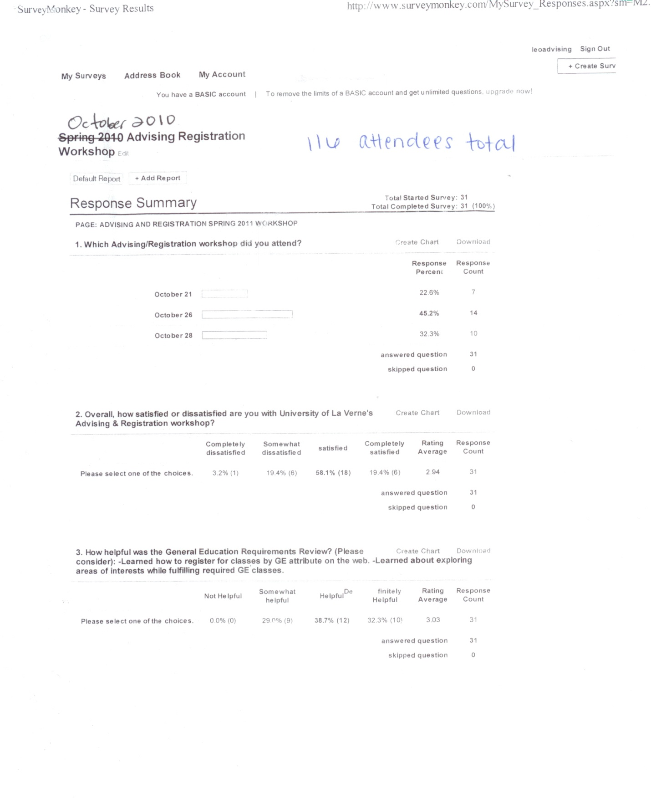

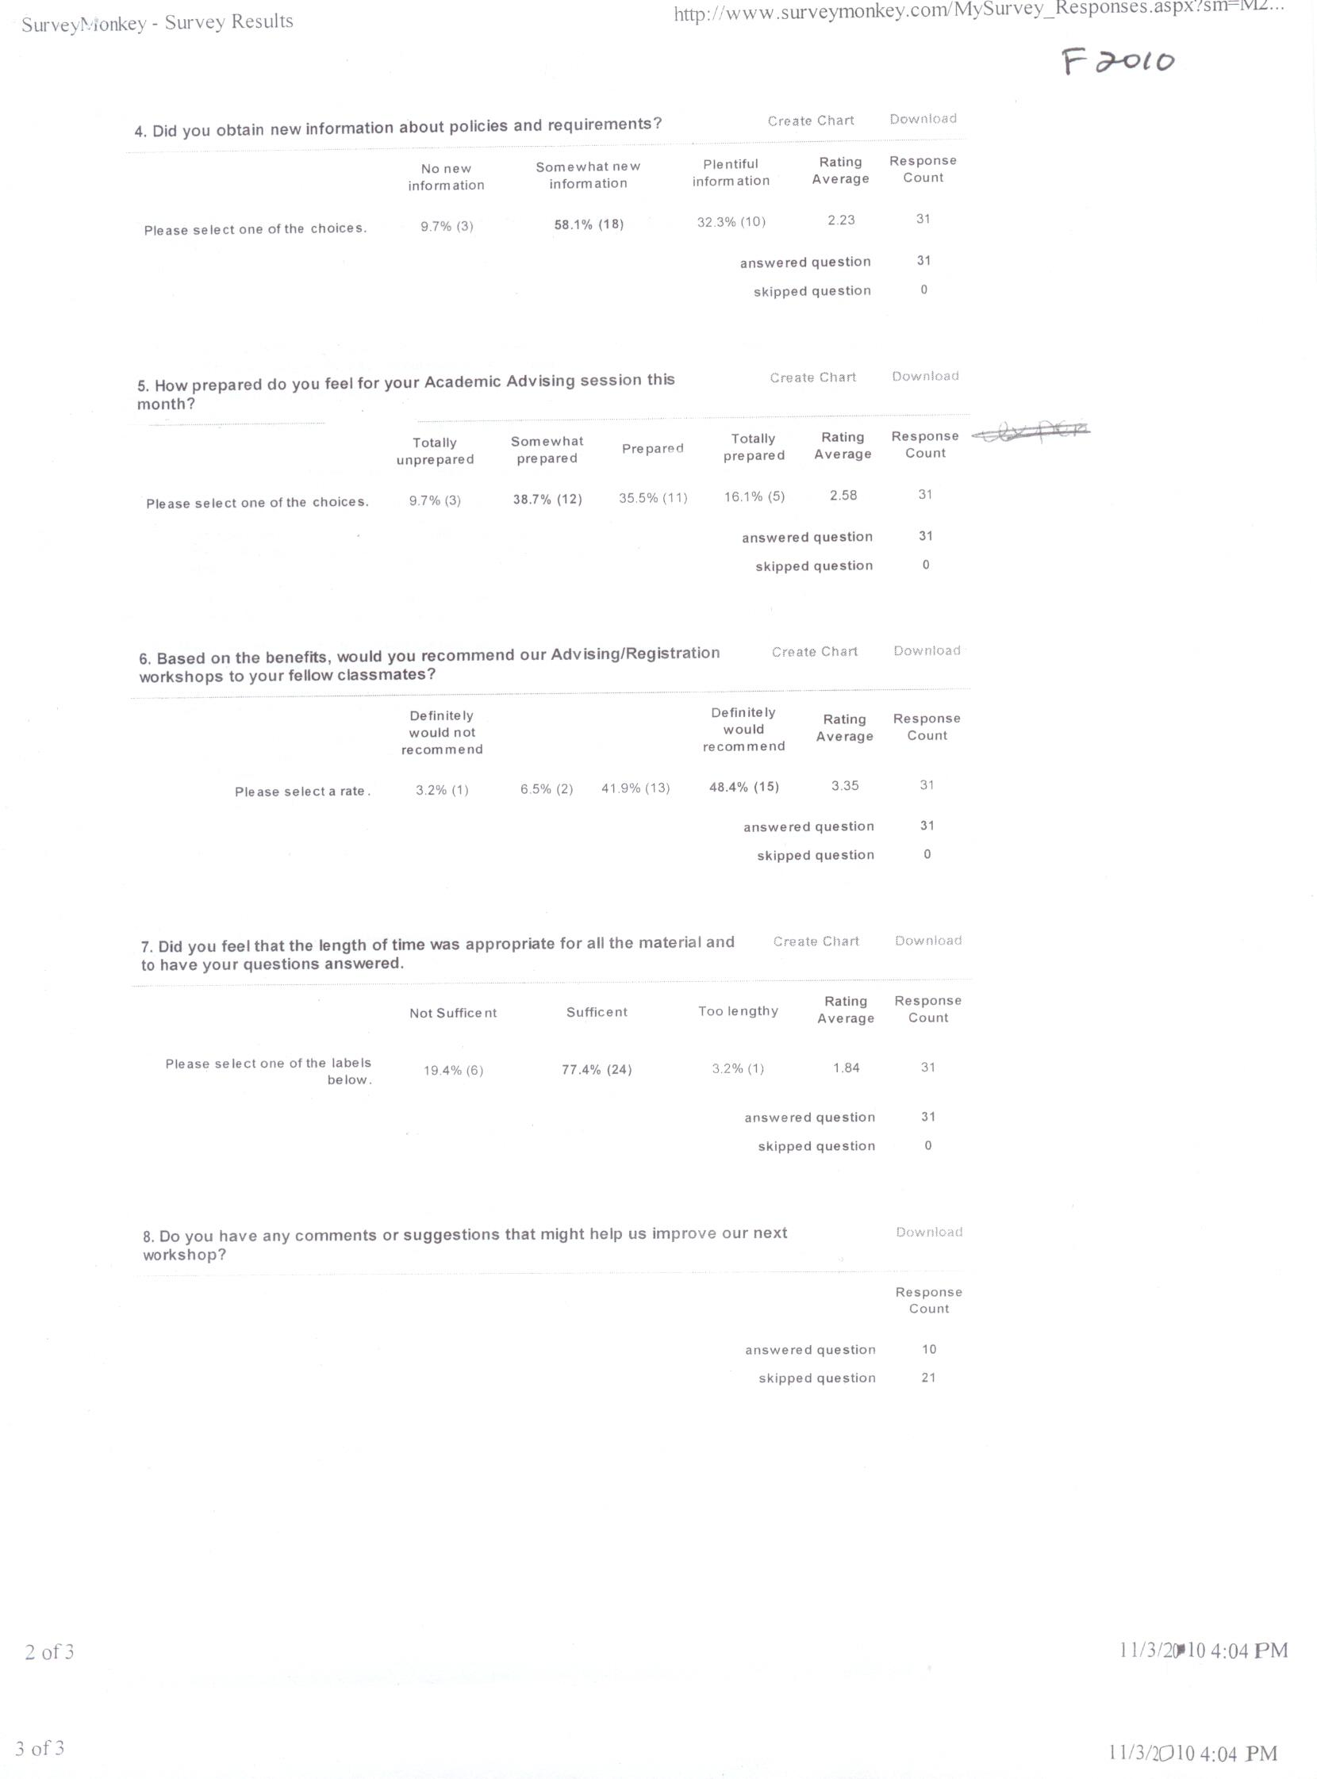

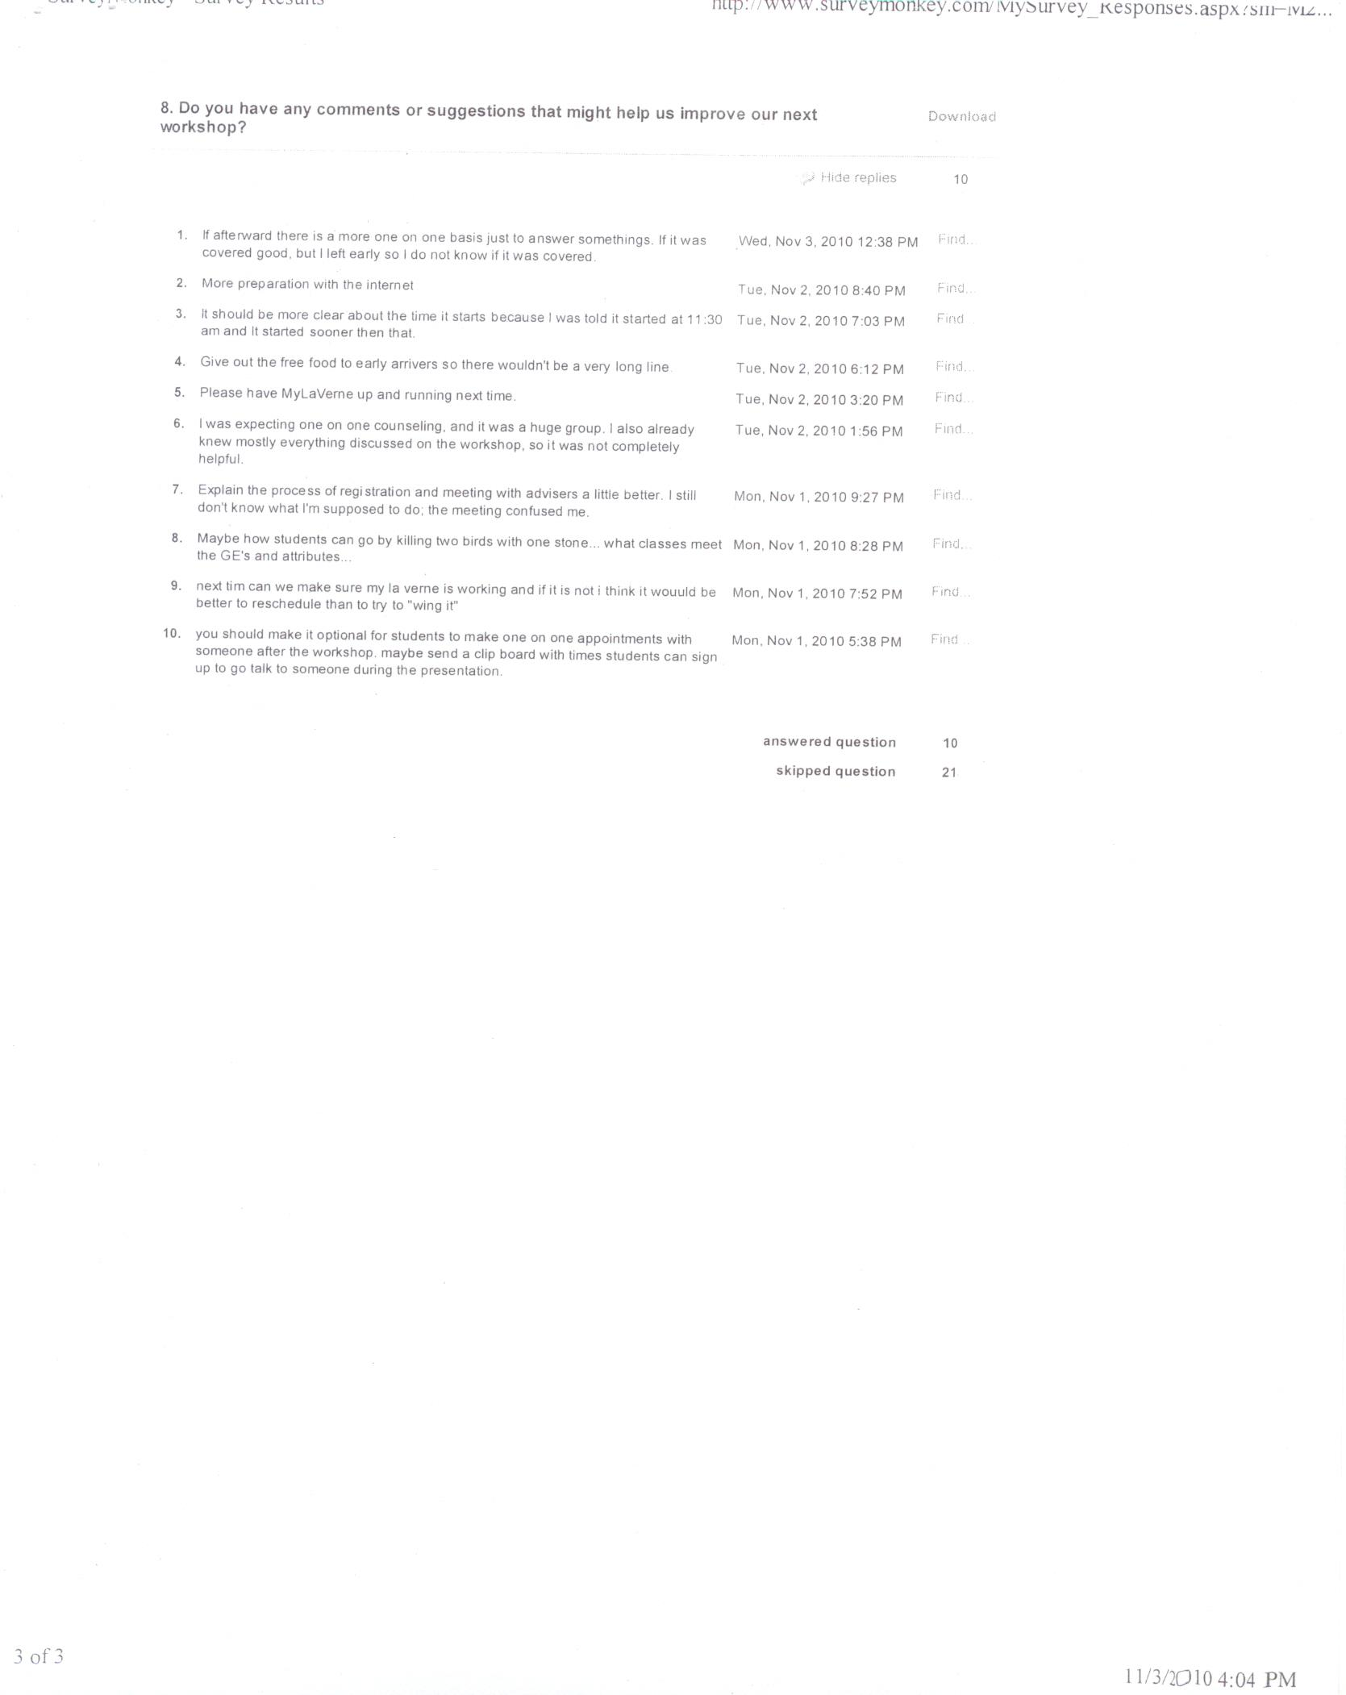

Student Registration Survey, Spring 2011

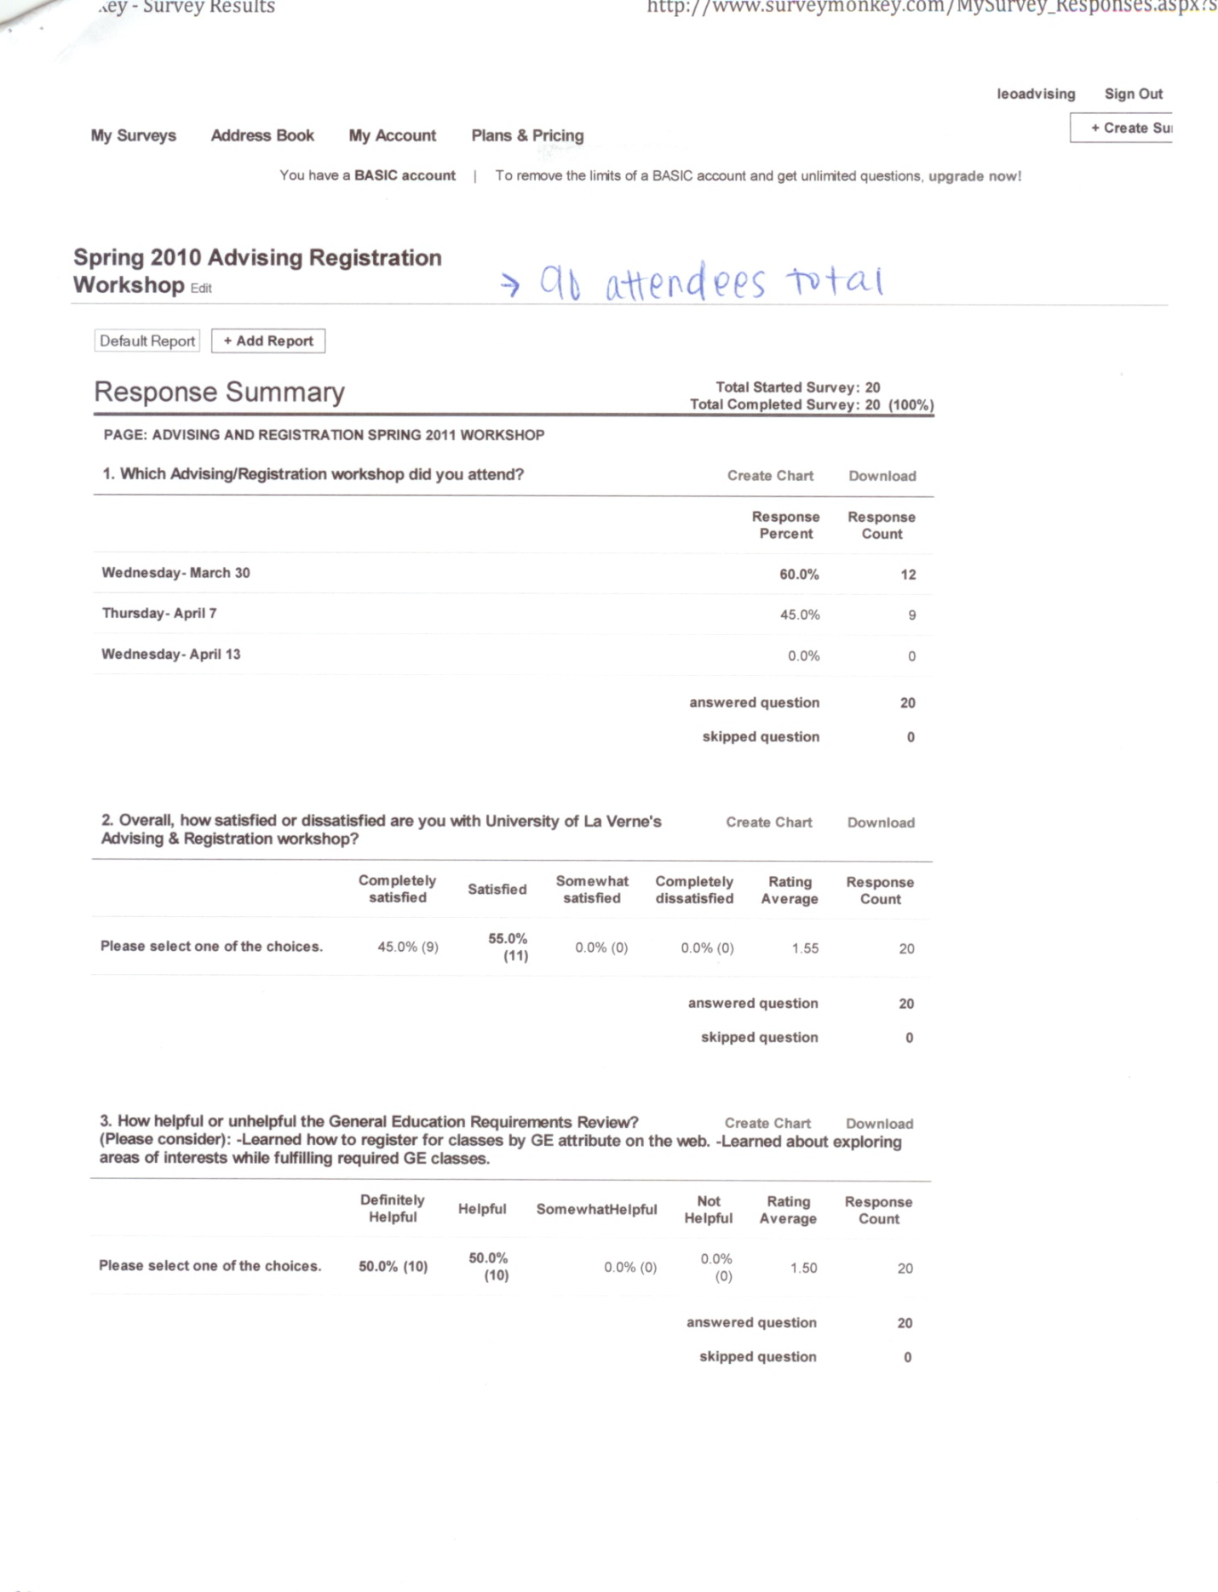

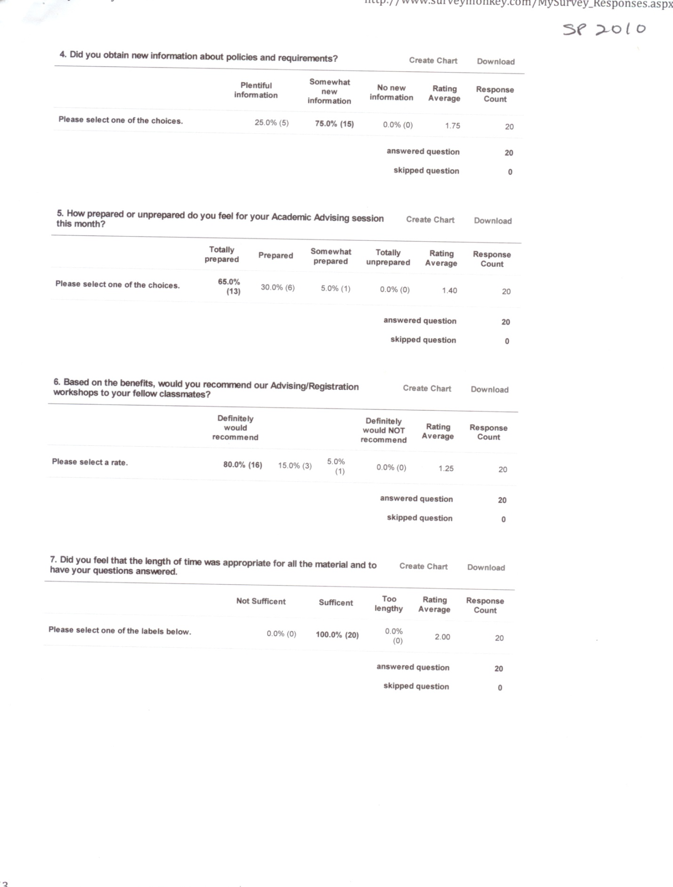

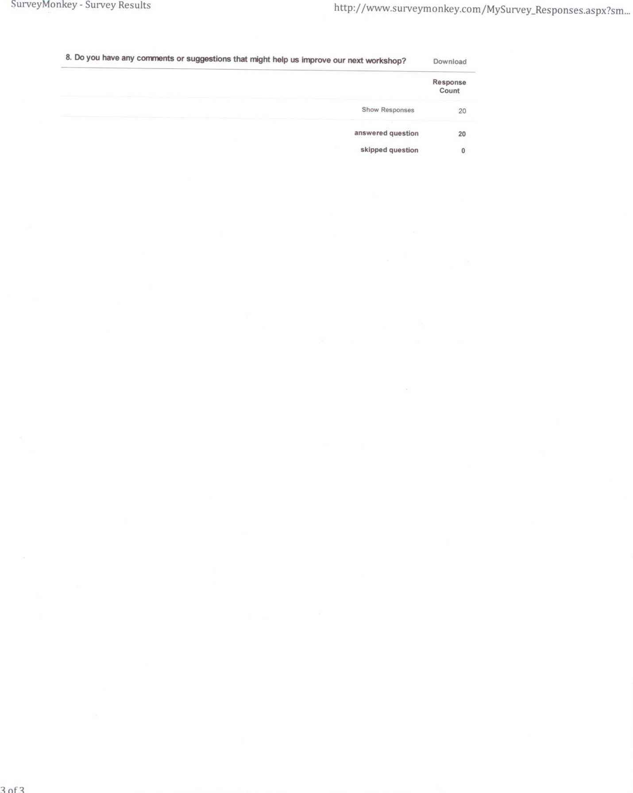

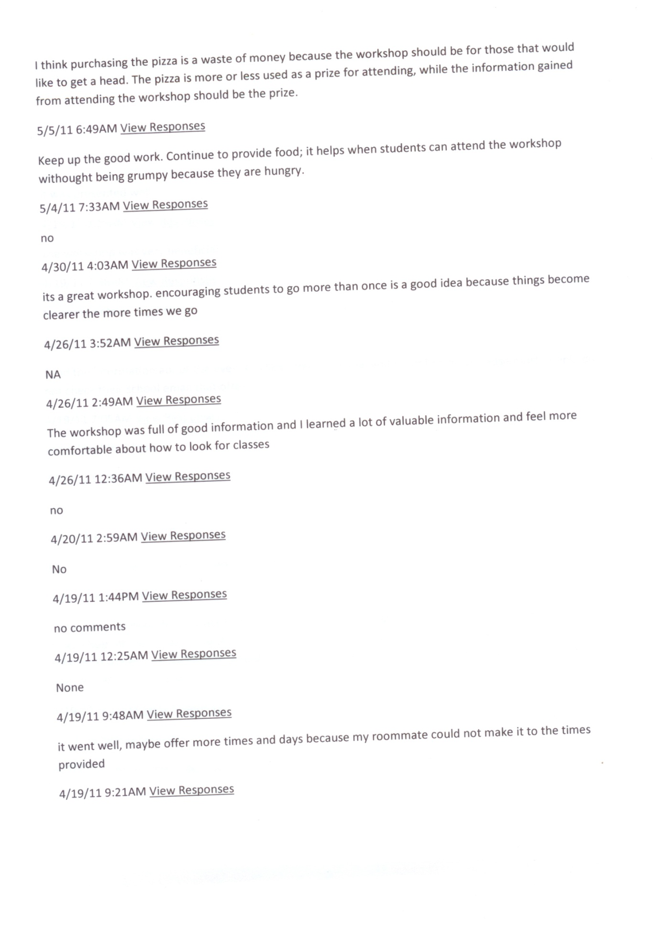

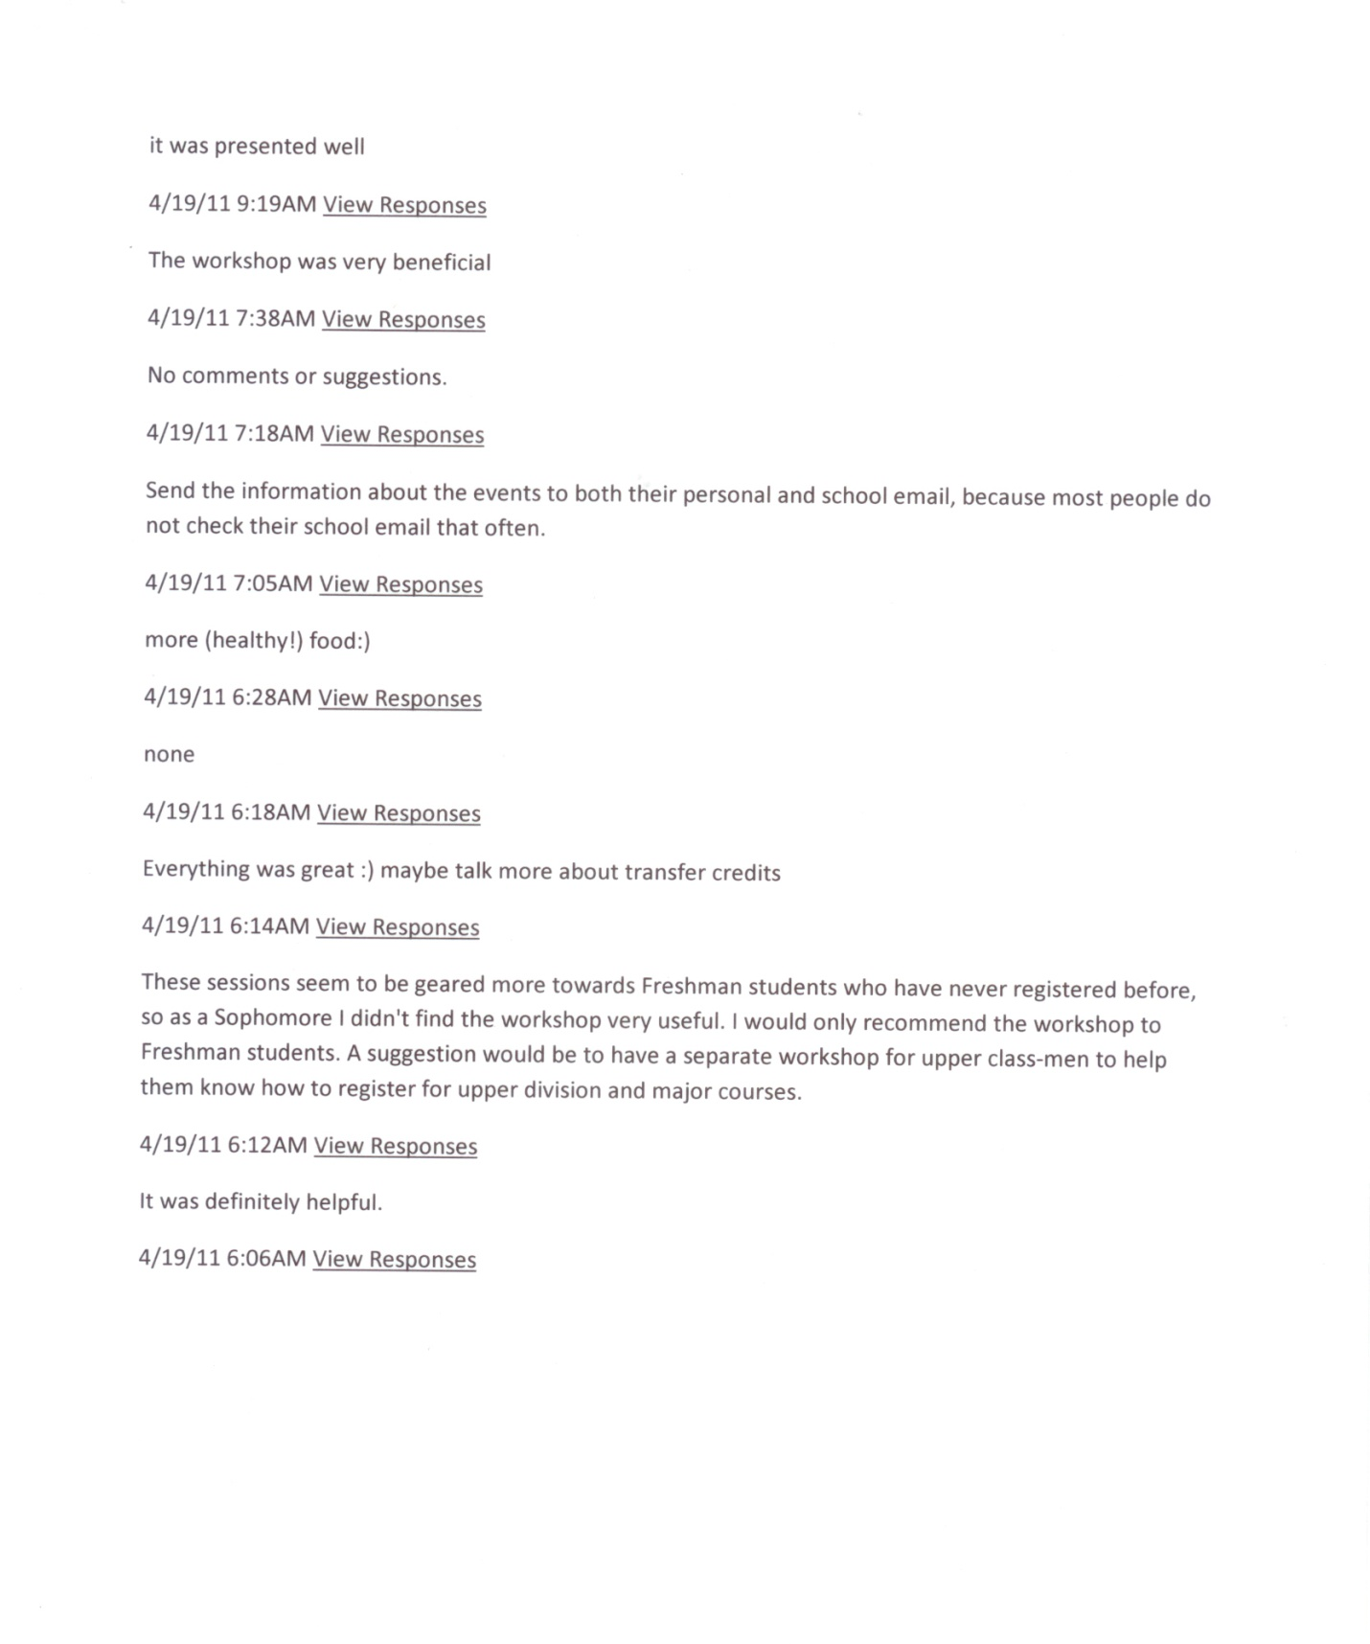

Appendix I

Demographic Information of Student & Advisor Survey Respondents

*Students*

|  |  |
| --- | --- |
| Survey Inquiry: Please select your class level. | |
| https://www.google.com/chart?cht=p&chs=345x150&chco=d00000&chl=Freshman%20%5B54%5D%7CSophomore%20%5B36%5D%7CJunior%20%5B56%5D%7CSenior%20%5B35%5D&chd=e%3ATFMuTyMX | |  |  |  |  | | --- | --- | --- | --- | | Freshman |  | 54 | 30% | | Sophomore |  | 36 | 20% | | Junior |  | 56 | 31% | | Senior |  | 35 | 19% | |

|  |  |
| --- | --- |
| Survey Inquiry: About you: Gender | |
| https://www.google.com/chart?cht=p&chs=345x150&chco=dcca02&chl=Female%20%5B141%5D%7CMale%20%5B40%5D&chd=e%3Ax2OI | |  |  |  |  | | --- | --- | --- | --- | | Female |  | 141 | 78% | | Male |  | 40 | 22% | |

|  |  |
| --- | --- |
| Survey Inquiry: About you: Ethnicity | |
|  | |  |  |  |  | | --- | --- | --- | --- | | African-American/Black |  | 10 | 6% | | Asian |  | 15 | 8% | | Hispanic/Latino |  | 79 | 44% | | Caucasian |  | 56 | 31% | | Other |  | 21 | 12% | |

*Academic Advisors*

|  |  |
| --- | --- |
| About you: Gender | |
| https://www.google.com/chart?cht=p&chs=345x150&chco=d00000&chl=Male%20%5B20%5D%7CFemale%20%5B20%5D&chd=e%3Af.f. | |  |  |  |  | | --- | --- | --- | --- | | Male |  | 20 | 50% | | Female |  | 20 | 50% | |

|  |  |
| --- | --- |
| About you: Years of Advising Experience | |
| https://www.google.com/chart?cht=p&chs=345x150&chco=dcca02&chl=1-5%20Years%20%5B11%5D%7C6-10%20Years%20%5B8%5D%7C11-15%20Years%20%5B8%5D%7C16%2B%20Years%20%5B13%5D&chd=e%3ARmMzMzUy | |  |  |  |  | | --- | --- | --- | --- | | 1-5 Years |  | 11 | 28% | | 6-10 Years |  | 8 | 20% | | 11-15 Years |  | 8 | 20% | | 16+ Years |  | 13 | 33% | |

|  |  |
| --- | --- |
| About you: Position | |
| https://www.google.com/chart?cht=p&chs=345x150&chco=00d000&chl=Staff%20Advisor%20%28not%20Faculty%29%20%5B5%5D%7CFaculty%20Advisor%20%28Tenured%20or%20Tenure-track%29%20%5B35%5D&chd=e%3AH.3. | |  |  |  |  | | --- | --- | --- | --- | | Staff Advisor (not Faculty) |  | 5 | 13% | | Faculty Advisor (Tenured or Tenure-track) |  | 35 | 88% | |

|  |  |
| --- | --- |
| About you: College of Employment | |
| https://www.google.com/chart?cht=p&chs=345x150&chco=9601ac&chl=Arts%20and%20Sciences%20%5B33%5D%7CCollege%20of%20Business%20%26%20Public%20Policy%20%5B4%5D%7CCollege%20of%20Education%20%5B3%5D&chd=e%3A0yGZEz | |  |  |  |  | | --- | --- | --- | --- | | Arts and Sciences |  | 33 | 83% | | College of Business & Public Policy |  | 4 | 10% | | College of Education |  | 3 | 8% | |

Appendix J

Advisor Survey Responses, Item 15.

|  |
| --- |
| **15. Please use this space to express any comments, concerns, or suggestions you may have regarding your academic advising experience. The more detailed the response, the more helpful your response will be.** |
| The CAPP report could be simplified (the way it was before ) with the classes needed left clearly on the report and have access to this online. |
| Having faculty serve as advisors is a disservice to the students. Faculty do not have the training, resources, or time given teaching and research responsibilities. A separate advising office, that does not have faculty involved as advisors, would be more effective and helpful to the students. |
| I support separating GE advising from major advising. |
| I am not sure that advising is all that well rewarded. There are faculty in my dept who know little about advising. Reward (monetary) and recognition would help. |
| I feel very fortunate to be an academic advisor for the University of La Verne. I value our students and feel privileged to serve them. I feel rewarded when they cross that stage at graduation. I feel my diligence in providing accurate advice is rewarded by their growth and development. |
| Academic advising times change from year to year. I would like to see those dates stay the same (or at least the same week in the semester). It makes planning a syllabus easier.  Also, advising adds a huge work load to already overworked faculty (at least in our department). I think the university should adequately staff the academic advising office so that students can get help with the GE requirements from them and come to faculty for the major only. |
| -Some of the questions here are not clear. For example, to whom is advising rewarded (in Question 12). -The response options to Question 10 is odd. A person either did or did not. -Requiring people to respond to items on a survey is questionable. The next time, I may not complete the survey at all.   -Faculty should be involved in professional development of students and in activities to help mentor students. However, advising for general education requirements, dealing with transfer units, etc., really should be handled by the advising office directly.  -The seemingly ongoing shift in General Education requirements (etc., which courses count for what requirement) is hard to follow. Faculty are prepping courses, engaged in scholarship, involved in community service (both on and off campus) and mentoring students. Following these ongoing changes is a bit much at times, particularly when you have 30+ advisees asking different questions about different courses and general education requirements. |
| The support we get from academic advising is great. |
| Although I have been advising for many years, I find myself hesitating to do GE advising because a single class can meet so many requirements. I find myself getting angry at the GE requirements when a second semester freshman is in the process of finishing his/her them wonders what to take next. I dislike and am embarrassed by our current GE requirements. |
| None. |
| I don't understand GE |
| I like that the MyLaVerne lists the GE requirements that courses fulfill. It is very clear. The advising sessions I attended were very helpful too. The cap report that gets done with the application to graduate is a very useful tool for advising. I like that we can find the advisor pin number online all the time through MyLaVerne. |
| Faculty advisors seem more prone to rule-breaking in an effort to help the students, but it often does more harm than good. Respect for the process, the policies, and the intent of the program may help curb some of these tendencies to bend some of the rules. |
| Somewhat difficult to keep up with changing GE requirements. |
| nothing to say. |
| The Capp reports are not up to date. The transfer evaluation reports usually are not correct. There need to be two to three stop days at the University where counseling is performed. The University used to have those stop days. If the University puts a premium on student advising, then it must provide opportunities for quality advising. Faculty advisers need to have access to student transcripts from students outside their majors/counseling list. We perform cross academic advising for students who, for one reason or another, are not able to meet with their assigned adviser. If you want us to advise students with authority, let us have access to the student transcript records. Summer advising has become untenable. No one in my department will do it anymore. There needs to be a new model. |
| I always felt group advising was inefficient. I am glad to see it is getting back to one on one. |
| The Office of Academic Advising provides a variety of helpful resources and support services (thank you!), but it can still be an overwhelming task to ensure that students are meeting their graduation requirements. While the online degree evaluation report faculty can access is helpful, it is not particularly user-friendly and often confuses both faculty and students. It would be preferable for faculty to be responsible for advising students on their major requirements (as well as overall educational goals and career aspirations), but having another party be responsible for GE requirements and other graduation requirements (sufficient upper level courses, 128 total units, values, etc.) One particular difficulty is transfer students, who seem to enter academic advising season late, and are at a disadvantage in trying to register for upper level courses (which are the courses they need because they have met GE and intro pre-requisites but these courses are already at capacity by the time they try to register). Transfer students also seem to have trouble getting credit for courses they have taken elsewhere. |
| Even though I go fairly often to the web site to get forms, I still have to search and look for them. They are not that easy to find. Also, there is confusion about whether forms are on your website or the registrar's. |
| I think it would be better to have the 5th option for each answer (from 1 -14) – no opinion (or neutral option) |
| none |
| Senior Thesis Advising has been essential in orienting students toward graduate studies. |
| As a Department Chair, I need to electronically review all of the courses offered in my Department and Division, not only the courses that I teach. |
| Communication and sharing of information is critical!! |
| I really agree with question #9. It would be great if we could focus on the MAJOR requirements only & individuals who are G.E. experts or specialists could help us with that part of the students' degree requirements.  In addition, I think it is imperative that we do not confuse Academic Advising with class scheduling. As an advisor, I must serve in an ADVISING capacity, which also includes providing students with the best advice regarding COURSE SEQUENCING, but does NOT require that I lay out the students' class schedule every semester. |
| Not happy with the number of advisees who do not read their e-mail and then come to me during registration in a panic because they need to register but have not been advised. There needs to be a system by which the students are bombarded with e-mails, texts, whatever. The upcoming online appointment system will hopefully also indicate who has NOT made and appointment, and continue to attempt to contact the student until they do. It is really frustrating to have to meet with the "slackers" and then try and find open classes. |
| none |
| Professional academic advisors should be advising. Faculty only for majors. My closest relationships with students are formed in the classroom, not as an advisor. In fact, I can't think of even one close relationship with a student that was formed on the basis of an advisor-advisee relationship. I can think of dozens formed in the classroom. It would also help to revamp the GE program which is ridiculously complicated. Keep it simple. So many courses in the social sciences, in the humanities, etc. and you're done. Every class should teach students how to think critically, yet we have it as a value that you pick up only in certain classes. |
| none |
| Students who attend workshops and then get preferential registration has proven very effective. |
| It often becomes a tug-of-war with advisees who procrastinate and wait until the last minute to schedule an advising appoinment. They become upset when I refuse to grant them their advising code without meeting with them or if I am unable to immediately schedule them. It is difficult for them to comprehend that I my calendar is limited due to appoinments with other students. This is a common experience that occurs every semester and regrettably the least rewarding element of the advising experience. |
| During Freshman Orientation, please make it clear to students that they should go see their faculty advisor before registration begins at the end of every semester (and this means responding to emails from advisors who wish to set up appointments with them). |
| As a faculty advisor, it is getting more and more difficult to serve the high number of advisees many of us have. Though I love to do advising, a new advising model may be necessay, at least in some departments. |
| The training that Academic Advising provides is very helpful. |
| It is the "College of Business and Public Management." |
| ...looking forward to a new GE... |

Appendix K

Advisor Survey Responses, Item 16.

|  |
| --- |
| **16. Please provide overall suggestions for improving the programs or services that are offered by the Office of Academic Advising in Woody Hall. The more detailed the response, the more helpful your response will be.** |
| It would be preferable to have a GE adviser separate from the major. |
| Create an advising office. Students deserve counselors that advise them on their schedules and degree completion- counselors who only serve in this capacity. |
| I've always been well supported by academic advising. |
| I think at certain times about having professional faculty advisors, i.e., faculty in each dept. who would do the advising for that dept., get paid for it, and maybe get a class off. |
| Advisors should be included on emails to students from the registrars and advising office so we are aware of information being dispersed to students. It would prove helpful. Also more frequent communications regarding policy and requirement changes such as changes made by UGAP etc. would be appreciated so we could keep our students better informed and be assured that we are giving current and correct advice. Also knowing such information such as graduation schedules, and graduation information such as deadlines for clearing students etc would be appreciated for the above reasons.Also if we could know the registration periods at the beginning of the semester, it would be helpful forI planning our calendars especially if it would be more consistent instead of changing from semester to semester. More communication in general would be appreciated. It has improved. |
| The orange GE sheet needs places on it to write the class numbers for each requirement satisfied as well as a place to mark the classes that satisfy university values. |
| The Academic Advising office coule pick up the advising for general education requirements.   Electronic pictures of advisees so that we can better remember their names. Pictures are all ready taken for their IDs. It should not be that hard to do.  Better way of communicating with advisees electronically. |
| Make sure students have all they need when they come for their initial appointment(such as promissory note) but I think you are working on it. Bringing students in the last day before the semester starts is very hard on us. |
| I would like the Office of Academic Advising to do the GE advising. I would like to specialize in my majors and in advising students into graduate school. I like getting to know my students and when 30 of them try to see me in the space of a few weeks, it is not conducive to doing so.   Also, it would be helpful if I had access to student transcripts for anyone who has a major in my area and might want to speak with me about their academic progress. Too often I find that "access is denied" when I try to help them with issues that might require my seeing their transcripts. |
| None. |
| Support a change in the GE |
| Sometimes it is difficult to reach someone in Academic Advising over the phone when a student is in for advising and a specific question comes up that needs to be answered before the student leaves or registers. Maybe having more staff on the phones during peak advising periods would be useful. I hope we do not redo the GE program again soon since it creates a lot of confusion in students and faculty when there are competing GE sets, and we have just adjusted to one. |
| - More notice with the advisor workshops; I often need to plan a two or three weeks in advance but only receive about a week's notice. Also, these dates are often grouped consecutively, so if someone is out (attending a conference, vacation, etc) they miss ALL the possible attendance dates. - More time to discuss advising challenges and "what if" situations - More enforcement of advisor workshop attendance; good advisors go. Bad advisors ignore the workshops and, hence, remain bad advisors. |
| Not a fan of the faculty advisor model, for advising not major-related. |
| nothing to say |
| The School of Business has employed an academic counselor to serve all its students. That model needs to be followed for the Arts and Sciences. The small departments with few majors have no idea what it is like to counsel 35-50 students in one-hour appointments. There is no way to take on that advising load while teaching three classes and meeting the mandatory work demands of the University. My department is burned out, seeking shortcuts and tired of the perception that the Academic Advising Office is continually finding ways to transfer its workload to them. |
| You have great staff. We appreciate all your hard work. |
| I have always received the help I needed from the Office of Academic Advising. |
| The degree evaluation Website should be more friendly for the user. |
| None |
| A career center for graduate school and employment opportunities Resources on graduate programs and scholarship opportunities Assistance during the application process |
| The services provided by Academic Advising Office are EXCELLENT. |
| The Office of Academic Advising is doing a fantastic job!  Specifically: training offered, sharing of information, utilizing feedback to make improvements.  Create online system that advisors can use to input advising session summary comments and email copy of advising session summary to students. This will help us to be greener and all parties will have access to the information. |
| Please see #15 above. In addition, I want to congratulate the Academic Advising Office for being available and accessible MORE than I truly anticipated. Often, I would expect to leave a message with [DELETE], & he would usually answer the phone and address my students' concern on the spot. Thanks for your dedicated & passionate attention to Advising, [DELETE]. Sincerely,[DELETE] |
| none |
| none |
| You're very good, pretty easy to get a hold of. [DELETE] is a great addition to the staff. I'd give you more staff -- professional academic advisors -- to do the advising and free up faculty to do more academic, less administrative, work (like research). |
| none |
| I can't think of anything they don't do well. |
| thanks |
| Not a lot of improvement is needed. |
| I appreciated the Advising workshops for students this semester. I would like to see the info on the workshop times come out earlier, and be more widely dispersed to the students. For the summer SOAR advising, I have been assigned to classrooms with poor computer systems, which can severely hinder the advising. Also, it has been very helpful to have a knowledgeable assitant assigned, when the gourp is four or more. Advising support gets better every year. Thank you. |
| The phone lines need to be answered more often. |
| None |
| OK |

Fall 2010 Advisor Workshops

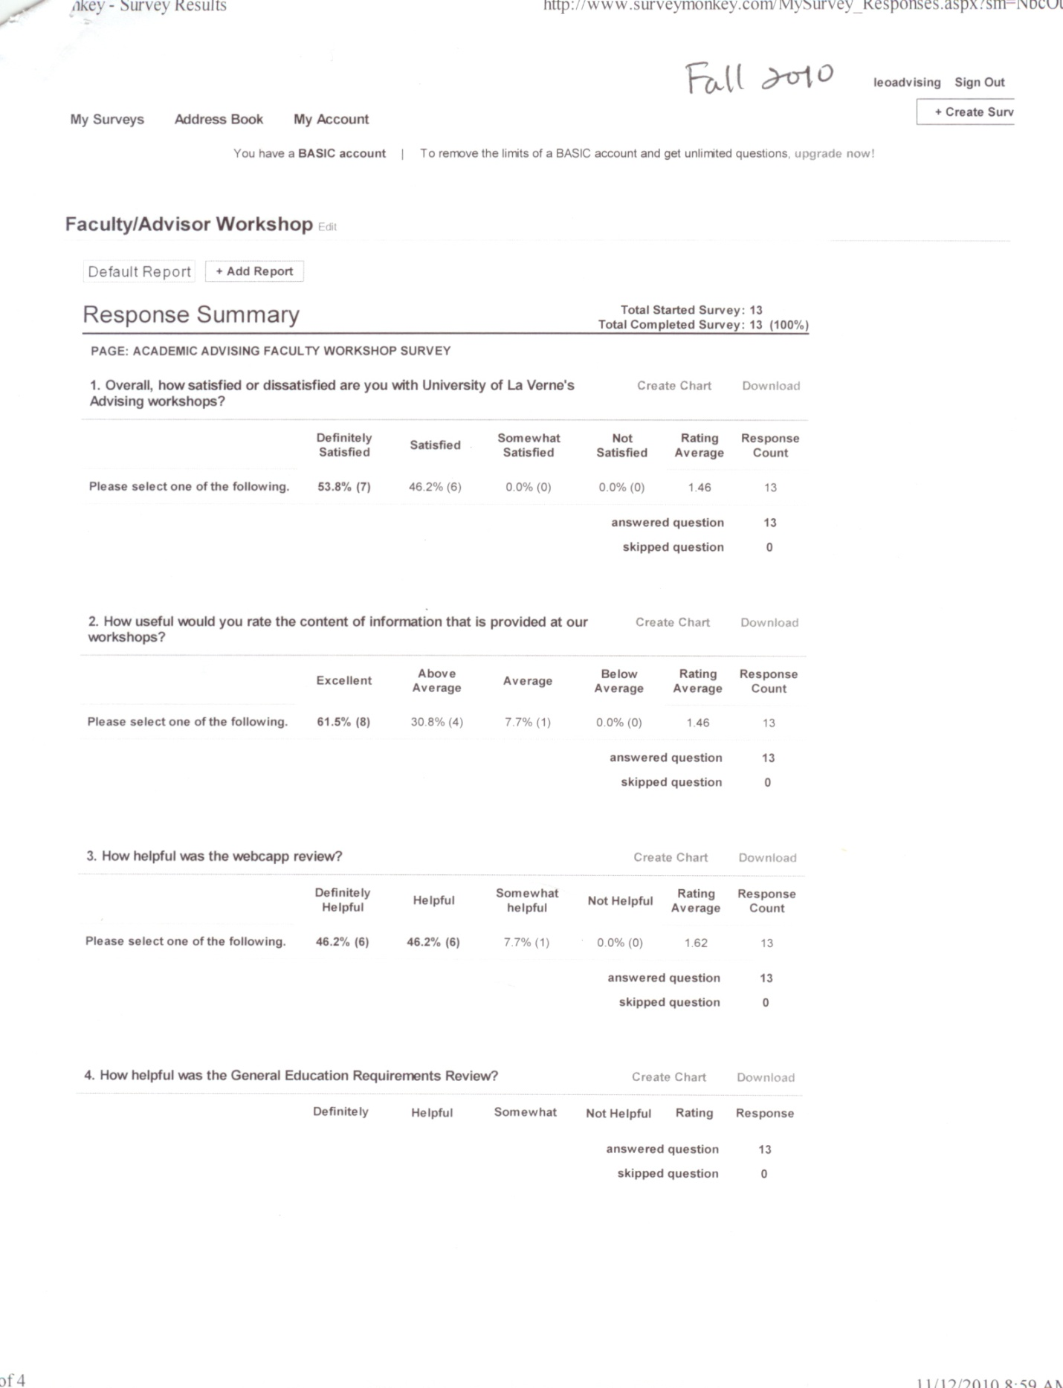

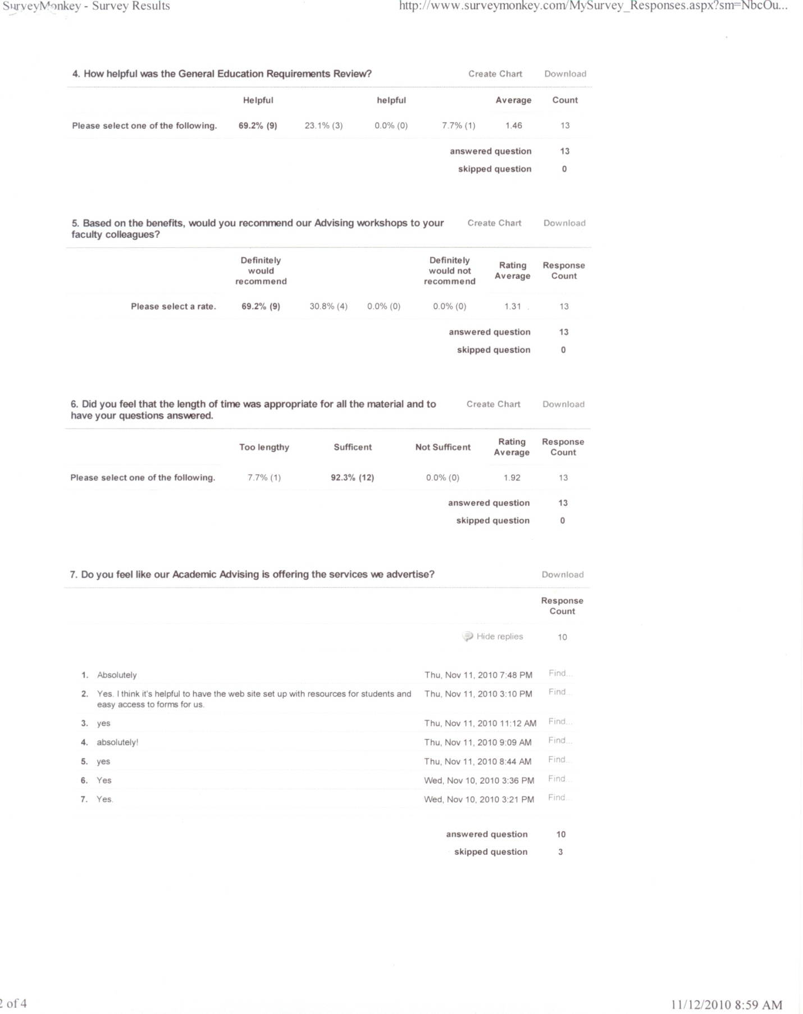

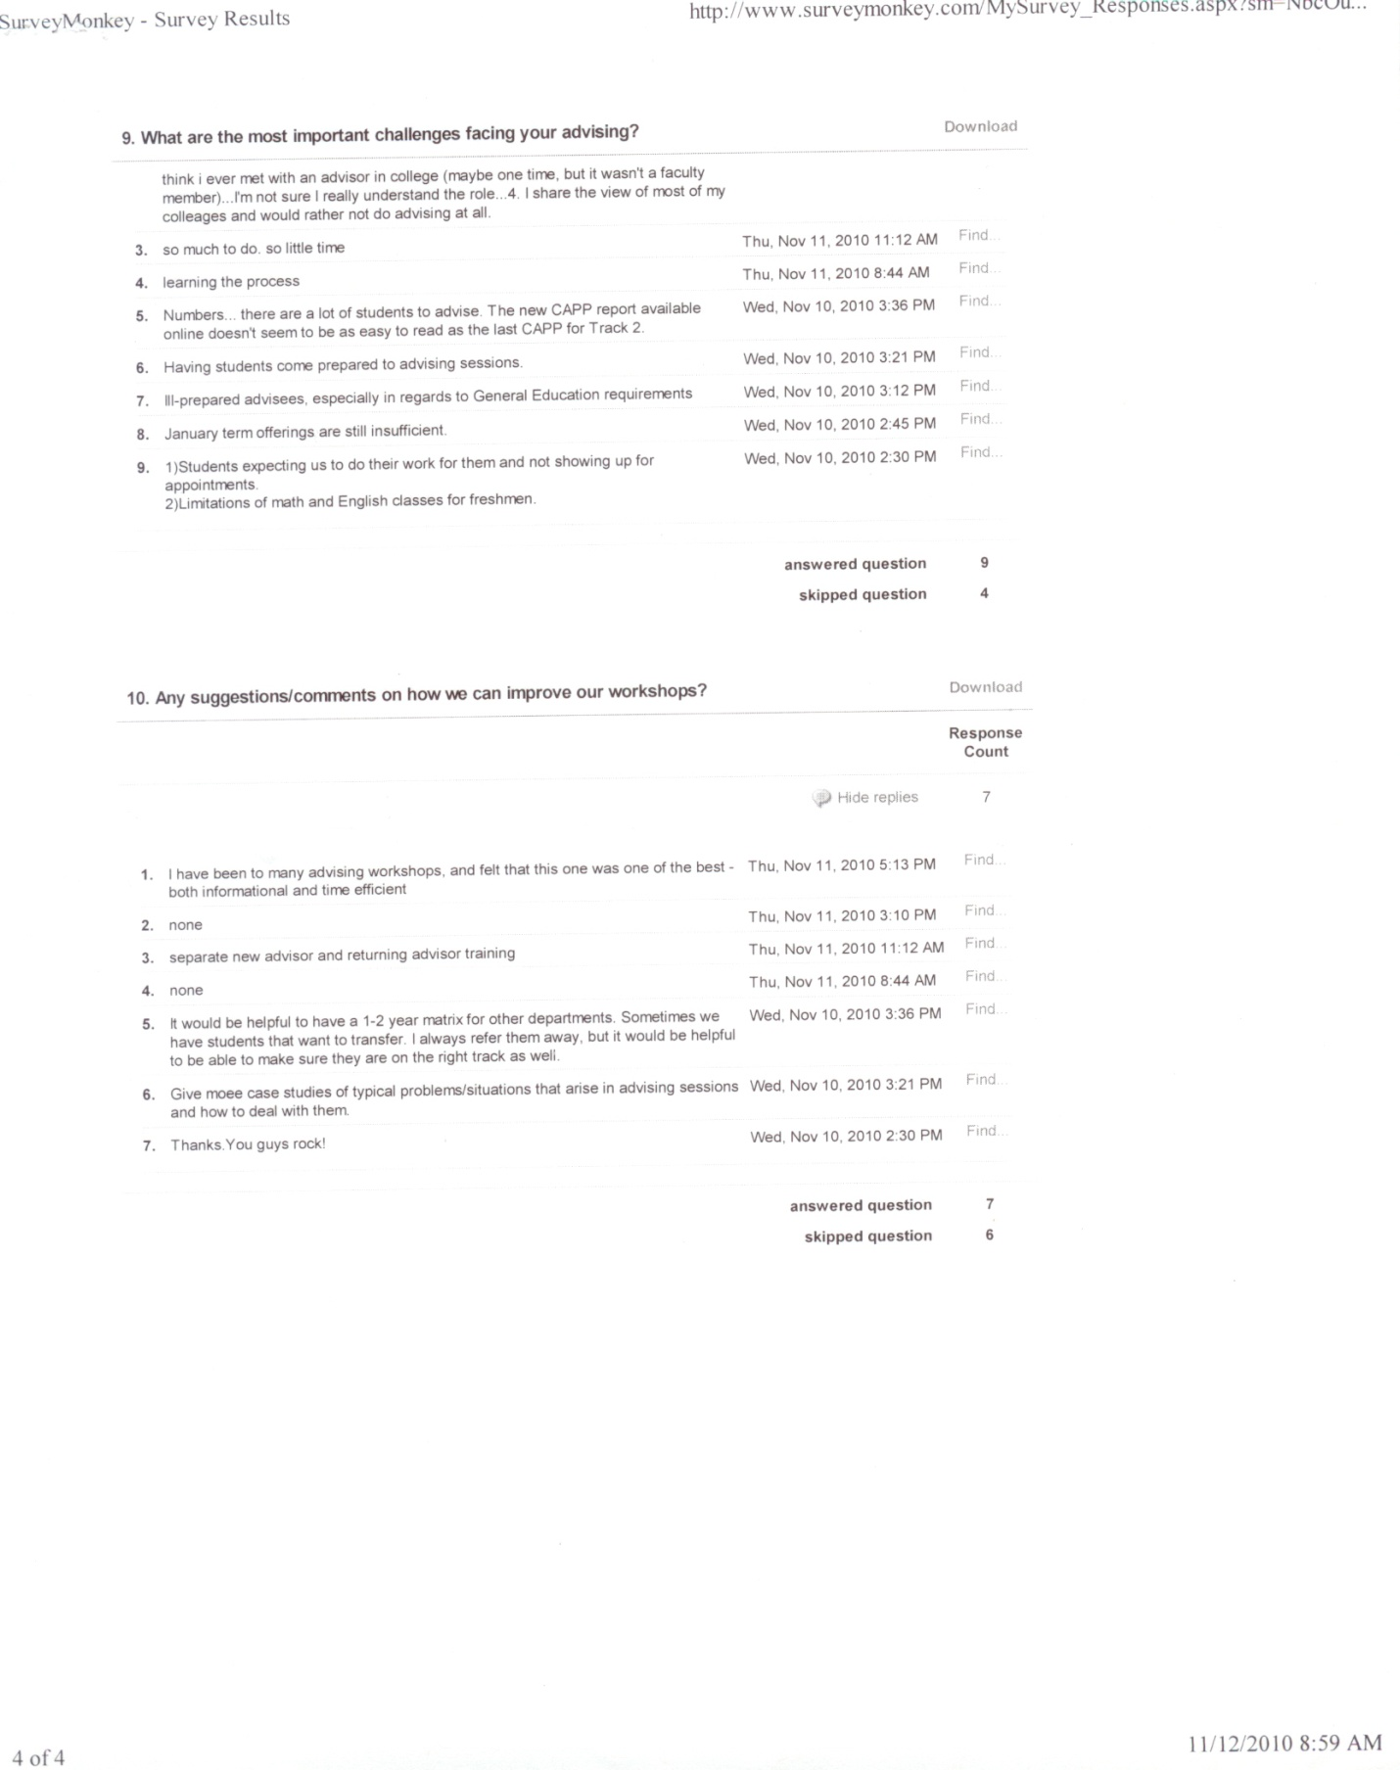

Spring 2011 Advisor Workshops

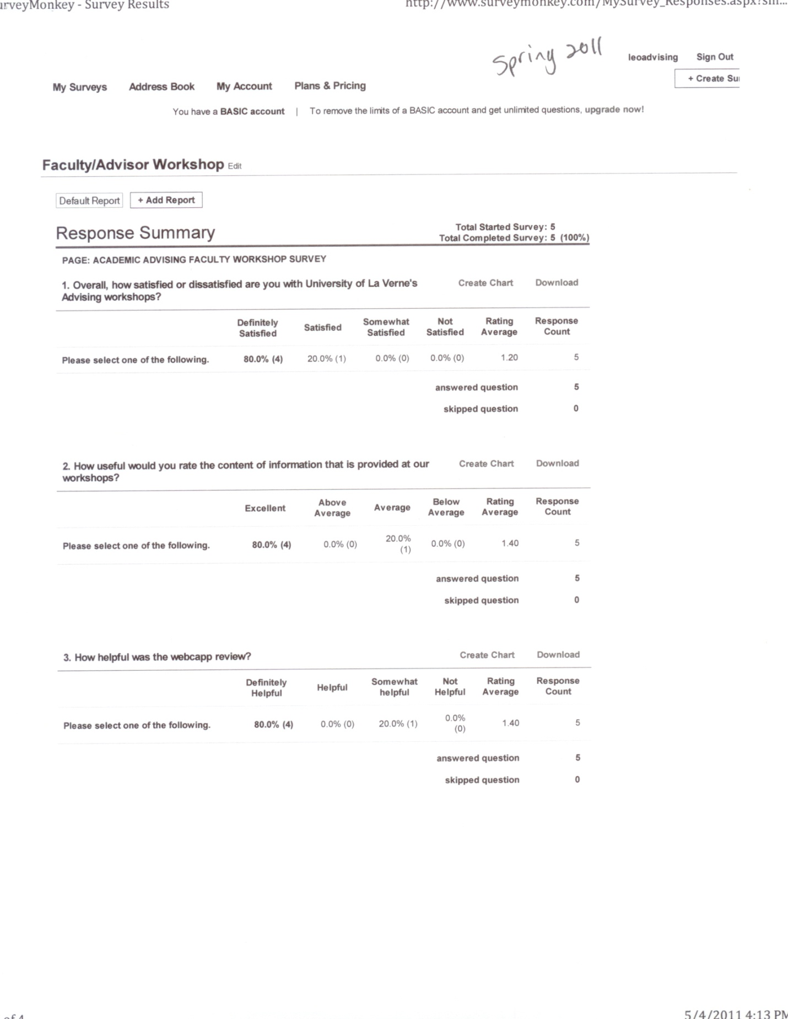

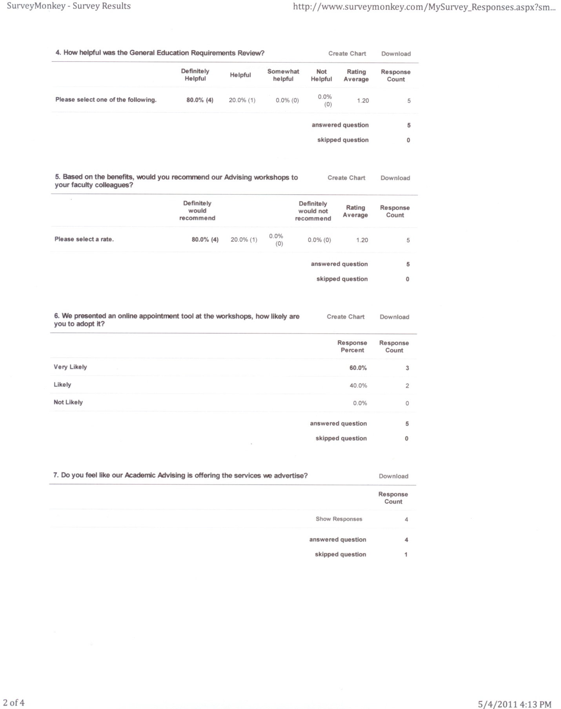

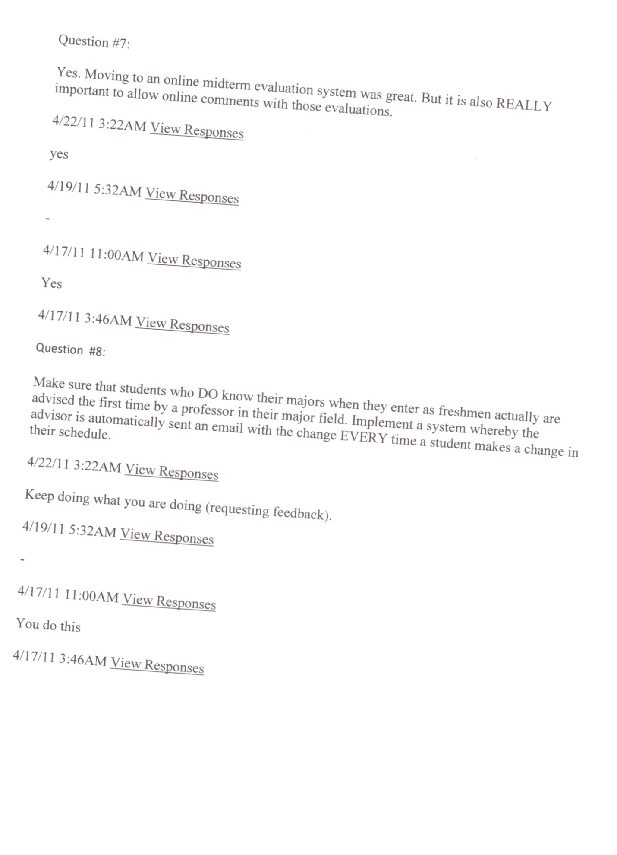

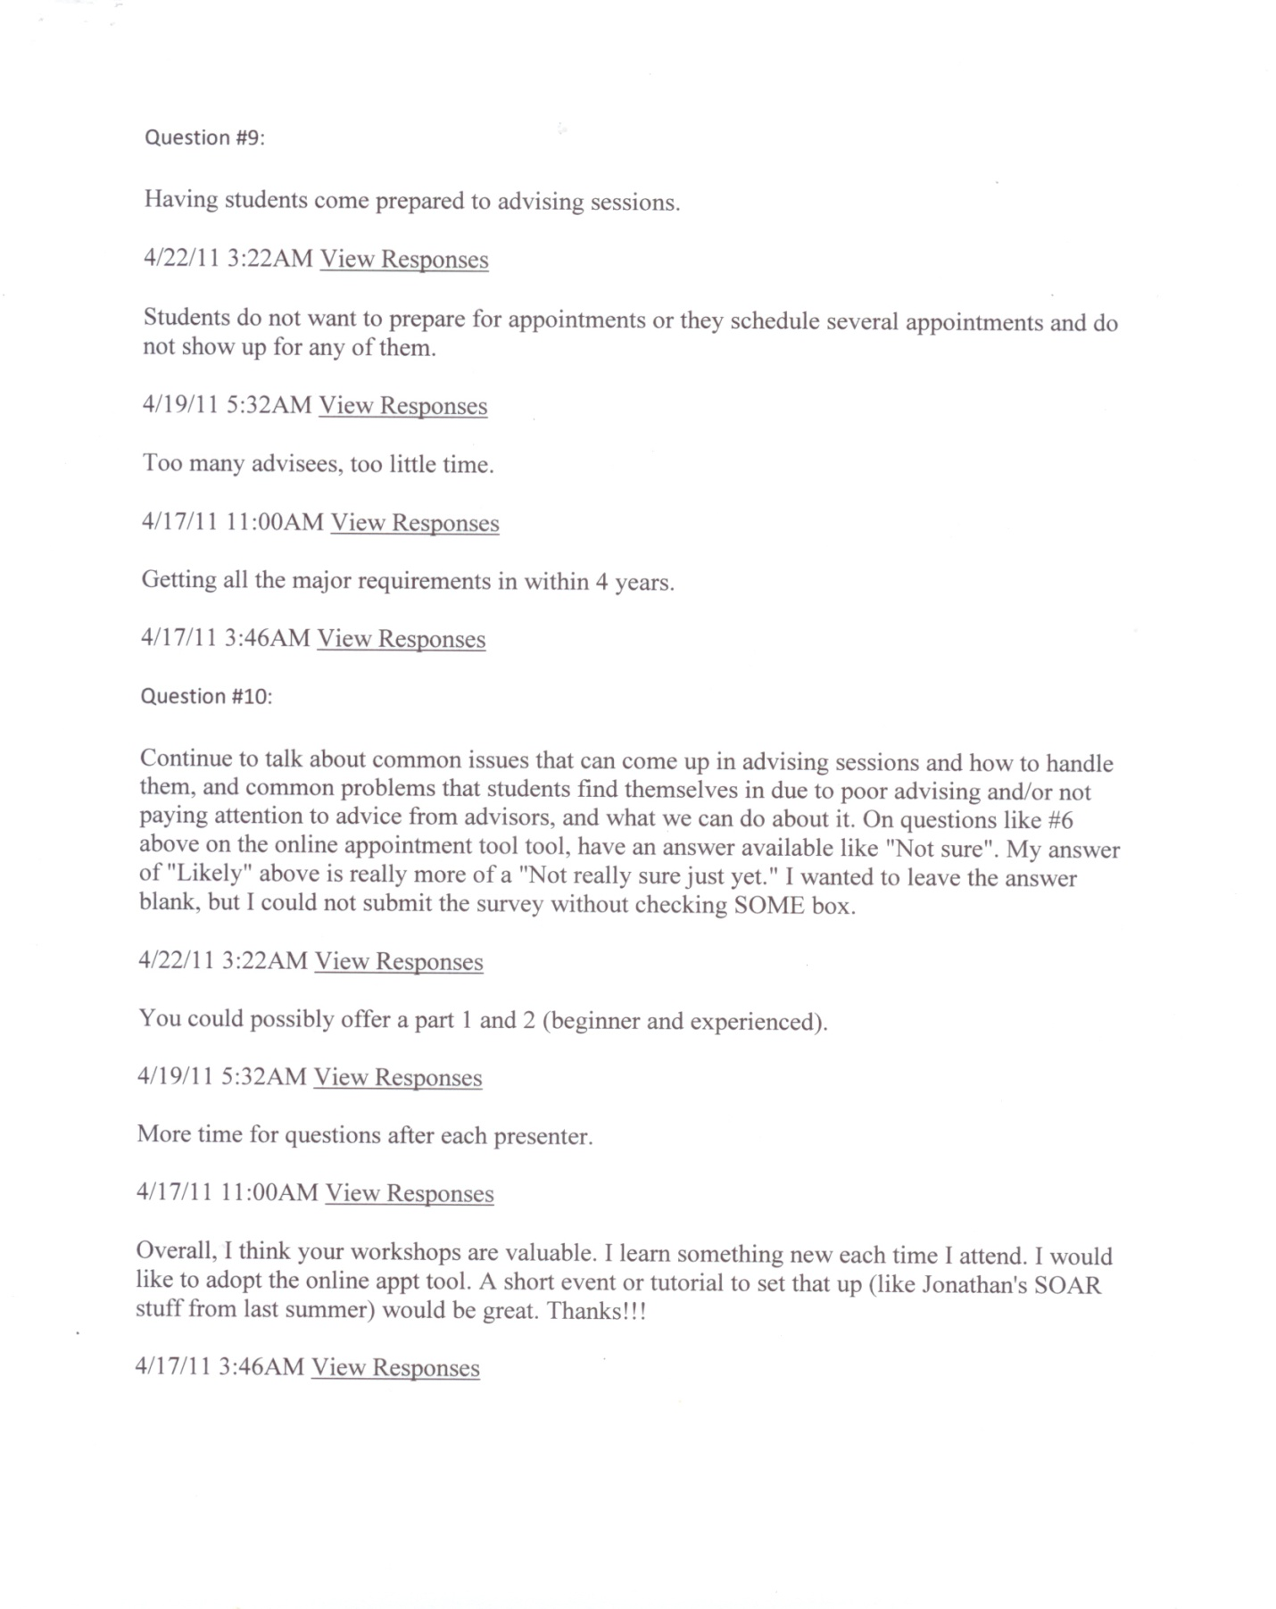

Appendix L

Persistence and Graduation Rates, First-time Freshmen

Retention by Race, (First-time Freshman), 2000-2009.

|  |  |  |  |
| --- | --- | --- | --- |
|  | FR-SO | SO-JR | JR-SR |
| Hispanics | 85% | 75% | 72% |
| African-Americans | 81.4% | 73.4% | 70% |
| Caucasians | 81.5% | 73% | 68% |
| Asian/Pacific Islanders | 84% | 73% | 71% |

Graduation by Race (First-time Freshman), 2000-2006.

|  |  |  |  |
| --- | --- | --- | --- |
|  | 4-Year | 5-Years | 6-Years |
| Hispanics | 42% | 53% | 56% |
| African-Americans | 40% | 52% | 55% |
| Caucasians | 43% | 54% | 58% |
| Asian/Pacific Islanders | 43% | 58% | 60% |

Retention by Gender, 2000-2009.

|  |  |  |  |
| --- | --- | --- | --- |
|  | FR-SO | SO-JR | JR-SR |
| Males | 78% | 67% | 61% |
| Females | 85% | 76% | 71% |

Graduation by Gender, 2000-2006.

|  |  |  |  |
| --- | --- | --- | --- |
|  | 4-Year | 5-Year | 6-Year |
| Males | 29% | 42% | 46% |
| Females | 43.5% | 55% | 58% |

Appendix M

Retention and Graduation Rates by Race and Gender

Retention by Race, (Transfers), 2000-2008.

|  |  |  |  |
| --- | --- | --- | --- |
|  | After 1 Year | After 2 Years | After 3 Years (2000-2007) |
| Hispanics | 81% | 50% | 22% |
| African-Americans | 72% | 45% | 16% |
| Caucasians | 84% | 49% | 20% |
| Asian/Pacific Islanders | 82% | 52% | 19% |

Graduation by Race, 2000-2008.

|  |  |  |  |  |  |
| --- | --- | --- | --- | --- | --- |
|  | Within 2-Year | Within 3-Years | Within 4-Years | Within 5-Years | Within 6-Years |
| Hispanics | 24% | 44% | 52% | 56% | 57% |
| African-Americans | 16% | 34% | 39% | 41% | 42% |
| Caucasians | 27% | 50% | 57% | 61% | 63% |
| Asian/Pacific Islanders | 20% | 40% | 50% | 52% | 56% |

Retention by Gender, 2000-2009.

|  |  |  |  |
| --- | --- | --- | --- |
|  | After 1-Year (2000-2009) | After 2-Years (2000-2008) | After 3-Years (2000-2007) |
| Males | 79% | 49% | 22% |
| Females | 82% | 47% | 18% |

Graduation by Gender, 2000-2008.

|  |  |  |  |  |  |
| --- | --- | --- | --- | --- | --- |
|  | Within 2-Years | Within 3-Years | Within 4-Years | Within 5-Years | Within 6-Years |
| Males | 16% | 36% | 43% | 46% | 48% |
| Females | 27% | 48% | 56% | 59% | 60% |

Appendix N

Residency Comparison between La Verne and Peer Institutions

|  |  |  |  |  |
| --- | --- | --- | --- | --- |
| **College** | **Residency** | **Grad. Rate-4 years** | **Grad. Rate-5 years** | **Grad. Rate 6 years* (2007)** |
| University of La Verne | 32 SH any time; 44 semester hours minimum upper division, 24 in major, 5 in General Education; at least 16 semester hours in major and 5 in General Educaiton must be at La Verne. | 38.6 | 46.8 | 58.7% |
| Azusa Pacific University | At least 30 units; 18 of the last 24 toward degree; at least 15 upper division, at least 50% of the units in minor area. | 71.1 | 54.4 | 67.4% |
| Cal Lutheran University | Thirty of the final 40 credits must be completed in residence at CLU. Credits by exam do not count as residency credits | 55.6 | 62.4 | 63.0% |
| Cal Poly Pomona | 50 quarter units; 36 must be at upper division, 18 units in major core, and 12 units in GE. Minimum of 60 units being 300- or 400- level courses, 18 of which must be in the major course. | 9.1 | 33.9 | 48.9% |
| Chapman University | Minimum of 48 credits after matriculation; 24 credit at UD, 15 of 24 UD credits within the major. Max of 18 credits may be transferred after matriculation. A max of 9 credits may be transferred once the student complete 90 credits, [thus, by default, the last 34 credits must be earned at Chapman (Cervantes, conclusion)] | 52.7 | 60.7 | 67.0% |
| Claremont McKenna College | Students must spend at least two years, including the senior year, and successfully complete at least 16 courses while in residence at CMC. | 82.3 | 87.4 | 89.3% |
| Loyola Marymount University | At least 30 of the last 36 semester hours for the bachelor's degree must be taken in residence at LMU. | 62.9 | 71.7 | 75.6% |
| Occidental College | Minimum of 64 units (excluding overseas studies) must be taken at Occidental College; 16 of the last 32 must be Occidental College courses taken in residence. | 78.3 | 80.4 | 81.4% |
| Pepperdine University | 64 units in residence, including 24 units of upper division in the major. The last 28 units of required courses and/or units toward the degree must be taken in residence. Up to 64 units are transferable, but once the total units from all schools reach 64, no further two-year college units are accepted | 70.7 | 78.3 | 79.2% |
| Pomona College | Minimum of 30 credits must be earned after admission and matriculation. At least 16 credits must be earned, and at least 4 semesters spent in residence at Pomona College. The final semester of the senior year must be taken in residence. | 86.7 | 92.2 | 93.6% |
| Redlands University | One year minimum residence, no fewer than 32 credits must be completed successfully. The last two semesters before graduation must be taken in residence. | 57.3 | 59.3 | 67.4% |
| Whittier College | 30 credits minimum, at least 12 credits for the major must be earned in residence. | 49.2 | 60.8 | 58.0% |
|  |  |  |  |  |
| Colleges with senior residency [in red] have higher graduation rates than La Verne | | | | |
| *Source: The Education Trust: http://www.collegeresults.org/mainMenu.aspx | | | | |

Appendix O

International Student Admissions Standards

Institutional Comparison of Undergraduate English Proficiency Admission Requirements

International Undergraduate Students

INSTITUTION          TOEFL iBT/pb         IELTS      SAT V        ACT E

Azusa Pacific                       78 (547 pb)                            6.5 530

Cal Lutheran                        80 (550 pb)                            6.5                   550             24

Chapman                              80 (550 pb)                            6.5                   550                      24

Loyola Marymount               80 (550 pb)                            6.5                   550                       24

Redlands                               80 (550 pb)                            6.5                   550                       24

Whittier                                  80 (550 pb)                            6.5                  550                       24

La Verne                                61 (500 pb)                            5                      480

Source: Enrollment Management, Spring 2011.

Appendix P

SOAR Online

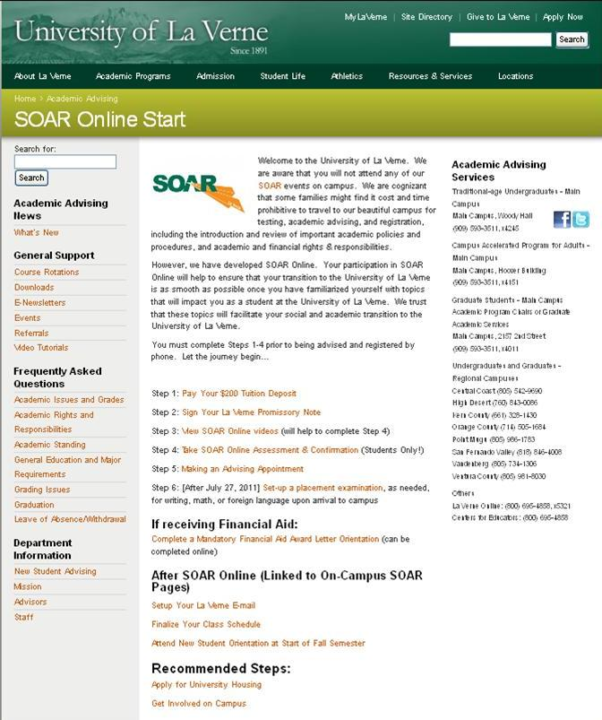

References

(Bean J P 2005 Nine themes of college student retention)Bean, J. P. (2005). Nine themes of college student retention. In A. Seidman (Ed.), *College student retention: Formula for student success* (pp. 215-243). Westport, CT: Praeger Publishers.

Creamer, D.G. (2000). Use of Theory in Academic Advising. In Gordon, V.N. & Habley, W.R.

(Eds.) Academic Advising: A Comprehensive Handbook . San Francisco: Jossey-Bass,

Inc., 17-24.

(Chickering A W Reisser L 2005 seven vectors)Chickering, A. W., & Reisser, L. (2005). The seven vectors. In M.E. Wilson & L.E. Wolf-Wendel (Eds.), *ASHE Reader on College Student Development Theory* (pp. 181-189). Boston, MA: Pearson Custom Publishing.

CIRP (2008). CIRP Survey. La Verne, CA: University of La Verne.

Crookson, B.B. (1994). [A Developmental View of Academic Advising as Teaching](http://www.nacada.ksu.edu/Clearinghouse/AdvisingIssues/documents/14-2-Crookston-pp5-9.pdf). NACADA

Journal , 14(2), 5-9.

Habley, W.R. (Ed.). (2004). The Status of Academic Advising: Findings from the ACT Sixth

National Survey. (Monograph No. 10). Manhattan, KS: NACADA.

(Heisserer D L Parette P 2002 Advising at-risk students in college and university settings)Heisserer, D. L., & Parette, P. (2002). Advising at-risk students in college and university settings. *College Student Journal, 36*(1), 69-84.

Institutional Research (2010). Non-returning Student Exit Survey. La Verne, CA: University of

La Verne.

Institutional Research (2010). Fact Book 2006-2010. La Verne, CA: University of La Verne.

Institutional Research (2010). Local CIRP Survey 2010. La Verne, CA: University of La Verne.

King, M. C. (2005). Developmental academic advising. Retrieved from NACADA Clearinghouse

of Academic Advising Resources Web site: [http://www.nacada.ksu.edu/Clearinghouse/AdvisingIssues/dev_adv.htm](http://www.nacada.ksu.edu/clearinghouse/advisingissues/dev_adv.htm)

King, M. C. (2000). Designing Effective Training for Academic Advisors. In Gordon, V.N. &

Habley, W.R. (Eds.) Academic Advising: A Comprehensive Handbook . San Francisco : Jossey-Bass, Inc., 289-297.

(Kuh G D Kinzie J Buckley J A Bridges B K Hayek J C 200607 What matters to student success: A review of the literature)Kuh, G. D., Kinzie, J., Buckley, J. A., Bridges, B. K., & Hayek, J. C. (2006). *What matters to student success: A review of the literature* (). Washington, DC: Commissioned Report for the National Symposium on Postsecondary Student Success: Spearheading a Dialog on Student Success, National Postsecondary Education Cooperative.

(Lang M 200120012002 Student retention in higher education: Some conceptual and programmatic perspectives)Lang, M. (2001). Student retention in higher education: Some conceptual and programmatic perspectives. *Journal of College Student Retention, 3*(3), 217-229.

(Light R J 2001 Making the most of college: Students speak their minds)Light, R. J. (2001). *Making the most of college: Students speak their minds*. Cambridge, MA: Harvard University Press.

Raushi, T.M. (1993). Developmental Academic Advising. In King, M.C. (Ed.) Academic

Advising: Organizing and Delivering Services for Student Success. New Directions for Community Colleges, 82, 5-19.

(Tinto V 1993 Leaving college: Rethinking the causes and cures of student attrition)Tinto, V. (1993). *Leaving college: Rethinking the causes and cures of student attrition* (2nd ed.). Chicago and London: The University of Chicago Press.

(Tinto V 2005 Epilogue: Moving from Theory to Action)Tinto, V. (2005). Epilogue: Moving from theory to action. In A. Seidman (Ed.), *College student retention: Formula for student success* (pp. 317-333). Westport, CT: Praeger Publishers.

(Tinto V 200620062007 Research and practice of student retention: What next?)Tinto, V. (2006). Research and practice of student retention: What next? *Journal of College Student Retention: Research, Theory & Practice, 8*(1), 1-20.

Tinto, V. (nd). Rethinking the First Year of College. Retrieved from Maricopa Community College Center for Learning & Instruction Web site: <http://hakatai.mcli.dist.maricopa.edu/fsd/c2006/docs/rethinkfirstyearcollege.pdf>

WASC. (2010). Capacity and Preparatory Review to the University of La Verne. La Verne,

CA.