**University of La Verne**

**College of Business and Public Management**

**BSOM Program Review**

**August 7, 2011**



Prepared By:

Janat Yousof, Ph.D.

Professor of Management

Table of Contents

1. Introduction…………………………………………………………………………… 2
2. The Programs………………………………………………………………………….. 2
3. Mission, Goals, Objectives, and Learning Outcomes…………………………… 2
4. Curriculum………………………………………………………………………. 6
5. Program Comparisons…………………………………………………………… 7
6. Students………………………………………………………………………………... 8
7. Admission Policy………………………………………………………………… 8
8. Applicant, Admitted, and Matriculated Students Profile……………………….. 8
9. Student Support……………………………………………………………………….. 8
10. Student Advising………………………………………………………………… 8
11. Counseling……………………………………………………………………….. 8
12. Learning Enhancement Center…………………………………………………… 9
13. Student Life………………………………………………………………………. 9
14. Library……………………………………………………………………………. 9
15. Career Services…………………………………………………………………... 10
16. Program Assessment…………………………………………………………………… 10
17. Direct and Indirect Assessment of Learning Objectives………………………… 10

1.1 BSOM Assessment………………………………………………………. 11

2. Faculty Coverage and Qualifications……………………………………………. 21

3. Profile of Graduating Students………………………………………………….. 21

4. Resources: Financial, Facilities, Information Technology……………………… 22

VI. Summary of Findings…………………………………………………………………. 22

VII. Recommendations…………………………………………………………………….. 22

VIII.BSOM Program Review Appendices………………………………………………….. 22

1. **Introduction**

The University of La Verne’s Bachelor of Science in Organizational Management (BSOM) program is designed to improve management, and interpersonal skills critical in a constantly changing environment. To enhance students’ personal and professional growth, the program is designed to provide in-depth understanding of all the management disciplines. When appropriate, the case study approach is utilized to effectively communicate application of theories in real world situations and include the opportunity for student research. Students will enhance their conceptual, interpersonal, and analytical competencies required to succeed in managing today's ever changing and diverse organizations.

The BSOM program at the University of La Verne started in the early 1980s. It underwent a major curriculum revision in 2007 when it was merged with the BS Business Management program into the current BSOM Major, and integrated the major courses from both to meet the interest of a larger pool of students. Several efficiencies were achieved as a result of these efforts including:

1. Identification of Core Courses and Electives that better meets the demands of the current environment, and
2. Integration of the research component of the BSOM that now integrates the methodology (MGMT 390), and the Senior Seminar Project (MGMT 499) into one integrated Senior Seminar in Management (MGMT 496),
3. Development of a Human Resource Management concentration, and,
4. Improved communication with the Regional Campus Administration (RCA) who manages the recruitment of students into the BSOM program.

Recent headcounts by Majors at all Campuses provided by the Institutional Research Census on November 2010 showed that the BSOM enrollment grew from 486 in Fall 2007 to 614 in Fall 2009, an increase of over 26%. The online BSOM program continues to be popular, and the enrollment in Fall 2010 was 524, with 112 enrolled as online students. The program is offered at the La Verne Campus, and the Inland Empire, High Desert, Kern County, Orange County, Point Mugu, San Fernando Valley, Vandenberg Center, Ventura County campuses, through the Campus Accelerated Program (CAPA), and online. The Program generated 3659 units in Fall 2010, of which 653 were generated online.

Four full-time faculty and approximately 50 part-time faculty members teach in the BSOM program at any given point in time. While the teaching by the full time faculty is concentrated on the La Verne campus, and online courses, the majority of the courses offered at the regional campuses are taught by adjunct faculty. Approximately 32 percent of the units offered in the BSOM program is taught by faculty with a doctoral degree, and 68 percent by those with a Masters Degree.

1. **The Programs**
2. **Mission, Goals, Objectives, and Learning Outcomes**

The mission of the organizational management program is to improve management, and interpersonal skills critical in a constantly changing environment. To enhance student's personal and professional growth, the program is designed to provide in-depth understanding of all the management disciplines. When appropriate, the case study approach is utilized to effectively communicate application of theories in real world situations and include an optional opportunity for student research. Students will enhance conceptual, interpersonal, and analytical competencies required to succeed in managing the current ever changing and diverse organizations that include the following:

1. An understanding of the role of the management functions to guide organizations toward goals accomplishment.

1. An understanding of the need for continuously gathering and evaluating of information to improve organizational outcomes as needed.
2. An understanding of the diversity of cultures that exists locally, nationally, and internationally.
3. An understanding of the role of social responsibility in managerial decision-making.
4. An understanding of the need to work collaboratively through group situations to solve problems.

The BSOM goals translate into the flowing program objectives and learning outcomes for the students:

**Goal 1**: An understanding of the role of the management functions to guide organizations toward goals accomplishment.

Organizational Management majors will:

**Learning Objective 1-1**: Demonstrates an understanding of the management functions.

Learning Outcome 1-1.1: Students will be able to perform environmental analysis by using planning tools such as SWOT analysis and/or the Porter’s Model (MGMT 300).

Learning Outcome 1-1.2: Students can identify and understand appropriateness of organizational forms (MGMT 300).

Learning Outcome 1-1.3: Student will be able to identify different types of controls used to anticipate, and prevent problems, and gather information that helps to prevent future problems (MGMT 300).

**Learning Objective 1-2**: Be able to apply tools and processes of communication, motivation, leadership, and group dynamics that enable organizations to achieve organizational goals.

Learning Outcome 1-2.1: Be able to analyze different forms of verbal and non-verbal communications as impacted by cultures (MGMT 358)

Learning Outcome 1-2.2: Be able to understand different theories of leadership for goal accomplishment (MGMT 355)

Learning Outcome 1-2.3: Students will demonstrate an understanding of different theories of motivation and their contingent applicability to insure high probability of organizational success. (MGMT 459)

Learning Outcome 1-2.4: Will demonstrate an understanding of the dynamics of groups and teams and their impact on organizational success (MGMT 459).

**Learning Objective 1-3**: Demonstrate the ability to solve organizational management issues, and make decisions.

Learning Outcome 1-3.1: Students will be able to identify, analyze, and apply data to solve management challenges (MGMT 388).

Learning Outcome 1-3.2: Students will demonstrate the ability to identify and utilize appropriate statistical tools appropriate to the situations (MGMT 388).

**Goal 2**: An understanding of the need for continuously gathering and evaluation of information to improve organizational outcomes as needed.

Organizational Management majors will:

**Learning Objective 2-1**: Be able to describe information that is needed to analyze the financial viability of organizations.

Learning Outcome 2-1.1: Students will demonstrate the ability to use cost-benefit analysis, discounting and the capital-market-line for informed decisions (MGMT 360).

Learning Outcome 2-1.2: Students will demonstrate and evaluate the use of ratio analysis to measure the financial soundness of an organization (MGMT 360).

**Learning Objective 2-2:** Students will demonstrate the ability to apply conceptual knowledge and understanding on an organizational issue to a specific research project

Learning Outcome 2-2.1: Students will demonstrate the ability to apply the tools of social scientific inquiry into an organizational issue (MGMT 496).

**Goal 3**: An understanding of the diversity of cultures that exist locally, nationally, and internationally.

Organizational Management majors will:

**Learning Objective 3-1**: Demonstrate an understanding of the impact of the environment on organizations.

Learning Outcome 3-1.1: Be able to understand changing demographics and their impacts on organizations, for example, diversity, multiculturalism, and globalization (MGMT 358).

Learning Outcome 3-1.2: Be able to make appropriate recommendations from the analysis to improve the study and practice of contemporary management (MGMT 496)

**Learning Objective 3-2**: Understanding the role of authority, responsibility, and delegation in organizations.

Learning Outcome 3-2.1: Understand the impact of centralization and decentralization on organizational stakeholders (MGMT 459).

Learning Outcome 3-2.2: Be able to identify appropriate conditions necessary for effective delegation (MGMT 355).

**Goal 4**: An understanding of the role of social responsibility in managerial decision-making.

Organizational Management majors will:

**Learning Objective 4-1**: Demonstrate an understanding of consequential and non-consequential theories of ethics.

Learning Outcome 4-1.1: Students will be able to apply consequential and non-consequential theories in managerial decision-making (BUS 343).

Learning Outcome 4-1.2: Students will be able to differentiate outcomes of decisions based on consequential and non-consequential theories of ethics (BUS 343).

**Goal 5**: An understanding of the need to work collaboratively within group situations to solve problems.

**Learning Objective 5-1**: Students will identify process and competencies to work collaboratively.

Learning Outcome 5-1.1: Students will identify processes for effective teamwork (MGMT 300)

Table 1 below highlights the CORE curriculum of the program and identifies the specific learning outcomes for each.

**Table 1: OUTCOMES MEASUREMENT GRID for the Organizational Management Program**

|  |  |
| --- | --- |
| **Learning Outcomes** | **Core Requirements** |

|  |  |  |  |  |  |  |  |  |
| --- | --- | --- | --- | --- | --- | --- | --- | --- |
|  | MGMT  300 | MGMT  355 | MGMT  358 | MGMT  360 | MGMT  388 | MGMT  459 | MGMT  496 | BUS  343 |
| Learning Outcome 1-1.1 | X |  |  |  |  |  |  |  |
| Learning Outcome 1-1.2 | X |  |  |  |  |  |  |  |
| Learning Outcome 1-1.3 | X |  |  |  |  |  |  |  |
| Learning Outcome 1-2.1 |  |  | X |  |  |  |  |  |
| Learning Outcome 1-2.2 |  | X |  |  |  |  |  |  |
| Learning Outcome 1-2.3 |  |  |  |  |  | X |  |  |
| Learning Outcome 1-2.4 |  |  |  |  |  | X |  |  |
| Learning Outcome 1-3.1 |  |  |  |  | X |  |  |  |
| Learning Outcome 1-3.2 |  |  |  |  | X |  |  |  |
| Learning Outcome 2-1.1 |  |  |  | X |  |  |  |  |
| Learning Outcome 2-1.2 |  |  |  | X |  |  |  |  |
| Learning Outcome 2-2.1 |  |  |  |  |  |  | X |  |
| Learning Outcome 3-1.1 |  |  | X |  |  |  |  |  |
| Learning Outcome 3-1.2 |  |  |  |  |  |  | X |  |
| Learning Outcome 3-2.1 |  |  |  |  |  | X |  |  |
| Learning Outcome 3-2.2 |  | X |  |  |  |  |  |  |
| Learning Outcome 4-1.1 |  |  |  |  |  |  |  | X |
| Learning Outcome 4-1.2 |  |  |  |  |  |  |  | X |
| Learning Outcome 5-1.1 | X |  |  |  |  |  |  |  |

1. **Curriculum**

The BSOM curriculum is a total of 40 credit hours as follows:

**Core Courses:** 32 semester hours

BUS 343 Foundations of Business Ethics (4)

MGMT 300 Principles of Management (4)

MGMT 355 Leadership in Organizations (4)

MGMT 358 Culture and Gender Issues in Management (4)

MGMT 360 Financial Management and Budgeting (4)

MGMT 388 Statistics (4)

MGMT 459 Organizational Behavior (4)

MGMT 496 Seminar in management (4)

**Electives:**  Two from the following (8 semester hours):

BUS 346 Written Business Communication (4)

BUS 410 Management Information Systems (4)

MGMT 353 Legal and Ethical Dimensions of Management (4)

MGMT 354 Oral Communications in Organizations (4)

MGMT 356 Introduction to organizational Theory (4)

MGMT 359 Management of Change and Conflict (4)

MGMT 390 Research Methods (4)

MGMT 451 International Management (4)

MGMT 455 Human Resources Management (4)

MGMT 458 Stress Management (4)

**Human Resources Concentration:**

MGMT 455 Human Resources Management (4)

Two of the following:

MGMT 353 Legal and Ethical Dimensions of Management (4)

MGMT 359 Management of Change and Conflict (4)

MGMT 458 Stress Management (4)

SPCM 332 Interviewing Principles and Practice (4)

1. **Program Comparisons**

A search of universities with comparable programs revealed that the B.S and/or the B.A in Organizational Management were offered at several academic institutions, and that the organizational management program at La Verne is comparable to these programs in most areas. The differences consisted mainly on the greater emphasis on leadership and entrepreneurship courses in the other programs. Given the adult student population served by the program, and the goals that the program is aiming to achieve, the requirements of the La Verne organizational management program were considered to be appropriate. A comparison of the curriculum of La Verne’s BSOM program with those of selected other institutions is shown in Appendix I. The selected five institutions and their respective offerings are:

Azusa Pacific University (Bachelor of Science in organizational Leadership)

Brandman University (Bachelor of Arts in Organizational Leadership)

University of the Pacific (Organizational Behavior)

Penn State Continuing Education (Bachelor’s Degree in Organizational Leadership)

Lubbock Christian University (Bachelor of Science in Organizational Management)

As shown in Appendix I, the BSOM program at La Verne requires about the same number of units as the comparative group median. La Verne’s BSOM’s core courses offer approximate functional areas, and breadth of electives as the comparative institutions. Some of the courses offered by other institutions, but not at La Verne focused on public sector policy-making.

1. **Students**
2. **Admission Policy**

All applications are reviewed carefully, based on a personal statement, letter of reference and additional criteria listed in La Verne’s catalog.

1. **Applicant, Admitted, and Matriculated Students Profile**

Appendix II shows the profile of the BSOM applicants, admitted, and matriculated students. Over the three years, 2007-2010, the average number of application per year was 425, out of which 246 were admitted which translated into a 57.9% admissions rate. Over the same three-year period, 68% of the admitted students matriculated at La Verne.

For the online program, over the three years, 2007-2010, the average number of application per year was 90, out of which 54 were admitted which translated into a 60% admissions rate. Over the same three-year period, 74.1% of the admitted students matriculated at La Verne.

The ethnic diversity of the BSOM student is a strong reflection of the region’s population with a 44.1% minority population of which on average 23.4% was Hispanic. More minorities applied (50.3%), and were admitted (48.5%) into the online BSOM program.

1. **Student Support**
2. **Student Advising**

Every BSOM student regardless of the location is assigned a professional advisor to help the student with course scheduling and sequencing. An individualized progress sheet helps the advisor and student in keeping track of the student’s program requirement. There is the equivalent of 1.5 advisors for the La Verne campus, 0.5 advisors for the online students and the equivalent of 4 advisors for RCA Business and Public Management students. The program advisors and the faculty are available for the student to advice on professional development and educational and academic development.

1. **Counseling**

The Psychology Department in the College of Arts and Sciences provides free of charge counseling services to all the students of the University of La Verne. Students can utilize the services at their own initiative with or without a referral from the faculty or staff.

1. **Learning Enhancement Center**

The Learning Enhancement Center (LEC) provides tutoring services to all the students of the University of La Verne free of charge. The tutoring covers discipline specific areas such as finance or statistics as well as communication skills. The services are available to students either in a face-to-face format or online. Tutors are available over the weekend and in the evening hours to accommodate the regional campuses students as well as working adults.

1. **Student life**

The BSOM students at the University of La Verne have ample opportunities to be active participants in the campus student life. Multiple opportunities are available to the students to participate in, and get involved, from 40 student clubs and organizations, multiple athletic activities, Greek Life (6 national and local fraternities), student government through the Associated Students of University of La Verne Association (ASULV). The Campus Board (CAB) also lists ongoing and forthcoming activities. The bulk of the students however, are adult student with work and family responsibilities and they tend not to participate in campus life.

1. **Library**

The BSOM students are served by multiple libraries, the main one being the Elvin and Betty Wilson Library located on the University La Verne’s main campus. The library houses a collection of 178,000 print and 40,000 electronic books. In the fields such as business, economics, finance, management, marketing, management information systems, law psychology, sociology, leadership and organization studies, and other relevant fields. Additional thousands of books are available to students. If Wilson Library does not own an item needed by a student, he/she can order the item from the library’s homepage to be delivered by LINK+, a consortium of 40+ libraries in California and Nevada that has five days a week courier service to get the book to La Verne in 48-72 hours. BSOM students have access to over 9 million additional books via LINK+. If an item is not available from LINK+, particularly articles that appear in journals unavailable through Wilson Library, students can order books and articles through LeoDelivers, the library’s web-based interlibrary loan system. Articles are scanned and sent from lending libraries to Wilson Library, then delivered via email to the requestor; books are mailed to the library and made available for pickup or mailed to the requestor. LeoDelivers provides access for La Verne students and faculty to resources available at thousands of libraries across the United States and around the world. Wilson Library subscribes to 25,680 journal titles: 250 are print journals and all other titles are electronic journals accessible 24/7 exclusively to La Verne students wherever they are located via the library’s proxy server. Of those journal titles, over 270 are of primary interest to business, management, marketing and organizational leadership, and over 10,000 journal titles are available in related disciplines. The library subscribes to 64 databases of which, 21 are directly relevant to the degree programs within the purview of the CBPM programs.

The library utilizes 24-hour online librarian access, 24-hour “LeoPac” access which allows students to access the library’s resources online, 24-hour “Leo delivers” which allows students to access materials from other libraries, and 24-hour “Link +” which allows students to access other libraries directly online. The library subscribes to many research sources such as Proquest, Sage, and Ebscohost.

1. **Career Services**

Career Services at the University of La Verne provides quality resources, counseling, and services to help students and alumni assess and apply their education and life experiences to a lifetime of fulfilling opportunities. Their mission is to assist undergraduate and graduate students and alumni with identifying, developing, and implementing their career goals through self-direction and personal responsibility. Career services provide BSOM students with:

Career planning, advice and guidance which includes assessments and interpretation

Resume and letter writing tips and review

Job search strategies

Mock Interviews

Graduate school advising that includes choosing a school, and the application process

Workshops on resume writing, interviewing techniques and job search

Career Services holds an Etiquette and Networking Dinner and Virtual Career Fairs to help students in their job search with their professional development. They also maintain a library of career-related books and employment source materials, accessible during business hours. Additionally, the office maintains directories and information on graduate school programs and national fellowship opportunities, for students whose professional goals might require additional research opportunities or advanced degrees. Online services include targeted information and links for career exploration, internships, summer jobs, full-time employment, graduate school, conducting a job search, and much more.

While the Career Services office is a resource available to help all of La Verne students the majority of the BSOM students are working adults who already have jobs/careers.

1. **Program Assessment**
2. **Direct and Indirect Assessment of Learning Objectives**

The BSOM assessment plan has two components: The first one is course embedded whereby the BSOM objectives and learning outcomes are assessed in BSOM’s core courses (see Appendix III for the assessment plan, assessments instruments, rubrics, and assessment sheets).

The second component of the assessment involves the utilization of student and alumni surveys that captured feedback on their educational experience in the program, and whether the program is current and relevant.

The student surveys were sent to students registered in the culminating course (MGMT 496: Seminar in Management) during Summer 2011 and Fall 2011, and the alumni surveys were sent via email to BSOM Alumni with a valid email address (see Appendix IV for a copy of the survey and Appendix V for the results).

Twenty-three (23) current students responded to the Current Student Survey of which the majority (56.5%) took the majority of their classes on the main campus. The majority of the respondents were females (56.3%), White (47.8%), with a GPA between 3-4 (95.6%), employed full-time (73.9%), took 2 years or less to complete their BSOM degree (65.2%). The majority (56.5%) rated 81-100 percent of their BSOM Instructors as excellent.

One hundred and fifteen (115) alumni responded to the survey of which the majority (41.7%) took the majority of their classes on the main campus. The majority of the respondents were females (53.9%), White (60.9%), with a GPA between 3-3.49 (70.4%), employed full-time (76.5%), took 3 1/2 years to complete their degree (63.5%), 75.2% reported that they were very or satisfied with the program, 90.5% said that they were better prepared as a result of the program, and 81.9% reported that the University of La Verne would again be their choice if they could do a program over.

With regard to the program goals, the majority reported positively (excellent to good) to the following enhancement of their skills through the program:

Utilize management functions and tools to achieve – 93.3%

Collect and utilize data to achieve organizational goals- 86.7%

Understand and appreciate diversity- 88.6%

Socially responsible decision-maker- 88.5%

Ability to work within teams- 92.4%

**1.1 BSOM Assessment**

In this section are the results of the direct and indirect assessments of the objectives and outcomes in the context of the program goals. The results of assessing the learning outcomes for each objective are shown in Appendix VIand the course evaluations are at Appendix VII**.**

**Program Goal 1**: An understanding of the role of the management functions to guide organizations towards goals accomplishment.

**Learning Objective 1-1: Demonstrates an understanding of the management functions.**

**Learning Outcome 1-1.1:** Students will be able to perform environmental analysis by using planning tools such as SWOT or Porter’s Model (MGMT 300).

**Direct assessment for Outcome 1-1.1:**

Fifty-four (54) observations were used to assess student’s achievement on this outcome.

Fifty-one (51) of the students have excellent to acceptable performance, 1 has poor performance and 2 have unsatisfactory performance. This implies that 94.4% have an acceptable to excellent mastery of the management functions to guide organizations towards goal accomplishment.

For the online program, four (4) observations were used to assess student’s achievement on this outcome. Three (3) of the students have excellent to acceptable performance, 1 has poor performance and none has unsatisfactory performance. This implies that 75% have an acceptable to excellent mastery of the management functions to guide organizations towards goal accomplishment.

Learning Outcome 1-1.2: Students can identify and understand appropriateness of organizational forms (MGMT 300).

**Direct assessment for Outcome 1-1.2:**

Fifty-four (54) observations were used to assess student’s achievement on this outcome.

Forty-three (43) of the students have excellent to acceptable performance, 10 have poor performance and1 has unsatisfactory performance. This implies that 79.6% have an acceptable to excellent mastery of the skills to identify and understand appropriateness of organizational forms to guide organizations towards goal accomplishment.

For the online program, four (4) observations were used to assess student’s achievement on this outcome. Four (4) of the students have excellent to acceptable. This implies that 100% have acceptable to excellent mastery of the skills to identify and understand appropriateness of organizational forms to guide organizations towards goal accomplishment.

Learning Outcome 1-1.3: Student will be able to identify different types of controls used to anticipate, and prevent problems, and gather information that helps to prevent future problems (MGMT 300).

**Direct assessment for Outcome 1-1.3:**

Fifty-four (54) observations were used to assess student’s achievement on this outcome.

Thirty-six (36) of the students have excellent to acceptable performance, 10 have poor performance and 8 have unsatisfactory performance. This implies that 66.7% have an acceptable to excellent mastery of the skills to identify different types of controls used to anticipate, and prevent problems, and gather information that helps to prevent future problems.

For the online program, four (4) observations were used to assess student’s achievement on this outcome. Three (3) have excellent to acceptable performance, 1 has poor performance and none has unsatisfactory performance. This implies that 75.0% have an acceptable to excellent mastery of the skills to identify different types of controls used to anticipate, and prevent problems, and gather information that helps to prevent future problems.

**Indirect assessment for outcomes 1_1.1, 1_1.2 and 1_1.3:**

The Teaching Evaluations average for the MGMT 300 course where this objective is assessed is 3.32 for Fall 2010 with 62 observations, and 3.6 for Winter 2011 (34 observations), and Spring 2011 (66 observations) respectively. For the online program the overall score was 3.3 (1 observation) for Fall 2010, 3.56 (11 observations) for Winter 2011, and 3.42 (6 observations) Spring 2011. This is out of a maximum possible score of 4.

**Learning Objective 1-2**: Be able to apply tools and processes of communication, motivation, leadership, and group dynamics that enable organizations to achieve organizational goals.

Learning Outcome 1-2.1: Be able to analyze different forms of verbal and non-verbal communications as impacted by cultures (MGMT 358)

**Direct assessment for Outcome 1-2.1:**

Ninety-two (92) observations were used to assess student’s achievement on this outcome.

Ninety-one (91) of the students have excellent to acceptable performance, none has poor performance and 1 has unsatisfactory performance. This implies that 98.9% have an acceptable to excellent mastery of the tools and processes of communication, motivation, leadership, and group dynamics that enable organizations to achieve organizational goals.

For the online program, sixty-two (62) observations were used to assess student’s achievement on this outcome. Fifty-three (53) of the students have excellent to acceptable performance, 9 have poor performance and none has unsatisfactory performance. This implies that 85.5% have an acceptable to excellent mastery of the tools and processes of communication, motivation, leadership, and group dynamics that enable organizations to achieve organizational goals.

**Indirect assessment for Outcome 1-2.1:**

The Teaching Evaluations average for the MGMT 358 course where this objective is assessed is 3.73 for Fall 2010 with 64 observations, and 3.45 for Winter 2011 (17 observations), and 3.8 for Spring 2011 (61 observations) respectively. For the online program the overall score was 3.79 (6 observations) for Fall 2010, 3.64 (27 observations) for Winter 2011, and 3.08 (6 observations) for Spring 2011. This is out of a maximum possible score of 4.

Learning Outcome 1-2.2: Be able to understand different theories of leadership for goal accomplishment (MGMT 355)

**Direct assessment for Outcome 1-2.2:**

One hundred forty-two (142) observations were used to assess student’s achievement on this outcome. One hundred thirty-one (131) of the students have excellent to acceptable performance, 7 have poor performance and 4 have unsatisfactory performance. This implies that 92.3% have an acceptable to excellent mastery of different theories of leadership for goal accomplishment.

**Indirect Assessment for outcome 1-2.2:**

The Teaching Evaluations average for the MGMT 355 course where this objective is assessed is 3.68 for Fall 2010 with 48 observations, and Winter 2011 (34 observations), and 3.63 for Spring 2011 (45 observations) respectively. For the online program the overall score was 3.86 (8 observations) for Fall 2010, 3.67 (7 observations) for Winter 2011, and 3.64 (9 observations) for Spring 2011. This is out of a maximum possible score of 4.

Learning Outcome 1-2.3: Students will demonstrate an understanding of different theories of motivation and their contingent applicability to insure high probability of organizational success. (MGMT 459)

**Direct assessment for Outcome 1-2.3:**

Fifty (50) observations were used to assess student’s achievement on this outcome. Forty-seven (47) of the students have excellent to acceptable performance, 2 have poor performance and 1 has unsatisfactory performance. This implies that 94.0% have an acceptable to excellent mastery of different theories of motivation and their contingent applicability to insure high probability of organizational success.

Learning Outcome 1-2.4: Will demonstrate an understanding of the dynamics of groups and teams and their impact on organizational success (MGMT 459).

**Direct assessment for Outcome 1-2.4:**

Fifty (50) observations were used to assess student’s achievement on this outcome. Forty-seven (47) of the students have excellent to acceptable performance, 1 has poor performance and 2 have unsatisfactory performance. This implies that 94.0% have an acceptable to excellent mastery of different theories of motivation and their contingent applicability to insure high probability of organizational success.

**Indirect Assessment for 1-2.3 and 1-2.4:**

The Teaching Evaluations average for the MGMT 459 course where this objective is assessed is 3.73 for Fall 2010 with 44 observations, and 3.7 for Winter 2011 (26 observations), and 3.75 for Spring 2011 (46 observations) respectively. For the online program the overall score was 3.61 (8 observations) for Fall 2010, 3.32 (10 observations) for Spring 2011. This is out of a maximum possible score of 4.

**Learning Objective 1-3**: Demonstrate the ability to solve organizational management issues, and make decisions.

Learning Outcome 1-3.1: Students will be able to identify, analyze, and apply data to solve management challenges (MGMT 388).

**Direct assessment for Outcome 1-3.1:**

Twenty (20) observations were used to assess student’s achievement on this outcome. Seventeen (17) of the students have excellent to acceptable performance, 1 has poor performance and 2 have unsatisfactory performance. This implies that 85.0% have an acceptable to excellent mastery of the skills to identify, analyze, and apply data to solve management challenges.

For the online program, seventeen (17) observations were used to assess student’s achievement on this outcome. Seventeen (17) of the students have excellent to acceptable performance. This implies that 100% have an acceptable to excellent mastery of the skills to identify, analyze, and apply data to solve management challenges

Learning Outcome 1-3.2: Students will demonstrate the ability to identify and utilize appropriate statistical tools appropriate to the situations (MGMT 388).

**Direct assessment for Outcome 1-3.2:**

Twenty (20) observations were used to assess student’s achievement on this outcome. Twenty (20) of the students have excellent to acceptable performance. This implies that 100% had a good or excellent mastery of skills to identify and utilize appropriate statistical tools appropriate to the organizational situations.

**Indirect Assessment for 1-3.1 and 1-3.2:**

The Teaching Evaluations average for the MGMT 388 course where this objective is assessed is 3.72 for Fall 2010 with 15 observations, and 3.71 for Winter 2011 (23 observations), and 3.89 for Spring 2011 (41 observations) respectively. For the online program the overall score was 4.00 (3 observations) for Fall 2010, 3.92 for Winter 2011 (9 observations), and 3.94 for Spring 2011 (8 observations. This is out of a maximum possible score of 4.

**Goal 2**: An understanding of the need for continuously gathering and evaluation of information to improve organizational outcomes as needed.

**Learning Objective 2-1**: Be able to describe information that is needed to analyze the financial viability of organizations.

Learning Outcome 2-1.1: Students will demonstrate the ability to use cost-benefit analysis, discounting and the capital-market-line for informed decisions (MGMT 360).

**Direct assessment for Outcome 2-1.1:**

Seventy-four (74) observations were used to assess student’s achievement on this outcome.

Sixty-six (66) of the students have excellent to acceptable performance, 8 have poor performance and none has unsatisfactory performance. This implies that 89.2% have an acceptable to excellent mastery of different tools to analyze the financial viability of organizations for informed decision-making.

For the online program, sixty-four (64) observations were used to assess student’s achievement on this outcome. Fifty-one (51) of the students have excellent to acceptable performance, 11 have poor performance and 2 have unacceptable performance. This implies that 79.7% have an acceptable to excellent mastery of different tools to analyze the financial viability of organizations for informed decision-making.

Learning Outcome 2-1.2: Students will demonstrate and evaluate the use of ratio analysis to measure the financial soundness of an organization (MGMT 360).

**Direct assessment for Outcome 2-1.2:**

Seventy-three (73) observations were used to assess student’s achievement on this outcome. Sixty-nine (69) of the students have excellent to acceptable performance, 3 have poor performance and 1 has unsatisfactory performance. This implies that 94.5% have an acceptable to excellent mastery of different ratio analysis to measure the financial soundness of an organization.

For the online program, 60 observations were used to assess student’s achievement on this outcome. Fifty-two (52) of the students have excellent to acceptable performance, 5 have poor performance and 3 have unacceptable performance. This implies that 86.7% have an acceptable to excellent mastery of different ratio analysis to measure the financial soundness of an organization.

**Indirect Assessment for 2-1.1 and 2-1.2:**

The Teaching Evaluations average for the MGMT 360 course where this objective is assessed is 3.45 for Fall 2010 with 14 observations, 3.62 for Winter 2011 (7 observations), and 3.53 for Spring 2011 (33 observations) respectively. For the online program the overall score was 3.69 (5 observations) for Fall 2010, 3.31 for Winter 2011 (11 observations), and 3.18 for Spring 2011 (6 observations. This is out of a maximum possible score of 4.

**Learning Objective 2-2:** Students will demonstrate the ability to apply conceptual knowledge and understanding on an organizational issue to a specific research project

Learning Outcome 2-2.1: Students will demonstrate the ability to apply the tools of social scientific inquiry into an organizational issue (MGMT 496).

**Direct assessment for Outcome 2-2.1:**

Seventy-four (74) observations were used to assess student’s achievement on this outcome.

Sixty-nine (69) of the students have excellent to acceptable performance, 4 have poor performance and 1 has unsatisfactory performance. This implies that 93.2% have an acceptable to excellent mastery of the skills to apply the tools of social scientific inquiry into an organizational issue.

For the online program, 14 observations were used to assess student’s achievement on this outcome. Fourteen (14) of the students have excellent to acceptable performance. This implies that 100% have an acceptable to excellent mastery of the skills to apply the tools of social scientific inquiry into an organizational issue.

**Indirect Assessment for Outcome 2-2.1:**

The Teaching Evaluations average for the MGMT 496 course where this objective is assessed is 3.67 for Fall 2010 with 15 observations, 3.35 for Winter 2011 (3 observations), and 3.71 for Spring 2011 (13 observations) respectively. For the online program the overall score was 3.66 (6 observations) for Fall 2010, 3.65 for Winter 2011 (10 observations), and 3.02 for Spring 2011 (7 observations. This is out of a maximum possible score of 4.

**Goal 3**: An understanding of the diversity of cultures that exist locally, nationally, and internationally.

**Learning Objective 3-1**: Demonstrate an understanding of the impact of the environment on organizations.

Learning Outcome 3-1.1: Be able to understand changing demographics and their impacts on organizations, for example, diversity, multiculturalism, and globalization (MGMT 358).

**Direct assessment for Outcome 3-1.1:**

Ninety-three (93) observations were used to assess student’s achievement on this outcome. Ninety-one (91) of the students have excellent to acceptable performance, 2 have poor performance and none has unsatisfactory performance. This implies that 97.8% have an acceptable to excellent understanding of changing demographics and their impacts on organizations, for example, diversity, multiculturalism, and globalization accomplishment.

For the online program, 63 observations were used to assess student’s achievement on this outcome. Fifty-nine (59) of the students have excellent to acceptable performance, 4 have poor performance and none has unsatisfactory performance. This implies that 93.7% have an acceptable to excellent understanding of changing demographics and their impacts on organizations, for example, diversity, multiculturalism, and globalization accomplishment.

**Indirect Assessment for Outcome 3-1.1:**

The Teaching Evaluations average for the MGMT 358 course where this objective is assessed is 3.73 for Fall 2010 with 64 observations, and 3.45 for Winter 2011 (17 observations), and 3.8 for Spring 2011 (61 observations) respectively. For the online program the overall score was 3.79 (6 observations) for Fall 2010, 3.64 (27 observations) for Winter 2011, and 3.08 (6 observations) for Spring 2011. This is out of a maximum possible score of 4.

Learning Outcome 3-1.2: Be able to make appropriate recommendations from the analysis to improve the study and practice of contemporary management (MGMT 496)

**Direct assessment for Outcome 3-1.2:**

Seventy-four (74) observations were used to assess student’s achievement on this outcome. Fifty-nine (59) of the students have excellent to acceptable performance, 14 have poor performance and 1 has unsatisfactory performance. This implies that 79.7% have an acceptable to excellent mastery of the analytical skills to make appropriate recommendations from the analysis to improve the study and practice of contemporary management.

For the online program, 14 observations were used to assess student’s achievement on this outcome. Eleven (11) of the students have excellent to acceptable performance, 3 have poor performance and none has unsatisfactory performance. This implies that 78.6% have an acceptable to excellent mastery of the analytical skills to make appropriate recommendations from the analysis to improve the study and practice of contemporary management.

**Indirect Assessment for Outcome 3-1.2:**

The Teaching Evaluations average for the MGMT 496 course where this objective is assessed is 3.67 for Fall 2010 with 15 observations, 3.35 for Winter 2011 (3 observations), and 3.71 for Spring 2011 (13 observations) respectively. For the online program the overall score was 3.66 (6 observations) for Fall 2010, 3.65 for Winter 2011 (10 observations), and 3.02 for Spring 2011 (7 observations. This is out of a maximum possible score of 4.

**Learning Objective 3-2**: Understanding the role of authority, responsibility, and delegation in organizations.

Learning Outcome 3-2.1: Understand the impact of centralization and decentralization on organizational stakeholders (MGMT 459).

**Direct assessment for Outcome 3-2.1:**

Fifty (50) observations were used to assess student’s achievement on this outcome.

Forty-six (46) of the students have excellent to acceptable performance, 3 have poor performance and 1 has unsatisfactory performance. This implies that 92% have an acceptable to excellent understanding of the impact of centralization and decentralization on organizational stakeholders.

**Indirect Assessment for Outcome 3-2.1:**

The Teaching Evaluations average for the MGMT 459 course where this objective is assessed is 3.73 for Fall 2010 with 44 observations, and 3.7 for Winter 2011 (26 observations), and 3.32 for Spring 2011 (46 observations) respectively. For the online program the overall score was 3.61 (8 observations) for Fall 2010, 3.02 (10 observations) for Spring 2011. This is out of a maximum possible score of 4.

Learning Outcome 3-2.2: Be able to identify appropriate conditions necessary for effective delegation (MGMT 355).

**Direct assessment for Outcome 3-2.2:**

One hundred forty-one (141) observations were used to assess student’s achievement on this outcome. One hundred twenty-four (124) of the students have excellent to acceptable performance, 14 have poor performance and 3 have unsatisfactory performance. This implies that 87.9% had a good or excellent mastery of different theories of leadership for goal accomplishment.

**Indirect Assessment for Outcome 3-2.2:**

The Teaching Evaluations average for the MGMT 355 course where this objective is assessed is 3.68 for Fall 2010 with 48 observations, and Winter 2011 (34 observations), and 3.63 for Spring 2011 (45 observations) respectively. For the online program the overall score was 3.86 (8 observations) for Fall 2010, 3.67 (7 observations) for Winter 2011, and 3.64 (9 observations) for Spring 2011. This is out of a maximum possible score of 4.

**Goal 4**: An understanding of the role of social responsibility in managerial decision-making.

**Learning Objective 4-1**: Demonstrate an understanding of consequential and non-consequential theories of ethics.

Learning Outcome 4-1.1: Students will be able to apply consequential and non-consequential theories in managerial decision-making (BUS 343).

**Direct assessment for Outcome 4-1.1:**

Three hundred-one (301) observations were used to assess student’s achievement on this outcome. Two hundred sixty-eight (268) of the students have excellent to acceptable performance, 29 have poor performance and 4 have unsatisfactory performance. This implies that 94.4% have an acceptable to excellent mastery of the skills to apply consequential and non-consequential theories in managerial decision-making.

For the online program, 77 observations were used to assess student’s achievement on this outcome. Fifty-two (52) of the students have excellent to acceptable performance, 17 have poor performance and 8 have unsatisfactory performance. This implies that 67.5% have an acceptable to excellent mastery of the skills to apply consequential and non-consequential theories in managerial decision-making.

Learning Outcome 4-1.2: Students will be able to differentiate outcomes of decisions based on consequential and non-consequential theories of ethics (BUS 343).

**Direct assessment for Outcome 4-1.2:**

Three hundred-one (301) observations were used to assess student’s achievement on this outcome. Two hundred sixty-five (265) of the students have excellent to acceptable performance, 27 have poor performance and 9 have unsatisfactory performance. This implies that 88.0% have an acceptable to excellent mastery of skills to differentiate outcomes of decisions based on consequential and non-consequential theories of ethics.

For the online program, 77 observations were used to assess student’s achievement on this outcome. Fifty-five (55) of the students have excellent to acceptable performance, 16 have poor performance and 6 have unsatisfactory performance. This implies that 71.4% have an acceptable to excellent mastery of skills to differentiate outcomes of decisions based on consequential and non-consequential theories of ethics.

**Indirect Assessment for 4-1.1 and 4-1.2:**

The Teaching Evaluations average for the BUS 343 course where this objective is assessed is 3.69 for Fall 2010 with 89 observations, 3.66 for Winter 2011 (28 observations), and 3.75 for Spring 2011 (82 observations) respectively. For the online program the overall score was 3.72 (10 observations) for Fall 2010, 3.49 (13 observations) for Winter 2011, and 3.46 (5 observations) for Spring 2011. This is out of a maximum possible score of 4.

**Goal 5**: An understanding of the need to work collaboratively within group situations to solve problems.

**Learning Objective 5-1**: Students will identify process and competencies to work collaboratively.

Learning Outcome 5-1.1: Students will identify processes for effective teamwork (MGMT 300)

.

**Direct assessment for Outcome 5-1.1:**

Fifty-four (54) observations were used to assess student’s achievement on this outcome.

Forty-one (41) of the students have excellent to acceptable performance, 3 have poor performance and 10 have unsatisfactory performance. This implies that 75.9% have an acceptable to excellent mastery of the process and competencies to work collaboratively to solve organizational problems.

For the online program, 4 observations were used to assess student’s achievement on this outcome. Four (4) of the students have excellent to acceptable performance. This implies that 100% have an acceptable to excellent mastery of the process and competencies to work collaboratively to solve organizational problems.

.

**Indirect Assessment for Outcome 5-1.1:**

The Teaching Evaluations average for the MGMT 300 course where this objective is assessed is 3.32 for Fall 2010 with 62 observations, and 3.6 for Winter 2011 (34 observations), and Spring 2011 (66 observations) respectively. For the online program the overall score was 3.3 (1 observation) for Fall 2010, 3.56 (11 observations) for Winter 2011, and 3.42 (6 observations) Spring 2011. This is out of a maximum possible score of 4.

1. **Faculty Coverage and Qualifications**

Appendix VIII shows the Fall 2010 units generated by campus, whether the class was taught by a full time faculty or an adjunct, whether the full time faculty was teaching the course on load, and whether the faculty has a doctorate degree or not. As shown in the Appendix, 68% of the BSOM units were taught by faculty with a doctorate degree, and 32% were taught by faculty with a Masters degree.

For the Regional campuses, 13.50% of the units were taught by full time faculty on load, 8.64% were taught by full time faculty on overload, and 77.87% of the units were taught by adjunct faculty. Of the units generated on the Regional campuses, 60% were taught by doctoral qualified faculty while the remainder was taught by adjunct faculty.

For the BSOM online, 85% of the units were taught by doctoral qualified faculty and 15% were taught by faculty with a Master degree. 60.45% of the units were taught by full time faculty as their loads, and 10.29% of the units were taught by full time faculty as overloads. Adjunct faculty taught 29.26% of the units.

1. **Profile of Graduating students**

The BSOM had 127, 133, and 125 graduates for the academic years 07-08, 08-09, 09-10 respectively. The online program graduated 41, 27, and 34 students over the same period. The majority of the students are White (52%) with 26% Hispanic, and a small majority of the students are female (53%), however for the online program 63% are females. Both genders take about 4 years to graduate. However, for the 2009-2010 academic year the data shows that for the online program males appear to take longer to graduate (4.4 versus 3.2). The data however should be interpreted cautiously as their respective entry-points might be different. The average age of the students in the program is about 36 years, about 40% of the males are first generation. The average GPA of the graduates is 3.59

1. **Resources: Financial, Facilities, Information Technology**

Some of the La Verne’s campus BSOM classes were forced to go off campus during the past three years because of the lack of sufficient classrooms. The growth in the traditional age undergraduate program will most probably result in moving some classes to a temporary rental facility this coming fall. Most of the time these temporary locations do not have the adequate technology or are not set up for classroom instructions. There are also facility issues in select sites of the regional campuses, but not online.

Sufficient computer labs and support service exist to help our student whether they are on the La Verne campus, regional campuses, or online. The only technology issue that impacts the BSOM Online student’s learning is the down time in Blackboard. Sufficient financial resources are available to support the program except for the resources needed to hire full time faculty and help with potential career placement as the rate of unemployment raises.

1. **Summary of Findings**
   1. Students exceeded the desired level of learning on 18 of the 19 learning outcomes.
   2. The program goals and objectives are appropriate for the degree
   3. Significant lack of full time faculty in the regional campuses
   4. Students are satisfied with the learning and teaching in the program.
   5. Students have some concerns about group projects, the lack of responsiveness from program administration, and career services (alumni survey open/ended questions).
   6. Lack of means to effectively communicate with the students.
   7. Lack of engagement with the BSOM alumni
   8. Gaps in Academic Advising over the sequencing of the research components
2. **Recommendations**
   1. Minor modifications to the curriculum/teaching to address the outcome where students are not meeting the 70% target.
   2. Increase the full time faculty coverage for the program at all locations.
   3. Develop better task and processes for group projects.
   4. Develop better career services with target population regarding placement.
   5. Develop a specific BSOM Blackboard community.
   6. Attract BSOM alumni to CBPM Alumni Association.
   7. Encourage students to think/select topics for research project at least one semester before MGMT496.
   8. To encourage academic advisors to advice students to take MGMT496 by itself.
   9. Students should take sequentially MGMT388 and MGMT496.

**VIII: BSOM Program Review Appendices:**

I: BSOM Program Comparison.

II: Profile of profile of the BSOM applicants, admitted, and matriculated students.

III: Assessments instruments, rubrics, and assessment sheets.

IV: Survey for students and alumni.

V: Results of the surveys.

VI: Learning Assessment Outcomes Results

VII: Course Evaluations

VIII: Faculty Coverage and Qualification

**Appendix I: BSOM Program Comparison**

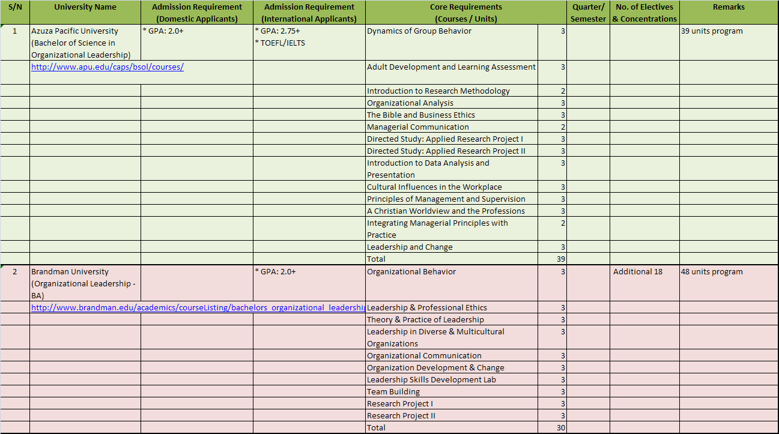

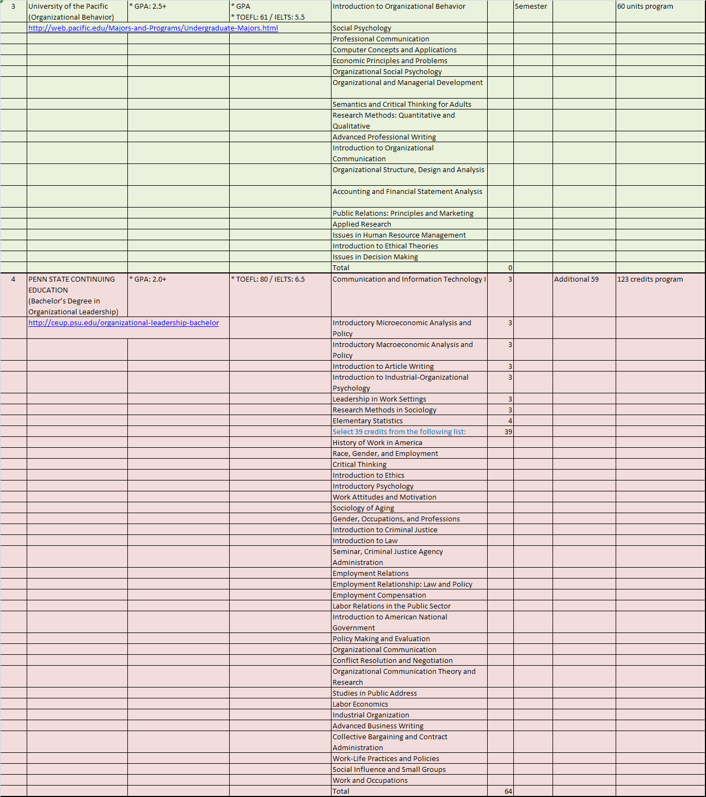

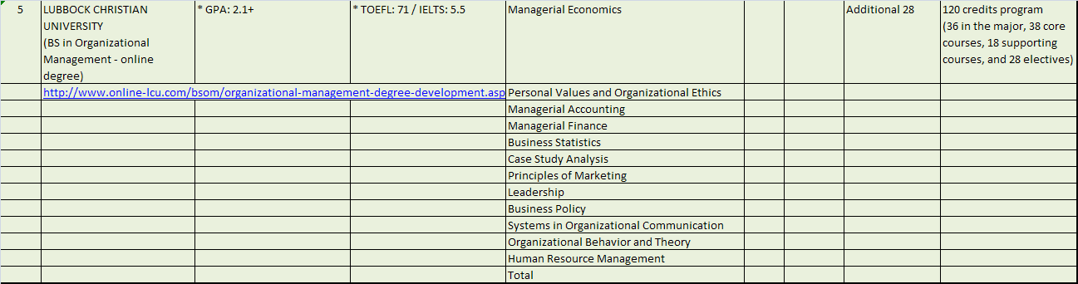

**Appendix II: Profile of the BSOM applicants, admitted, and matriculated students**

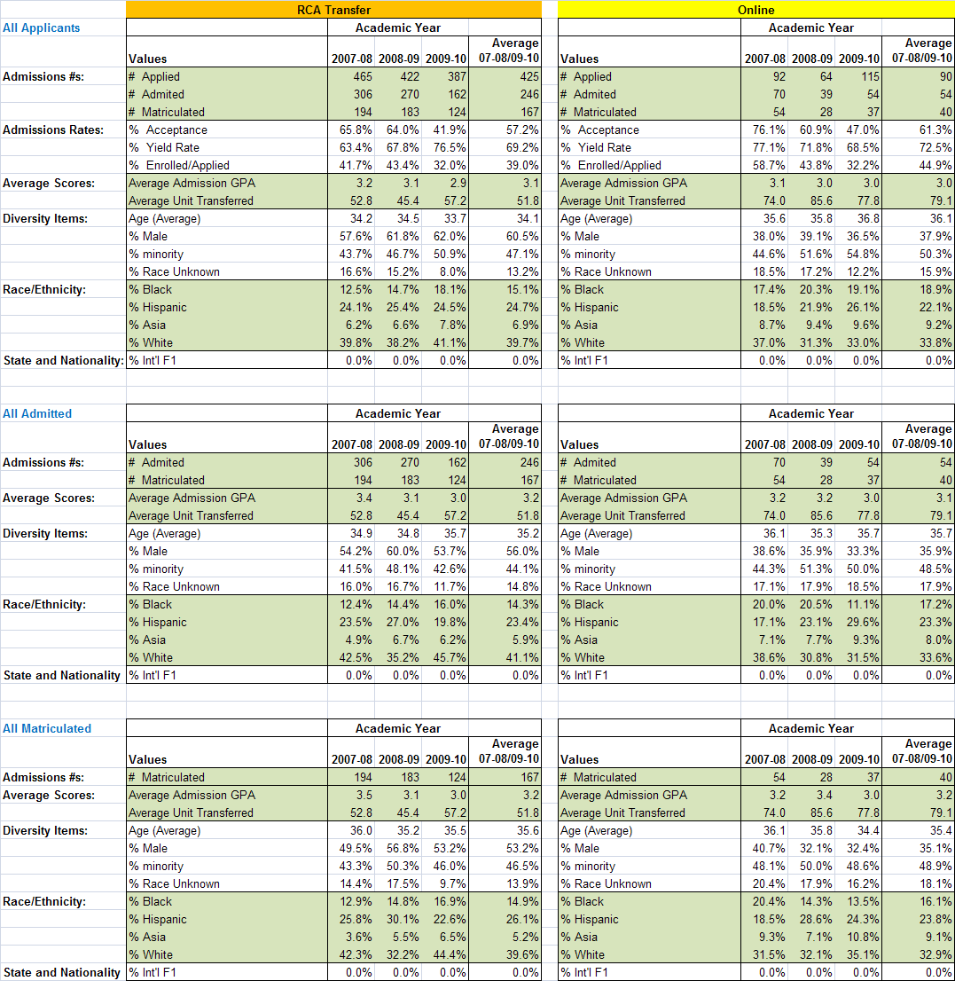

**Appendix III: Assessment instruments, rubrics, and assessment sheets**

1. **Assessments instruments**

**for Learning Objectives 6-1.1**

**Measured in Mgmt 300**

Each student/group will select a **business organization** and write a research paper: 10-12 pages, double-spaced, size 12-point Times New Roman font, with 1" margins. You must reference all your research in the text. Please proof read your paper before submitting it. The paper must be free of spelling and grammar mistakes. It must be a logically written, coherent paper. It should include at least 10 references.

(**Suggestion:** Select an organization that has a lot of information available and/or where you have access to the management personnel). You are required to research the selected organization and address the following areas:

**Content of the Project Paper**

1. **Organizational Context**

* include the history, organizational image, size, locations of operation, type of products, and/or services offered

1. **Environment in which the Organization Operates**

Task Environment

* customers
* suppliers
* competitors
* regulatory group

General Environment

* economic environment
* social/cultural environment
* political environment
* legal environment
* technological environment

1. **Organization's Mission/Vision and Goals**

* mission
* its appropriateness and relevance to organizational history and environment

1. **Organization's Strategy**

* its relationship with organizational goals and mission/vision
* its relationship with the environment in which organization exists

1. **Organizational Structure**

* appropriateness of structure to the environment, objectives, and strategy

1. **Control Features used by the Organization**
2. **Organizational Culture\***

“Personality” of each organization, which includes:

* important rituals
* important symbols and artifacts
* relationship with employees
* its appropriateness and relevance to organizational history and the culture

**\* This is the most difficult analysis of your project. You will rarely find an article describing the culture of an organization. You will need to read and analyze many articles about the organization, analyze their messages to their various constituencies (e.g., customers, stockholders, etc.), and identify and interpret the symbols that are important to them. This will help you identify their espoused values and basic assumptions of operation.**

1. **Leadership**
2. **SWOT Analysis**
3. **Your Recommendations**

The project will be graded by the following criteria:

70% content of the paper including references

15% organization

15% language and grammar

**BS Organizational Management BUS 343 – Business Ethics**

**Learning Objective 4-1:** Demonstrate an understanding of consequence-based and rule-based theories of ethics.

**Learning Outcome 4-1.1:** Students will be able to apply consequence-based and rule-based theories of ethics in managerial decision-making.

**Learning Outcome 4-1.2:** Students will be able to differentiate outcomes of decisions based on consequence-based and rule-based theories of ethics in managerial decision-making.

**Written Paper or Project**

In a written paper or other project, each student is required demonstrate an understanding of consequence-based and rule-based theories of ethics. As described more fully in the Rubric (see below) for these Learning Outcomes, students must be able to (1) define or explain certain ethical theories, (2) apply them to real-world situations, and (3) compare and contrast different outcomes that may be generated by applying different ethical theories to real-world situations.

***Weight of Paper or Project for Grading***

The weight, for purposes of computing the final course grade, of the paper or project selected to assess these outcomes depends upon the assignment chosen by the instructor. As described in the BUS 343 Course Outline 11.10.09, Activities of Participants ¶ 6 b, c & d, it may be a written assignment, oral presentation, or group activity.

The estimated weights of these components are 10% - 25% for a written assignment and 10% - 15% for an oral presentation. See Course Outline at ¶ 8 Assessment Process (d) & (e). These components may be combined for individual students or in a group activity (see below).

***Rubric and Assessment Sheet for Assessing Quality of Work***

The Rubric which provides the criteria for assessing students’ work, the Assessment Sheet for rating each student’s mastery of the criteria, and the BUS 343 Course Outline 11.10.09, can be found in Blackboard. Click the Community tab at the top of the page, then the CBPM website, Outlines & Syllabi tab, Undergraduate Business Courses, and open the BUS 347 folder.

***Time and Dress Requirements for Oral Presentations***

For oral presentations, the presentation must be at least 5 minutes in length, and generally no longer than 10 minutes.

To ensure students understand that this is a formal presentation, “business casual” dress is required. For men and women: no jeans, running shoes, sweats, shorts, tank tops, or gym attire. For men: Long or short sleeve sports shirts with a collar, slacks, and leather shoes. For women: Skirts and blouses, suits, or pants suits. Reasonable exceptions should be granted, for example for students who must come to class directly from work and don’t have time to change out of required work uniforms, members of the military in their attire, and the like.

***Optional Visual Aids***

When appropriate to oral presentation, students may wish to use visual aids. Not all presentations require them. Some professors feel that the best public speakers can command an audience without them. Power points, summary sheets, flip charts, overhead slides, copies of slides, and YouTube are among the options professors may permit or require students to employ.

***Representative Papers and Projects***

The following are representative papers and projects professors have assigned. Others are possible. Design your own as long as it (a) assesses the learning outcomes above, and (b) satisfies the criteria stated in the Rubric.

1. Written Case Study Analysis

The student prepares a written analysis of one of the case studies in the main textbook which includes a discussion of ethical theories as described above and their views on the value or importance of the case study.

2. Oral Case Study Presentation

The student prepares an oral presentation to the class of one of the case studies in the main textbook which includes a discussion of ethical theories as described above and their views on the value or importance of the case study.

3. Written Analysis and Oral Case Study Presentation

This combines 1 and 2 above, requiring less of each component than would be required if a written or oral presentation alone were made.

4. PowerPoint of Case Analysis and Accompanying Oral Presentation

The student creates and presents orally to the class a PowerPoint summary and analysis of one of the case studies in the main textbook which includes a discussion of ethical theories as described above and their views on the value or importance of the case study. Illustrative images or video may be imbedded in the PowerPoint.

5. Group Wiki

The student creates a wiki page, as part of a group wiki project, on a selected topic which includes a discussion of ethical theories as described above and their views on the value or importance of the topic. Illustrative images or video may be imbedded in the wiki. As with other written formats, an oral presentation to the class of the work is also an option.

**MGMT 355**

**Learning Outcomes 1-2.2 and 3-3.2**

**Sample Assessment Instrument for Program Learning Outcomes and GE Learning Outcomes**

The following is a sample assessment plan that may be used to measure the course learning outcomes related to the BSOM Program goals and also GE Life Long Learning Outcomes.

**Leadership Analysis Paper**

Students select a leader and write an analytic paper about that leader’s leadership practices. Please pick a leader (a manager/leader in your own organization or a manager/leader in other organizations) about whom you can collect information. You will analyze his/her leadership practices using one or more of the theories that we cover in this course. The paper should be about 15 pages long and must contain 5 chapters.  
  
Chapter 1: Introduction. This chapter should include: the background of the chosen leader (education, experience, and other characteristics), the organization in which the leader operates (brief history of the organization, goals/missions of the organization, structure of the organization, functions of the organization in society, etc.), the roles and responsibilities of the leader in that organization, and some characteristics of the followers.

Chapter 2: Leadership Practices. What kind of leadership practices (leadership behavior, leadership actions, leadership decisions, leadership plans, leadership efforts, leadership activities, etc.) does the leader show? In other words, list and describe the things that the leader does to lead his/her followers (provision of monetary incentives, frequent communication, open door policy, social gatherings, clear directions, ….?). If needed, you may describe the chosen leader’s leadership practices in the following 10 areas (dimensions of leadership practice):  
1.      Vision (This may refer to long term views of the organization and its environment, big picture, perceiving the future and preparing for the future. To what extent the leader is visionary? What kind of leadership practices does the leader show in this area? For example, does the leader emphasize strategic planning, talks about the future of the organization? ……. )  
2.      Inspiration orientation (Is the leader inspiration oriented? To what extent does the leader try to inspire followers?)  
3.      Goal orientation (organizational goal orientation—To what extent is the leader goal-oriented?)  
4.      Problem solving orientation (To what extent?)  
5.      Day to day operations (hands off, hands on, somewhere in between—control vs. delegation)  
6.      Relationship orientation (relationship building, attention to others’ individual needs, career advice…. To what extent?)  
7.      Communication [style (assertive, aggressive, passive, passive-aggressive), frequency, method]  
8.      Rewards and punishment (Does the leader use rewards and punishment? To what extent and in what way?)  
9.      Collaboration orientation (collaboration oriented vs. authority oriented)  
10.    Ethics orientation (To what extent?)

Chapter 3: Analysis of Leadership Practices I: Leadership Style and Organizational Goal Achievement. This chapter analyzes the leadership practices of the chosen leader using one (or more, if needed) of the theories that we cover in the course. Briefly describe the central ideas of the 5 major leadership theories (situational leadership, style, leader-member exchange, transformational leadership, team leadership theories). (Cite the source with page numbers.) Briefly describe the leadership style(s) associated with each of these leadership theories. Then select one leadership style that most closely matches the leadership practices described in Chapter 2 above, explaining why that particular style matches the leader’s leadership practices described earlier [Here we are determining the leadership style of the leader. If needed, you may use the leadership instrument that is included at the end of the chosen book chapter to figure out the leader’s leadership style (ask the leader or followers to fill in the questions in the leadership instrument). You may rely on your own research and observations about the leader, the leader’s own self descriptions, followers’ descriptions of the leader, the news media’s descriptions, and others’ descriptions.] Assess the compatibility/incompatibility between the leader’s leadership style/practices and the organization’s goals. Make a set of thoughtful (showing consideration for the leader, the organization, and society at large) and practical (applicable to the leader in the contexts of the organization and society at large) recommendations that can improve the leader’s leadership style and/or leadership practices (including leadership skills) in achieving the organization’s goals and in meeting the needs of society at large.

Chapter 4: Analysis of Leadership Practices II: Leadership Style and Delegation. Identify appropriate conditions necessary for effective delegation focusing on the developmental levels of the followers (competence and commitment as explained in the situational approach). Briefly describe the extent to which the leader delegates authority, tasks, and responsibilities to subordinates (followers) based on the information in Chapter 2 above. Describe the extent to which the leader’s delegation practice is compatible with the developmental levels of the followers. Make a set of thoughtful (showing consideration for both the leader and the organization) and practical (applicable to the leader in the context of the organization) recommendations that can improve the leader’s delegation practice.

Chapter 5: Conclusions. Brief summary of the paper, statements about any remaining unresolved aspects of the leadership case, statements about the personal lessons learned from analyzing the leader, statements about the personal lessons learned by going through the analysis paper writing process, statements about how we can apply the lessons learned to one or more aspects of our life (for example, to our career, our education….), and other concluding remarks.

The following additional information is relevant to the leadership analysis paper:

1. Additional information that cannot be included in the text because of space limitations can be included in an appendix.

2. Any writing style (APA, MLA, Chicago, Turabian, etc.) is acceptable. Regardless of the writing style chosen, the information from the textbook must be used throughout the paper and cited with specific page numbers.

3. A references page must be included at the end of the paper. References may include books (including the textbook), journal articles, newspaper articles, reports, etc. A minimum of 5 external references are required.

4. Well-written papers are expected. Asking someone else to read it and comment on it before it is submitted is a good idea (You may consult the University’s Learning Enhancement Center if you would like to get your writing polished and improve your writing skills). The paper guidelines must be followed as closely as possible. A cover page, a page number on all pages except for the title page, and a neat references page are expected.

5. Please make sure to incorporate the leadership concepts/theories/techniques that we learned from the textbook/course into your paper. Using and citing (with specific page numbers) the information from the textbook throughout the paper is required.

**MGMT 358 Culture and Gender Issues in Management**

Grading: Learning Outcome 1-2.1: Students will be able to analyze different forms of verbal and non-verbal communication impacted by cultures

Tool: Through an exam or essay question a student will demonstrate the ability to describe the communication process, identify problems associated with cross-cultural communication, and ways in which an organization can train people to effectively communicate cross-culturally.

Grading: Learning Outcome 3-1.1: Students will be able to understand changing demographics and their impact on organizations, for example, diversity, multiculturalism, and globalization.

Tool: Through an exam or essay question a student will demonstrate the ability to use the cultural variance models (1) to identify cultural variances and (2) to use the models to recognize variances within one’s own work are thorough and complete

**Learning Outcome 2-1.1**: Students will demonstrate the ability

to use cost-benefit analysis, discounting and the capital-market-line for informed decisions (M 360).

**Instrument:**

# Mandatory Exam Question:

1. Financial planning is very important in today’s economy but uncertainty plays a very significant role in forecasting. Why and what significance does a high or low level of uncertainty translate into? What can one do to minimize their effects? (This should include the use of the Capital market Line for efficient investment decision-making).

**Take Home Assignment:**

1. A University is offered the choice of how to receive a valuable gift. The donation is either a gift of $100,000 immediately, or $30,000 for each of the next 4 years beginning a year from now.  Assume there is no inflation and a discount rate of 10%, how would you advice the university?

**Learning Outcome 2-1.2**: Students will demonstrate and evaluate the use of ratio analysis to measure the financial soundness of an organization (M 360).

**Mandatory Exam Question:**

1. As a lending agency, what criteria would you use to determine how much to grant, to whom, and under what conditions?

There are two parts to this question.

1. First, identify the criteria you would use to determine how much to grant, to whom and under what conditions.

2. As part of your response to 1 above, where applicable under the respective and/or select criteria, please identify the financial ratio(s) that are critical for supporting lending decisions (see Commonly Used Ratios list (Spiro, 1996:60 (Table 4).  Please provide the rationale(s) for why the selected ratio(s) identified are important.

**ASSESSMENT INSTRUMENT**

**Information:**

MGMT388 is used to assess two of the Bachelor of Science in Organizational Management (BSOM) program goals. The two BSOM Learning Outcomes are: Students will demonstrate the ability to identify and utilize appropriate statistical tools appropriate to the situations and Students will be able to identify, analyze, and apply data to solve management challenges. The College of Business and Public Management Assessment Coordinator will contact the faculty to inform them on whether assessment data will be collected in a specific term. The Assessment Coordinator will provide the faculty with a copy of the instruments, the grading sheets, and the rubric. In addition to the program assessment, the other learning objectives of this course need to be assessed as well and should play an integral part in determining the grade in this course. Faculty have the liberty to use any combination of instruments or assessment methods that they deem fit. The following is a sample assessment plan.

**Sample Assessment Plan**

The learning objective #8 (described in Section 4) is related to a BSOM program learning outcome: Students will demonstrate the ability to identify and utilize appropriate statistical tools appropriate to the situations.  Specific learning outcomes that are associated with this overall learning outcome are:

1. Be able to identify the independent and dependent variables involved in a management challenge.
2. Be able to identify the level of measurement of the variables involved in the management challenge.
3. Be able to identify a statistical method that is appropriate for the management challenge. Appropriate statistical methods include, but are not limited to, a population approximation test, difference of means test, crosstabulation analysis, and regression analysis.
4. Be able to identify an appropriate statistical method for a hypothetical situation that is extrapolated from the management challenge.

           These learning outcomes will be measured with a series of questions in the final exam (Questions 32-35). Performance categories are: Excellent-Answers all 4 questions correctly. Good-Answers only the first 3 questions correctly. Acceptable-Answers only the first 2 questions correctly. Poor-Answers only the first question correctly. Unsatisfactory-Answers none of the questions correctly, or answers questions correctly in a noncumulative way (for example, answers question 4 correctly, but answers 1, 2, 3 incorrectly).

  The learning objective #9 is related to a BSOM program learning outcome: Students will be able to identify, analyze, and apply data to solve management challenges. Specific learning outcomes that are associated with this overall learning outcome are:

1. Be able to identify the appropriate data to address a management challenge.
2. Be able to analyze the data using an appropriate statistical method.
3. Be able to make appropriate recommendations to address the management challenge.
4. Be able to identify an appropriate statistical method for a hypothetical situation that is extrapolated from the management challenge.

          These learning outcomes will be measured with a series of questions in the final exam (Questions 27-31). Performance categories are: Excellent-Answers all 4 questions correctly. Good-Answers only the first 3 questions correctly. Acceptable-Answers the first 2 questions correctly. Poor-Answers only the first question correctly. Unsatisfactory-Answers all questions incorrectly or answers the questions correctly in a non cumulative way (for example, answers questions 3 and 4 correctly, but answers questions 1 and 2 incorrectly).

**Sample Assessment Instrument for Learning Outcome #3-1.1:**

**Exam Questions**

|  |  |  |  |
| --- | --- | --- | --- |
| **Questions** 28-31. A human resources manager thinks that employees who work in a more open work environment are more satisfied with their jobs than those who work in a less open work environment. She selects a random sample of 400 employees and measures their work environment (high-more open, low-less open) and job satisfaction (high, low). He learns that 140 of the 200 employees who work in a more open work environment report high job satisfaction and that 100 of the 200 employees who work in a less open work environment report low job satisfaction. He wants to know whether he should make the work environment more open or less open. Note 1: X = Independent variable. Y = Dependent variable. Note 2: H = High, L = Low.  28. Which of the following data is appropriate for addressing this management challenge? | | | |
| **Answer** | | | |  |  | | --- | --- | |  | A.  X = H,L,L,L,H,H,L,H,H,H,......Y = H,L,L,H,H,L,H,,L,L,H,..... Which can be summarized as:  Mean satisfaction scores by Environment                                                         Mean     Standard deviation More Open Work Environment (H)       140                 8 Less Open work Environment (L)           80                10 | |  | B.  X = H,L,L,L,H,H,L,H,H,H,...... Y = H,L,L,,H,H,L,H,L,L,H,..... Which can be tabled as:                                           Work Environment (X)                                               L           H Job Satisfaction (Y) L          100         60                                          H            100        140 | |  | C.  X = 1,30,21,40,32,40,35, ....... Y = 3,2,4,5,6,7,3,4,5,6,7,8,....... Which can be reduced to: Y = 100 +20X | |  | D.  X = 1,30,21,40,32,40,35, ....... Y = 3,2,4,5,6,7,3,4,5,6,7,8,....... Which can be reduced to: Mean = 140, Standard deviation = 40. | |
|  | | |  |
|  | | |  |
| **Question** 29. Analyze (or interpret) the data that you chose in Question 28. Which of the following is the appropriate analysis outcome? | | | |
| **Answer** | | |  |  | | --- | --- | |  | A. Those who work in a more open work environment are 20% more likely to be satisfied with their jobs than those who work in a less open work environment. | |  | B. We conclude that the average job satisfaction score of those who work in a less open work environment is significantly higher than those who work in a more open work environment. When we claim this, we would be wrong less than 5% of the time. | |  | C. When the work environment score goes up by 10, the job satisfaction score goes up by 20. | |  | D.  Those who work in a more open work environment are 90% more likely to be satisfied with their jobs than those who work in a less open work environment. | | |
| **Question** 30. Given the outcome of the analysis, what would you recommend to the human resources manager? | | | |
| **Answer** | |  |  | | --- | --- | |  | A.  Try to do nothing because the outcome indicates that there is no relationship between work environment and job satisfaction. | |  | B.  Try to make the work environment less open so that job satisfaction can go up. | |  | C.  Try to make the work environment more open so that job satisfaction can go up, particularly if there are no other factors that can account for job satisfaction. | |  | D. Try to take a warm bubble bath and reanalyze the data because the data are not analyzed appropriately. | | | |

|  |  |  |  |  |  |  |  |  |  |  |
| --- | --- | --- | --- | --- | --- | --- | --- | --- | --- | --- |
| |  |  | | --- | --- | | **Question** 31. Variables can be measured at several different levels. The level of measurement determines or constrains the types of statistical method that can be used to address a given management challenge. Which of the following hypothetical statements would be correct? | | |  | |  | | --- | |  | |  | |  | |  | | | | |
| **Answer** | |  |  | | --- | --- | |  | A.  If we measure the work environment variable at the nominal level (with two categories: open work environment and closed work environment) and the job satisfaction variable at the interval-ratio level (with an index of job satisfaction), we can use crosstabulation analysis to examine the relationship between these two variables. | |  | B. If we measure the work environment variable at the ordinal level (with two categories: more open work environment and less open work environment) and the job satisfaction variable at the ordinal level (with two categories: more satisfaction and less satisfaction), we can do regression analysis to examine the relationship between these two variables. | |  | C. If we measure the work environment variable at the interval-ratio level (with an index) and the job satisfaction variable at the ordinal level (with two categories: more satisfaction and less satisfaction), we can do a difference of means test to examine the relationship between these two variables. | |  | D.  If we measure the work environment variable at the interval-ratio level (with an index) and the job satisfaction variable at the interval-ratio level (with an index), we can do regression analysis to examine the relationship between these two variables. | | |
| **Sample Assessment Tools for Learning Outcome #3-1.2: Exam Questions**  **Questions** 32-35. A restaurant manager suspects that more verbal interactions with customers generate a higher amount of tips than fewer verbal interactions. In order to test her suspicion, she collects the following information:  Amount of daily tips in dollars by levels of verbal interactions Level of verbal interactions Mean Standard deviation Number of cases High                                  500             100                      50 Low                                  400               50                      50   32. What are the independent variable and the dependent variable? | | |
| **Answer** | | |  |  | | --- | --- | |  | A.  Independent variable: Manager; Dependent variable: Amount of tips | |  | B.  Independent variable: More tips; Dependent variable: Less tips | |  | C.  Independent variable: Levels of verbal interactions; Dependent variable: Amount of tips | |  | D.  Independent variable: Mean tips; Dependent variable: Median tips | |

|  |  |
| --- | --- |
| **Question** 33. At what level are the independent and dependent variables measured? | |
| **Answer** | |  |  | | --- | --- | |  | A.  Independent variable: Ordinal; Dependent variable: Interval-ratio | |  | B.  Independent variable: Interval-ratio; Dependent variable: Nominal | |  | C.  Independent variable: Ordinal; Dependent variable: Nominal | |  | D.  Independent variable: Ordinal; Dependent variable: Ordinal | |

|  |  |
| --- | --- |
| **Question** 34. What statistical method would you use to address this management challenge? | |
| **Answer** | |  |  | | --- | --- | |  | A.  Difference of means test (T or Z test with two sample means) | |  | B.  Crosstabulation analysis | |  | C.  Population approximation test (T or Z test with one sample mean) | |  | D.  Regression analysis | |

|  |  |
| --- | --- |
| **Question** 35. Variables can be measured at several different levels. The level of measurement determines or constrains the types of statistical method that can be used to address a given management challenge. Which of the following hypothetical statements would be correct? | |
| **Answer** | |  |  | | --- | --- | |  | A.  If we measure the level of interaction variable at the nominal level (with two categories: interaction and no interaction) and the amount of tips variable at the ordinal level (high, low), we can use regression analysis to examine the relationship between these two variables. | |  | B.  If we measure the levels of interaction variable at the interval-ratio level (number of interactions) and the amount of tips variable at the interval-ratio level (in dollars), we can use crosstabulation analysis to examine the relationship between these two variables. | |  | C.  If we measure the levels of interaction variable at the interval-ratio level (number of interactions) and the amount of tips variable at the ordinal level (high and low), we can use crosstabulation analysis to examine the relationship between these two variables. | |  | D. If we measure the levels of interaction variable at the ordinal level (high, low) and the amount of tips variable at the ordinal level (high, low), we can use crosstabulation analysis to examine the relationship between these two variables.   |  | | --- | |  | |  | |  | | |

***MGMT 459 Leadership Interview and Summary Paper***

**Paper should cover the concepts of: 1. Motivation, 2. Group Dynamics, 3. Organizational Structure**

Assignment:

1. You will conduct an interview with an organizational leader to identify the key organizational issues and challenges he/she faces regularly.

**Selecting the Person to be Interviewed:**

Ideally the person you will select for to interview will have worked for several years and is older than 35. The more experienced at work and life the person is the more relevant examples and information you will be able to elicit. *The person should not be in your immediate family (father, mother, etc.) nor be in a significant relationship with you.*

The interview should be more of a conversation than just Q&A. *Be sure to tell the person the purpose of the interview and assure him/her that you will not use his/her name anywhere in the paper. In addition,* ***keep*** *that promise - do not share what was said in the interview with others.*

1. You will develop a specific list of interview questions that you will ask during the interview. The final list of interview questions will be developed by you and submitted to the instructor for approval. As you design the interview questions, keep them open ended by starting with words such as Who? What? When? Where? Why? How much? For example, *what positive ways have the leaders you have worked for over your career motivated you? Please give specific examples of what the people did and what made those actions “motivating” for you.*
2. You will summarize the interview responses in an individual paper which includes:

1) an overview of the relevant theories and concepts from chapters 7, 8 and 15;

2) a summary of the interview responses; and

3) recommendations on what could be changed or improved based on the interview conducted.

The objective of conducting this interview and writing this paper is to learn (in detail) about the individual’s experience with each of the following important areas of Organizational Behavior:

* How people are motivated at work (and what demotivates them) ***Chapter 7***
* Successful and unsuccessful groups and teams and how the teams’ effectiveness (or lack thereof) impact organizational performance and productivity ***Chapter 8***
* Organizational structure (how people are arranged into teams/departments on the organization chart), specifically the impact of Hierarchy and Centralization/Decentralization (and span of control, division of labor, etc.) on individual’s ability to solve problems and make decisions. ***Chapter 15.***

***Organization of the Paper***

***Remember each section should be at least a page long***

***(What I wrote below is just an example)***

***Subheadings for each section of the paper.***

***Understanding Motivation:*** This section includes an overview of the 2 – 3 major theories discussed in chapter 7. Briefly summarize the theories that were covered during the interview (do not repeat the interview questions that you asked in this section)

***Summary of Responses:*** This section includes a summary of the responses and examples given by the person you interviewed. Do not repeat the interview questions, instead write a summary of what the person said and then link it to one of the theories described in the first section. For example, *The leader indicated how important it was to ensure that people are paid appropriately for the work that they were assigned. Paying people appropriately was important since individuals in her organization became demotivated when they found out that other people working for their competitors made more. This is related to the theory of equity which states that people will adjust their performance (downward) if they believe that others are making more money for completing the same work.*

***Recommendations to Improve Motivation:*** Based on the interview information, I recommend that this organization review its compensation and benefits to ensure that their pay is equitable. This will help to reduce the turnover since the leader indicated that her employees leave within a year and go work for competitors who are paying more per hour and offering even their part time workers benefits.

***Repeat this same pattern of subheadings for the sections on teams and organization structure.***

**MGMT 496: Senior Seminar Paper**

The **senior seminar paper** [about 25 pages long (20-30 pages)] will be written on the topic of your choice. The paper can be a quantitative one (most often in the form of a survey), or a qualitative one (most often in the form of in-depth interviews). You may choose your own topic, or select one of the topics/titles in Appendix A (pp. 177-178) of the textbook.

Senior Project Paper Guidelines

(See Appendix E and G, or Appendix F and H of the textbook for a sample project paper)

Title Page

All project papers have a title page. Put “Senior Project Paper” in the top center and the title of the paper below that. The class identification (MGMT 496: Seminar in Management), your name, and the date should also appear on this page. The title should include critical key words such as your dependent and independent variables. Avoid unnecessary words like “A Study of …” It is often a good idea to have a subtitle that explains or supplements the main title.

Abstract Page

Provide an abstract of the senior project paper, which is a brief summary of the content of the full paper. It may include the purpose, hypothesis, methodology, and significance of the study or project. Some phrases or words are “abstracted” from the main body of the proposal and so, some repetition is acceptable. The length should be less than one page (usually a half page or about 350 words). The abstract is usually included on a separate page, although it is often acceptable to have it on top of the first page of the proposal. It should be single-spaced (all other sections of the text should be double spaced; table of contents, references, and texts inside the tables should be single-spaced). It is a good idea to write an abstract after all the other sections of the proposal are completed.

Chapter I: Introduction

Two most important things in the introduction section are the purpose and significance of the study.

Statement of the problem: (Statement of the need): What is the (social, administrative, or management) problem that will be studied? If no specific problem will be addressed, some basic information about the topic can be provided in this section.

Purpose of the study: This section begins with “The purpose of this study is ….”

Hypotheses: Express the hypothesis in the research hypothesis format (not in the null hypothesis format). Directional hypotheses are preferred. Each hypothesis should indicate the dependent and independent variables. Limit the number of hypotheses to 2 or 3.

Importance (significance) of the study: Why should we care about the topic? Why is the study important? (Is it because it solves some real world problems? Is it because it adds new pieces of information to the existing literature?)

Definitions of terms: Defines unusual terms and phrases (this is an optional section and it may go to an appendix, if necessary).

Delimitations of the study: This section defines or narrows the scope of the study by explaining what will be studied and what will NOT be studied. In most cases, we cannot study all aspects of a topic because we do not have enough time, energy, or technical skills. So, we delimit the scope of the study by focusing on only one or more aspects of a topic. For example, assume that we plan to study the issue of quality of life. We may state that we will study the issue of quality of life only in terms of social relationships (excluding the financial, health, and other aspects of quality of life). Then, we are delimiting the scope of the study. We may also delimit the scope of the study by defining or narrowing the study population. For example, we may state that the study will deal with the issue of quality of life only among the senior citizens in one city. This way, we are delimiting the scope of the study to the population of senior citizens in that city.

Chapter II: Review of the Literature

This chapter presents an organized review of the relevant literature. The review should explain the current status of the literature on the topic. The most important item that needs to be included in this chapter is the review of the studies that support the respective relationships in the stated hypotheses. In the process of presenting the studies that support the hypotheses, we may also present some studies that contradict the hypotheses. It is best to organize the literature review around the research hypotheses (or around the dependent and independent variables). A suggestion is to identify the relationship being tested in each hypothesis and using these as the sub-headings. The last part of this chapter should clearly explain why/how your study is different from the existing studies that are reviewed in this chapter. We need to review a minimum of 5 scholarly articles that are written on the chosen topic.

Chapter III: Theoretical Framework

This chapter explains the theories that are behind the hypotheses. Theories explain why the independent variable leads to the dependent variable in each of the hypotheses. You should find a theory or theories that explain each of your hypothesis. You should name your theory and explain the background, structure, and components of the theory or theories. Diagrams or figures may be useful in explaining them. More specifically, this chapter may need the following components: Theory Specification---we select a theory or theories and explain what they are; Theory Connection---we explain the relationships between the independent and dependent variables in connection with the theories specified previously; Theoretical Models---we provide a diagram that depicts the relationships among the components of the theories. In most cases, that means that we specify the relationships between the independent, dependent, and control variables.

Chapter IV: Methodology

Research design: Overall research process: inductive or deductive? The units of analysis (observation)? What is the specific design that will be used to test the hypotheses? Some examples are: cross-sectional design, classic experimental design, one group pre-test post-test design, longitudinal design, correlational design, case study design, qualitative design, etc. The independent, dependent, and control variables of each hypothesis should be stated as well.

Measurement of variables (Instrumentation): How will the concepts (variables) in the hypotheses be measured? More specifically, what are the indicators and instruments of the variables? If the variables are measured with survey questions, specific survey questions should be attached in an appendix. However, which instruments measure what variables should be explained here.

Sampling: Define the study population and sample. What is the specific sample that will be used? How will the sample elements be selected? For a survey, the minimum sample size should be 50. For an in-depth interview project, the sample size should be about 8-20.

Research Methods: What is the method by which the necessary information will be collected? Is it an experiment, test, survey, existing data (secondary data), focus group, content analysis, in-depth interview, etc.? What are the actual data collection procedures?

Plan of Analysis: Data acquisition and management procedures (coding, inputting, cleaning, etc.). (Statistical) Analysis methods (what methods and why they are appropriate).

Chapter V: Data Analysis

Sample characteristics: This section describes the characteristics of the sample. If the population characteristics are available, we should compare them with the sample characteristics to see if they are comparable.

Analysis results: This section reports the results of data analysis. Because we are testing several hypotheses, it should be organized around each of the hypotheses (each hypothesis should be a sub-heading for this section). Supplement narrative explanations of your findings with tables.

Chapter VI: Conclusions

In general, this chapter serves to integrate key elements introduced in the previous chapters.

Introduction: This section should begin with a recap of the stated purposes for the research, including restatement of the hypotheses investigated.

Summary of findings. This section summarizes the findings that are presented in Chapter 5.

Interpretation of findings & integration: The section should interpret Chapter 5 findings in terms of the previous research (tie back to the literature review in Chapter 2) and theories (Chapter 3) that were used.

Recommendations: This section should make recommendations for practice and also for future research.

Endnotes:

If there are any, and if footnotes are not used in the text.

Appendixes:

Survey or in-depth interview questions, transcripts for in-depth interviews, and/or other relevant information should be included.

References:

A minimum of 5 scholarly articles need to be referenced. Others references such as newspaper and magazine articles, books, company annual reports, and budgets should also be included.

Project Paper Grading Criteria:

**Content** (All the items---title page, abstract, 6 chapters, appendixes, references---are expected.)

The paper must be double-spaced except for the table of contents, tables, references, and others. All pages except for the title page must be numbered.

**Writing Quality**(Grammar, punctuation, paragraph structures, etc. Consider getting some writing help from the University’s Learning Enhancement Center)

**References** (A minimum of 5 scholarly sources—cited in the text and included in the references---are expected. A total of 10-20 reference sources (scholarly and non scholarly) should be included. Students are encouraged to use the Proquest, EBSCOhost, and other electronic databases at the library website. Students should also consider utilizing various library services.)

**Writing Style Format** (No specific writing style format is required. APA, Turabian, MLA, Chicago, and other styles are all acceptable as long as they are followed consistently. In other words, please be consistent and do not mix two different styles. The professor will give you some feedback on the style once you post your draft proposal.)

1. **Rubrics**

**RUBRICS**

**MEASURED IN MGMT 300: Principles of Management.**

**Program Goal 1**: An understanding of the role of the management functions to guide organizations towards goals accomplishment.

**Learning Objective 1-1: Demonstrates an understanding of the management functions.**

**Learning Outcome 1-1.1:** Students will be able to perform environmental analysis by using planning tools such as SWOT or Porter’s Model (MGMT 300).

|  |  |  |  |  |
| --- | --- | --- | --- | --- |
| **Excellent** | **Good** | **Acceptable** | **Poor** | **Unsatisfactory** |
| In the performance of the SWOT analysis, the student correctly identifies the internal strength(s) (S), and weakness(es) (W), and matches them with the external opportunity(ies) (O), and threat(s) (T), | In the performance of the SWOT analysis, the student correctly identifies the internal strength(s) (S), and weakness(es) (W), and matches them with the external opportunity(ies) (O), or threat(s) (T) only, | In the performance of the SWOT analysis, the student correctly identifies the internal strength(s) (S), or weakness(es) (W), and matches them with the external opportunity(ies) (O), or threat(s) (T) only, | In the performance of the SWOT analysis, the student correctly identifies the internal strength(s) (S), or weakness(es) (W), but does not matches them with the external opportunity(ies) (O), or threat(s) (T) only, | In the performance of the SWOT analysis, the student is unable to identify the internal strength(s) (S), and weakness(es) (W), and the external opportunity(ies) (O), or threat(s) (T) . |

**Learning Outcome 1-1.2:** Students can identify and understand appropriateness of organizational forms (MGMT 300).

|  |  |  |  |  |
| --- | --- | --- | --- | --- |
| **Excellent** | **Good** | **Acceptable** | **Poor** | **Unsatisfactory** |
| Correctly identifies organizational forms (mechanistic or organic), and thoroughly analyzes their appropriateness for organizational effectiveness. | Correctly identifies organizational forms (mechanistic or organic) and adequately analyzes their appropriateness for organizational effectiveness. | Correctly identifies organizational forms (mechanistic or organic), and sketchily analyzes their  appropriateness for organizational effectiveness. | Correctly identifies organizational forms (mechanistic to organic), but does not analyze their appropriateness. | No real knowledge of organizational forms (mechanistic or organic). |

**Learning Outcome 1-1.3:** Students are able to identify commonly used organizational controls in order to anticipate and prevent present and future problems (MGMT 300).

|  |  |  |  |  |
| --- | --- | --- | --- | --- |
| **Excellent** | **Good** | **Acceptable** | **Poor** | **Unsatisfactory** |
| Correctly identifies all three types of organizational controls (pre-control, con-current control, & feedback control). Correctly discusses where each is used, or should be used in their company, with examples. | Correctly identifies two of the types of organizational controls (pre-control, con-current control, & feedback control). Correctly discusses where each is used, or should be used in their company, with examples. | Correctly identifies two of the types of organizational controls (pre-control, con-current control, & feedback control). Incorrectly discusses where each is used, or should be used in their company, with poor (or no) examples. | Incorrectly identifies one or two types of organizational controls (pre-control, con-current control, & feedback control). No discussion of where each should be used, and no examples, or inaccurate examples. | Does not identify, nor describe any type of controls. |

**Program Goal 5**: An understanding of the need to work collaboratively within group situations to solve problems.

**Learning Objective 5-1: Students will identify process/competencies to work collaboratively.**

**Learning Outcome 5-1.1:** Students will identify processes/competencies for effective teamwork (MGMT 300).

|  |  |  |  |  |
| --- | --- | --- | --- | --- |
| **Excellent** | **Good** | **Acceptable** | **Poor** | **Unsatisfactory** |
| Students identify  at least six of the following competencies as important for effective teamwork, with accurate descriptions and examples:   * Communicating effectively in teams * Resolving team conflicts * Making meetings work * Utilizing team members’ abilities * Creating a shared team purpose * Evaluating team performance * Making team decisions by consensus | Students identify at least four of the following competencies as important for effective teamwork, with accurate descriptions and examples:   * Communicating effectively in teams * Resolving team conflicts * Making meetings work * Utilizing team members’ abilities * Creating a shared team purpose * Evaluating team performance * Making team decisions by consensus | Students identify at least three of the following competencies as important for effective teamwork, with accurate descriptions and examples:   * Communicating effectively in teams * Resolving team conflicts * Making meetings work * Utilizing team members’ abilities * Creating a shared team purpose * Evaluating team performance * Making team decisions by consensus | Students identify two of the following competencies as important for effective teamwork, with accurate descriptions and examples:   * Communicating effectively in teams * Resolving team conflicts * Making meetings work * Utilizing team members’ abilities * Creating a shared team purpose * Evaluating team performance * Making team decisions by consensus | Students identify less than two of the following competencies as important for effective teamwork, or identifies more, but lacks accurate descriptions and examples:   * Communicating effectively in teams * Resolving team conflicts * Making meetings work * Utilizing team members’ abilities * Creating a shared team purpose * Evaluating team performance * Making team decisions by consensus |

**RUBRICS**

**MEASURED IN MGMT 355: Leadership in Organizations**

**Program Goal 1**: An understanding of the role of the management functions to guide organizations toward goals accomplishment.

**Learning Objective 1-2**: **Be able to apply tools and processes of communication, motivation, leadership, and group dynamics that enable organizations to achieve organizational goals.**

**Learning Outcome 1-2.2**: Be able to understand different theories of leadership for goal accomplishment (MGMT 355)

|  |  |  |  |  |
| --- | --- | --- | --- | --- |
| **Excellent** | **Good** | **Satisfactory** | **Poor** | **Unsatisfactory** |
| Clearly and thoughtfully describes all of the central ideas of the 5 major leadership theories (situational leadership, style, leader-member exchange, transformational leadership, and team leadership theories). | Clearly and thoughtfully describes most of the central ideas of the 5 major leadership theories (situational leadership, style, leader-member exchange, transformational leadership, and team leadership theories). | Clearly and thoughtfully describes some of the central ideas of the 5 major leadership theories. (situational leadership, style, leader-member exchange, transformational leadership, and team leadership theories). | Clearly and thoughtfully describes few of the central ideas of the 5 major leadership theories. (situational leadership, style, leader-member exchange, transformational leadership, and team leadership theories). | Poorly and not thoughtfully describes few of the central ideas of the 5 major leadership theories (situational leadership, style, leader-member exchange, transformational leadership, and team leadership theories). |
| Clearly describes all of the leadership styles that are associated with the situational leadership, style, leader-member exchange, transformational leadership, and team leadership theories | Clearly describes some of the leadership styles that are associated with the situational leadership, style, leader-member exchange, transformational leadership, and team leadership theories | Clearly describes some of the leadership styles that are associated with the situational leadership, style, leader-member exchange, transformational leadership, and team leadership theories | Poorly describes some of the leadership styles that are associated with the situational leadership, style, leader-member exchange, transformational leadership, and team leadership theories | Poorly describes few of the leadership styles that are associated with the situational leadership, style, leader-member exchange, transformational leadership, and team leadership theories |
| Correctly identifies the leadership style and explains the reasons for the choice appropriately | Correctly identifies the leadership style and explains most of the reasons for the choice appropriately | Correctly identifies the leadership style and explains some reasons for the choice appropriately | Somewhat correctly identifies the leadership style and explains some reasons for the choice appropriately | Incorrectly identifies the leadership style and explains the reasons for the choice inappropriately |
| Accurately assesses the comparability/incomparability between the leader’s leadership style and the organization’s goals | Accurately assesses the compatibility/incompatibility between the leader’s leadership style and the organization’s goals with few exceptions | Accurately assesses the comparability/incomparability between the leader’s leadership style and the organization’s goals with some exceptions | Somewhat inaccurately assesses the comparability/incomparability between the leader’s leadership style and the organization’s goals with some exceptions | Inaccurately assesses the comparability/incomparability between the leader’s leadership style and the organization’s goals |
| Makes many thoughtful (showing consideration for both the leader and the organization) and practical (applicable to the leader in the context of the organization) recommendations. | Makes several thoughtful and practical recommendations. | Makes one or two thoughtful and practical recommendations. | Makes one thoughtful and practical recommendation. | Does not make any thoughtful and practical recommendations. |

**Program Goal 3**: An understanding of the diversity of cultures that exist locally, nationally, and internationally.

**Learning Objective 3-2: Understanding the role of authority, responsibility, and delegation in organizations.**

**Learning Outcome 3-2.2**: Be able to identify appropriate conditions necessary for effective delegation (MGMT 355).

|  |  |  |  |  |
| --- | --- | --- | --- | --- |
| **Excellent** | **Good** | **Satisfactory** | **Poor** | **Unsatisfactory** |
| Clearly identifies the conditions necessary for effective delegation based on the competence and commitment levels of the followers as explained in the situational approach. | Clearly identifies the conditions necessary for effective delegation based on the competence and commitment levels of the followers with few exceptions as explained in the situational approach. | Clearly identifies the conditions necessary for effective delegation based on the competence and commitment levels of the followers with some exceptions as explained in the situational approach. | Somewhat identifies the conditions necessary for effective delegation based on the competence and commitment levels of the followers with some exceptions as explained in the situational approach. | Does not identify the conditions necessary for effective delegation based on the competence and commitment levels of the followers as explained in the situational approach. |
| Clearly and thoughtfully describes the extent to which a leader delegates authority, tasks, and responsibilities to subordinates (followers). | Clearly and thoughtfully describes the extent to which a leader delegates authority, tasks, and responsibilities to subordinates (followers) with few exceptions. | Clearly and thoughtfully describes the extent to which a leader delegates authority, tasks, and responsibilities to subordinates (followers) with some exceptions. | Somewhat clearly and thoughtfully describes the extent to which a leader delegates authority, tasks, and responsibilities to subordinates (followers) with some exceptions. | Does not describe the extent to which a leader delegates authority, tasks, and responsibilities to subordinates (followers). |
| Accurately describes the extent to which the leader’s delegation practice is compatible with the developmental levels of the followers. | Accurately describes the extent to which the leader’s delegation practice is compatible with the developmental levels of the followers with few exceptions. | Accurately describes the extent to which the leader’s delegation practice is compatible with the developmental levels of the followers with some exceptions. | Somewhat accurately describes the extent to which the leader’s delegation practice is compatible with the developmental levels of the followers with some exceptions. | Does not accurately describe the extent to which the leader’s delegation practice is compatible with the developmental levels of the followers. |
| Makes many thoughtful (showing consideration for both the leader and the organization) and practical (applicable to the leader in the context of the organization) recommendations. | Makes several thoughtful and practical recommendations. | Makes one or two thoughtful and practical recommendations. | Makes one thoughtful and practical recommendations. | Does not make thoughtful and practical recommendations. |

**RUBRICS**

**MEASURED IN** **MGMT 358: Culture and Gender Issues in Management**

**Program Goal 1**: An understanding of the role of the management functions to guide organizations toward goals accomplishment.

**Learning Objective 1-2: Be able to apply tools and processes of communication, motivation, leadership, and group dynamics that enable organizations to achieve organizational goals.**

**Learning Outcome 1-2.1**: Students will be able to analyze different forms of verbal and non-verbal communication impacted by cultures (MGMT 358).

|  |  |  |  |  |
| --- | --- | --- | --- | --- |
| **Excellent** | **Good** | **Acceptable** | **Poor** | **Unsatisfactory** |
| Student identification of the following are thorough and complete: 1. at least 3 problems associated with cross-cultural communication, and 2. 3 ways in which an organization can train people to effectively communicate cross-culturally. | Student identification of the following are good but slightly in complete 1: at least 3 problems associated with cross-cultural communication, and 2. 3 ways in which an organization can train people to effectively communicate cross-culturally. | Student identification of the following are somewhat incomplete and unclear: 1. at least 3 problems associated with cross-cultural communication, and 2. 3 ways in which an organization can train people to effectively communicate cross-culturally. | Student identification of the following are mostly incomplete and unclear or incorrect: 1. at least 3 problems associated with cross-cultural communication, and 2. 3 ways in which an organization can train people to effectively communicate cross-culturally. | Student is not able to identify: 1. any problems associated with cross-cultural communication, and 2. any ways in which an organization can train people to effectively communicate cross-culturally. |

**Program Goal 3**: An understanding of the diversity of cultures that exist locally, nationally, and internationally.

**Learning Objective 3-1**:  **Demonstrate an understanding of the impact of the environment on organizations.**

**Learning Outcome 3-1.1:** Students will be able to understand changing demographics and their impact on organizations, for example, diversity, multiculturalism, and globalization (MGMT 358).

|  |  |  |  |  |
| --- | --- | --- | --- | --- |
| **Excellent** | **Good** | **Acceptable** | **Poor** | **Unsatisfactory** |
| Using both Kluckhohn and Strodtbeck’s and Hofstede’s models on variances, student’s explanation of 1. how cultures vary, and 2. How the models may be used to recognize variances within one’s own work are thorough and complete. | Using both Kluckhohn and Strodtbeck’s and Hofstede’s models on variances, student’s explanation of 1. how cultures vary, and 2. The models may be used to recognize variances within one’s own work are thorough and complete. | Using both Kluckhohn and Strodtbeck’s and Hofstede’s models on variances, student’s explanation of 1. how cultures vary, and 2. How the models may be used to recognize variances within one’s own work are somewhat incomplete and unclear. | Using both Kluckhohn and Strodtbeck’s and Hofstede’s models on variances, student’s explanation of 1. how cultures vary, and 2. How the models may be used to recognize variances within one’s own work are some mostly incomplete and unclear. | Student is not able to use either Kluckhohn and Strodtbeck’s or Hofstede’s models on variances, to explain how 1. how cultures vary, and 2. How the models may be used to recognize variances within one’s own work. |

**RUBRICS**

**MEASURED IN MGMT 360: Financial Management and Budgeting**

**Program Goal 2**: An understanding of the need for continuously gathering and evaluation of information to improve organizational outcomes as needed.

**Learning Objective 2-1: Be able to describe information that is needed to analyze the financial viability of organizations.**

**Learning Outcome 2-1.1**: Students will demonstrate the ability to use cost-benefit analysis, discounting and the capital-market-line for informed decisions (M 360).

|  |  |  |  |  |
| --- | --- | --- | --- | --- |
| **Excellent** | **Good** | **Acceptable** | **Poor** | **Unsatisfactory** |
| Student definitions, or explanations are thorough and complete, and 2. Student’s application of the analytical tool is thorough and complete, and demonstrate an excellent understanding of the tool’s applicability for informed financial decision-making. | Student’s definitions, or explanations are good, but slightly incomplete or unclear, and 2. Student’s application of the analytical tool is good and demonstrates a good understanding of the tool’s applicability for informed financial decision-making. | Student’s definitions, or explanations are somewhat incomplete or unclear, and 2. Student’s application of the analytical tool is good and demonstrates an acceptable understanding of the tool’s applicability for informed financial decision-making. | Student’s definitions, or explanations are mostly incomplete or incorrect, and 2. Student’s application of the analytical tool is not thorough or incomplete and demonstrates some misunderstanding of the tool’s applicability for informed financial decision-making. | Student is not able to define or explain at least one tool, or demonstrate the tool’s applicability for informed financial decision-making. |

**Learning Outcome 2-1.2**: Students will demonstrate and evaluate the use of ratio analysis to measure the financial soundness of an organization (M 360).

|  |  |  |  |  |
| --- | --- | --- | --- | --- |
| **Excellent** | **Good** | **Acceptable** | **Poor** | **Unsatisfactory** |
| Student definitions, or explanations are thorough and complete, and 2. Student’s application of the ratio analysis is thorough and complete, and demonstrates an excellent understanding of the ratio’s applicability for extending credit. | Student’s definitions, or explanations are good, but slightly incomplete or unclear, and 2. Student’s application of the ratio analysis is good and demonstrates a good understanding of the ratio’s applicability for extending. | Student’s definitions, or explanations are somewhat incomplete or unclear, and 2. Student’s application of the ratio analysis is good and demonstrates an acceptable understanding of the tool’s applicability for extending credit. | Student’s definitions, or explanations are mostly incomplete or incorrect, and 2. Student’s application of the ratio analysis is not thorough or incomplete and demonstrates some misunderstanding of the ratio’s applicability for informed financial decision-making. | Student is not able to define or explain at least one ratio analysis, or demonstrates the ratio analysis’ applicability for extending credit. |

**RUBRICS**

**MEASURED IN MGMT 388: Statistics**

**Program Goal 1**: An understanding of the role of the management functions to guide organizations toward goals accomplishment.

**Learning Objective 1-3**: **Demonstrate the ability to solve organizational management issues, and make decisions.**

**Learning Outcome 1-3.1**: Students will be able to identify, analyze, and apply data to solve management challenges (MGMT 388).

|  |  |  |  |  |
| --- | --- | --- | --- | --- |
| **Excellent** | **Good** | **Satisfactory** | **Poor** | **Unsatisfactory** |
| Correctly identifies the independent and dependent variables, levels of measurement of the variables, and the statistical method that is appropriate for a given management challenge.  Applies the ability to select the correct statistical method to other management challenges. | Correctly identifies the independent and dependent variables, levels of measurement of the variables, and the statistical method that is appropriate for a given management challenge.  Unable to apply the ability to select the correct statistical method to other management challenges. | Incorrectly identifies the independent and dependent variables, Correctly identifies the levels of measurement of the variables, and the statistical method that is appropriate for a given management challenge. Unable to apply the ability to select the correct statistical method to other management challenges. | Incorrectly identifies the independent and dependent variables, and the levels of measurement of the variables. Correctly identifies the statistical method that is appropriate for a given management challenge. Unable to apply the ability to select the correct statistical method to other management challenges. | Incorrectly identifies the independent and dependent variables, the levels of measurement of the variables, and the statistical method that is appropriate for a given management challenge. Unable to apply the ability to select the correct statistical method to other management challenges. |

**Learning Outcome 1-3.2**: Students will demonstrate the ability to identify and utilize appropriate statistical tools appropriate to the situations (MGMT 388).

|  |  |  |  |  |
| --- | --- | --- | --- | --- |
| **Excellent** | **Good** | **Satisfactory** | **Poor** | **Unsatisfactory** |
| Identifies, analyzes, and applies the data to solve management challenges. Applies the data selection ability to other management challenges. | Identifies, analyzes, and applies the data to solve management challenges, but unable to apply the data selection ability to other management challenges. | Identifies, analyzes, and applies the data to solve management challenges., but unable to apply the data to solve the management challenge. Unable to apply the data selection ability to other management challenges. | Identifies, analyzes, and applies the data to solve the management challenge, but unable to apply the data to solve the management challenge. Unable to apply the data selection ability to other management challenges. | Identifies, analyzes, but unable to apply the data to solve the management challenge, or to apply the data to solve the management challenge. Unable to apply the data selection ability to other management challenges. |

**RUBRICS**

**MEASURED IN MGMT 459: Organizational Behavior: Theory and Application**

**Program Goal 1**: An understanding of the role of the management functions to guide organizations toward goals accomplishment.

**Learning Objective 1-2: Be able to apply tools and processes of communication, motivation, leadership, and group dynamics that enable organizations to achieve organizational goals.**

**Learning Outcome 1-2.3:** Students will demonstrate an understanding of different theories of motivation and their contingent applicability to insure high probability of organizational success (MGMT 459).

|  |  |  |  |  |
| --- | --- | --- | --- | --- |
| **Excellent** | **Good** | **Acceptable** | **Poor** | **Unsatisfactory** |
| Develops and integrates all critical factors related to motivation theories and concepts and clearly integrates those theories with information and examples gathered during the leadership interview. Provides clear recommendations on what actions can be taken to improve motivation in the organization. | Develops and integrates some critical factors related to motivation theories and concepts with information and examples gathered during the leadership interview. Provides reasonable recommendations on what actions can be taken to improve motivation in the organization. | Identifies and summarizes some critical factors related to motivation theories and concepts with information and examples gathered during the leadership interview. Provides a few recommendations on what actions can be taken to improve motivation in the organization. | Misses some important basic factors related to motivation theories and concepts. Has difficulty linking motivation theories with examples gathered during the leadership interview. Does not provide relevant recommendations on what actions can be taken to improve motivation in the organization. | Misses important basic factors related to motivation theories and concepts. Gathered no relevant information on motivation theories during the leadership interview. Provides no recommendations on what actions can be taken to improve motivation in the organization. |

**Learning Outcome 1-2.4:** Will demonstrate an understanding of the dynamics of groups and teams and their impact on organizational success (MGMT 459)

|  |  |  |  |  |
| --- | --- | --- | --- | --- |
| **Excellent** | **Good** | **Acceptable** | **Poor** | **Unsatisfactory** |
| Develops and integrates all critical factors related to theories and concepts about groups and teams. Clearly integrates those theories with information and examples gathered during the leadership interview. Provides clear recommendations on what actions can be taken to improve team and group effectiveness in the organization. | Develops and integrates some critical factors related to groups and team theories and concepts with information and examples gathered during the leadership interview. Provides reasonable recommendations on what actions can be taken to improve group and team effectiveness in the organization. | Identifies and summarizes some critical factors related to team and group effectiveness theories and concepts with information and examples gathered during the leadership interview. Provides a few recommendations on what actions can be taken to improve team effectiveness in the organization. | Misses some important basic factors related to team and group theories and concepts. Has difficulty linking theories on effective teams and groups with examples gathered during the leadership interview. Does not provide relevant recommendations. | Misses important basic factors related to theories and concepts of effective groups and teams. Gathered no relevant information on teams and groups during the leadership interview. Provides no recommendations on what actions can be taken to improve team effectiveness in the organization. |

**Program Goal 3**: An understanding of the diversity of cultures that exist locally, nationally, and internationally.

**Learning Objective 3-2**: **Understanding the role of authority, responsibility, and delegation in organizations.**

**Learning Outcome 3-2.1**: Understand the impact of centralization and decentralization on organizational stakeholders (MGMT 459)

|  |  |  |  |  |
| --- | --- | --- | --- | --- |
| **Excellent** | **Good** | **Acceptable** | **Poor** | **Unsatisfactory** |
| Develops and integrates all critical factors related to theories and concepts of centralization and decentralization and clearly integrates those theories with information and examples gathered during the leadership interview. Provides clear recommendations on what actions can be taken to improve the organization. | Develops and integrates some critical factors related to theories and concepts of centralization and decentralization with information and examples gathered during the leadership interview. Provides reasonable recommendations on what actions can be taken to improve the organization. | Identifies and summarizes some critical factors related to theories and concepts of centralization and decentralization with information and examples gathered during the leadership interview. Provides a few recommendations on what actions can be taken to improve the organization. | Misses some important basic factors related to theories and concepts of centralization and decentralization. Has difficulty linking theories with examples gathered during the leadership interview. Does not provide relevant recommendations on what actions can be taken to improve the organization. | Misses important basic factors related to theories and concepts of centralization and decentralization. Gathered no relevant information or examples of these theories during the leadership interview. Provides no recommendations on what actions can be taken to improve the organization. |

**RUBRICS**

**MEASURED IN MGMT 496: Seminar in Management**

**Program Goal 2**: An understanding of the need for continuously gathering and evaluation of information to improve organizational outcomes as needed.

**Learning Objective 2-2: Students will demonstrate the ability to apply conceptual knowledge and understanding on an organizational issue to a specific research project**

**Learning Outcome 2-2.1**: Students will demonstrate the ability to apply the tools of social scientific inquiry into an organizational issue (MGMT 496).

|  |  |  |  |  |
| --- | --- | --- | --- | --- |
| **Excellent** | **Good** | **Acceptable** | **Poor** | **Unsatisfactory** |
| In the context of the research study of an organizational issue, student demonstrates mastery of the components of the research proposal including:  1, Problem Statement  2. Literature review  3. Theory  4. Methodology  5. Findings  6. Interpretation, & Recommendations | In the context of the research study of an organizational issue, student demonstrates superior grasp of the components of the research proposal including:  1, Problem Statement  2. Literature review  3. Theory  4. Methodology  5. Findings  6.Interpretation, & Recommendations | In the context of the research study of an organizational issue, student demonstrates average grasp of the components of the research proposal including:  1, Problem Statement  2. Literature review  3. Theory  4. Methodology  5. Findings  6.Interpretation, & Recommendations | In the context of the research study of an organizational issue, student demonstrates some grasp of the components of the research proposal including:  1, Problem Statement  2. Literature review  3. Theory  4. Methodology  5. Findings  6.Interpretation, & Recommendations | In the context of the research study of an organizational issue, student demonstrates little grasp of the components of the research proposal including:  1, Problem Statement  2. Literature review  3. Theory  4. Methodology  5. Findings  6.Interpretation, and Recommendations |

**Program Goal 3**: An understanding of the diversity of cultures that exist locally, nationally, and internationally.

**Learning Objective 3-1: Demonstrate an understanding of the impact of the environment on organizations.**

**Learning Outcome 3-1.2**: Be able to make appropriate recommendations from the analysis to improve the study and practice of contemporary management (MGMT 496)

|  |  |  |  |  |
| --- | --- | --- | --- | --- |
| **Excellent** | **Good** | **Acceptable** | **Poor** | **Unsatisfactory** |
| Based on the outcomes of the data analysis of the research study, the student demonstrates the ability to make very strong recommendations on:   1. Applicabili-ty of the outcomes from sample to population; 2. Importance for improving future study 3. Improving practice of future manage-ment 4. Limitations of the study. | Based on the outcomes of the data analysis of the research study, the student demonstrates the ability to make strong recommendations on:   1. Applicabili-ty of the outcomes from sample to population; 2. Importance for improving future study 3. Improving practice of future manage-ment 4. Limitations of the study. | Based on the outcomes of the data analysis of the research study, the student demonstrates the ability to make good recommendations on:   1. Applicabili-ty of the outcomes from sample to population; 2. Importance for improving future study 3. Improving practice of future manage-ment 4. Limitations of the study. | Based on the outcomes of the data analysis of the research study, the student demonstrates the ability to make fair recommendations on:   1. Applicabili-ty of the outcomes from sample to population; 2. Importance for improving future study 3. Improving practice of future manage-ment 4. Limitations of the study | Based on the outcomes of the data analysis of the research study, the student demonstrates the ability to make weak recommendations on:   1. Applicabili-ty of the outcomes from sample to population; 2. Importance for improving future study 3. Improving practice of future manage-ment 4. Limitations of the study. |

**RUBRICS**

**MEASURED IN BUS 343: Business Ethics**

**Program Goal 4**: An understanding of the role of social responsibility in managerial decision-making.

**Learning Objective 4-1: Demonstrate an understanding of consequence-based and rule-based theories of ethics.**

**Learning Outcome 4-1.1:** Students will be able to apply consequence-based and rule-based theories of ethics in managerial decision-making.

|  |  |  |  |  |
| --- | --- | --- | --- | --- |
| **Excellent** | **Good** | **Acceptable** | **Poor** | **Unsatisfactory** |
| *1. Student demonstrates*  *ability to define or explain*  *at least one rule-based*  *theory of ethics and at least*  *one consequence-based theory of ethics*  Student's definitions  or explanations are  thorough and complete | *1. Student demonstrates*  *ability to define or explain*  *at least one rule-based*  *theory of ethics and at least*  *one consequence-based theory of ethics*  Student's definitions  or explanations are  good but slightly incomplete or slightly unclear | *1. Student demonstrates*  *ability to define or explain*  *at least one rule-based*  *theory of ethics and at least*  *one consequence-based theory of ethics*  Student's definitions  or explanations are  somewhat incomplete or unclear | *1. Student demonstrates*  *ability to define or explain*  *at least one rule-based*  *theory of ethics and at least*  *one consequence-based theory of ethics*  Student's definitions  or explanations are  mostly incomplete, unclear or incorrect | *1. Student demonstrates*  *ability to define or explain*  *at least one rule-based*  *theory of ethics and at least*  *one consequence-based theory of ethics*  Student is not able to define or explain at least one rule-based theory of ethics and at least one consequence-based theory of ethics |
| *2. Student demonstrates*  *ability to apply at least one rule-based theory of ethics and at least one consequence-based theory of ethics to the facts*  Student's application of theory to facts is thorough and complete and demonstrates an excellent understanding of the ethical theories | *2. Student demonstrates*  *ability to apply at least one rule-based theory of ethics and at least one consequence-based theory of ethics to the facts*  Student's application of theory to facts is good and demonstrates a superior understanding of the ethical theories | *2. Student demonstrates*  *ability to apply at least one rule-based theory of ethics and at least one consequence-based theory of ethics to the facts*  Student's application of theory to facts is not thorough and complete and demonstrates some minor misunderstanding of the ethical theories | *2. Student demonstrates*  *ability to apply at least one rule-based theory of ethics and at least one consequence-based theory of ethics to the facts*  Student's application of theory to facts is not thorough and complete and demonstrates some significant misunderstanding of the ethical theories | *2. Student demonstrates*  *ability to apply at least one rule-based theory of ethics and at least one consequence-based theory of ethics to the facts*  Student's application of theory to facts is not thorough and complete and demonstrates a general misunderstanding of all ethical theories. |

**Learning Outcome 4-1.2:** Students will be able to differentiate outcomes of decisions based on consequence-based and rule-based theories of ethics in managerial decision-making.

|  |  |  |  |  |
| --- | --- | --- | --- | --- |
| **Excellent** | **Good** | **Acceptable** | **Poor** | **Unsatisfactory** |
| *Student demonstrates ability to compare and contrast different outcomes that may be generated through the application of at least one rule-based*  *theory of ethics and at least one consequence-based theory of ethics*  Student demonstrates a mastery of the ethical theories and a keen insight into the different results or outcomes that may be generated by the theories | *Student demonstrates ability to compare and contrast different outcomes that may be generated through the application of at least one rule-based*  *theory of ethics and at least one consequence-based theory of ethics*  Student demonstrates a superior grasp of the ethical theories and a good insight into the different results or outcomes that may be generated by the theories | *Student demonstrates ability to compare and contrast different outcomes that may be generated through the application of at least one rule-based*  *theory of ethics and at least one consequence-based theory of ethics*  Student demonstrates an average grasp of the ethical theories and some insight into the different results or outcomes that may be generated by the theories | *Student demonstrates ability to compare and contrast different outcomes that may be generated through the application of at least one rule-based*  *theory of ethics and at least one consequence-based theory of ethics*  Student demonstrates some knowledge of the ethical theories and fails to appreciate some significant aspects of the different results or outcomes that may be generated by the theories | *Student demonstrates*  *ability to compare and contrast different outcomes that may be generated through the application of*  *at least one rule-based*  *theory of ethics and at*  *least one consequence-based theory of ethics*  Student demonstrates little knowledge of the ethical theories and generally fails to appreciate the different results or outcomes that  may be generated by the theories |

1. **Assessment sheets**

***ASSESSMENT* BA Bus Admin/BSOM MGMT 300 Principles of Management**

***Semester/Year:*** ***Campus:*** ***Section (Days/Times):*** ***CRN:*** *Student: ______________________ Date __________* *Topic: _________________________________________*

**Learning Outcome 1-1.1: Students will be able to perform environmental analysis by using planning tools such as SWOT.**

**Please complete the following grid by placing an “X” next to the student’s/group’s level of achievement on each outcome**

|  |  |  |  |  |  |
| --- | --- | --- | --- | --- | --- |
|  | **Excellent** | **Good** | **Acceptable** | **Poor** | **Unacceptable** |
|  |  |  |  |  |
| Correctly identifies all four parts of SWOT, including internal & external. Correctly places all company and industry facets in quadrants, and gives thorough reasoning behind choices |  |  |  |  |  |

L**earning Outcome 1-1.2: Can identify and understand appropriateness of organizational forms.**

|  |  |  |  |  |  |
| --- | --- | --- | --- | --- | --- |
| Correctly identifies organizational form(s) and thoroughly analyzes its appropriateness |  |  |  |  |  |

**Learning Outcome 1-1.3: Students are able to identify commonly used organizational controls in order to anticipate and prevent present and future problems**

|  |  |  |  |  |  |
| --- | --- | --- | --- | --- | --- |
| Correctly identifies all three types of organizational controls in use (with examples) or should be in use including pre-control, concurrent control, and feedback control |  |  |  |  |  |

**Learning Outcome: 5-1.1: Students will identify processes for effective teamwork**

Tool: Group Process Analysis (20% of Grade for the final Business organization Analysis Paper).

|  |  |  |  |  |  |
| --- | --- | --- | --- | --- | --- |
| Correctly identifies 6 to 7 of the following skills:  1.Communicating effectively in teams,  2.Resolving team conflicts,  3.making meetings work, 4.utilizing team members’ abilities,  5. creating a shared team purpose, 6.evaluating team performance,  7.making team decisions by consensus |  |  |  |  |  |

***ASSESSMENT* BS Organizational Management BUS 343 – Business Ethics**

**Learning Objective 4-1:** Demonstrate an understanding of consequence-based and rule-based theories of ethics.

***Semester/Year:*** ***Campus:*** ***Section (Days/Times):*** ***CRN:*** *Student: ______________________ Date __________* *Topic: _________________________________________*

**Learning Outcome 4-1.1:** Students will be able to apply consequence-based and rule-based theories of ethics in managerial decision-making.

**Please complete the following grid by placing an “X” next to the student’s/group’s level of achievement on each outcome**

|  |  |  |  |  |  |
| --- | --- | --- | --- | --- | --- |
| **In the context of a written paper or project concerning a fact-based business ethics issue:**  *Student demonstrates ability to define or explain at least one rule-based theory of ethics and at least one consequence-based theory of ethics* | **Excellent** | **Good** | **Acceptable** | **Poor** | **Unacceptable** |
|  |  |  |  |  |
| *Student demonstrates ability to apply at least one rule-based theory of ethics and at least one consequence-based theory of ethics to the facts* |  |  |  |  |  |

**Learning Outcome 4-1.2:** Students will be able to differentiate outcomes of decisions based on consequence-based and rule-based theories of ethics in managerial decision-making.

|  |  |  |  |  |  |
| --- | --- | --- | --- | --- | --- |
| **In the context of a written paper or project concerning a fact-based**  **business ethics issue:**  *Student demonstrates ability to compare and contrast different outcomes that may be generated through the application of at least one rule-based theory of ethics and at least one consequence-based theory of ethics* | **Excellent** | **Good** | **Acceptable** | **Poor** | **Unacceptable** |
|  |  |  |  |  |

***OPTIONAL***: OVERALL ASSESSMENT/ADDITIONAL COMMENTS: **Optional: Grade →**

***ASSESSMENT SHEET* BA in Bus Admin/BSOM**

**MGMT 355**  **Leadership in Organizations**

***Semester/Year:*** ***Campus:***

***Section (Days/Times):*** ***CRN:***

*Student/Group: ______________________*

*Date __________* *Topic: _________________________________________*

**Learning Objective: 1-2.2 Be able to understand different theories of leadership for goal accomplishment**.

**Please complete the following grid by placing an “X” next to the student’s/group’s level of achievement on each outcome**

|  |  |  |  |  |  |
| --- | --- | --- | --- | --- | --- |
| Learning Outcome | Excellent | Good | Satisfactory | Poor | Unsatisfactory |
| 1. Describe the central ideas of the five major leadership theories (situational leadership, style, leader-member exchange, transformational leadership, and team leadership theories). |  |  |  |  |  |
| 2. Describe the leadership styles that are associated with the 5 major leadership theories. |  |  |  |  |  |
| 3. Identify the leadership style of a leader based on his or her leadership practices. |  |  |  |  |  |
| 4. Assess the comparability of the leader’s leadership style with the organization’s goals. |  |  |  |  |  |
| 5. Make a set of thoughtful and practical recommendations that can improve the leader’s leadership style/leadership practices in achieving the organization’s goals and in meeting the needs of society at large. |  |  |  |  |  |

**Learning Objective 2-3.2: Be able to identify appropriate conditions for effective delegation**

|  |  |  |  |  |  |
| --- | --- | --- | --- | --- | --- |
| Learning Outcome | Excellent | Good | Satisfactory | Poor | Unsatisfactory |
| 1. Identify appropriate conditions necessary for effective delegation focusing on the developmental levels of the followers (competence and commitment as explained in the situational approach). |  |  |  |  |  |

***ASSESSMENT* for BSOM**

**MGMT 358 Culture and Gender Issues in Management**

***Semester/Year:*** ***Campus:***

***Section (Days/Times):*** ***CRN:***

*Student: ______________________ Date __________*

**Learning Outcome 1-2.1**: Students will be able to analyze different forms of verbal and non-verbal communication impacted by cultures

**Please complete the following grid by placing an “X” next to the student’s/group’s level of achievement on each outcome**

|  |  |  |  |  |  |
| --- | --- | --- | --- | --- | --- |
|  | **Excellent** | **Good** | **Acceptable** | **Poor** | **Unacceptable** |
| Student identification of the following are thorough and complete: 1. at least 3 problems associated with cross-cultural communication, and 2. 3 ways in which an organization can train people to effectively communicate cross-culturally |  |  |  |  |  |

**Learning Outcome 3-1.1:** Students will be able to understand changing demographics and their impact on organizations, for example, diversity, multiculturalism, and globalization

|  |  |  |  |  |  |
| --- | --- | --- | --- | --- | --- |
|  | **Excellent** | **Good** | **Acceptable** | **Poor** | **Unacceptable** |
| Using both Kluckhohn and Strodtbeck’s and Hofstede’s models on variances, student’s explanation of 1. how cultures vary, and 2. How the models may be used to recognize variances within one’s own work are thorough and complete. |  |  |  |  |  |

***ASSESSMENT SHEET***

**BS Organizational Management MEASURED IN MGMT 360**

***Semester/Year:*** ***Campus:*** ***Section (Days/Times):*** ***CRN:*** *Student: ______________________ Date __________* *Topic: _________________________________________*

**Learning Objective 2-1: Be able to describe information that is needed to analyze the financial viability of organizations.**

**Learning Outcome 2-1.1**: Students will demonstrate the ability to use cost-benefit analysis, discounting and the capital-market-line for informed decisions (M 360).

**Please complete the following grid by placing an “X” next to the student’s/group’s level of achievement on each outcome**

|  |  |  |  |  |  |
| --- | --- | --- | --- | --- | --- |
|  | **Excellent** | **Good** | **Acceptable** | **Poor** | **Unsatisfactory** |
| Student definitions, or explanations are thorough and complete, and 2. Student’s application of the analytical tool is thorough and complete, and demonstrate an excellent understanding of the tool’s applicability for informed financial decision-making. |  |  |  |  |  |

**Learning Outcome 2-1.2**: Students will demonstrate and evaluate the use of ratio analysis to measure the financial soundness of an organization (M 360).

|  |  |  |  |  |  |
| --- | --- | --- | --- | --- | --- |
|  | **Excellent** | **Good** | **Acceptable** | **Poor** | **Unsatisfactory** |
| Student definitions, or explanations are thorough and complete, and 2. Student’s application of the ratio analysis is thorough and complete, and demonstrates an excellent understanding of the ratio’s applicability for extending credit. |  |  |  |  |  |

***ASSESSMENT SHEET***

**BS Organizational Management MEASURED IN MGMT 388**

***Semester/Year:*** ***Campus:*** ***Section (Days/Times):*** ***CRN:*** *Student: ______________________ Date __________* *Topic: _________________________________________*

Learning Outcome 1-3.1: Students will be able to identify, analyze, and apply data to solve management challenges

**Please complete the following grid by placing an “X” next to the student’s/group’s level of achievement on each outcome**

|  |  |  |  |  |  |
| --- | --- | --- | --- | --- | --- |
| Learning Objective/ Performance Category | Excellent | Good | Acceptable | Poor | Unsatisfactory |
| Identify an appropriate statistical method for a given management challenge |  |  |  |  |  |

Learning Outcome 1-3.2: Students will demonstrate the ability to identify and utilize appropriate statistical tools appropriate to the situations

|  |  |  |  |  |  |
| --- | --- | --- | --- | --- | --- |
| Learning Objective/ Performance Category | Excellent | Good | Acceptable | Poor | Unsatisfactory |
| Identify, analyze, and apply data to solve management challenges |  |  |  |  |  |

***ASSESSMENT SHEET***

**BS Organizational Management**

**MEASURED IN MGMT 459: Organizational Behavior: Theory and Application**

***Semester/Year:*** ***Campus:***

***Section (Days/Times):*** ***CRN:***

*Student/Group______________________ Date __________*

**Learning Outcome 1-2.3:** Students will demonstrate an understanding of different theories of motivation and their contingent applicability to insure high probability of organizational success (MGMT 459).

**Please complete the following grid by placing an “X” next to the student’s/group’s level of achievement on each outcome**

|  |  |  |  |  |  |
| --- | --- | --- | --- | --- | --- |
|  | **Excellent** | **Good** | **Acceptable** | **Poor** | **Unsatisfactory** |
| Develops and integrates all critical factors related to motivation theories and concepts and clearly integrates those theories with information and examples gathered during the leadership interview. Provides clear recommendations on what actions can be taken to improve motivation in the organization. |  |  |  |  |  |

**Learning Outcome 1-2.4:** Will demonstrate an understanding of the dynamics of groups and teams and their impact on organizational success (MGMT 459)

|  |  |  |  |  |  |
| --- | --- | --- | --- | --- | --- |
|  | **Excellent** | **Good** | **Acceptable** | **Poor** | **Unsatisfactory** |
| Develops and integrates all critical factors related to theories and concepts about groups and teams. Clearly integrates those theories with information and examples gathered during the leadership interview. Provides clear recommendations on what actions can be taken to improve team and group effectiveness in the organization |  |  |  |  |  |

**Learning Outcome 3-2.1**: Understand the impact of centralization and decentralization on organizational stakeholders (MGMT 459)

|  |  |  |  |  |  |  |
| --- | --- | --- | --- | --- | --- | --- |
|  | **Excellent** | **Good** | **Acceptable** | **Poor** | **Unsatisfactory** | |
| Develops and integrates all critical factors related to theories and concepts of centralization and decentralization and clearly integrates those theories with information and examples gathered during the leadership interview. Provides clear recommendations on what actions can be taken to improve the organization. |  |  |  |  |  |

***ASSESSMENT SHEET***

**BS Organizational Management MEASURED IN MGMT 496: Seminar in Management**

***Term/ Semester/Year:*** ***Campus:*** ***Section (Days/Times):***

***CRN:***  ***Student:/Group ______________________ Date __________***

**Learning Outcome 2-2.1**: Students will demonstrate the ability to apply the tools of social scientific inquiry into an organizational issue (MGMT 496).

**Please complete the following grid by placing an “X” next to the student’s/group’s level of achievement on each outcome**

|  |  |  |  |  |  |
| --- | --- | --- | --- | --- | --- |
|  | **Excellent** | **Good** | **Acceptable** | **Poor** | **Unsatisfactory** |
| In the context of the research study of an organizational issue, student demonstrates mastery of the components of the research process including:  1, Problem Statement  2. Literature review  3. Theory  4. Methodology  5. Findings  6. Interpretation |  |  |  |  |  |

**Learning Outcome 3-1.2**: Be able to make appropriate recommendations from the analysis to improve the study and practice of contemporary management (MGMT 496)

|  |  |  |  |  |  |
| --- | --- | --- | --- | --- | --- |
|  | **Excellent** | **Good** | **Acceptable** | **Poor** | **Unsatisfactory** |
| Based on the outcomes of the data analysis of the research process, the student clearly and thoughtfully makes 4 or more recommendations on:   1. Applicability of the outcomes from sample to population; 2. Improving the study of contemporary management 3. Improving the practice of contemporary management |  |  |  |  |  |

**Appendix IV: Survey for students and alumni**

**IV-1: Alumni Survey**

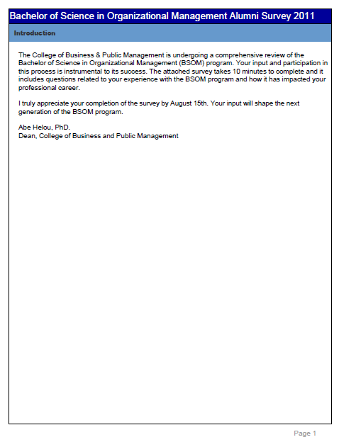 



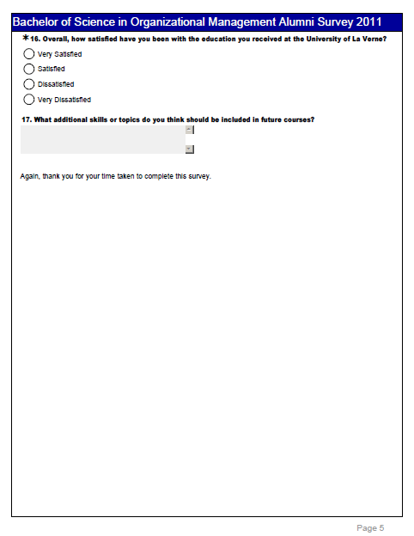

**IV-2: Current Student Survey**

 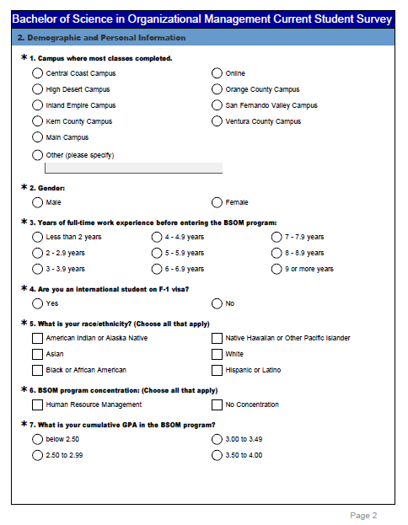

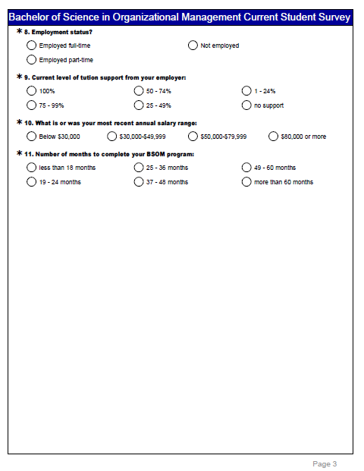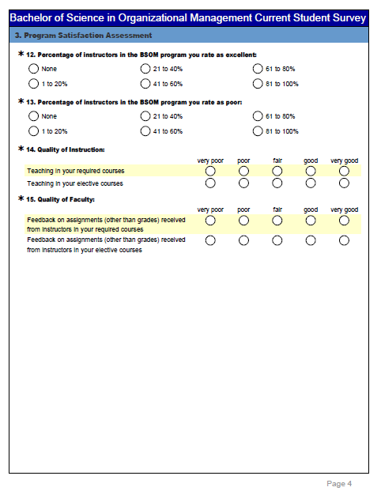

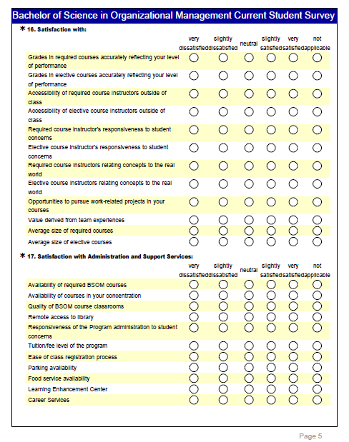 

**Appendix V: Results of the surveys**

**V-1: Alumni**

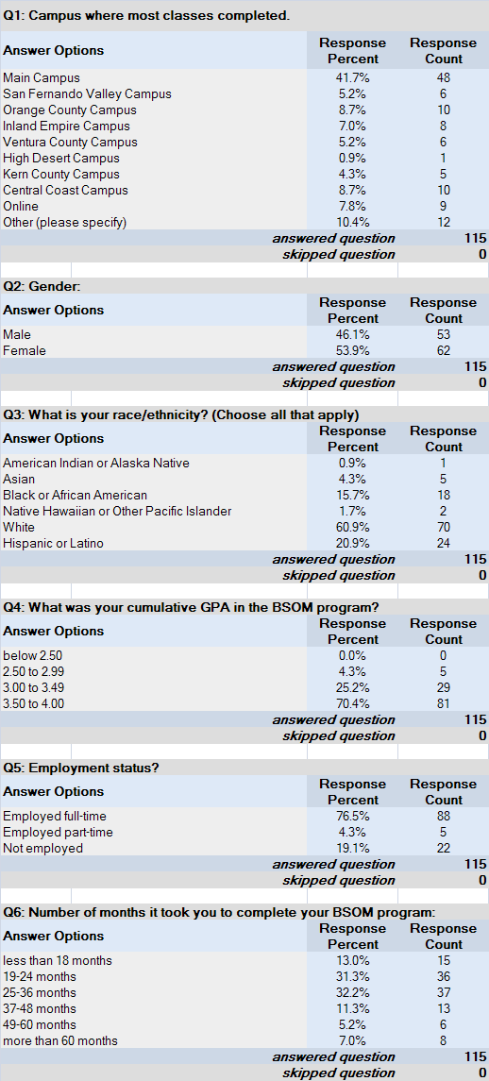

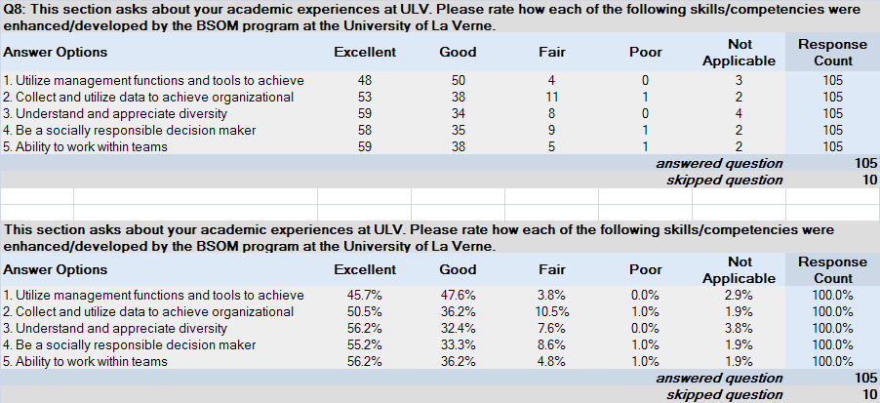

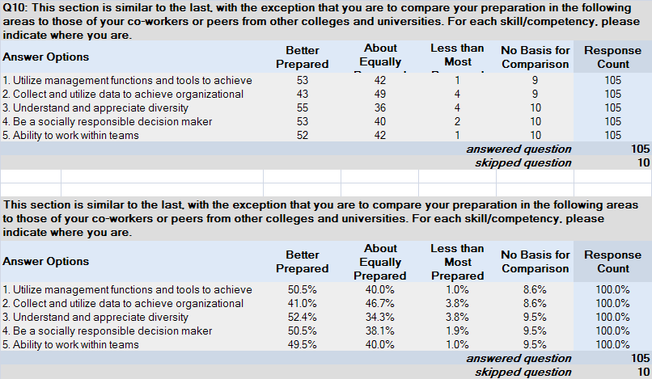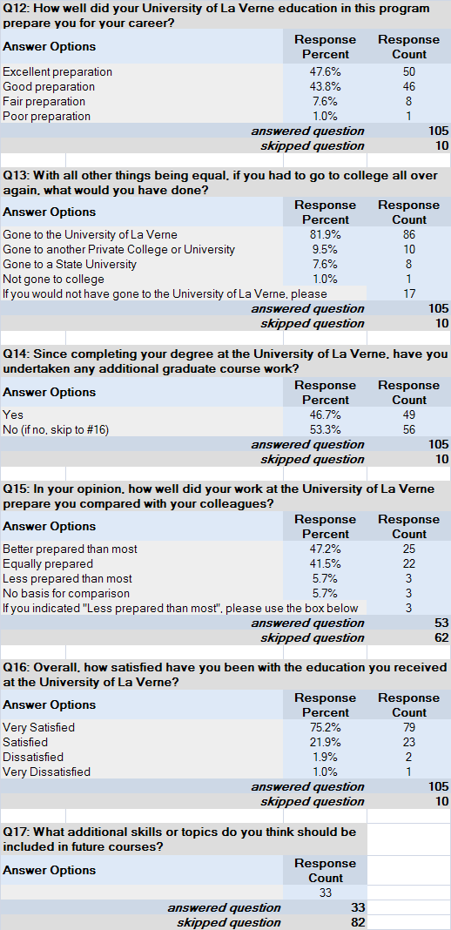

**V-2: Current Student**

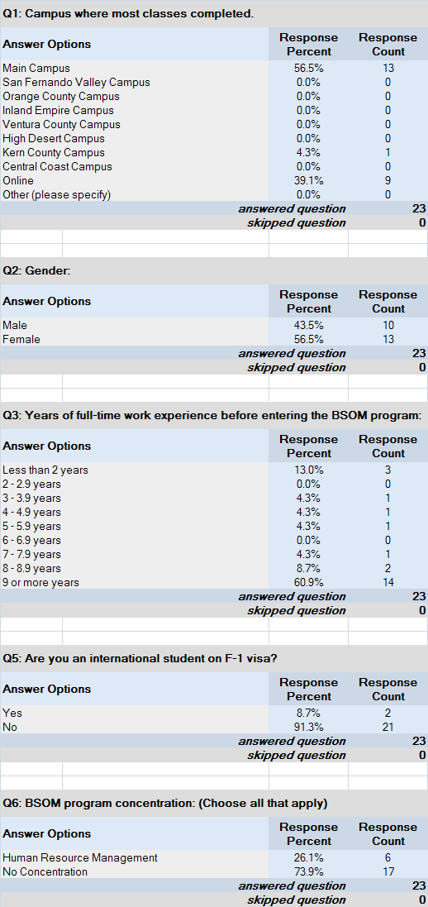

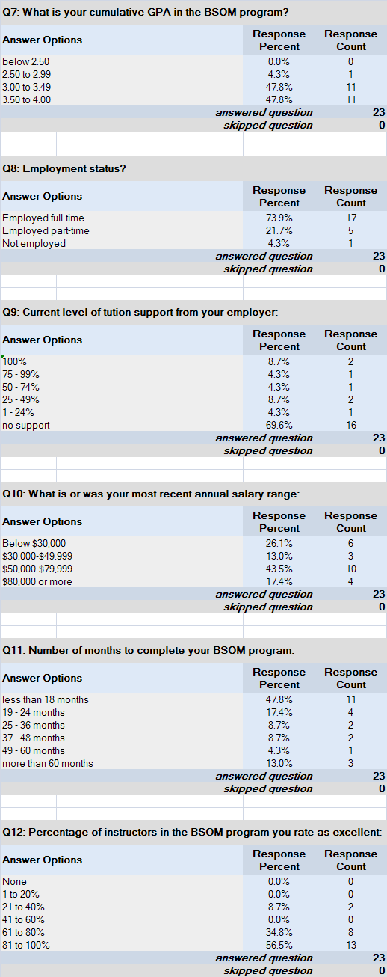

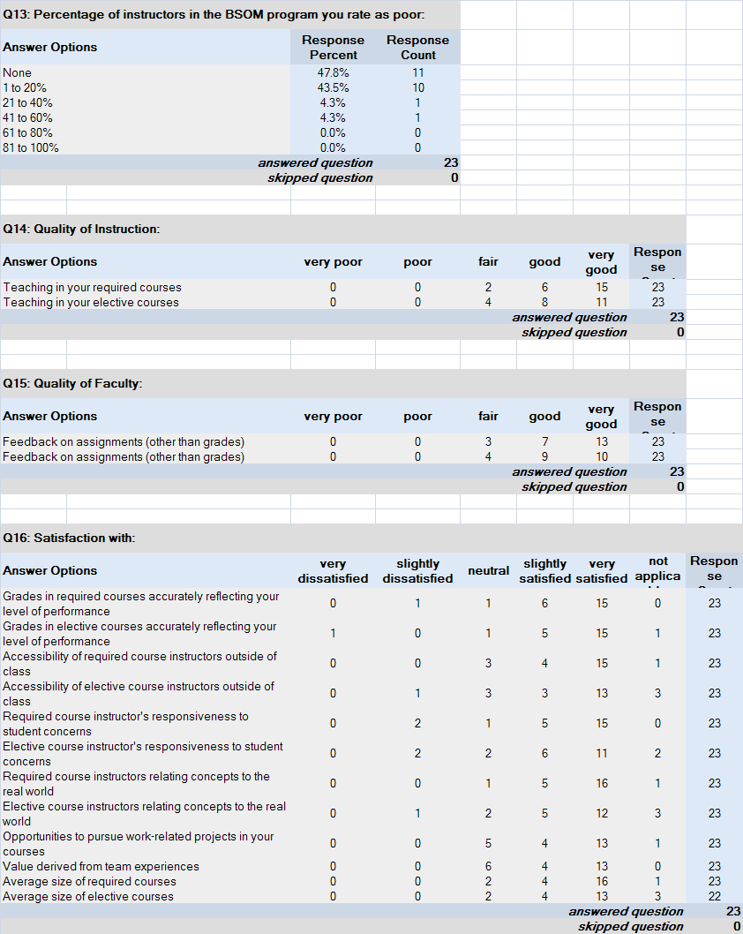

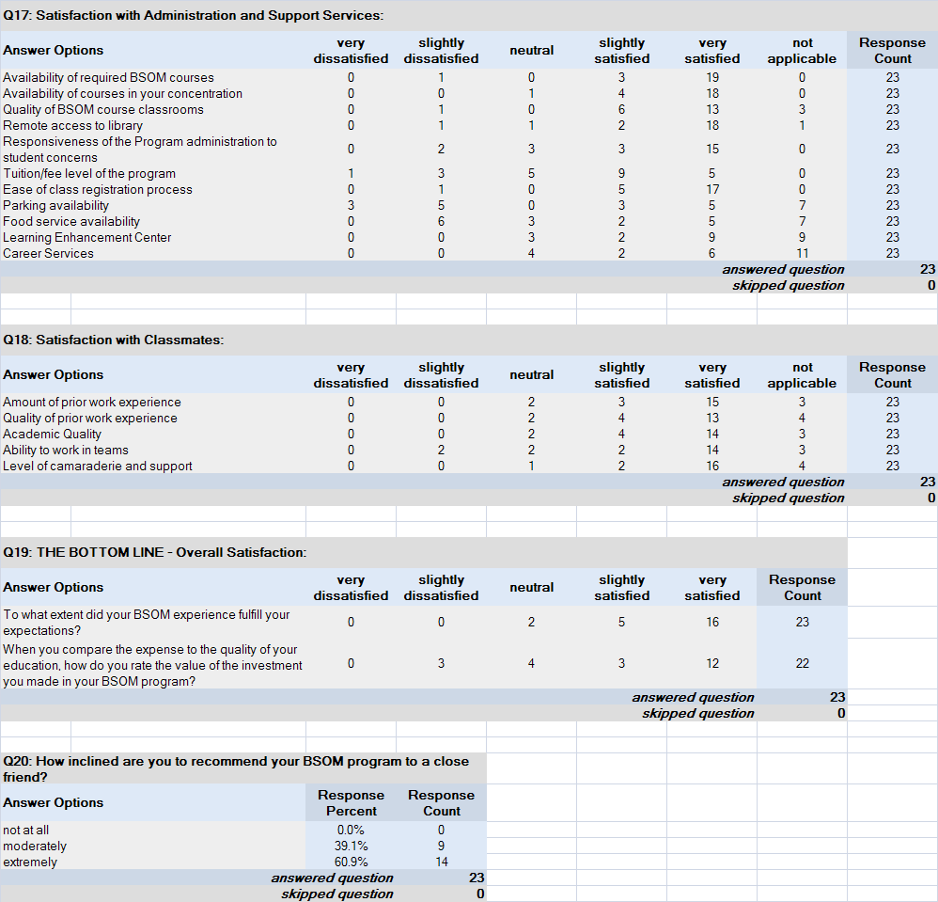

**Appendix VI: Leaning Assessment Outcomes Results**

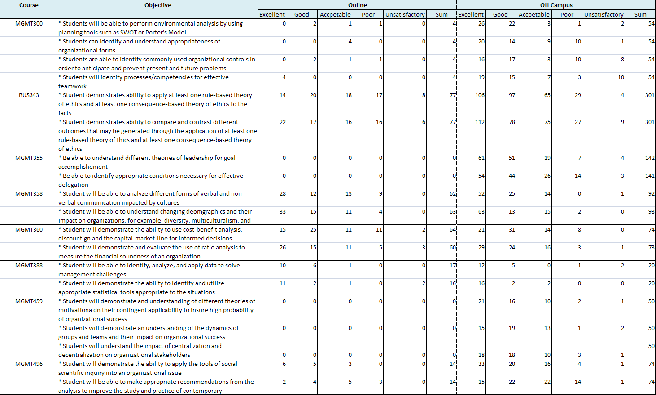

**Appendix VII: Course Evaluations**

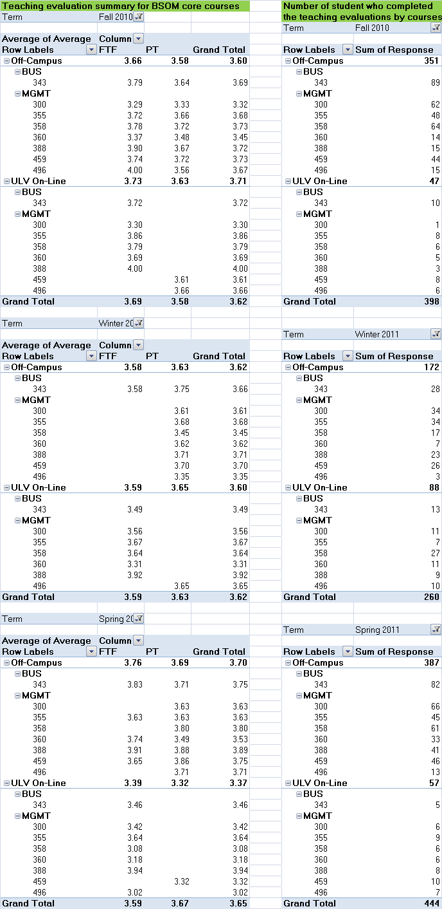

**Appendix VIII: Faculty Coverage and Qualification**

