Active Students by Major/Minor
we have two reports now available in Cognos.

- Active Students by Major/Minor – Registered: Students with a major or minor in the selected discipline who are actively registered in the selected term.
- Active Students by Major/Minor – Not Registered: Students with a major or minor in the selected discipline who are still in active status but are not actively registered in the selected term.

These reports are in the Student/Faculty Student Reports folder in Cognos: Before you begin: You must be either on campus and attached to the campus network, or you must be logged into the Virtual Desktop Interface in order to access the report. For instructions on logging into VDI, visit this website: https://laverne.edu/technology/virtual-desktop/

- Log into the portal and click on Cognos Production from the Staff Resources section.

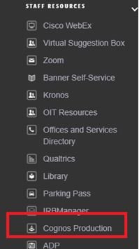

- You should be logged into Cognos and see the landing page. Click on Team Content and then click on the Faculty Student Folder.

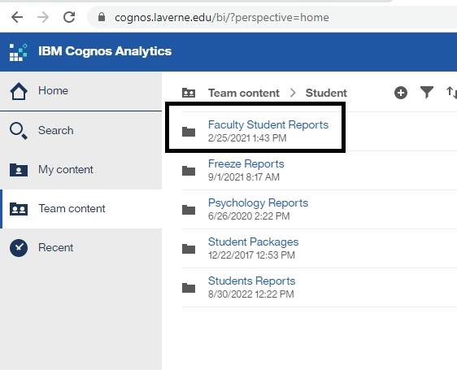
- Click on the report you would like to run.